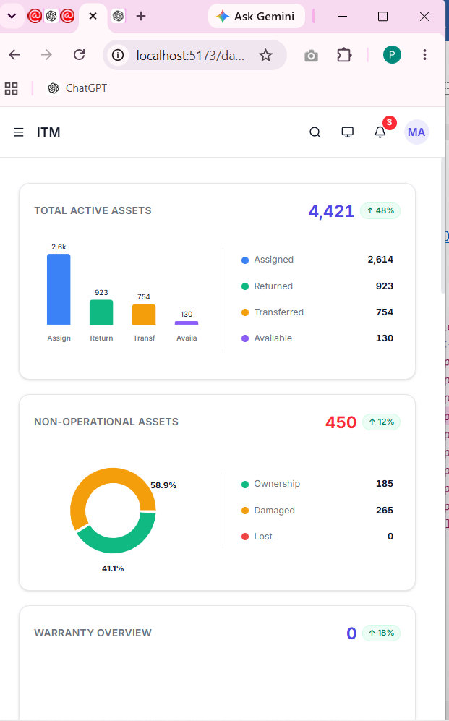
Need to show top bar Dashboad, Assigned-TT, Create TT and Logout

