https://chatgpt.com/c/6a29381f-0528-83a4-a117-fa1ece38f4ab

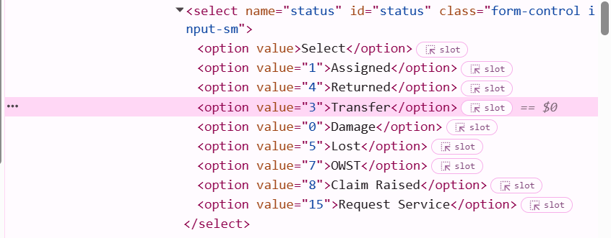

SELECT
status,
COUNT(*) AS total
FROM public.it_equipment
WHERE COALESCE(active, 0) > 0
GROUP BY status
ORDER BY total DESC;

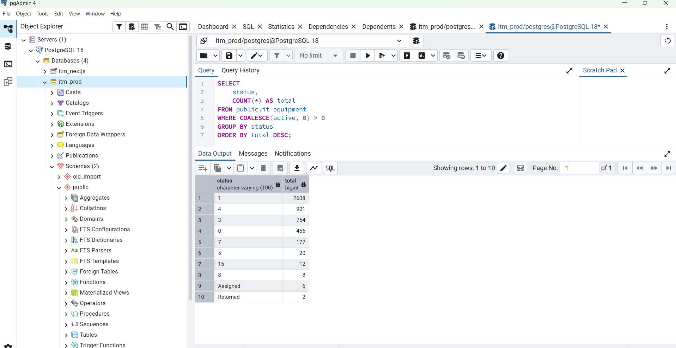

Important correction
Old MySQL status mapping says:
1 = Assigned
4 = Returned
3 = Transfer
So previous code where status = 4 was mapped to Available was wrong. Available should come from stack_inventory.device_assigned_status = 0.

Test SQL in pgAdmin
Run these to verify counts:
SELECT COUNT(*) AS assigned
FROM public.it_equipment
WHERE COALESCE(active, 0) > 0
AND (status = '1' OR LOWER(COALESCE(status, '')) = 'assigned');
SELECT COUNT(*) AS returned
FROM public.it_equipment
WHERE COALESCE(active, 0) > 0
AND (status = '4' OR LOWER(COALESCE(status, '')) = 'returned');
SELECT COUNT(*) AS transferred
FROM public.it_equipment
WHERE COALESCE(active, 0) > 0
AND (status = '3' OR LOWER(COALESCE(status, '')) IN ('transfer', 'transferred'));
SELECT COUNT(*) AS available
FROM public.stack_inventory
WHERE COALESCE(status, 1) = 1
AND COALESCE(device_assigned_status, 0) = 0;

Restart backend
netstat -ano | findstr :8080
taskkill /PID YOUR_PID /F
cd D:\ITM-Data\itm\backend
go run ./cmd/server

Test API
Invoke-RestMethod `
-Uri "http://localhost:8080/api/v1/dashboard/summary" `
-Method GET `
-Headers @{ Authorization = "Bearer $token" } |
ConvertTo-Json -Depth 10
Expected active_assets:
"active_assets": {
"total": 4285,
"items": [
{ "label": "Assigned", "value": 2614 },
{ "label": "Returned", "value": 923 },
{ "label": "Transferred", "value": 754 },
{ "label": "Available", "value": 48 }
]
}
Available value depends on your stack_inventory count.

http://localhost:5173/dashboard/reports/assets?status=Assigned (Unable to load data)

Thought for 14s
BOSS, issueটা almost sure backend route missing.
তোমার frontend page:
http://localhost:5173/dashboard/reports/assets?status=Assigned
frontend internally call করছে:
http://localhost:8080/api/v1/reports/assets?status=Assigned
কিন্তু তোমার current backend ReportHandler.Register() এ /reports/assets route নেই। আছে শুধু /reports/assigned, /reports/warranty, /reports/service etc. তাই page Unable to load data দেখাচ্ছে.
Step 1: Backend route add করো
File:
backend/internal/handler/handlers.go
এই function খুঁজো:
func (h *ReportHandler) Register(rg *gin.RouterGroup) {
g := rg.Group("/reports")
g.GET("/assigned", h.Assigned)
g.GET("/warranty", h.Warranty)
g.GET("/service", h.Service)
g.GET("/users", h.Users)
g.GET("/disposal", h.Disposal)
g.GET("/stock-status", h.StockStatus)
g.GET("/resignation", h.Resignation)
g.GET("/renewal", h.Renewal)
g.GET("/non-operational", h.NonOperational)
}
Replace করো:
func (h *ReportHandler) Register(rg *gin.RouterGroup) {
g := rg.Group("/reports")
g.GET("/assigned", h.Assigned)
g.GET("/assets", h.Assigned) // frontend alias for /dashboard/reports/assets
g.GET("/warranty", h.Warranty)
g.GET("/service", h.Service)
g.GET("/users", h.Users)
g.GET("/disposal", h.Disposal)
g.GET("/stock-status", h.StockStatus)
g.GET("/resignation", h.Resignation)
g.GET("/renewal", h.Renewal)
g.GET("/non-operational", h.NonOperational)
}
Step 2: Backend restart করো
netstat -ano | findstr :8080
taskkill /PID YOUR_PID /F
cd D:\ITM-Data\itm\backend
go run ./cmd/server
Step 3: API direct test করো
New PowerShell:
$loginBody = @{
username = "admin"
password = "Admin@1234"
} | ConvertTo-Json
$login = Invoke-RestMethod `
-Uri "http://localhost:8080/api/v1/auth/login" `
-Method POST `
-ContentType "application/json" `
-Body $loginBody
$token = $login.data.token
Invoke-RestMethod `
-Uri "http://localhost:8080/api/v1/reports/assets?status=Assigned" `
-Method GET `
-Headers @{ Authorization = "Bearer $token" } |
ConvertTo-Json -Depth 5
যদি data আসে, frontend refresh করো:
Ctrl + Shift + R

Step 4: If still unable to load data
Browser DevTools → Network → failed request এ দেখো:
Status code 404 = route missing
Status code 401 = token missing / expired
Status code 500 = backend SQL error
But based on your current backend route list, first fix is definitely this:
g.GET("/assets", h.Assigned)
After this /dashboard/reports/assets?status=Assigned page should load.

Working Flow : Frontend to Go

frontend page → reportApi.assets() → http://localhost:8080/api/v1/reports/assets ✅ Go backend

