02-0071
Mirza Galib Hossain
Roster Time : 22:00:00-07:00:00 (Not Approved)
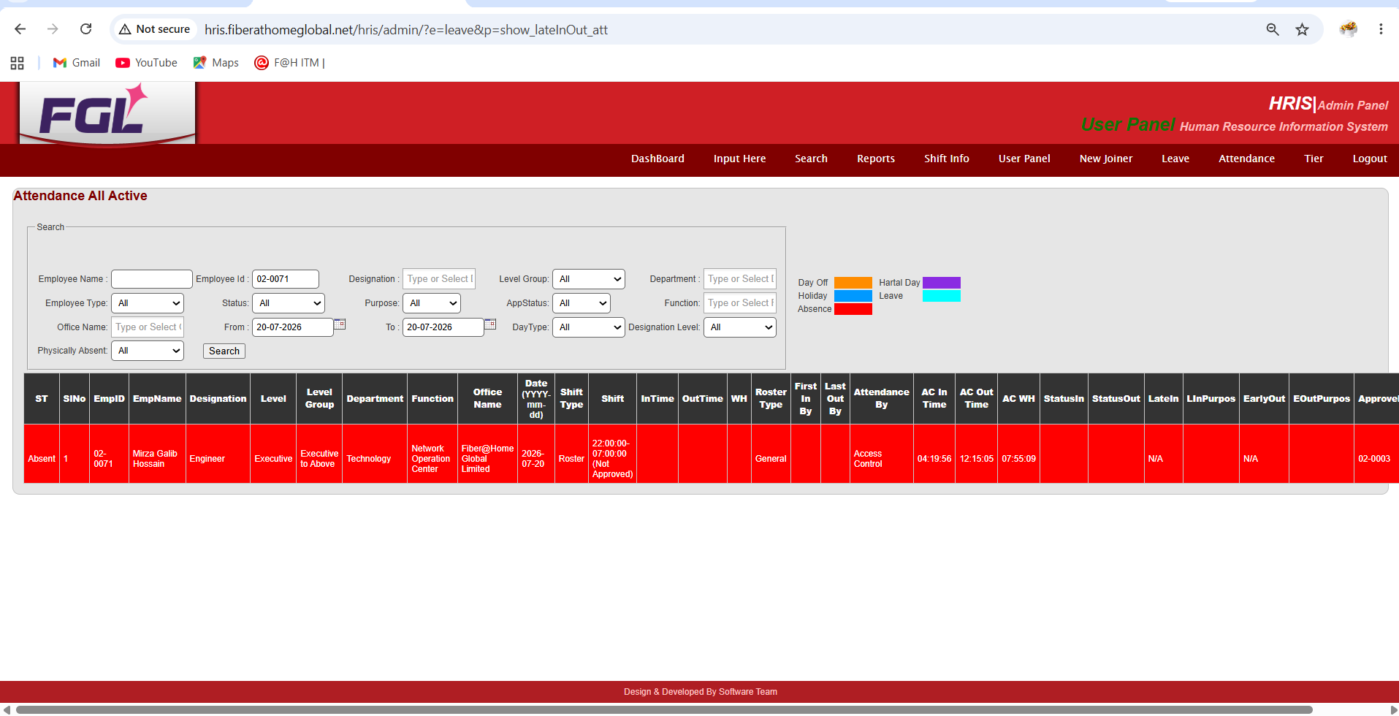

02-0046
G.M. SHARIF ULLAH AL MAMUN
Shift | InTime OutTime

07:00:00-15:00:00 (Not Approved) | 16-07-2026 08:00:01

ID # 02-0121
Roster Duty : Biplob Kumar Paine
Date : 18th July
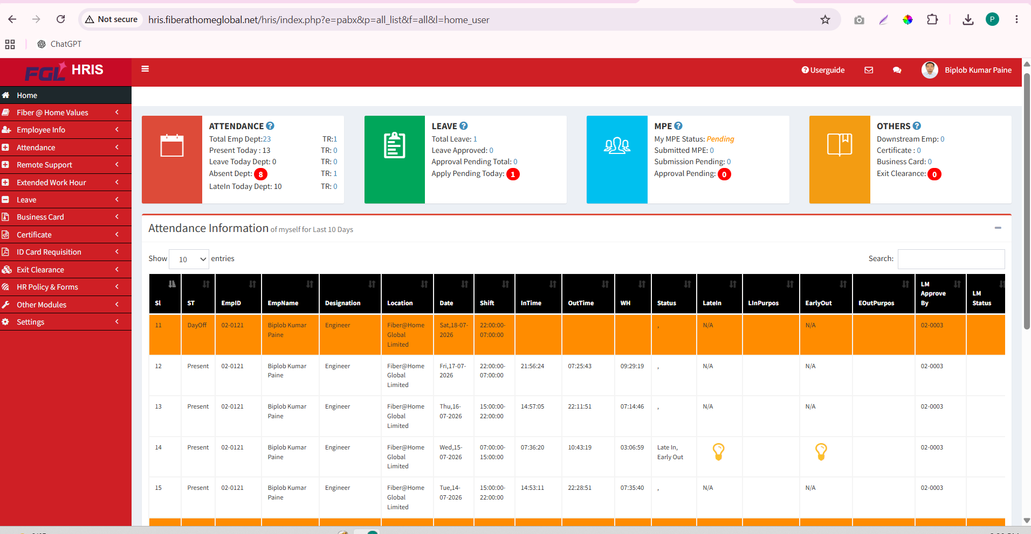
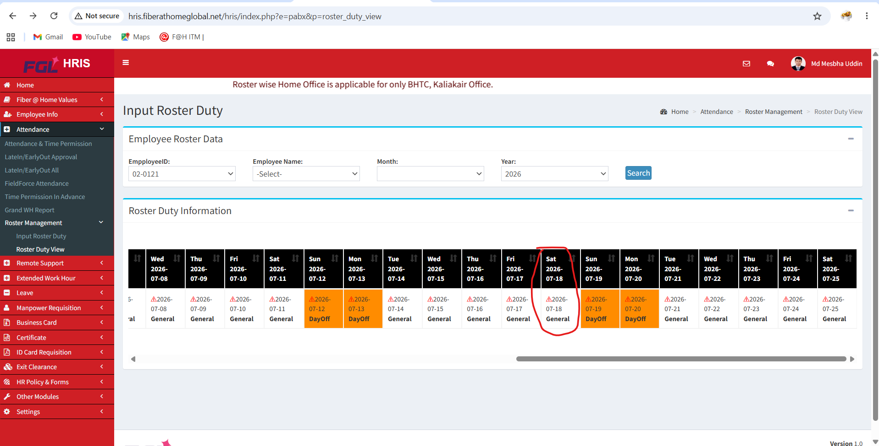

Attendance Panel


DayOff | 02-0092 | Sujan Ruhi Das | Engineer | Fiber@Home Global Limited | ⚠2026-06-28

⚠2026-06-28 :

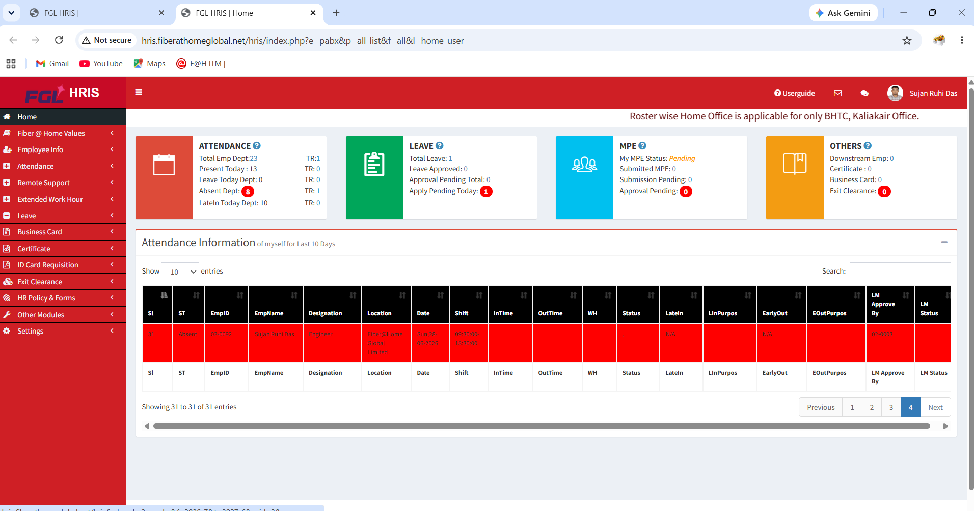

⚠Friday 2026-07-24 : General
