SELECT * FROM itm.tbl_device_clamin_history where reference_no_claim = 14533 AND EXTRACT(YEAR FROM create_at) = 2026;
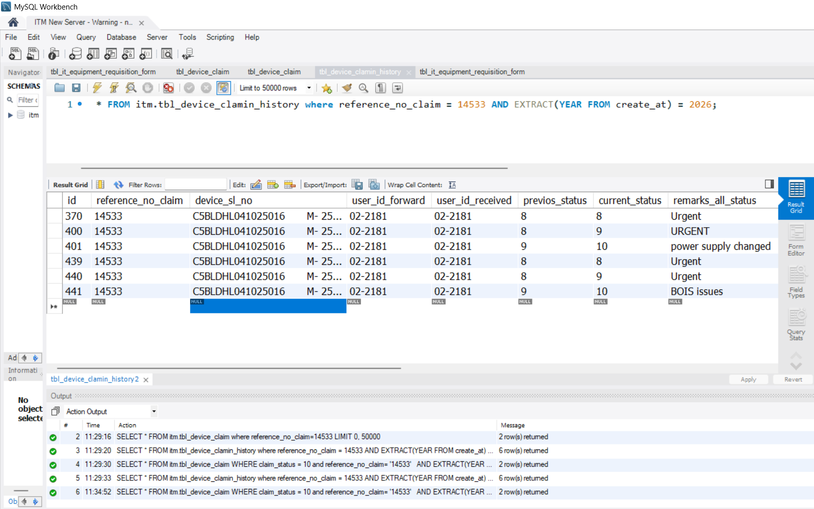
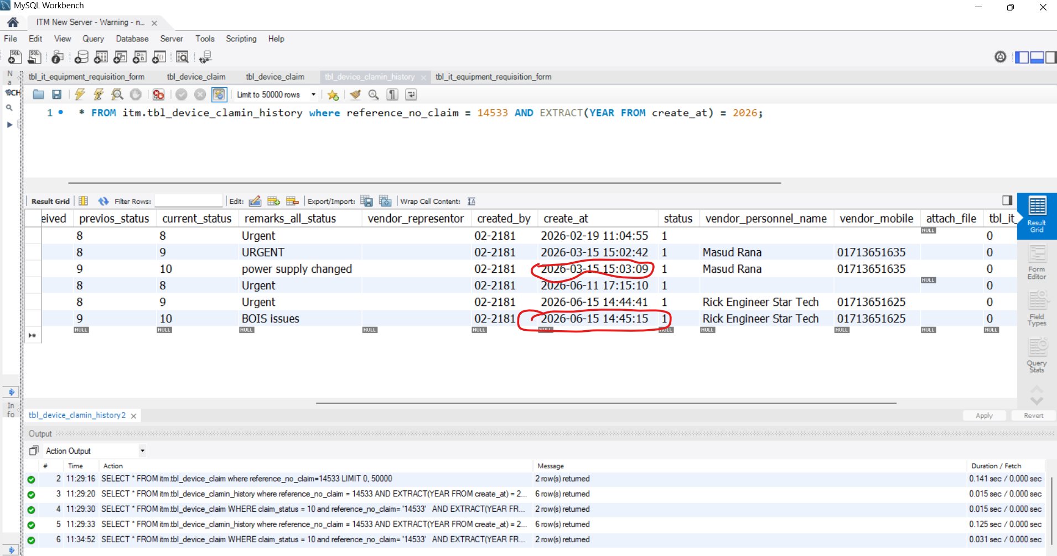

SELECT *
FROM itm.tbl_device_claim
WHERE claim_status = 10 and reference_no_claim= '14533'
AND EXTRACT(YEAR FROM created_at) = 2026;

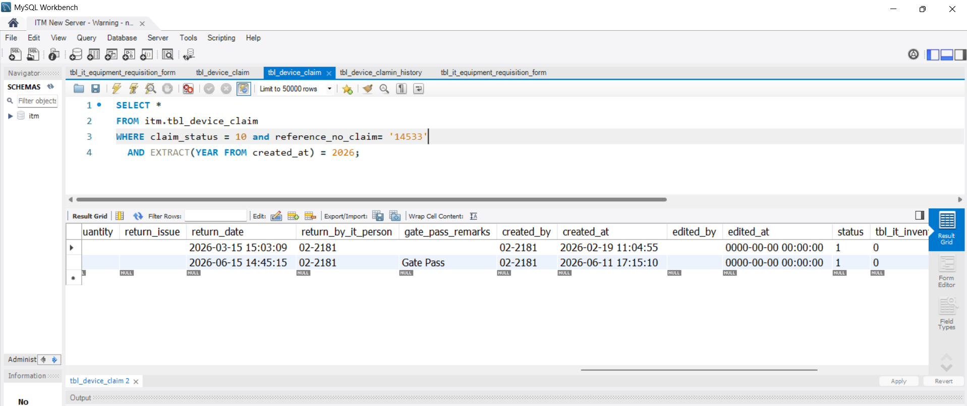

Reference : 14533

SELECT
reference_no_claim,
MAX(create_at) AS closing_date
FROM itm.tbl_device_clamin_history
WHERE reference_no_claim = 14533
AND current_status = 10
AND EXTRACT(YEAR FROM create_at) = 2026
GROUP BY reference_no_claim;

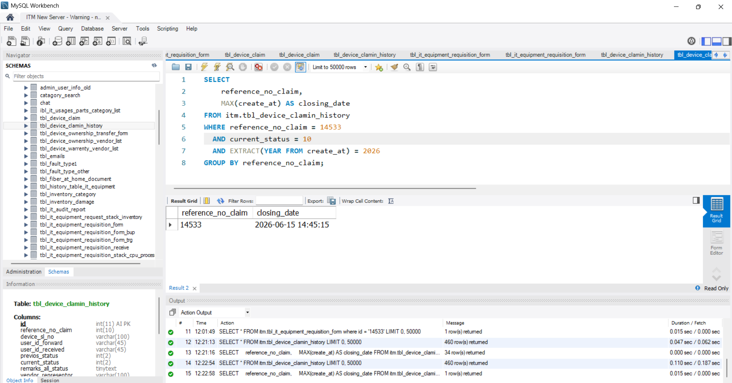

SELECT
reference_no_claim,
MAX(create_at) AS closing_date
FROM itm.tbl_device_clamin_history
WHERE current_status = 10 and tbl_device_clamin_history.reference_no_claim = 14533
AND EXTRACT(YEAR FROM create_at) = 2026
GROUP BY reference_no_claim;

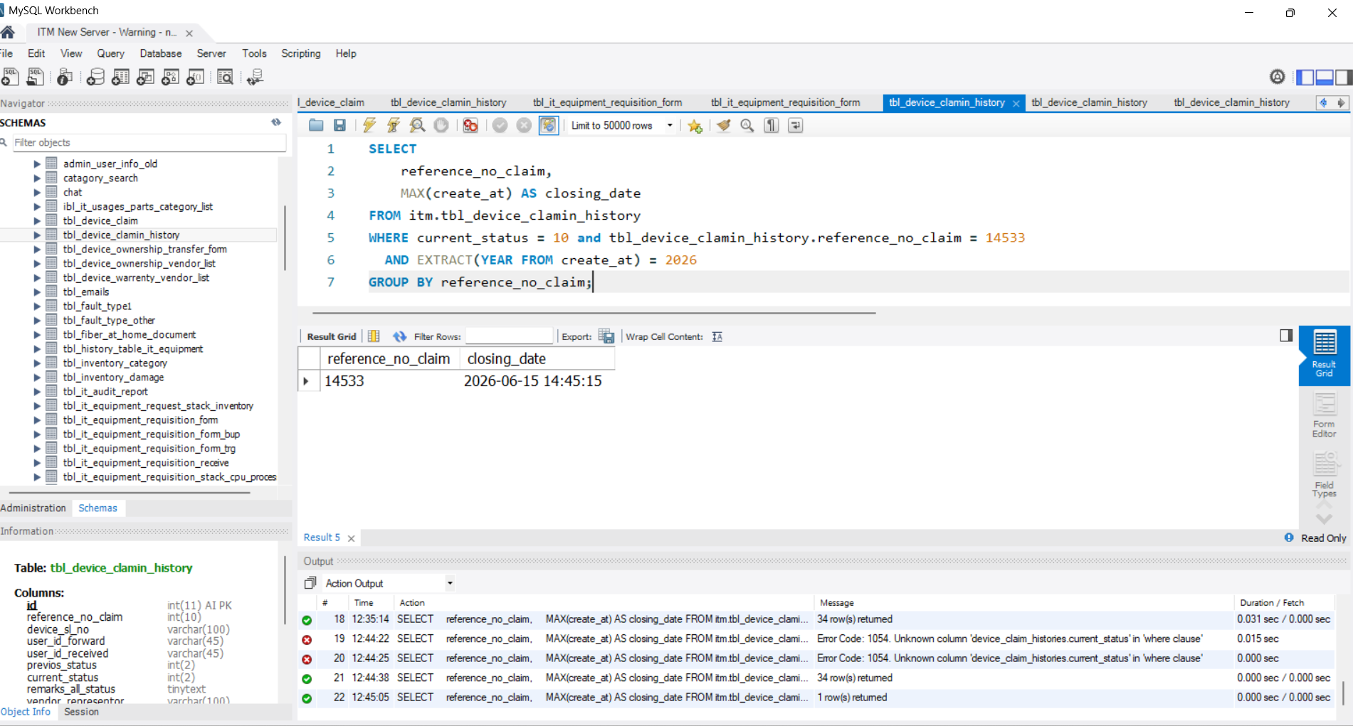

SELECT
h.claim_reference_no,
MAX(h.created_at) AS closing_date
FROM public.device_claim_histories h
WHERE h.claim_reference_no = '14533'
AND h.current_status = 10
AND h.created_at >= DATE_TRUNC('year', CURRENT_DATE)
AND h.created_at < DATE_TRUNC('year', CURRENT_DATE) + INTERVAL '1 year'
GROUP BY h.claim_reference_no;

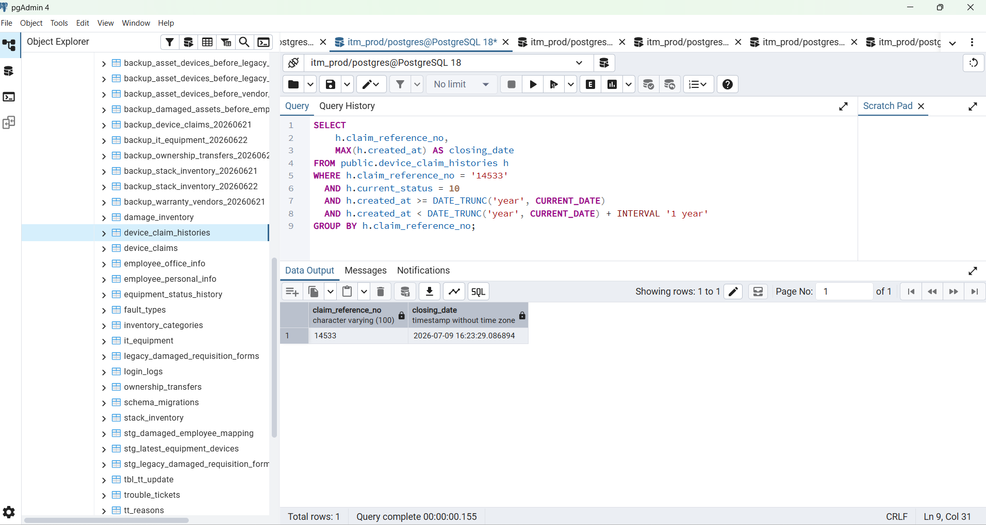

Recovered Count List
SELECT
h.claim_reference_no,
MAX(h.created_at) AS closing_date
FROM public.device_claim_histories h
WHERE h.current_status = 10
AND h.created_at >= DATE_TRUNC('year', CURRENT_DATE)
AND h.created_at < DATE_TRUNC('year', CURRENT_DATE) + INTERVAL '1 year'
GROUP BY h.claim_reference_no;

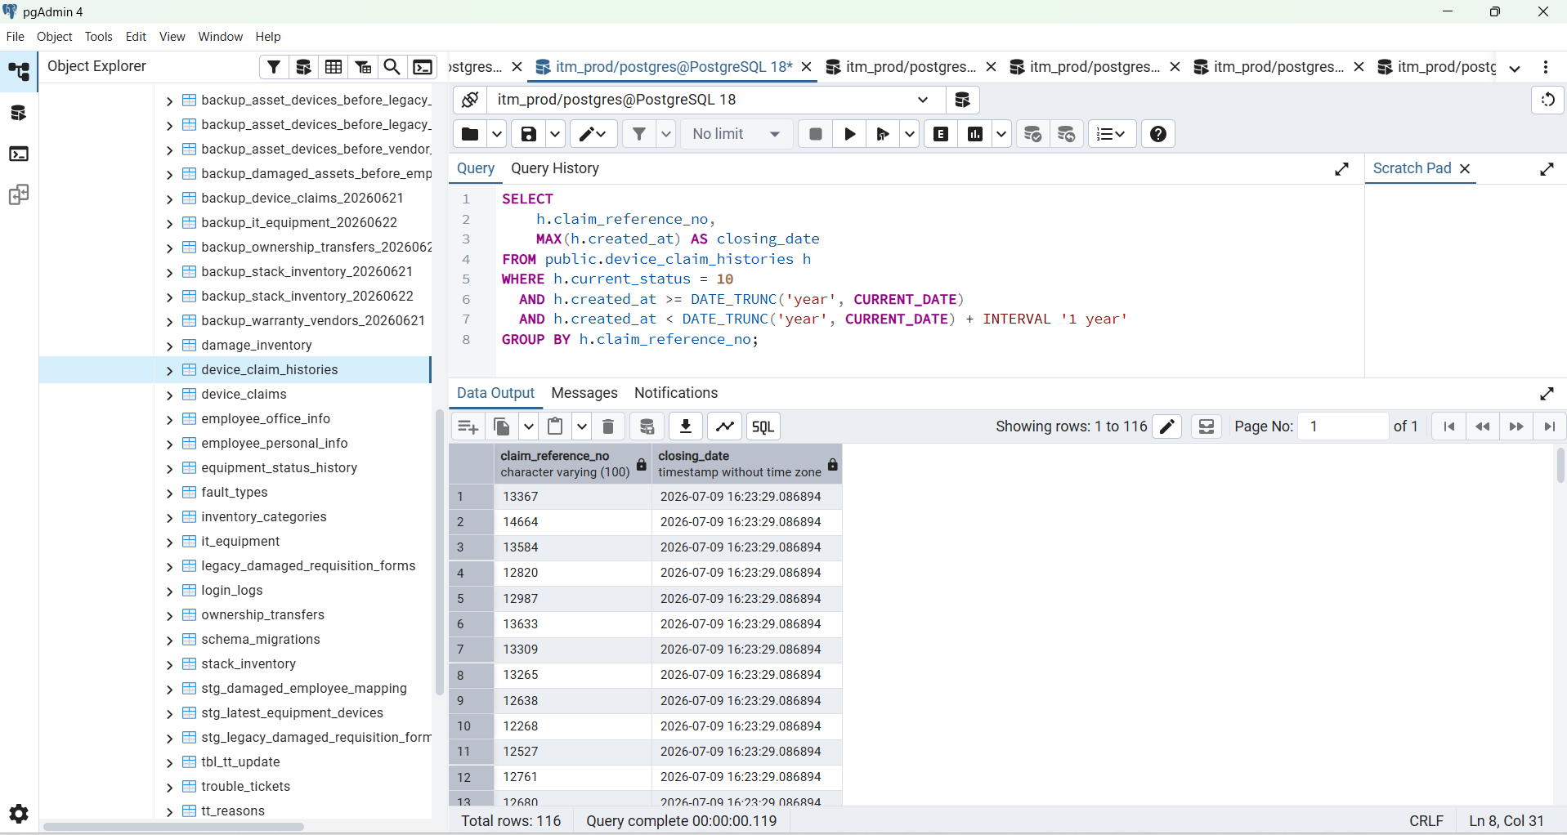

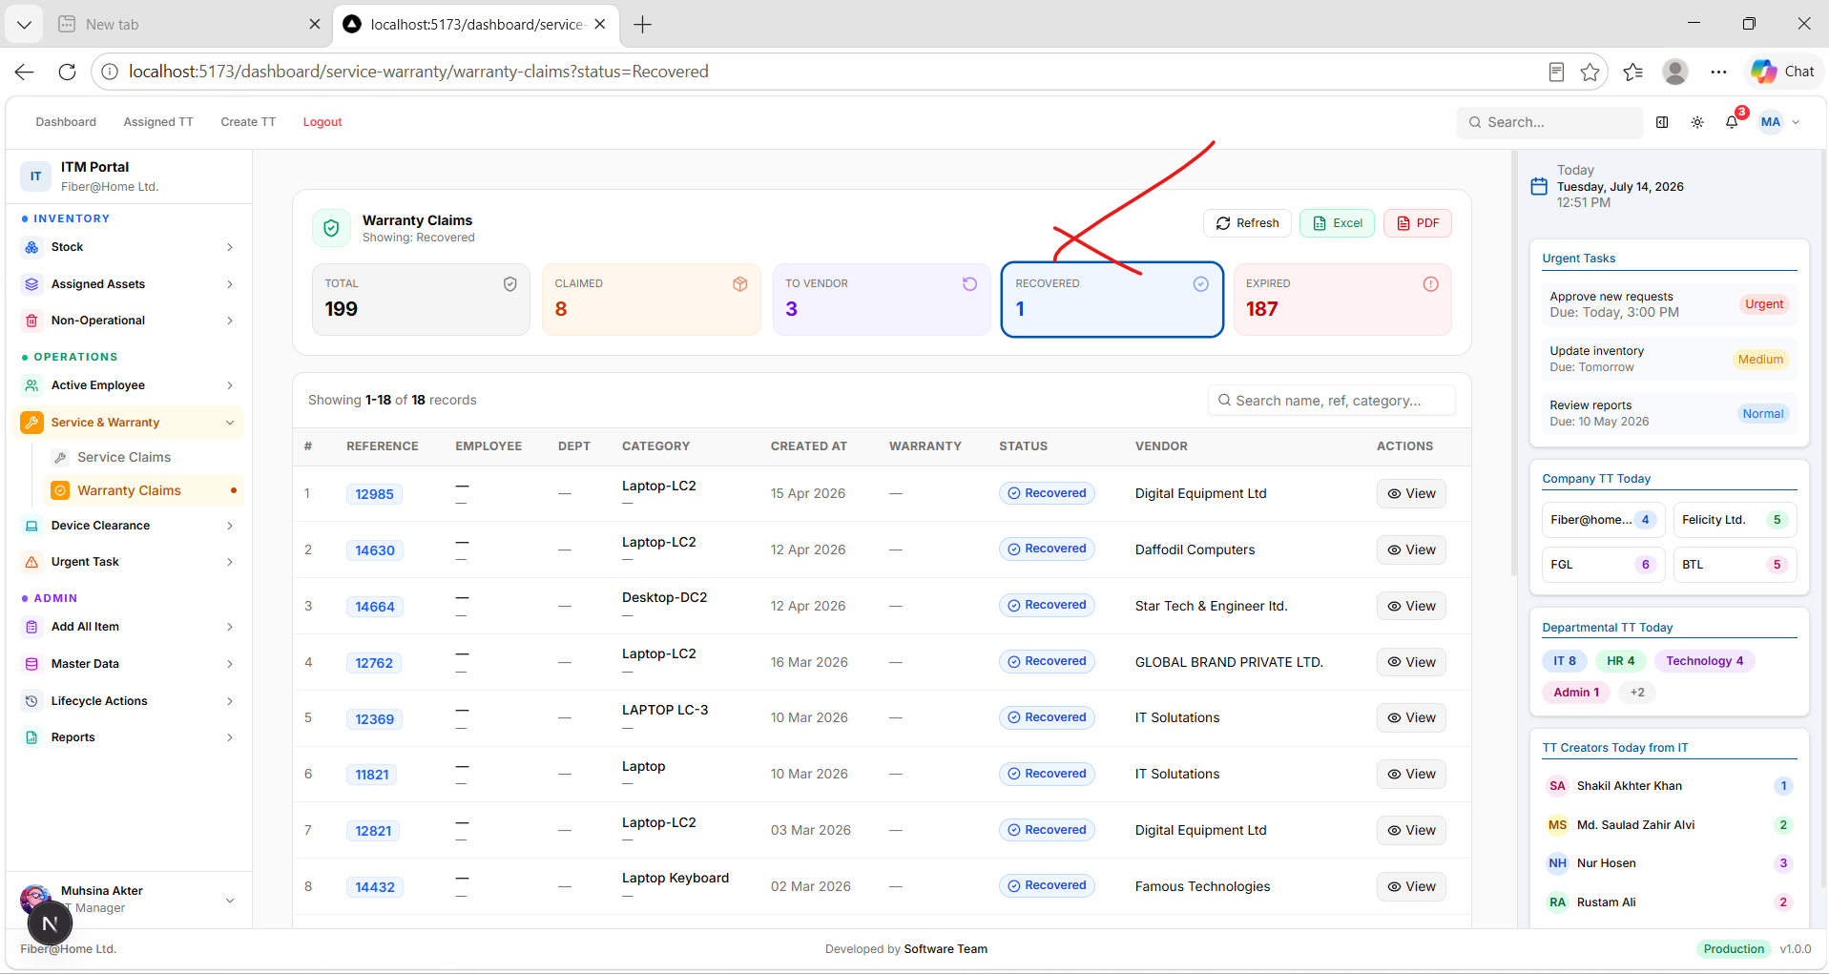

SELECT
dc.reference_no_claim,
MAX(dc.return_date) AS closing_date
FROM public.device_claims dc
WHERE dc.claim_status = 10
AND dc.return_date IS NOT NULL
AND dc.return_date::date >= DATE_TRUNC('year', CURRENT_DATE)::date
AND dc.return_date::date < (DATE_TRUNC('year', CURRENT_DATE) + INTERVAL '1 year')::date
GROUP BY dc.reference_no_claim
ORDER BY closing_date DESC;

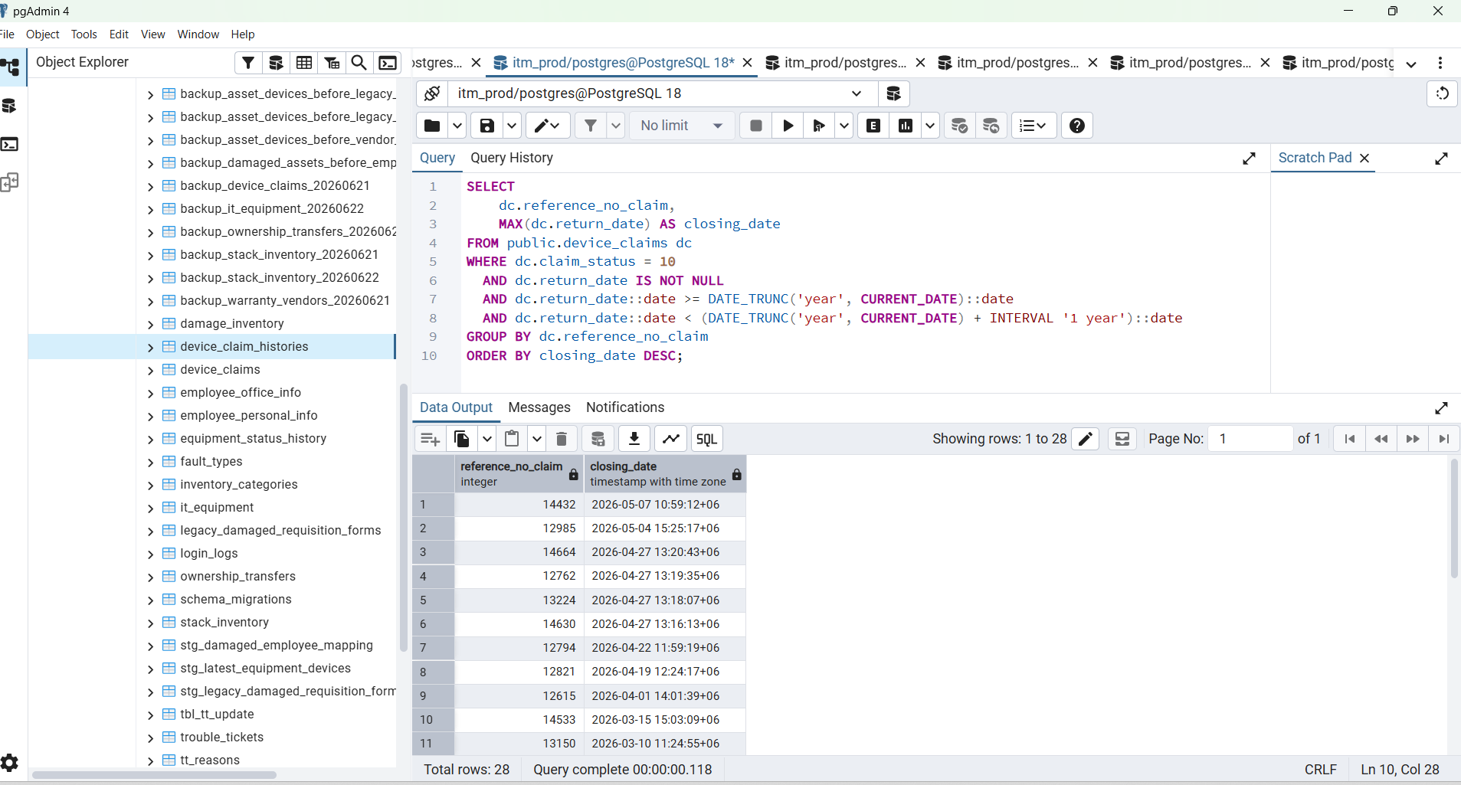

Warranty Claims
Showing: Recovered
RefreshExcelPDF
Total
227
Claimed
8
To Vendor
4
Recovered
28
Expired
187

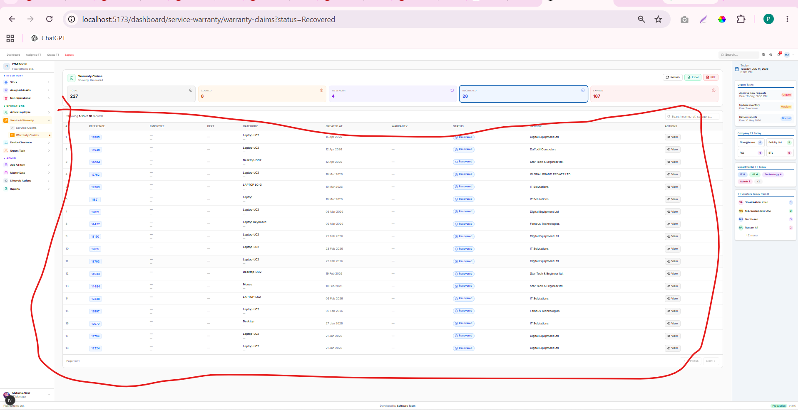

WITH year_bounds AS (
SELECT
DATE_TRUNC('year', CURRENT_DATE)::date AS year_start,
(DATE_TRUNC('year', CURRENT_DATE) + INTERVAL '1 year')::date AS next_year_start
),

recovered_rows AS (
SELECT DISTINCT ON (dc.reference_no_claim)
dc.reference_no_claim,
dc.return_date AS closing_date
FROM public.device_claims dc
CROSS JOIN year_bounds yb
WHERE dc.claim_status = 10
AND dc.reference_no_claim IS NOT NULL
AND dc.return_date IS NOT NULL
AND dc.return_date::date >= yb.year_start
AND dc.return_date::date < yb.next_year_start
ORDER BY
dc.reference_no_claim,
dc.return_date DESC NULLS LAST,
dc.id DESC
)

SELECT COUNT(*) AS recovered_count
FROM recovered_rows;

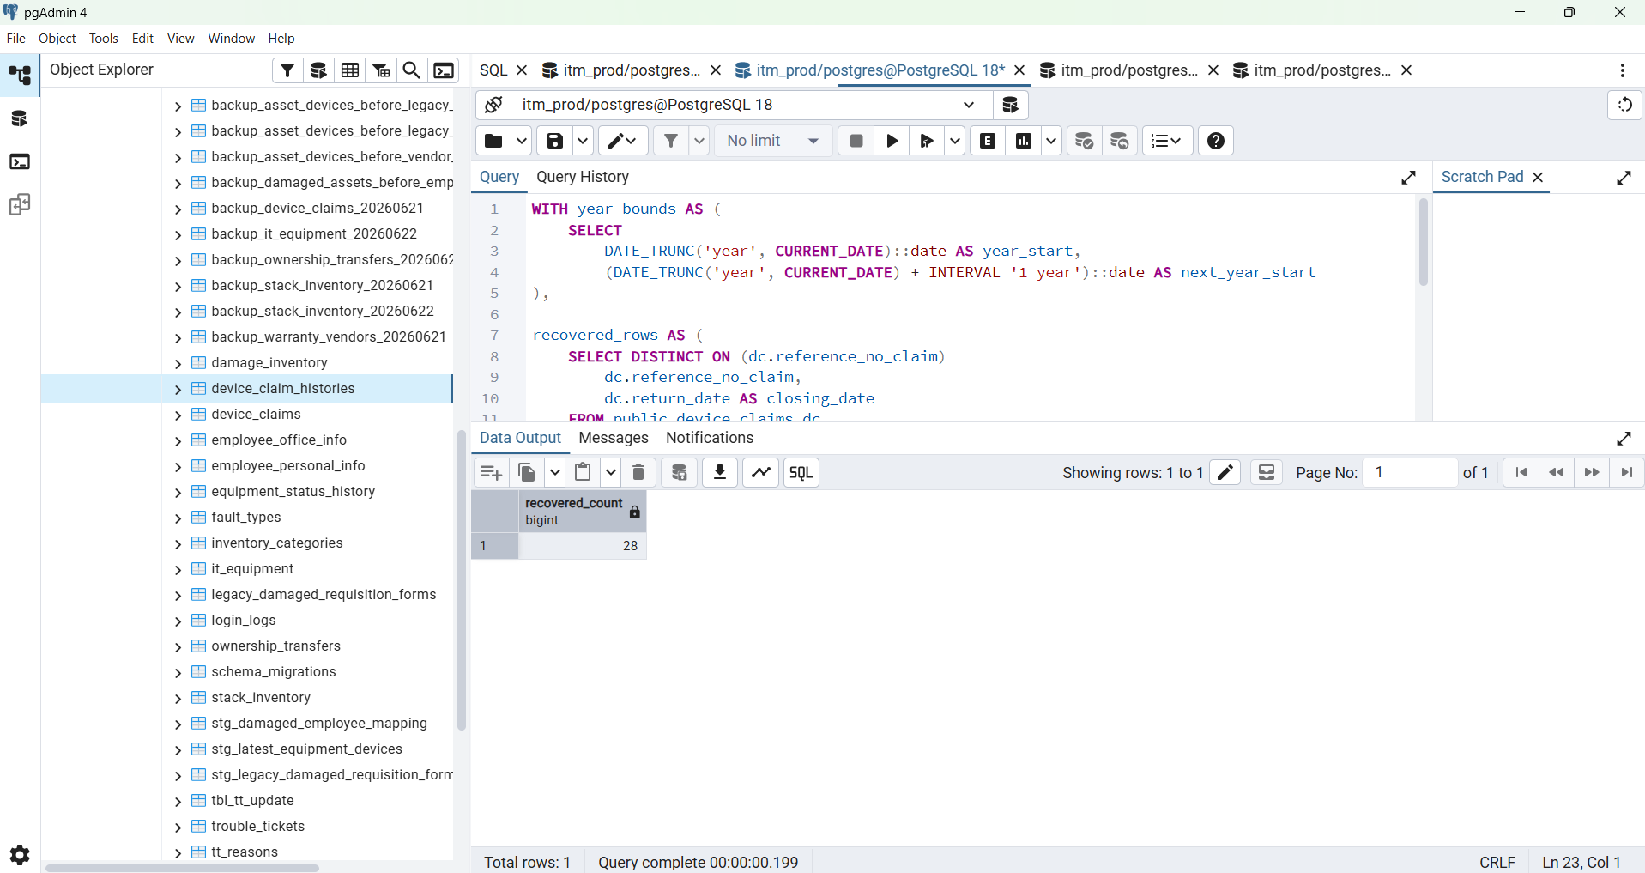

SELECT
dc.reference_no_claim,
MAX(dc.return_date) AS closing_date
FROM public.device_claims dc
WHERE dc.claim_status = 10
AND dc.return_date IS NOT NULL
AND dc.return_date::date >= DATE_TRUNC('year', CURRENT_DATE)::date
AND dc.return_date::date < (DATE_TRUNC('year', CURRENT_DATE) + INTERVAL '1 year')::date
GROUP BY dc.reference_no_claim
ORDER BY closing_date DESC;

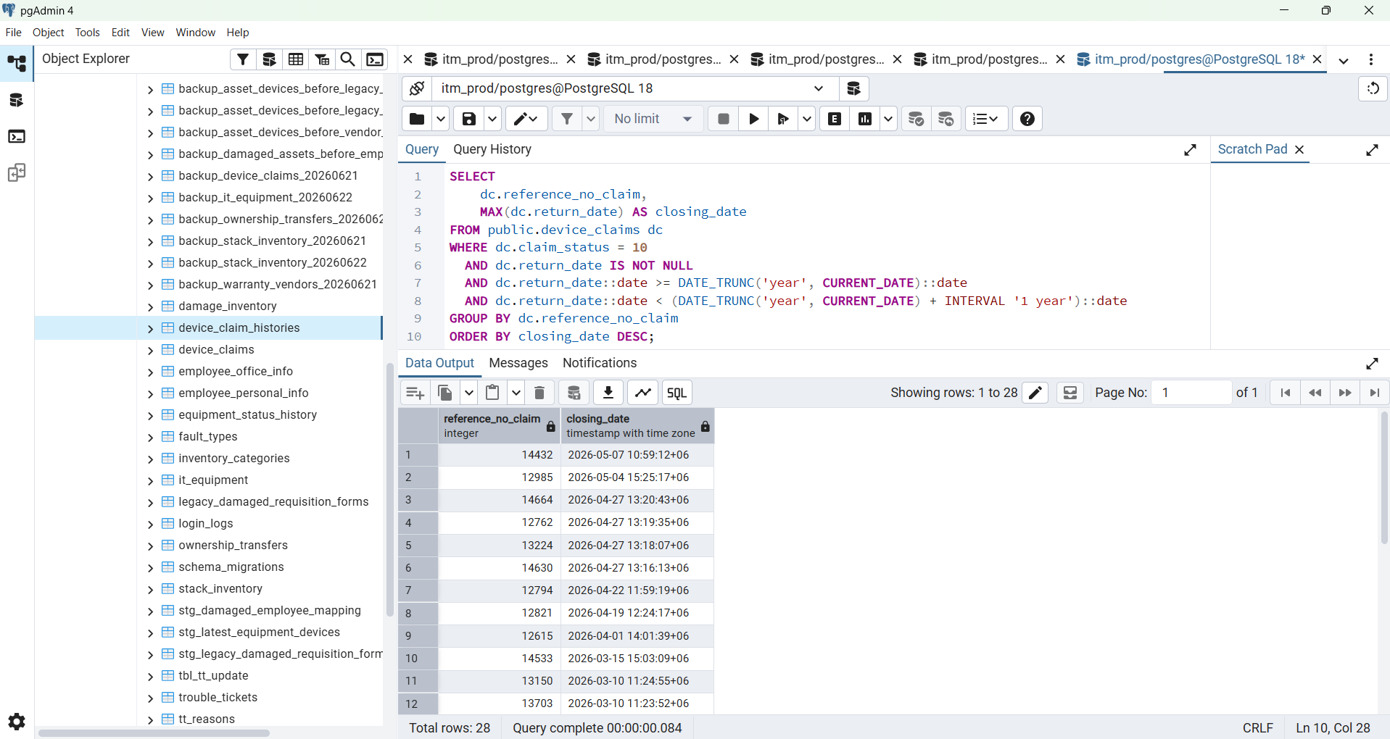

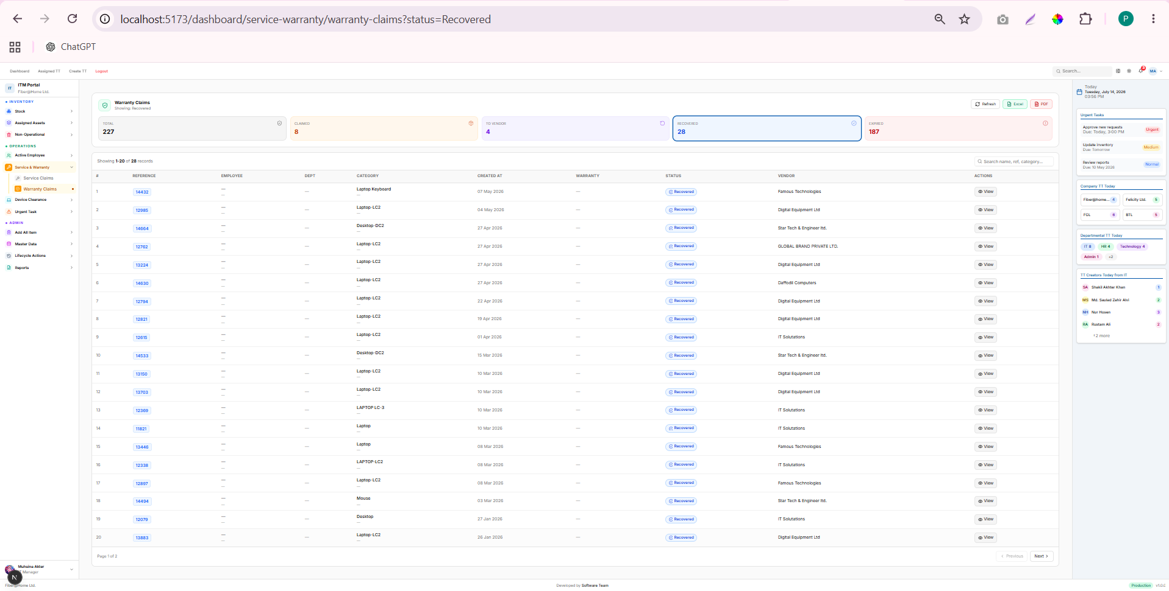

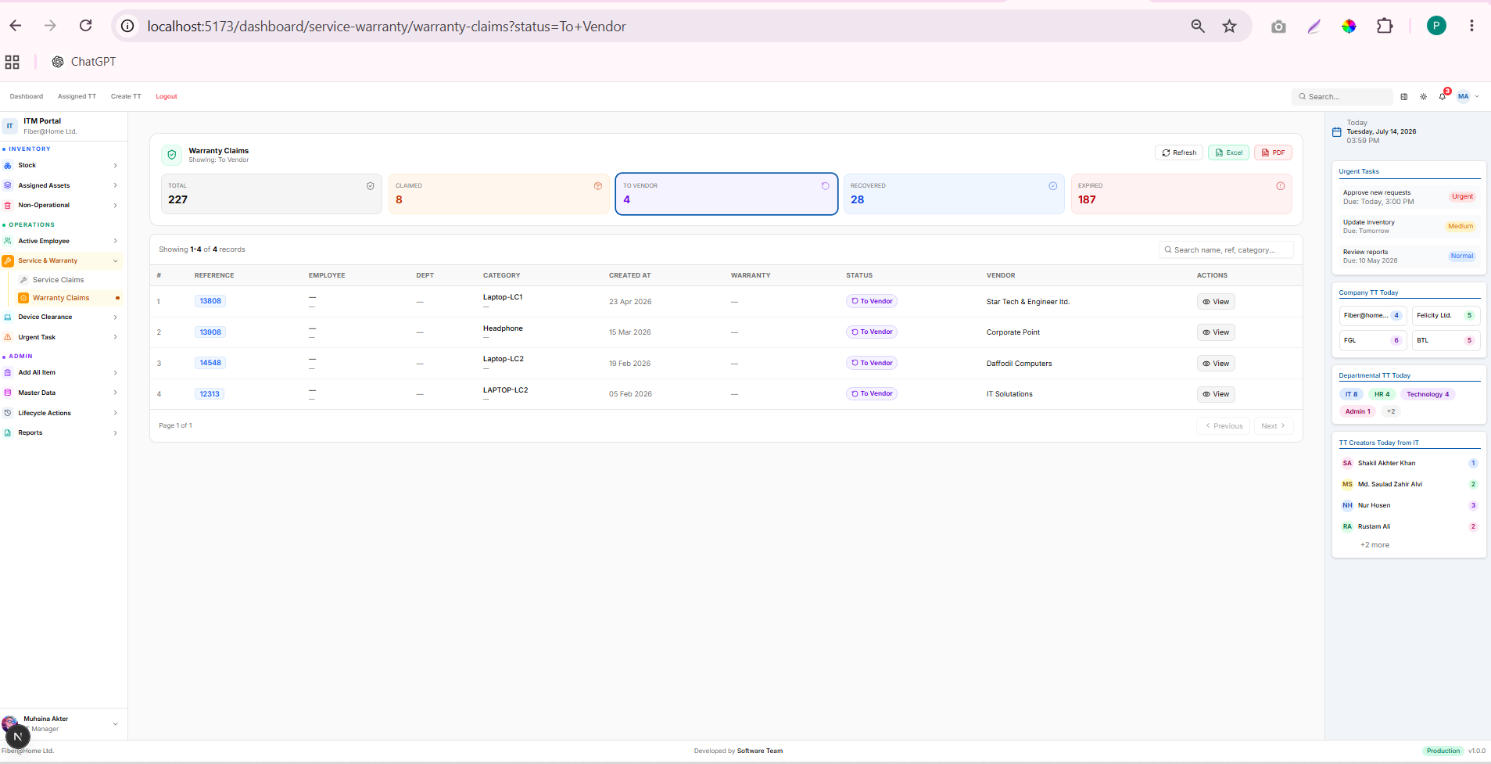

Postman

Method : GET : http://localhost:8080/api/v1/assets/warranty/claims?status=Recovered

{
"data": [
{
"id": 136,
"reference": "14432",
"employee": null,
"emp_id": null,
"department": null,
"designation": null,
"category": "Laptop Keyboard",
"brand": null,
"model": null,
"device_serial": "n0sn5602",
"warranty_date": null,
"status": "Recovered",
"vendor": "Famous Technologies",
"problems": "Hardware Issue \r\n",
"created_at": "2026-05-07 10:59:12+06"
},
{
"id": 147,
"reference": "12985",
"employee": null,
"emp_id": null,
"department": null,
"designation": null,
"category": "Laptop-LC2",
"brand": null,
"model": null,
"device_serial": "F8F19T3",
"warranty_date": null,
"status": "Recovered",
"vendor": "Digital Equipment Ltd",
"problems": "1. Laptop cooling fan error â€“ needs replacement.\r\n2. Display color issues",
"created_at": "2026-05-04 15:25:17+06"
},
{
"id": 144,
"reference": "14664",
"employee": null,
"emp_id": null,
"department": null,
"designation": null,
"category": "Desktop-DC2",
"brand": null,
"model": null,
"device_serial": "C5BLDHL041025018 M- 25361B009134",
"warranty_date": null,
"status": "Recovered",
"vendor": "Star Tech & Engineer ltd.",
"problems": "No Power (This Is the Second Time. The First Time, the Power Supply Was Replaced.)\r\n",
"created_at": "2026-04-27 13:20:43+06"
},
{
"id": 143,
"reference": "12762",
"employee": null,
"emp_id": null,
"department": null,
"designation": null,
"category": "Laptop-LC2",
"brand": null,
"model": null,
"device_serial": "H68SGJ3",
"warranty_date": null,
"status": "Recovered",
"vendor": "GLOBAL BRAND PRIVATE LTD.",
"problems": "No Sound",
"created_at": "2026-04-27 13:19:35+06"
},
{
"id": 123,
"reference": "13224",
"employee": null,
"emp_id": null,
"department": null,
"designation": null,
"category": "Laptop-LC2",
"brand": null,
"model": null,
"device_serial": "5CD3062R5P",
"warranty_date": null,
"status": "Recovered",
"vendor": "Digital Equipment Ltd",
"problems": "Display (upper portion shows a black line)",
"created_at": "2026-04-27 13:18:07+06"
},
{
"id": 145,
"reference": "14630",
"employee": null,
"emp_id": null,
"department": null,
"designation": null,
"category": "Laptop-LC2",
"brand": null,
"model": null,
"device_serial": "5CD536F3FC",
"warranty_date": null,
"status": "Recovered",
"vendor": "Daffodil Computers",
"problems": "The touchpad is working automatically.",
"created_at": "2026-04-27 13:16:13+06"
},
{
"id": 124,
"reference": "12794",
"employee": null,
"emp_id": null,
"department": null,
"designation": null,
"category": "Laptop-LC2",
"brand": null,
"model": null,
"device_serial": "2RL19T3",
"warranty_date": null,
"status": "Recovered",
"vendor": "Digital Equipment Ltd",
"problems": "Touchpad not working",
"created_at": "2026-04-22 11:59:19+06"
},
{
"id": 137,
"reference": "12821",
"employee": null,
"emp_id": null,
"department": null,
"designation": null,
"category": "Laptop-LC2",
"brand": null,
"model": null,
"device_serial": "BK719T3",
"warranty_date": null,
"status": "Recovered",
"vendor": "Digital Equipment Ltd",
"problems": "No power",
"created_at": "2026-04-19 12:24:17+06"
},
{
"id": 134,
"reference": "12615",
"employee": null,
"emp_id": null,
"department": null,
"designation": null,
"category": "Laptop-LC2",
"brand": null,
"model": null,
"device_serial": "23Z1HJ3",
"warranty_date": null,
"status": "Recovered",
"vendor": "IT Solutations",
"problems": "Power Issue (Charger port)",
"created_at": "2026-04-01 14:01:39+06"
},
{
"id": 131,
"reference": "14533",
"employee": null,
"emp_id": null,
"department": null,
"designation": null,
"category": "Desktop-DC2",
"brand": null,
"model": null,
"device_serial": "C5BLDHL041025016 M- 25361B009098",
"warranty_date": null,
"status": "Recovered",
"vendor": "Star Tech & Engineer ltd.",
"problems": "No power\r\n(Gaming Desktop)",
"created_at": "2026-03-15 15:03:09+06"
},
{
"id": 135,
"reference": "13150",
"employee": null,
"emp_id": null,
"department": null,
"designation": null,
"category": "Laptop-LC2",
"brand": null,
"model": null,
"device_serial": "5CD25036WV",
"warranty_date": null,
"status": "Recovered",
"vendor": "Digital Equipment Ltd",
"problems": "The laptop powers on, but there is no display.",
"created_at": "2026-03-10 11:24:55+06"
},
{
"id": 133,
"reference": "13703",
"employee": null,
"emp_id": null,
"department": null,
"designation": null,
"category": "Laptop-LC2",
"brand": null,
"model": null,
"device_serial": "FL719T3",
"warranty_date": null,
"status": "Recovered",
"vendor": "Digital Equipment Ltd",
"problems": "No power",
"created_at": "2026-03-10 11:23:52+06"
},
{
"id": 139,
"reference": "12369",
"employee": null,
"emp_id": null,
"department": null,
"designation": null,
"category": "LAPTOP LC-3",
"brand": null,
"model": null,
"device_serial": "5CD201K54X",
"warranty_date": null,
"status": "Recovered",
"vendor": "IT Solutations",
"problems": "Keyboard Key broken",
"created_at": "2026-03-10 11:04:01+06"
},
{
"id": 138,
"reference": "11821",
"employee": null,
"emp_id": null,
"department": null,
"designation": null,
"category": "Laptop",
"brand": null,
"model": null,
"device_serial": "BQN0P93",
"warranty_date": null,
"status": "Recovered",
"vendor": "IT Solutations",
"problems": "The display shows only a black screen",
"created_at": "2026-03-10 10:52:00+06"
},
{
"id": 111,
"reference": "13446",
"employee": null,
"emp_id": null,
"department": null,
"designation": null,
"category": "Laptop",
"brand": null,
"model": null,
"device_serial": "73HJ303",
"warranty_date": null,
"status": "Recovered",
"vendor": "Famous Technologies",
"problems": "Display damaged",
"created_at": "2026-03-08 13:03:07+06"
},
{
"id": 129,
"reference": "12338",
"employee": null,
"emp_id": null,
"department": null,
"designation": null,
"category": "LAPTOP-LC2",
"brand": null,
"model": null,
"device_serial": "K2202N0108444",
"warranty_date": null,
"status": "Recovered",
"vendor": "IT Solutations",
"problems": "Laptop Hinges Broken",
"created_at": "2026-03-08 13:01:05+06"
},
{
"id": 127,
"reference": "12897",
"employee": null,
"emp_id": null,
"department": null,
"designation": null,
"category": "Laptop-LC2",
"brand": null,
"model": null,
"device_serial": "1SF0HJ3",
"warranty_date": null,
"status": "Recovered",
"vendor": "Famous Technologies",
"problems": "Display",
"created_at": "2026-03-08 12:56:13+06"
},
{
"id": 130,
"reference": "14494",
"employee": null,
"emp_id": null,
"department": null,
"designation": null,
"category": "Mouse",
"brand": null,
"model": null,
"device_serial": "2508APW6YT49",
"warranty_date": null,
"status": "Recovered",
"vendor": "Star Tech & Engineer ltd.",
"problems": "Mouse not working",
"created_at": "2026-03-03 11:14:11+06"
},
{
"id": 126,
"reference": "12079",
"employee": null,
"emp_id": null,
"department": null,
"designation": null,
"category": "Desktop",
"brand": null,
"model": null,
"device_serial": "9FTQGH3",
"warranty_date": null,
"status": "Recovered",
"vendor": "IT Solutations",
"problems": "Motherboard",
"created_at": "2026-01-27 10:42:46+06"
},
{
"id": 103,
"reference": "13883",
"employee": null,
"emp_id": null,
"department": null,
"designation": null,
"category": "Laptop-LC2",
"brand": null,
"model": null,
"device_serial": "FZD19T3",
"warranty_date": null,
"status": "Recovered",
"vendor": "Digital Equipment Ltd",
"problems": "1. Touch pad with button\r\n2. Keyboard (<<>>>)\r\n2.",
"created_at": "2026-01-26 17:13:18+06"
}
],
"page": 1,
"page_size": 20,
"success": true,
"total": 28
}

Postman : Method : GET : http://localhost:8080/api/v1/assets/warranty/claims?status=Expired
Local Brower : http://localhost:5173/dashboard/service-warranty/warranty-claims?status=Expired

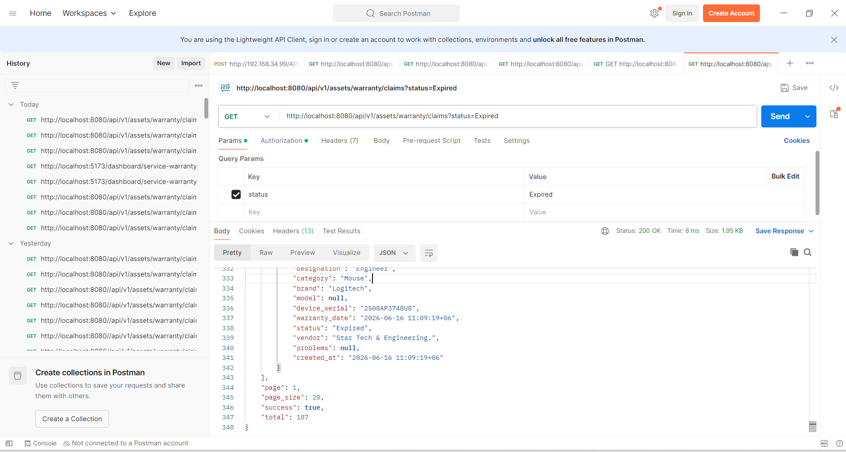

{
"data": [
{
"id": 388,
"reference": "388",
"employee": "Jasim Uddin",
"emp_id": "02-2004",
"department": "Finance and Accounts",
"designation": null,
"category": "Multiplug and Power Strip",
"brand": "Many",
"model": "G251 5port with Switch",
"device_serial": "20260411n0sn",
"warranty_date": "2026-07-11 19:52:32+06",
"status": "Expired",
"vendor": "Famous Technologies",
"problems": null,
"created_at": "2026-07-11 19:52:32+06"
},
{
"id": 3066,
"reference": "3066",
"employee": "Md. Moniruzzaman",
"emp_id": "02-1824",
"department": "Supply Chain",
"designation": "Senior Associate Executive",
"category": "Laptop-LC2",
"brand": "DELL",
"model": "DELL VOSTRO 3400",
"device_serial": "CQL19T3",
"warranty_date": "2026-07-06 15:31:03+06",
"status": "Expired",
"vendor": "Digital Equipment Ltd",
"problems": null,
"created_at": "2026-07-06 15:31:03+06"
},
{
"id": 3736,
"reference": "3736",
"employee": "Md. Ariful Islam Bhuiyan",
"emp_id": "02-2625",
"department": "Branding and Communications",
"designation": "Graphics Designer",
"category": "Converter",
"brand": "UGREEN",
"model": "MM137 Ugreen DP Male to HDMI Female 4k*2k 60HZ 25",
"device_serial": "P/N: 70694",
"warranty_date": "2026-06-26 11:27:44+06",
"status": "Expired",
"vendor": "Global Brand",
"problems": null,
"created_at": "2026-06-26 11:27:44+06"
},
{
"id": 1315,
"reference": "1315",
"employee": "Md. Parvez Akhtar",
"emp_id": "02-2718",
"department": "Finance and Accounts",
"designation": "Assistant Manager",
"category": "Mouse",
"brand": "Logitech",
"model": "M170",
"device_serial": "2227LZX1PRC8",
"warranty_date": "2026-06-16 16:37:23+06",
"status": "Expired",
"vendor": "Star Tech & Engineering.",
"problems": null,
"created_at": "2026-06-16 16:37:23+06"
},
{
"id": 1693,
"reference": "1693",
"employee": "Prianka Roy",
"emp_id": "02-2720",
"department": "Pico Public Cloud",
"designation": "Senior Engineer",
"category": "Mouse",
"brand": "Logitech",
"model": null,
"device_serial": "2508APM71V78",
"warranty_date": "2026-06-16 11:09:19+06",
"status": "Expired",
"vendor": "Star Tech & Engineering.",
"problems": null,
"created_at": "2026-06-16 11:09:19+06"
},
{
"id": 1682,
"reference": "1682",
"employee": "Md. Asrafuzzaman",
"emp_id": "02-2707",
"department": "Pico Public Cloud",
"designation": "Engineer",
"category": "Mouse",
"brand": "Logitech",
"model": null,
"device_serial": "2508AP3748U8",
"warranty_date": "2026-06-16 11:09:19+06",
"status": "Expired",
"vendor": "Star Tech & Engineering.",
"problems": null,
"created_at": "2026-06-16 11:09:19+06"
}
],
"page": 1,
"page_size": 20,
"success": true,
"total": 187
}

2026-14-07
Final verified logic for Warranty Claimed
Claimed → asset_devices.asset_status = 8 AND row_status = 1

To Vendor → device_claims.claim_status = 9
current year created_at
one row per reference_no_claim

Recovered → device_claims.claim_status = 10
current year return_date
one row per reference_no_claim

Expired → asset_devices.warranty_date in current year
warranty_date < current date
row_status = 1

