https://chatgpt.com/g/g-p-6aa643e2dadc8191aa94244a899b7ea1-itm/c/6aaf7481-f48c-83ee-a136-9afb063d2445

date : 20th September, 2026

PS D:\ITM-Data\itm> New-Item -ItemType Directory -Force -Path "D:\ITM-Data\itm\backups"

Directory: D:\ITM-Data\itm

Mode LastWriteTime Length Name
---- ------------- ------ ----
d----- 9/20/2026 11:59 AM backups

PS D:\ITM-Data\itm> & "D:\Program Files\PostgreSQL\18\bin\pg_dump.exe" -h localhost -p 5432 -U postgres -d itm_prod -F c -f "D:\ITM-Data\itm\backups\itm_prod_before_009.dump"
Password:

PS D:\ITM-Data\itm> Get-Item "D:\ITM-Data\itm\backups\itm_prod_before_009.dump"

Directory: D:\ITM-Data\itm\backups

Mode LastWriteTime Length Name
---- ------------- ------ ----
-a---- 9/20/2026 12:06 PM 20814278 itm_prod_before_009.dump

PS D:\ITM-Data\itm> Test-Path "D:\ITM-Data\itm\sql\009_scm_partial_import_resolution.sql"
False
PS D:\ITM-Data\itm> Get-ChildItem -Path "D:\ITM-Data\itm" -Recurse -Filter "009_scm_partial_import_resolution.sql" -ErrorAction SilentlyContinue
PS D:\ITM-Data\itm> Get-ChildItem -Path "D:\ITM-Data\itm" -Recurse -Filter "009_scm_partial_import_resolution.sql" -ErrorAction SilentlyContinue
PS D:\ITM-Data\itm> & "D:\Program Files\PostgreSQL\18\bin\pg_restore.exe" `
>> -l "D:\ITM-Data\itm\backups\itm_prod_before_009.dump" |
>> Select-Object -First 20
;
; Archive created at 2026-09-20 12:06:14
; dbname: itm_prod
; TOC Entries: 675
; Compression: gzip
; Dump Version: 1.16-0
; Format: CUSTOM
; Integer: 4 bytes
; Offset: 8 bytes
; Dumped from database version: 18.4
; Dumped by pg_dump version: 18.4
;
;
; Selected TOC Entries:
;
10; 2615 66124 SCHEMA - backup postgres
7; 2615 25024 SCHEMA - old_import postgres
6199; 0 0 ACL - SCHEMA public pg_database_owner
2; 3079 16711 EXTENSION - pg_trgm
6200; 0 0 COMMENT - EXTENSION pg_trgm
PS D:\ITM-Data\itm> Test-Path "D:\ITM-Data\itm\backups\ITM_Fix\sql\009_scm_partial_import_resolution.sql"
True
PS D:\ITM-Data\itm> Get-Content "D:\ITM-Data\itm\backups\ITM_Fix\sql\009_scm_partial_import_resolution.sql"
BEGIN;

/*
SCM partial-import / serial-conflict resolution support.

Goal:
- every SCM row can be committed to stack_inventory;
- asset_devices still keeps one physical row per normalized serial;
- a conflicting serial is recorded as a stock-level conflict, not duplicated;
- retry after SCM serial correction updates the SAME stock row by MR + source index.
*/

ALTER TABLE public.stack_inventory
ADD COLUMN IF NOT EXISTS scm_source_index INTEGER,
ADD COLUMN IF NOT EXISTS asset_device_id BIGINT,
ADD COLUMN IF NOT EXISTS asset_resolution VARCHAR(32),
ADD COLUMN IF NOT EXISTS asset_conflict_asset_id BIGINT,
ADD COLUMN IF NOT EXISTS asset_resolution_note TEXT;

/* Existing linked stock rows can be backfilled safely from legacy_stack_id. */
WITH linked AS (
SELECT DISTINCT ON (ad.legacy_stack_id)
ad.legacy_stack_id AS stock_id,
ad.id AS asset_id
FROM public.asset_devices ad
WHERE ad.legacy_stack_id IS NOT NULL
AND COALESCE(ad.row_status, 1) = 1
ORDER BY ad.legacy_stack_id, ad.id DESC
)
UPDATE public.stack_inventory s
SET asset_device_id = linked.asset_id,
asset_resolution = COALESCE(NULLIF(BTRIM(s.asset_resolution), ''), 'linked_legacy')
FROM linked
WHERE linked.stock_id = s.id
AND s.asset_device_id IS NULL;

/* New SCM imports are idempotent by the stable row index returned by SCM. */
CREATE UNIQUE INDEX IF NOT EXISTS uq_stack_inventory_scm_mr_source
ON public.stack_inventory (mr_id, scm_source_index)
WHERE scm_source_index IS NOT NULL
AND COALESCE(status, 1) = 1;

CREATE INDEX IF NOT EXISTS idx_stack_inventory_asset_device_id
ON public.stack_inventory(asset_device_id)
WHERE asset_device_id IS NOT NULL;

CREATE INDEX IF NOT EXISTS idx_stack_inventory_conflict_asset_id
ON public.stack_inventory(asset_conflict_asset_id)
WHERE asset_conflict_asset_id IS NOT NULL;

DO $$
BEGIN
IF NOT EXISTS (
SELECT 1 FROM pg_constraint
WHERE conname = 'fk_stack_inventory_asset_device_id'
) THEN
ALTER TABLE public.stack_inventory
ADD CONSTRAINT fk_stack_inventory_asset_device_id
FOREIGN KEY (asset_device_id)
REFERENCES public.asset_devices(id)
NOT VALID;
END IF;

IF NOT EXISTS (
SELECT 1 FROM pg_constraint
WHERE conname = 'fk_stack_inventory_conflict_asset_id'
) THEN
ALTER TABLE public.stack_inventory
ADD CONSTRAINT fk_stack_inventory_conflict_asset_id
FOREIGN KEY (asset_conflict_asset_id)
REFERENCES public.asset_devices(id)
NOT VALID;
END IF;
END $$;

COMMIT;
PS D:\ITM-Data\itm> & "D:\Program Files\PostgreSQL\18\bin\psql.exe" `
>> -v ON_ERROR_STOP=1 `
>> -h localhost `
>> -p 5432 `
>> -U postgres `
>> -d itm_prod `
>> -f "D:\ITM-Data\itm\backups\ITM_Fix\sql\009_scm_partial_import_resolution.sql"
Password for user postgres:

BEGIN
ALTER TABLE
UPDATE 528
CREATE INDEX
CREATE INDEX
CREATE INDEX
DO
COMMIT
PS D:\ITM-Data\itm> & "D:\Program Files\PostgreSQL\18\bin\psql.exe" `
>> -h localhost `
>> -p 5432 `
>> -U postgres `
>> -d itm_prod `
>> -c "SELECT column_name, data_type FROM information_schema.columns WHERE table_schema='public' AND table_name='stack_inventory' AND column_name IN ('scm_source_index','asset_device_id','asset_resolution','asset_conflict_asset_id','asset_resolution_note') ORDER BY column_name;"
Password for user postgres:

column_name | data_type
-------------------------+-------------------
asset_conflict_asset_id | bigint
asset_device_id | bigint
asset_resolution | character varying
asset_resolution_note | text
scm_source_index | integer
(5 rows)

PS D:\ITM-Data\itm> & "D:\Program Files\PostgreSQL\18\bin\psql.exe" `
>> -h localhost `
>> -p 5432 `
>> -U postgres `
>> -d itm_prod `
>> -c "SELECT indexname FROM pg_indexes WHERE schemaname='public' AND tablename='stack_inventory' AND indexname IN ('uq_stack_inventory_scm_mr_source','idx_stack_inventory_asset_device_id','idx_stack_inventory_conflict_asset_id');"
Password for user postgres:

indexname
---------------------------------------
uq_stack_inventory_scm_mr_source
idx_stack_inventory_asset_device_id
idx_stack_inventory_conflict_asset_id
(3 rows)

PS D:\ITM-Data\itm> & "D:\Program Files\PostgreSQL\18\bin\psql.exe" `
>> -h localhost `
>> -p 5432 `
>> -U postgres `
>> -d itm_prod `
>> -c "SELECT conname, convalidated FROM pg_constraint WHERE conname IN ('fk_stack_inventory_asset_device_id','fk_stack_inventory_conflict_asset_id');"
Password for user postgres:

conname | convalidated
--------------------------------------+--------------
fk_stack_inventory_asset_device_id | f
fk_stack_inventory_conflict_asset_id | f
(2 rows)

PS D:\ITM-Data\itm> & "D:\Program Files\PostgreSQL\18\bin\psql.exe" `
>> -v ON_ERROR_STOP=1 `
>> -h localhost `
>> -p 5432 `
>> -U postgres `
>> -d itm_prod `
>> -f "D:\ITM-Data\itm\backups\ITM_Fix\sql\009_scm_partial_import_resolution.sql"
Password for user postgres:

BEGIN
psql:D:/ITM-Data/itm/backups/ITM_Fix/sql/009_scm_partial_import_resolution.sql:18: NOTICE: column "scm_source_index" of relation "stack_inventory" already exists, skipping
psql:D:/ITM-Data/itm/backups/ITM_Fix/sql/009_scm_partial_import_resolution.sql:18: NOTICE: column "asset_device_id" of relation "stack_inventory" already exists, skipping
psql:D:/ITM-Data/itm/backups/ITM_Fix/sql/009_scm_partial_import_resolution.sql:18: NOTICE: column "asset_resolution" of relation "stack_inventory" already exists, skipping
psql:D:/ITM-Data/itm/backups/ITM_Fix/sql/009_scm_partial_import_resolution.sql:18: NOTICE: column "asset_conflict_asset_id" of relation "stack_inventory" already exists, skipping
psql:D:/ITM-Data/itm/backups/ITM_Fix/sql/009_scm_partial_import_resolution.sql:18: NOTICE: column "asset_resolution_note" of relation "stack_inventory" already exists, skipping
ALTER TABLE
UPDATE 0
psql:D:/ITM-Data/itm/backups/ITM_Fix/sql/009_scm_partial_import_resolution.sql:41: NOTICE: relation "uq_stack_inventory_scm_mr_source" already exists, skipping
CREATE INDEX
psql:D:/ITM-Data/itm/backups/ITM_Fix/sql/009_scm_partial_import_resolution.sql:45: NOTICE: relation "idx_stack_inventory_asset_device_id" already exists, skipping
CREATE INDEX
psql:D:/ITM-Data/itm/backups/ITM_Fix/sql/009_scm_partial_import_resolution.sql:49: NOTICE: relation "idx_stack_inventory_conflict_asset_id" already exists, skipping
CREATE INDEX
DO
COMMIT
PS D:\ITM-Data\itm>

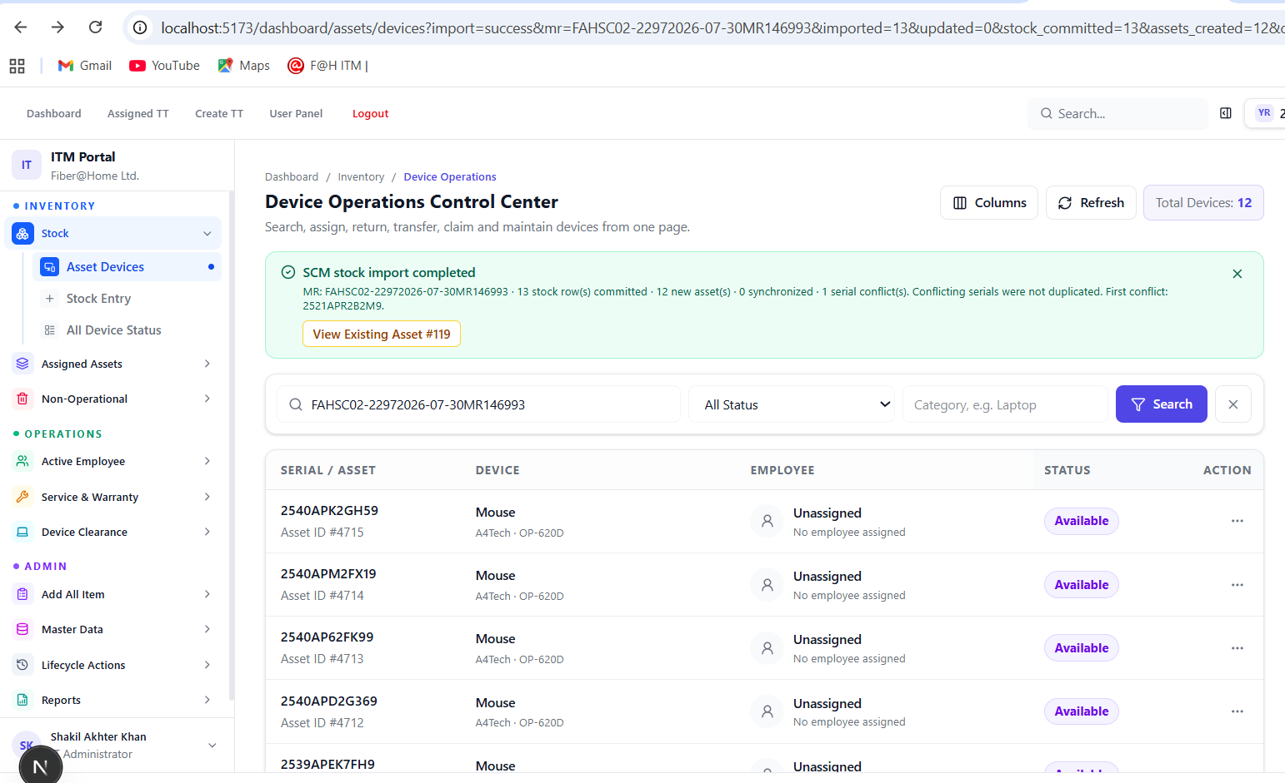

Device Operations Control Center
Search, assign, return, transfer, claim and maintain devices from one page.
ColumnsRefresh
Total Devices:12
SCM stock import completed
MR: FAHSC02-22972026-07-30MR146993 · 13 stock row(s) committed · 12 new asset(s) · 0 synchronized · 1 serial conflict(s). Conflicting serials were not duplicated. First conflict: 2521APR2B2M9.
View Existing Asset #119

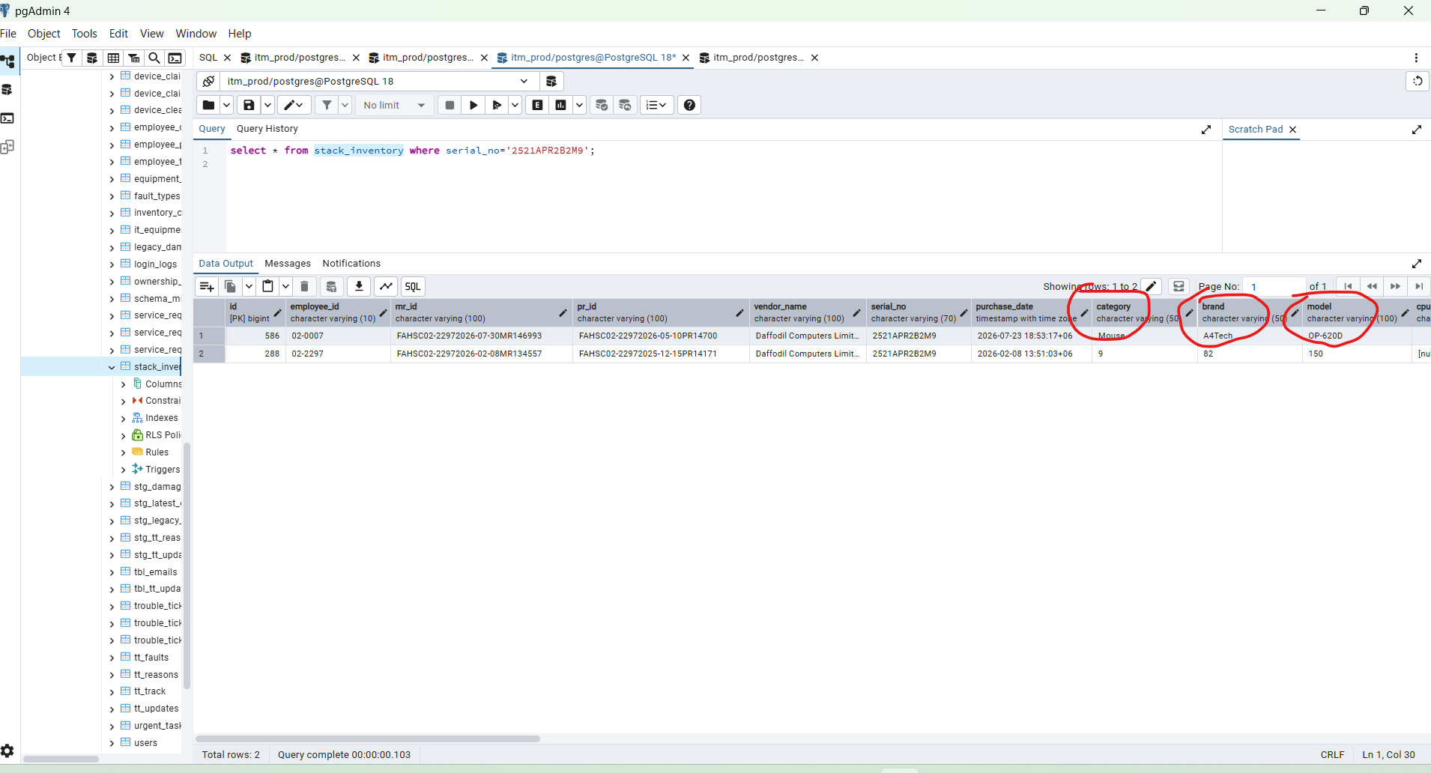

BEGIN;

/*
SCM partial-import / serial-conflict resolution support.

Goal:
- every SCM row can be committed to stack_inventory;
- asset_devices still keeps one physical row per normalized serial;
- a conflicting serial is recorded as a stock-level conflict, not duplicated;
- retry after SCM serial correction updates the SAME stock row by MR + source index.
*/

ALTER TABLE public.stack_inventory
ADD COLUMN IF NOT EXISTS scm_source_index INTEGER,
ADD COLUMN IF NOT EXISTS asset_device_id BIGINT,
ADD COLUMN IF NOT EXISTS asset_resolution VARCHAR(32),
ADD COLUMN IF NOT EXISTS asset_conflict_asset_id BIGINT,
ADD COLUMN IF NOT EXISTS asset_resolution_note TEXT;

/* Existing linked stock rows can be backfilled safely from legacy_stack_id. */
WITH linked AS (
SELECT DISTINCT ON (ad.legacy_stack_id)
ad.legacy_stack_id AS stock_id,
ad.id AS asset_id
FROM public.asset_devices ad
WHERE ad.legacy_stack_id IS NOT NULL
AND COALESCE(ad.row_status, 1) = 1
ORDER BY ad.legacy_stack_id, ad.id DESC
)
UPDATE public.stack_inventory s
SET asset_device_id = linked.asset_id,
asset_resolution = COALESCE(NULLIF(BTRIM(s.asset_resolution), ''), 'linked_legacy')
FROM linked
WHERE linked.stock_id = s.id
AND s.asset_device_id IS NULL;

/* New SCM imports are idempotent by the stable row index returned by SCM. */
CREATE UNIQUE INDEX IF NOT EXISTS uq_stack_inventory_scm_mr_source
ON public.stack_inventory (mr_id, scm_source_index)
WHERE scm_source_index IS NOT NULL
AND COALESCE(status, 1) = 1;

CREATE INDEX IF NOT EXISTS idx_stack_inventory_asset_device_id
ON public.stack_inventory(asset_device_id)
WHERE asset_device_id IS NOT NULL;

CREATE INDEX IF NOT EXISTS idx_stack_inventory_conflict_asset_id
ON public.stack_inventory(asset_conflict_asset_id)
WHERE asset_conflict_asset_id IS NOT NULL;

DO $$
BEGIN
IF NOT EXISTS (
SELECT 1 FROM pg_constraint
WHERE conname = 'fk_stack_inventory_asset_device_id'
) THEN
ALTER TABLE public.stack_inventory
ADD CONSTRAINT fk_stack_inventory_asset_device_id
FOREIGN KEY (asset_device_id)
REFERENCES public.asset_devices(id)
NOT VALID;
END IF;

IF NOT EXISTS (
SELECT 1 FROM pg_constraint
WHERE conname = 'fk_stack_inventory_conflict_asset_id'
) THEN
ALTER TABLE public.stack_inventory
ADD CONSTRAINT fk_stack_inventory_conflict_asset_id
FOREIGN KEY (asset_conflict_asset_id)
REFERENCES public.asset_devices(id)
NOT VALID;
END IF;
END $$;

COMMIT;

NOTICE: column "scm_source_index" of relation "stack_inventory" already exists, skipping
NOTICE: column "asset_device_id" of relation "stack_inventory" already exists, skipping
NOTICE: column "asset_resolution" of relation "stack_inventory" already exists, skipping
NOTICE: column "asset_conflict_asset_id" of relation "stack_inventory" already exists, skipping
NOTICE: column "asset_resolution_note" of relation "stack_inventory" already exists, skipping
NOTICE: relation "uq_stack_inventory_scm_mr_source" already exists, skipping
NOTICE: relation "idx_stack_inventory_asset_device_id" already exists, skipping
NOTICE: relation "idx_stack_inventory_conflict_asset_id" already exists, skipping
COMMIT

Query returned successfully in 90 msec.

-- Read-only diagnostics for SCM / asset serial conflicts.
-- IMPORTANT: do NOT drop uq_asset_devices_serial_key.

-- 1) Confirm the unique physical-device identity constraint.
SELECT conname, pg_get_constraintdef(oid)
FROM pg_constraint
WHERE conname = 'uq_asset_devices_serial_key';

-- 2) Existing table should not contain duplicate normalized serial keys.
SELECT device_serial_key, COUNT(*) AS rows_with_key
FROM public.asset_devices
WHERE NULLIF(BTRIM(device_serial_key), '') IS NOT NULL
GROUP BY device_serial_key
HAVING COUNT(*) > 1
ORDER BY rows_with_key DESC, device_serial_key;

-- 3) Current reported conflict. Replace the literal for another serial.
WITH incoming AS (
SELECT UPPER(
REGEXP_REPLACE(
BTRIM('2521APR2B2M9'),
'[^A-Za-z0-9]+',
'',
'g'
)
) AS serial_key
)
SELECT
a.id,
a.legacy_stack_id,
a.device_serial,
a.device_serial_key,
a.mr_number,
a.pr_number,
a.category,
a.brand,
a.model,
a.asset_status,
a.row_status,
a.emp_id,
a.emp_name,
a.assigned_date,
a.created_at
FROM public.asset_devices a
JOIN incoming i ON i.serial_key = a.device_serial_key;

-- 4) Show every stock receipt carrying the same normalized serial.
SELECT
s.id AS stock_id,
s.mr_id,
s.pr_id,
s.serial_no,
s.category,
s.brand,
s.model,
s.item_group,
s.item_name,
s.status,
s.device_assigned_status,
s.created_at
FROM public.stack_inventory s
WHERE UPPER(
REGEXP_REPLACE(
BTRIM(COALESCE(s.serial_no, '')),
'[^A-Za-z0-9]+',
'',
'g'
)
) = UPPER(
REGEXP_REPLACE(
BTRIM('2521APR2B2M9'),
'[^A-Za-z0-9]+',
'',
'g'
)
)
ORDER BY s.id;

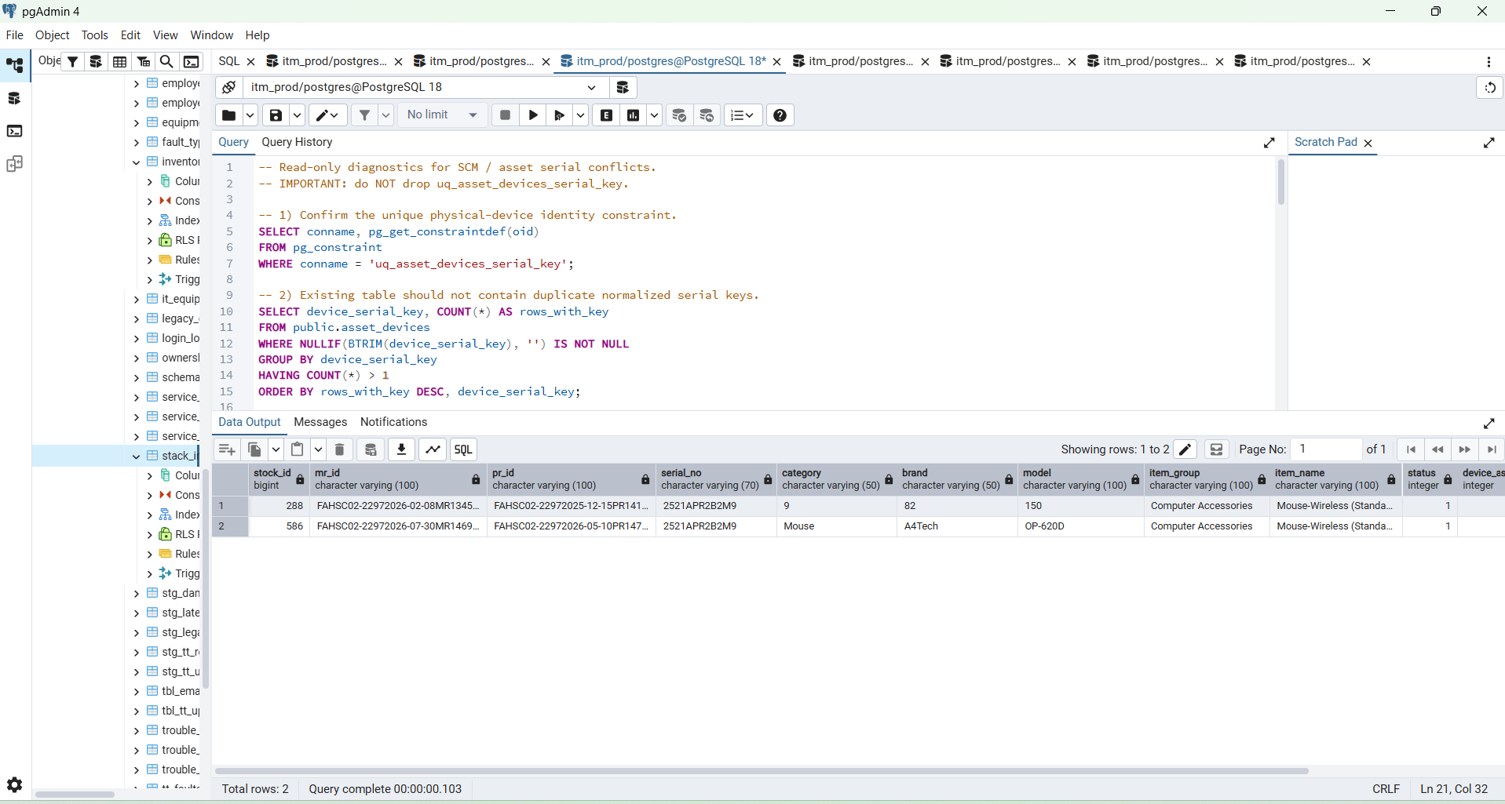

----------------------------------------------------------------------------------------------------------------------------------

-- Verify the urgent MR after import.
SELECT
id,
mr_id,
scm_source_index,
serial_no,
asset_device_id,
asset_resolution,
asset_conflict_asset_id,
asset_resolution_note,
status,
device_assigned_status
FROM public.stack_inventory
WHERE BTRIM(COALESCE(mr_id, '')) = BTRIM('FAHSC02-22972026-07-30MR146993')
ORDER BY scm_source_index NULLS LAST, id;

-- Expected after first import when one serial is already assigned elsewhere:
-- 13 stock rows total
-- 12 rows: asset_resolution = created, asset_device_id IS NOT NULL
-- 1 row : asset_resolution = serial_conflict, asset_conflict_asset_id = 119

SELECT
COUNT(*) AS stock_rows,
COUNT(*) FILTER (WHERE asset_resolution = 'created') AS assets_created,
COUNT(*) FILTER (WHERE asset_resolution = 'synchronized') AS assets_synchronized,
COUNT(*) FILTER (WHERE asset_resolution = 'serial_conflict') AS serial_conflicts
FROM public.stack_inventory
WHERE BTRIM(COALESCE(mr_id, '')) = BTRIM('FAHSC02-22972026-07-30MR146993')
AND COALESCE(status, 1) = 1;

-- Existing Asset #119 must remain unchanged and unique.
SELECT
id, legacy_stack_id, device_serial, device_serial_key,
mr_number, pr_number, asset_status, row_status, emp_id, emp_name
FROM public.asset_devices
WHERE id = 119
OR device_serial_key = '2521APR2B2M9'
ORDER BY id;

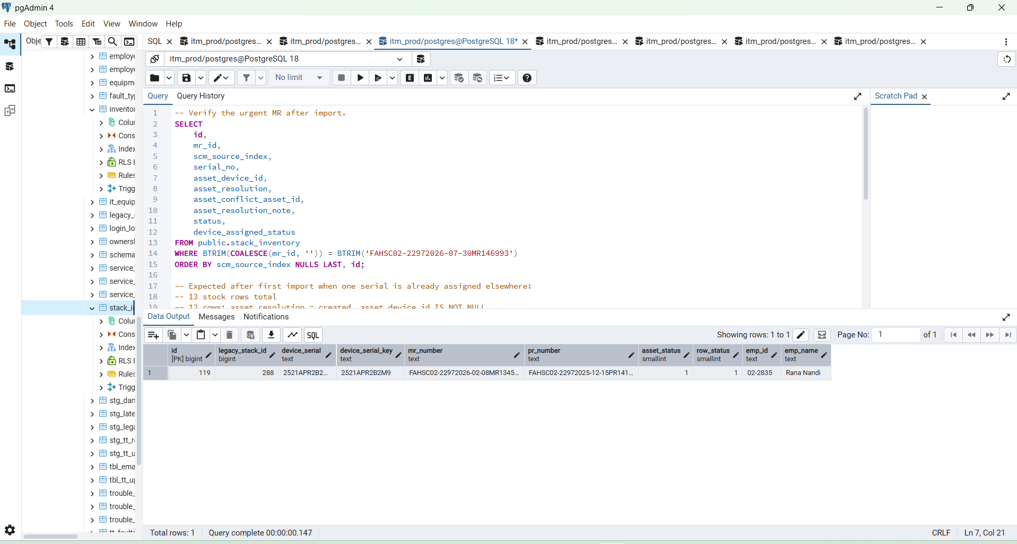

-----------------------------------------------------------------------------------------------------------------

SELECT
id,
mr_id,
scm_source_index,
serial_no,
category,
brand,
model,
asset_device_id,
asset_resolution,
asset_conflict_asset_id,
asset_resolution_note
FROM public.stack_inventory
WHERE mr_id = 'FAHSC02-22972026-07-30MR146993'
ORDER BY scm_source_index, id;

SELECT
id,
mr_id,
scm_source_index,
serial_no,
category,
brand,
model,
asset_device_id,
asset_resolution,
asset_conflict_asset_id,
asset_resolution_note
FROM public.stack_inventory
WHERE mr_id = 'FAHSC02-22972026-07-30MR146993'
ORDER BY scm_source_index, id;

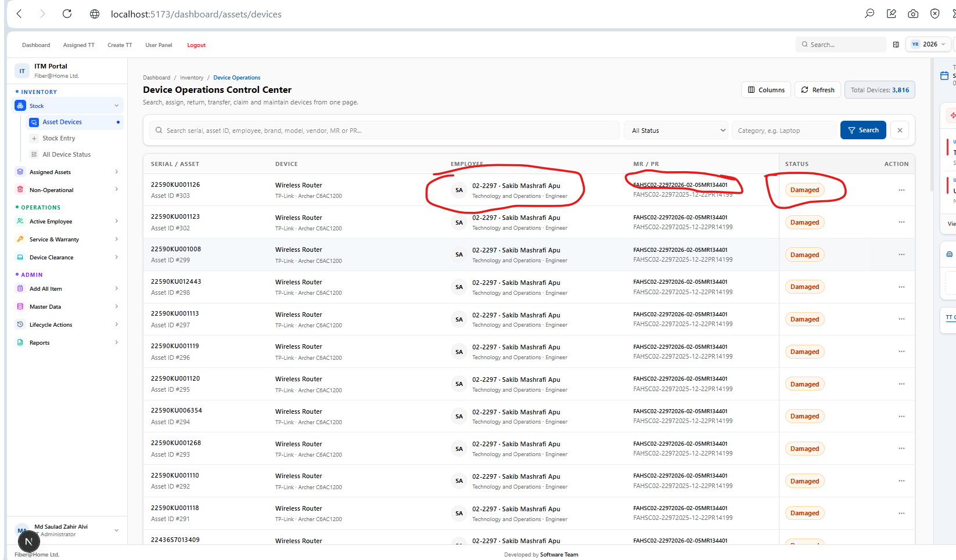

damaged_status_comapred_FAHSC02-22972026-02-05MR134401.csv

damaged_status_FAHSC02-22972026-02-05MR134401.csv

SELECT
id,
legacy_stack_id,
device_serial,
device_serial_key,
mr_number,
pr_number,
asset_status,
row_status,
emp_id,
emp_name,
department,
designation,
assigned_date,
created_at,
updated_at
FROM public.asset_devices
WHERE mr_number = 'FAHSC02-22972026-02-05MR134401'
ORDER BY id;

SELECT
s.id AS stock_id,
s.scm_source_index,
s.serial_no,
s.asset_device_id,
s.asset_resolution,
s.device_assigned_status,
a.id AS existing_asset_id,
a.device_serial,
a.asset_status,
a.emp_id,
a.emp_name
FROM public.stack_inventory s
LEFT JOIN public.asset_devices a
ON a.device_serial_key = UPPER(
REGEXP_REPLACE(
BTRIM(COALESCE(s.serial_no, '')),
'[^A-Za-z0-9]+',
'',
'g'
)
)
WHERE s.mr_id = 'FAHSC02-22972026-02-05MR134401'
ORDER BY s.scm_source_index, s.id;

Yes. Now that those 13 existing assets are correctly showing Available / Unassigned, you can proceed with a new MR.
For the next MR, the importer should follow these rules:
New MR + new unique serial
→ create new stack_inventory row
→ create new asset_devices row
→ Status = Available
→ Employee = Unassigned

Same MR + same serial
→ synchronize the existing row
→ do not create duplicate

Different MR + same serial
→ serial conflict
→ do not overwrite the existing asset
→ do not duplicate the asset
→ continue importing the other valid rows
Before testing the next MR, I recommend one quick verification:
SELECT
COUNT(*) AS total,
COUNT(*) FILTER (WHERE asset_status = 0) AS available,
COUNT(*) FILTER (WHERE emp_id IS NULL) AS unassigned
FROM public.asset_devices
WHERE mr_number = 'FAHSC02-22972026-02-05MR134401';
Expected:
total = 13
available = 13
unassigned = 13
Then go to:
/dashboard/stock/stock-entry
enter your new MR, classify Category → Brand → Model → Warranty, and import.
After success, check the new MR with:
SELECT
id,
device_serial,
mr_number,
asset_status,
emp_id,
emp_name
FROM public.asset_devices
WHERE mr_number = 'YOUR_NEW_MR'
ORDER BY id;
For genuinely new stock, the expected result is:
asset_status = 0
emp_id = NULL
emp_name = NULL
and the Device Operations page should show:
Status: Available
Employee: Unassigned
So yes — you can now move forward with a new MR.

Select Count Row
---------------------------------------------------------------------------------------------------
SELECT
COUNT(*) AS total,
COUNT(*) FILTER (WHERE asset_status = 0) AS available,
COUNT(*) FILTER (WHERE emp_id IS NULL) AS unassigned
FROM public.asset_devices
WHERE mr_number = 'FAHSC02-22972026-02-05MR134401';

Expected:
total = 13
available = 13
unassigned = 13

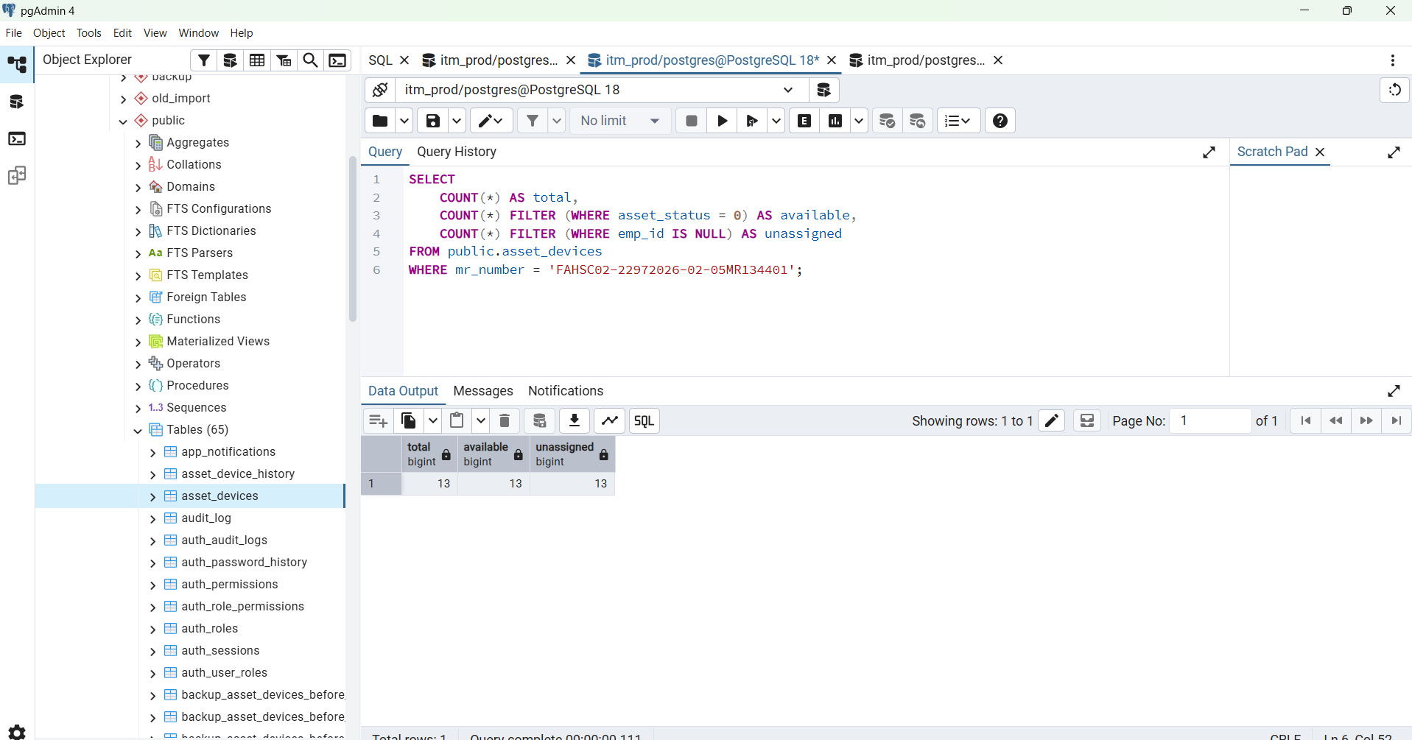

Next work for assigned

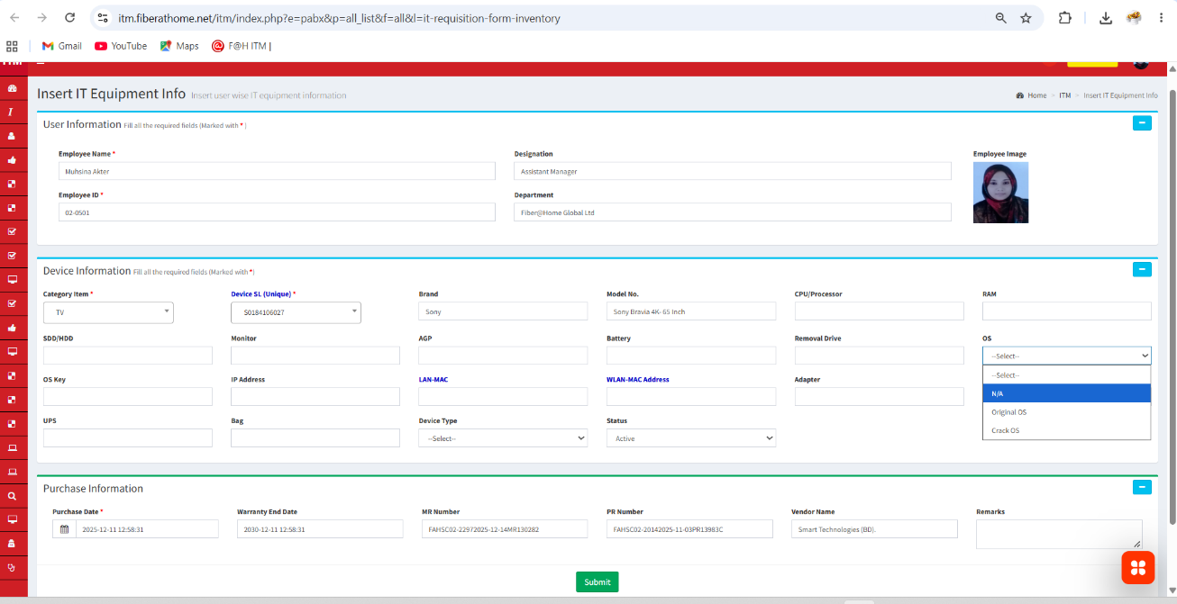

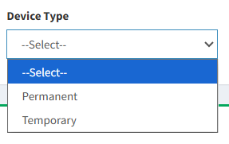
showing overlapping column and need to add serial 1, 2, ..... and column space consistency and action will be dropdown and device type will be permanent or Temporary
this is my previous form assigned form and php and SQL assigned form and now need to Implement properly in my new system

Not Available in live database working now MR #
FAHSC02-22972025-02-10MR107919

