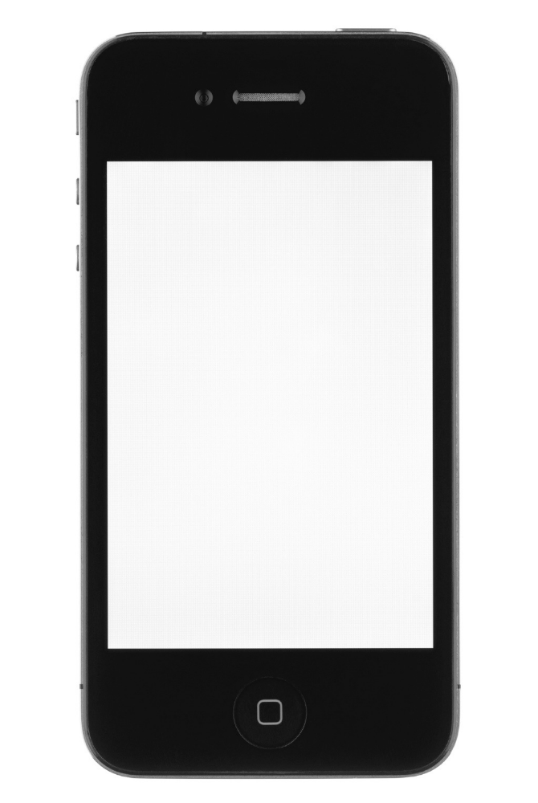
Percent bar
All stores

+6

83

34

Score

Change since Sep

Number of customers

Plot 3: Change Score
Plot 2: States Score
Plot 1: YTD Score
Nav bar
Percent bar
Cappuccino

-8

33

52

Percent bar
Macchiato

-4

71

72

Percent bar
Iced coffee

+2

81

78

Percent bar
Long black

+1

83

85

Percent bar
Mocha

-2

12

50

Percent bar
Flat white

-6

42

54

Percent bar
Vienna

+7

55

65

Percent bar
Doppio
+10

70

67

Percent bar
Espresso

+3

72

74

Percent bar
Latte
-3

93

89

Plot 1: YTD Score
Nav bar

