Student:

- Is there anything we can do to control for the email to go to spam? If not, we need to add a blurb. “If you haven’t received your verification within 5 minutes, check your spam, or ????? (do they need to start over?)
- Student profile: phone number has to have a prescribed number of digits. Right now will accept up to 28 characters…. Needs to be restricted to numbers and 10
- Error coming up when putting in experience, training and volunteer — event with typing in field, won’t let progress
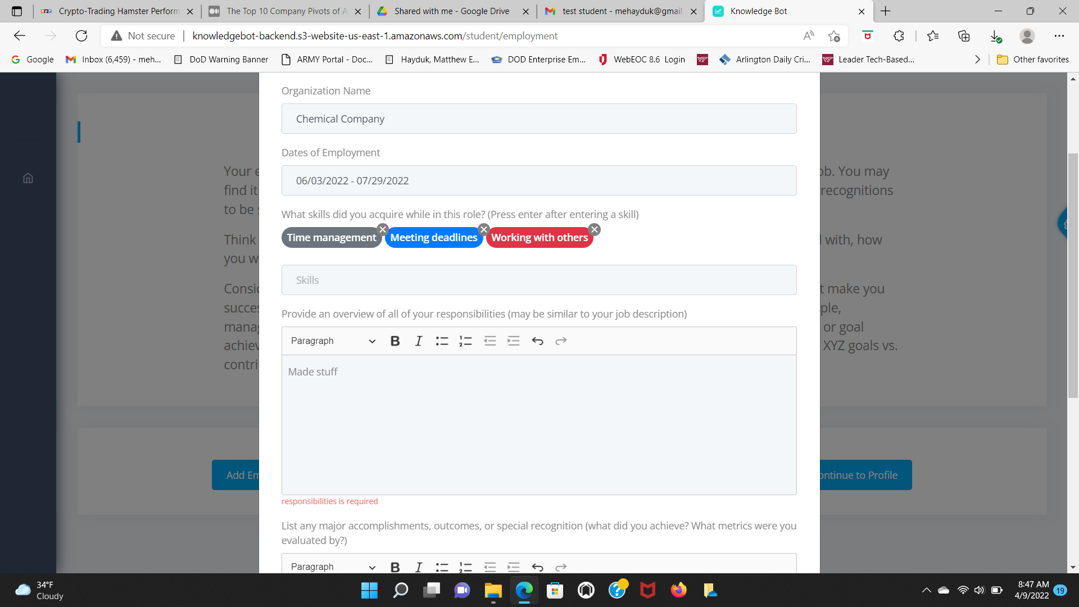
- When relog back in, gives the same welcome page - even though the experience input has been started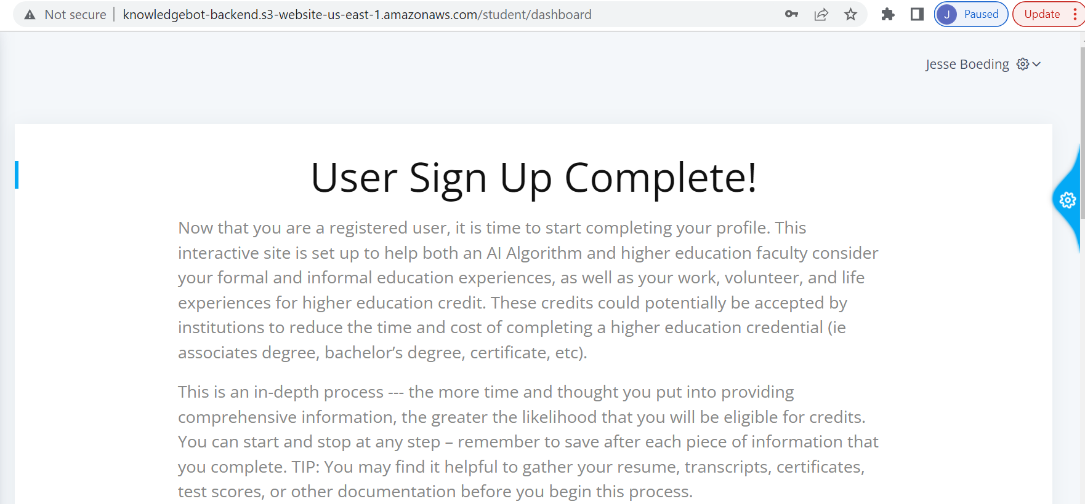
- Firefox and Explorer do not work consistently — is that due to set up? Or do we need to tell people to use Chrome?

Admin
- Need to make sure that the dashboard needs to reflect the institution/partner/student name
- This error is b/c the data input is inaccurate not that the page was unresponsive. Is it possible to have more specific error messages with directions on what to do.
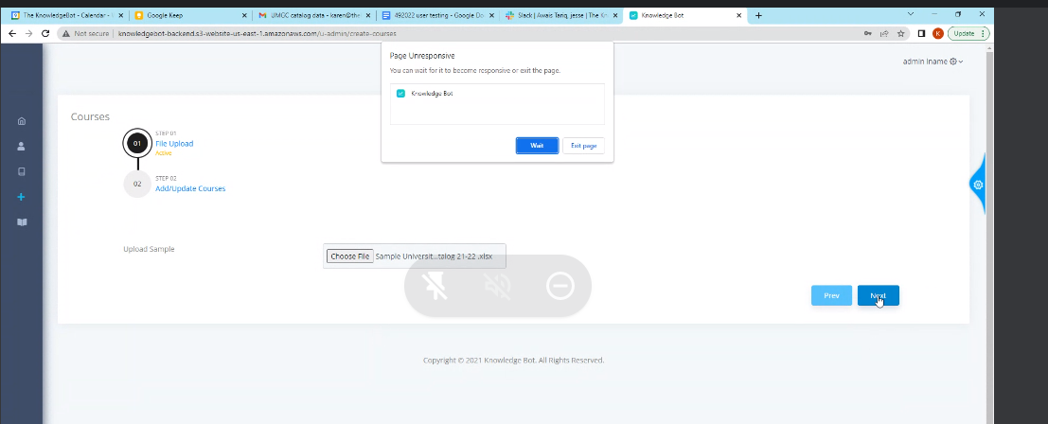
- The views need to be clearer… see this drop down “Computer Sciences” is one thing and it is split. 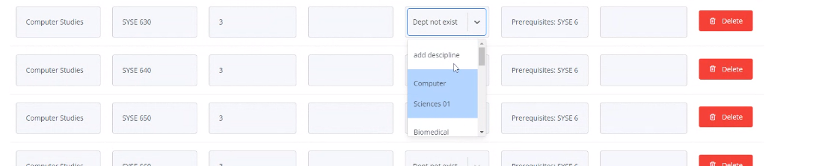
- Unable to add disciplines
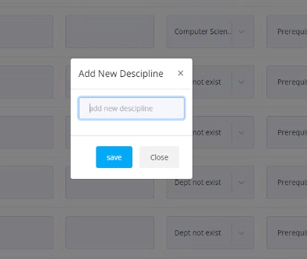
- Now frozen… escape, close, back, etc doesn’t work… the back “waiting for API execution”

- 