-- 1.1 E.g Select the names of all the products in the store.

select Name from Products;

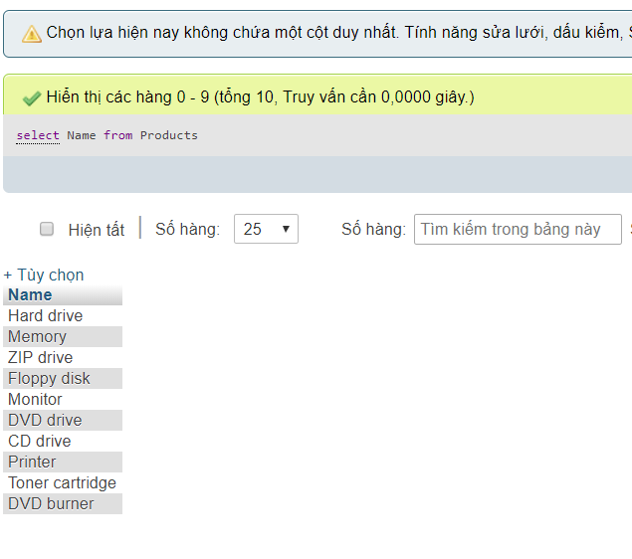

-- 1.2 Select the names and the prices of all the products in the store.

SELECT `Name`,`Price` FROM `products`

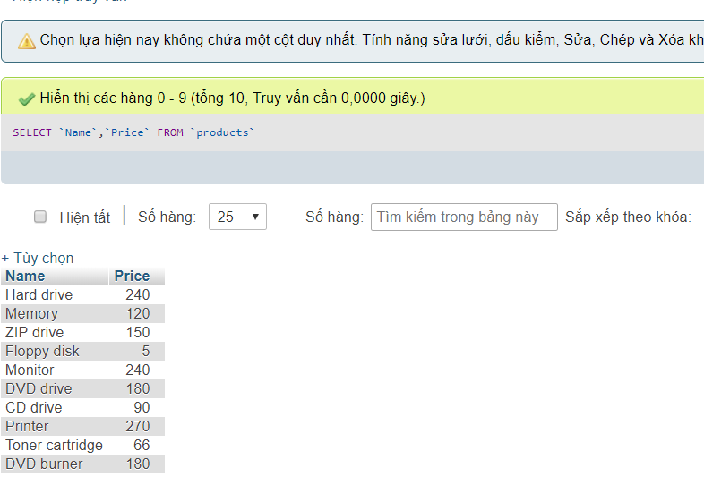

1.3 Select the name of the products with a price less than or equal to $200.

SELECT `Name` FROM `products` WHERE `Price` >= 200

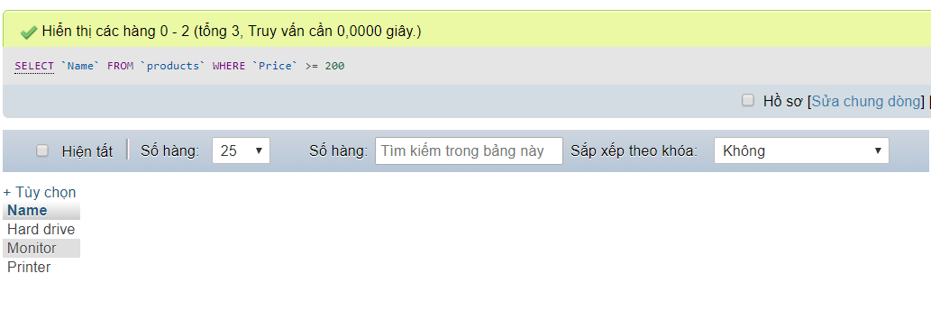

-- 1.4 Select all the products with a price between $60 and $120.

SELECT * FROM `products` WHERE `Price` BETWEEN 60 AND 120

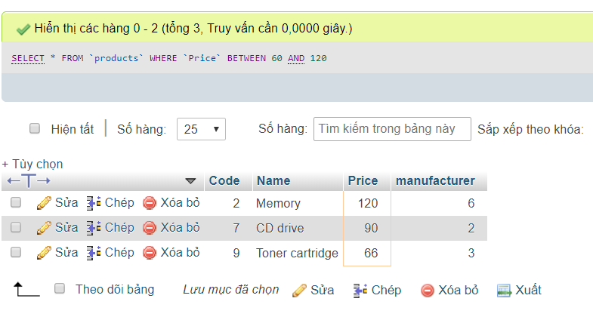

-- 1.5 Select the name and price in cents (i.e., the price must be multiplied by 100).

[SELECT](http://localhost/phpmyadmin/url.php?url=https://dev.mysql.com/doc/refman/5.5/en/select.html) `Name` ,`Price`*100 AS 'Price' FROM `products`

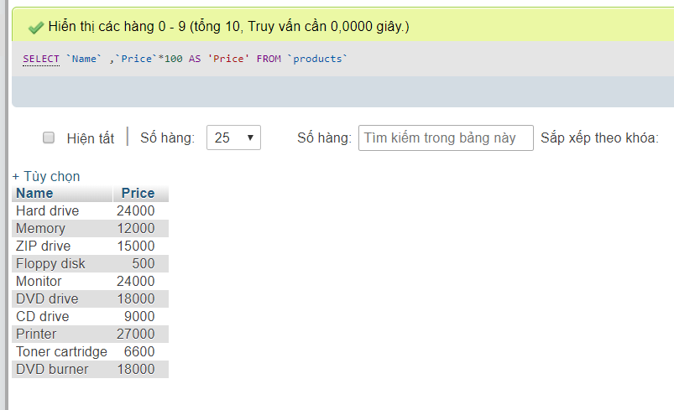

-- 1.6 Compute the average price of all the products.

[SELECT](http://localhost/phpmyadmin/url.php?url=https://dev.mysql.com/doc/refman/5.5/en/select.html) [AVG](http://localhost/phpmyadmin/url.php?url=https://dev.mysql.com/doc/refman/5.5/en/group-by-functions.html#function_avg)(`Price`) AS 'Average Price ' FROM `products`

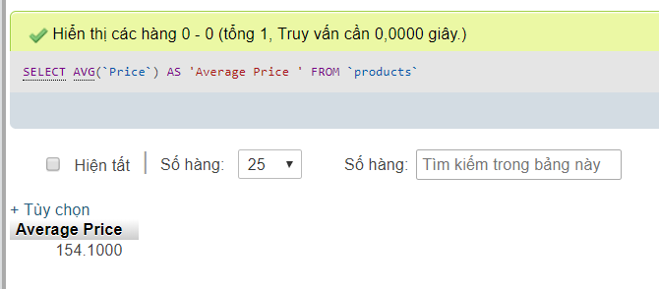

-- 1.7 Compute the average price of all products with manufacturer code equal to 2.

[SELECT](http://localhost/phpmyadmin/url.php?url=https://dev.mysql.com/doc/refman/5.5/en/select.html) [AVG](http://localhost/phpmyadmin/url.php?url=https://dev.mysql.com/doc/refman/5.5/en/group-by-functions.html#function_avg)(`Price`) AS 'Average Price ' FROM `products` WHERE manufacturer =2

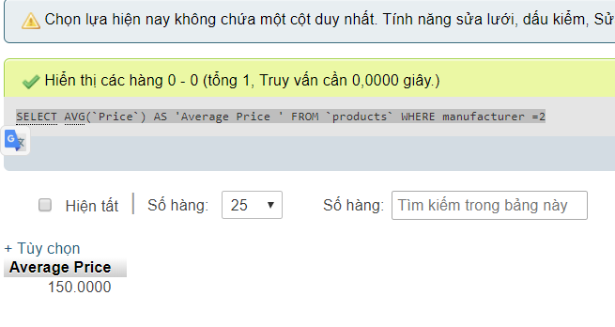

-- 1.8 Compute the number of products with a price larger than or equal to $180.

[SELECT](http://localhost/phpmyadmin/url.php?url=https://dev.mysql.com/doc/refman/5.5/en/select.html) [COUNT](http://localhost/phpmyadmin/url.php?url=https://dev.mysql.com/doc/refman/5.5/en/group-by-functions.html#function_count)(`Name`) AS 'Sum Product' FROM `products` WHERE `Price` >=180

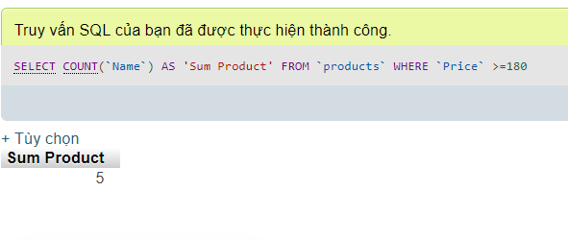

-- 1.9 Select the name and price of all products with a price larger than or equal to $180, and sort first by price (in descending order), and then by name (in ascending order).

[SELECT](http://localhost/phpmyadmin/url.php?url=https://dev.mysql.com/doc/refman/5.5/en/select.html) `Name`,`Price` FROM `products` WHERE `Price` >= 180 ORDER BY `Price` DESC , `Name` ASC

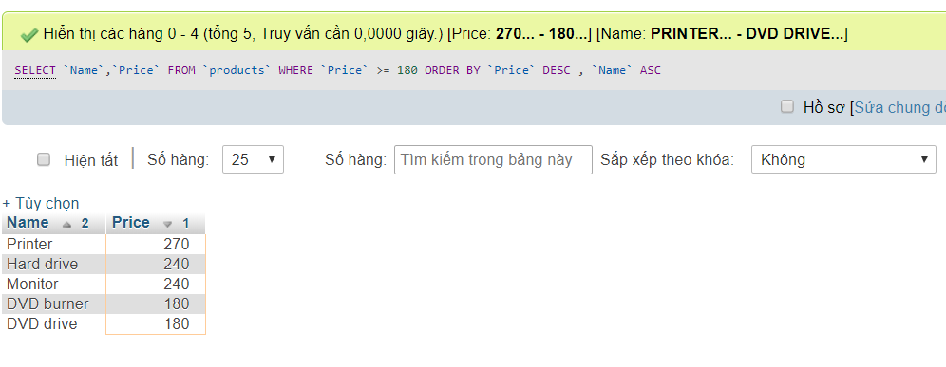

-- 1.10 Select all the data from the products, including all the data for each product's manufacturer.

-- 1.11 Select the product name, price, and manufacturer name of all the products.

-- 1.12 Select the average price of each manufacturer's products, showing only the manufacturer's code.

-- 1.13 Select the average price of each manufacturer's products, showing the manufacturer's name.

-- 1.14 Select the names of manufacturer whose products have an average price larger than or equal to $150.

-- 1.15 Select the name and price of the cheapest product.

-- 1.16 Select the name of each manufacturer along with the name and price of its most expensive product.

-- 1.17 Add a new product: Loudspeakers, $70, manufacturer 2.

-- 1.18 Update the name of product 8 to "Laser Printer".

-- 1.19 Apply a 10% discount to all products.

-- 1.20 Apply a 10% discount to all products with a price larger than or equal to $120.