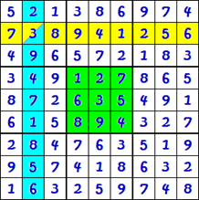

To play, each row, column, and block should contain the numbers 1 through 9 with no repeats.

Colored cages should add up to the number in the corner, 10 in this case.



**Not yet complete.**

**please check**

**the solution**



**Correct, great**

**work!**



**Congrats, you**

**Have completed**

**This Demo!**



**Congrats, you**

**Have completed**

**All of the Levels!**

Welcome to Sum Sudoku! To play, fill each column, row, and block with the numbers one through nine, without repeating any numbers. An example of a row is shown in yellow, a column is shown in blue, and an example block is shown in green.

To help solve the puzzles, cages are painted with colors and the sum of the numbers for the cage is shown in the top right corner. The light blue cage with the number 10 in the corner is an example.



**Please enter a**

**PUzzle number**

**(1 to 115)**

**Please enter a**

**Valid number**