Controlling by smartphone via internet two relays with Blynk and ESP 8266-01
M. Todica

This work presents a very simple method of controlling two led or two relays with the smartphone trough the internet. The work is based on the very good tutorial presented on this link:
https://spidyhero.wordpress.com/2015/08/01/esp8266-esp-01-blynk-led-controller-thai-version/

In addition to this tutorial I added some modifications and supplementary explanations.
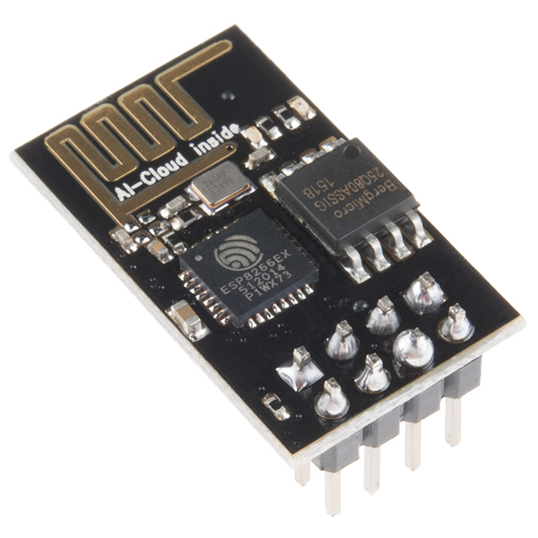
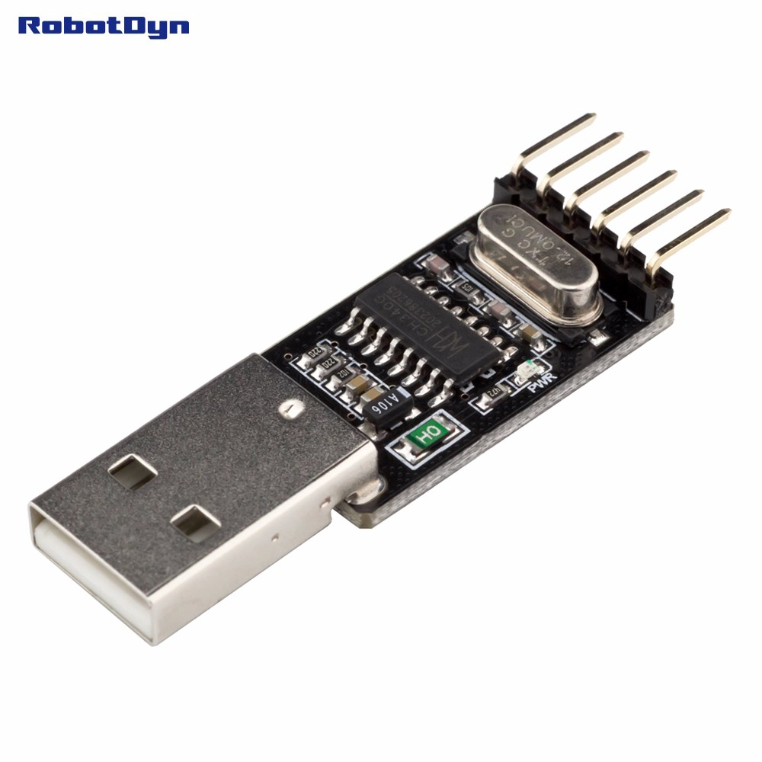
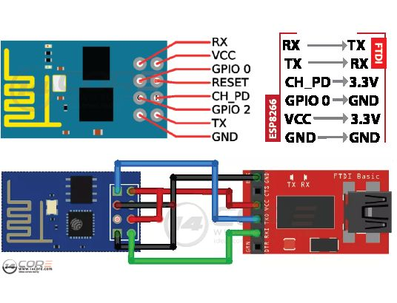
The project is based on the use of the WiFi internet module ESP 8266-01, (version 01), but other versions can be used as well, (Fig. 1). The module is able to connect to internet and communicate with other devices on the network. No IP or other settings are requested. This device can work alone, after charging the code, or attached to the Arduino board. In this project we use the first feature, the work without Arduino. This device can be programmed directly by the computer, without Arduino or other boards, the only requested accessories being one TTL adapter, CH340G 5V/3.3V, USB to TTL-UART Serial Converter, (Fig. 2).
Fig. 1. General view of module ESP8266-01
Fig. 2. General view of USB to TTL-UART Serial Converter
Fig. 3. The pin configuration of ESP8266-01 and connection to USB to TTL-UART converter
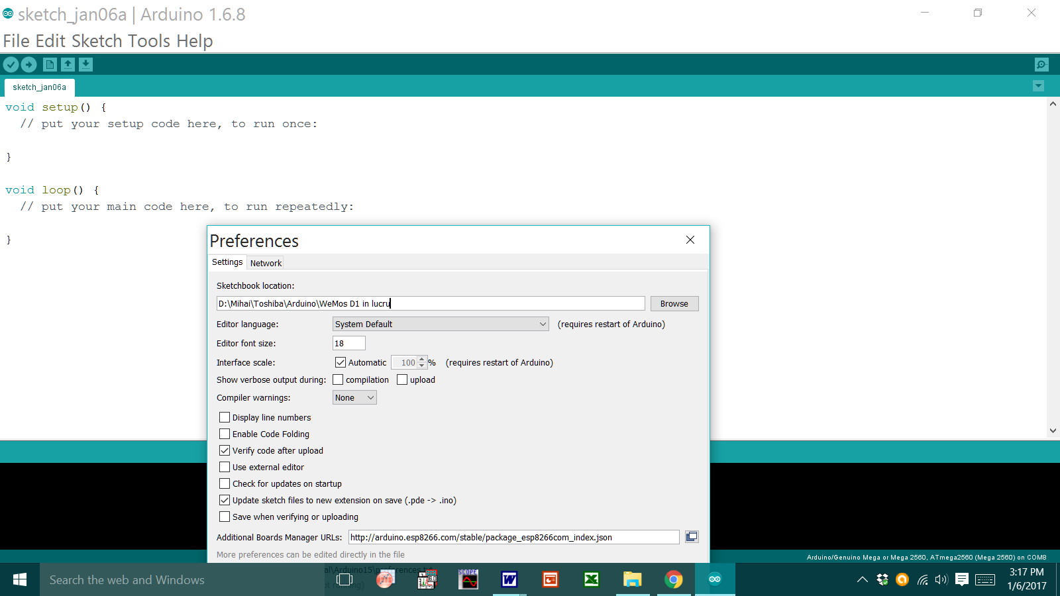
The adapter is necessarily to ensure USB connection to the computer and convert the TTL level signals provided by PC to 3.3 volts, because ESP8266 support power supply and signals with 3.3V maximum amplitude. The pinot of the module and the connection to the USB to TTL-UART adapter are shown in figure 3. This configuration will be used only for programming the ESP 8266. The GPIO 0 pin must be connected to GND. After charging the code, this pin will be disconnected from the ground and will be connected to the first led; it become output for this project. The project consists of two mains parts, setting the Arduino to recognize and communicate with the ESP 8266, and setting the Blynk application on the smartphone.
Fig. 4. Setting the Arduino preferences

Part 1. Setting Arduino IDE.

1. Download and install the version Arduino 1.6.8 from the official site.
https://www.arduino.cc/en/main/software .

2. Add the information of the board ESP8266 to the Arduino. Open the Arduino IDE, go to the menu File/ Preference, and introduce into the box: Additional Boards Manager URLs
the address of the board of JSON file ESP8266, http://arduino.esp8266.com/package_esp8266com_index.json. , (Fig. 4).

3. Manage ESP library. Go to the menu Sketch/ Include Library/ Manage Libraries/ and add the Library of ESP8266 in the Arduino IDE, (Fig. 5).
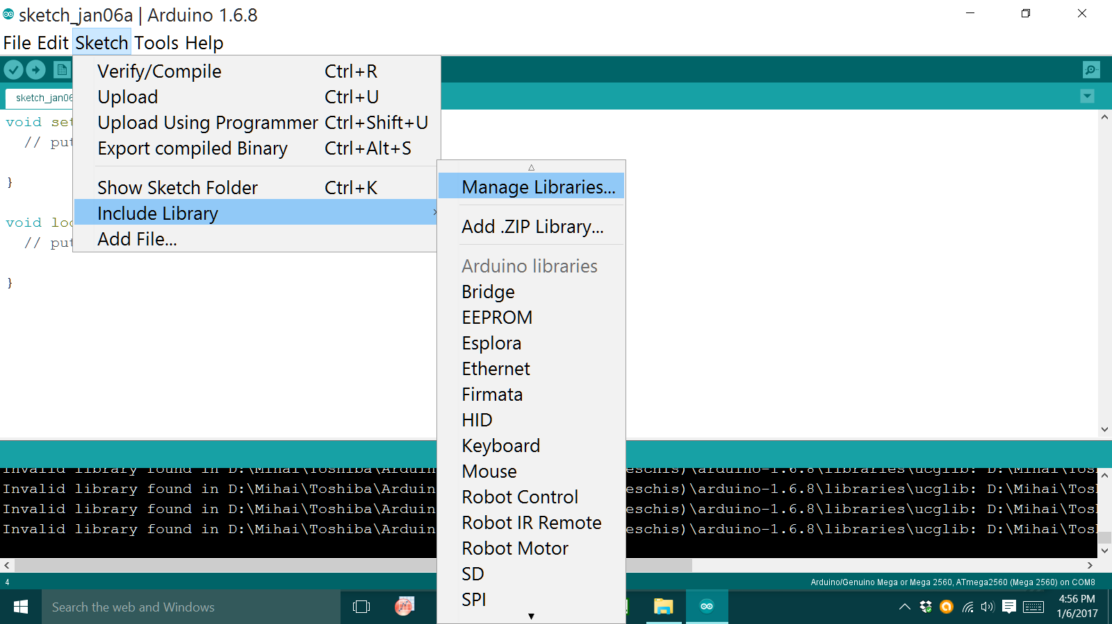
Fig. 5
4. Into the pop up box type ESP8266 and press install. The window looks like Fig. 6.
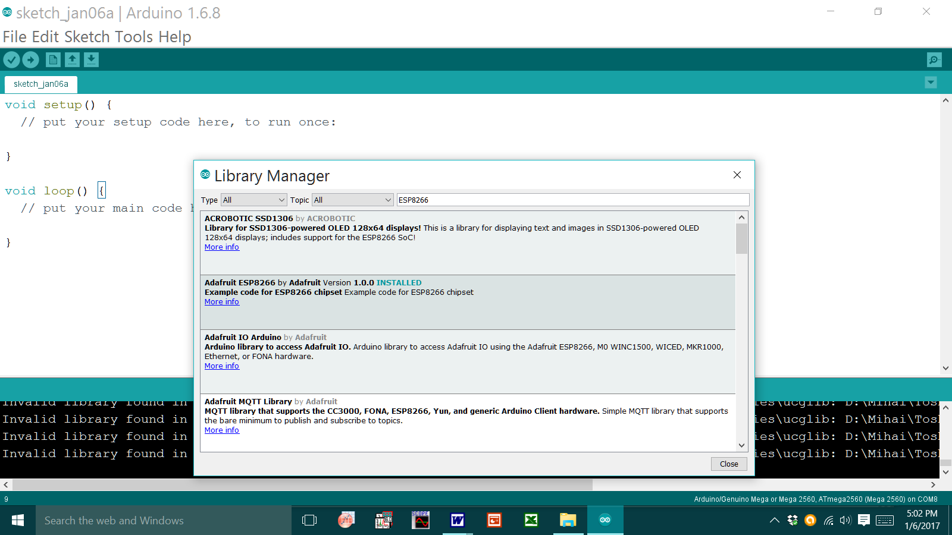
Fig. 6.

5. Setting the ESP8266 board. Go to menu Tools/ Board/ Boards Manager/ ... Select Generic ESP8266 Module board. The screen displays this: (Fig. 7).
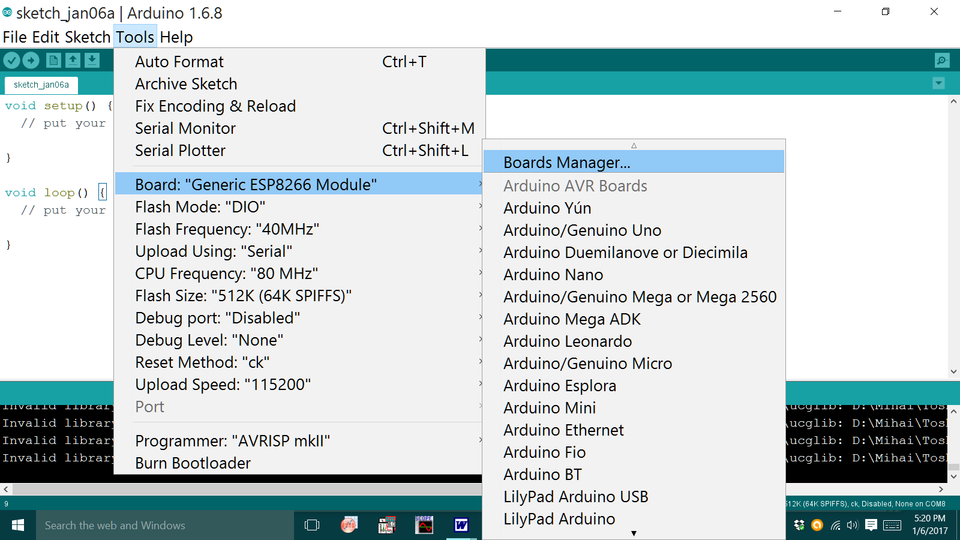
Fig. 7.
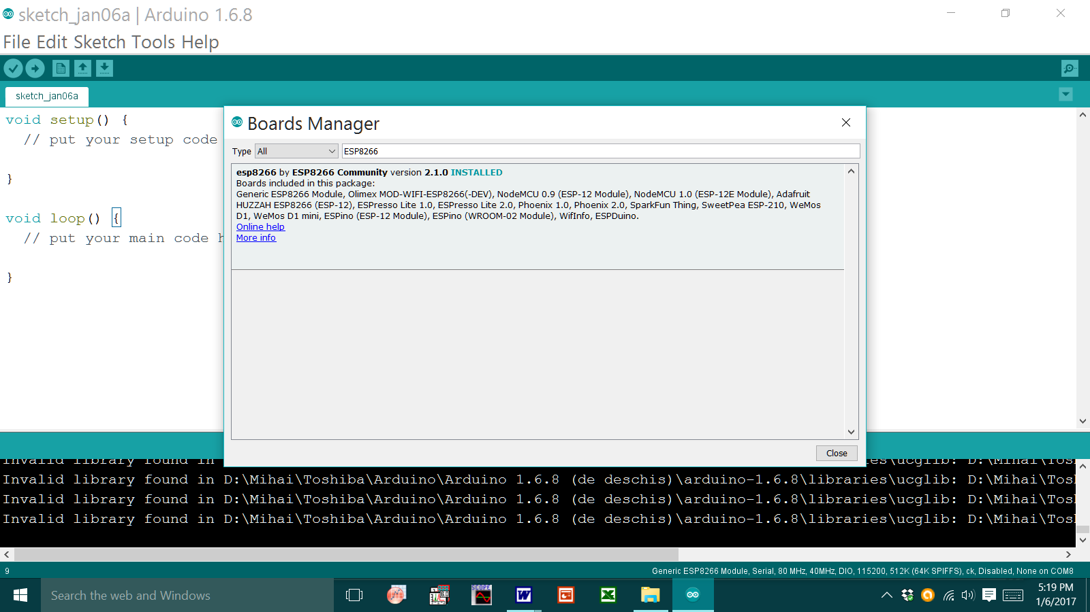
Fig. 8.
6. In the pop up box types ESP8266 and then install. We obtain, (Fig. 8).

7. Go to the Tools> Board:> Boards Manager ... then choose Generic ESP8266 Module board, (Fig. 9).
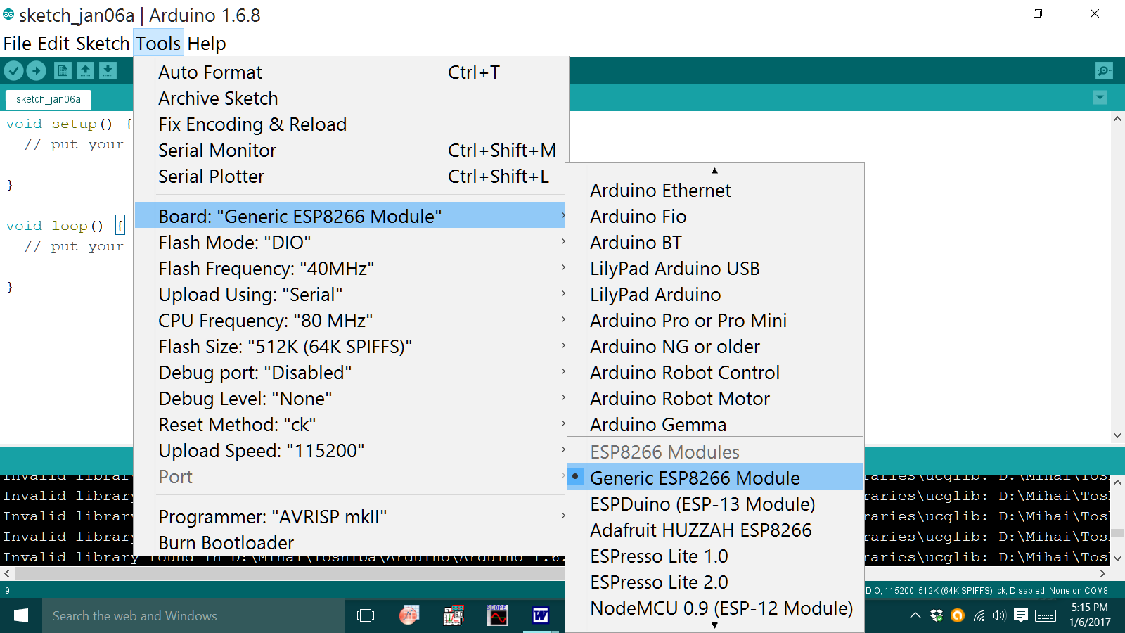
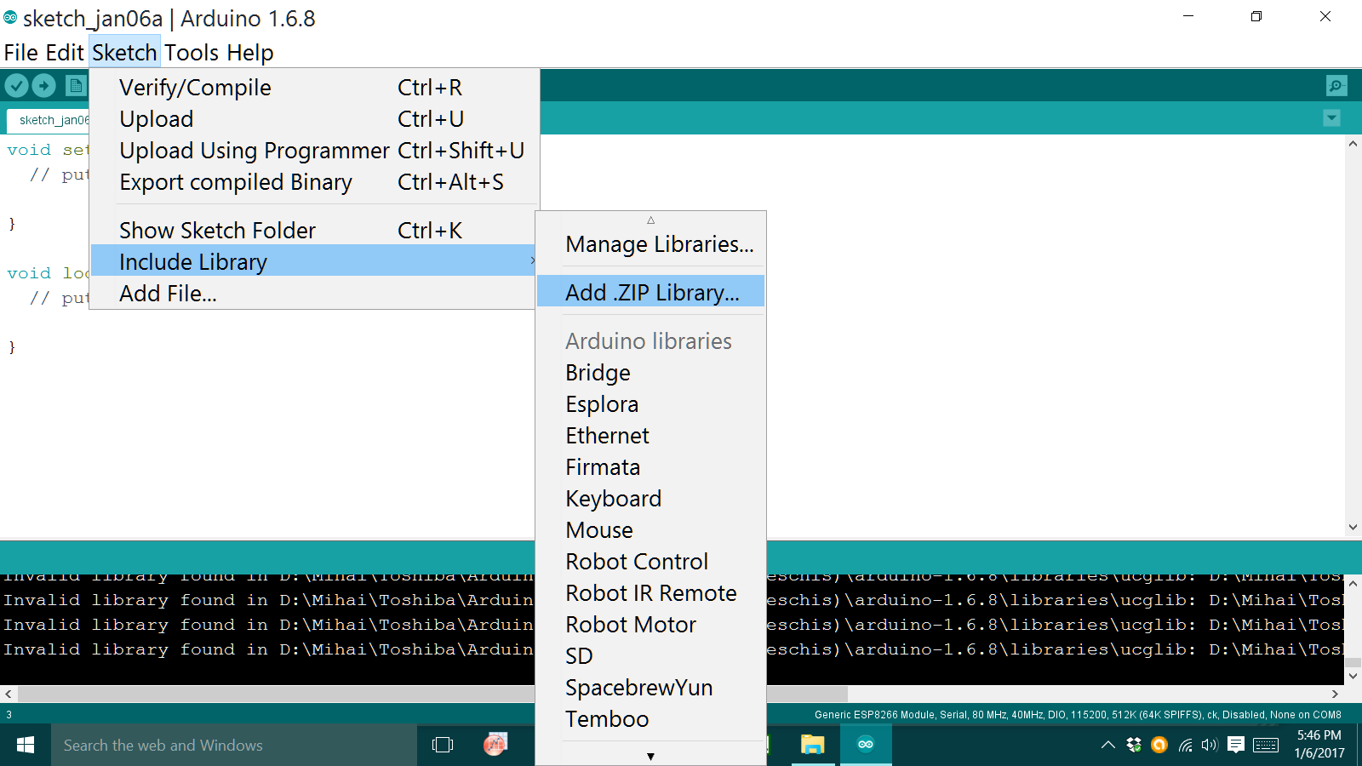
Fig. 9.
Fig. 10.

8. Downoload and install Blynk library 0.4.0 from
http://www.blynk.cc/getting-started/
Save into desired folder, unzip and add manually into Arduino/libraries folder.
Alternatively you can use the option Add zip library. To do this go
to Arduino IDE, menu Sketch> Include Library> Add .ZIP Library and then select the downloaded file, (Fig. 10).

9. Connect the ESP8266 board to the computer as shown in figure 2. The GPIO 0 pin must be connected at GND.

10. Uploading the code. Go to the File> Examples> Blynk> Boards_WiFi> ESP8266_Standalone, (Fig. 11). Upload the code ESP8266_Standalone to the ESP board.

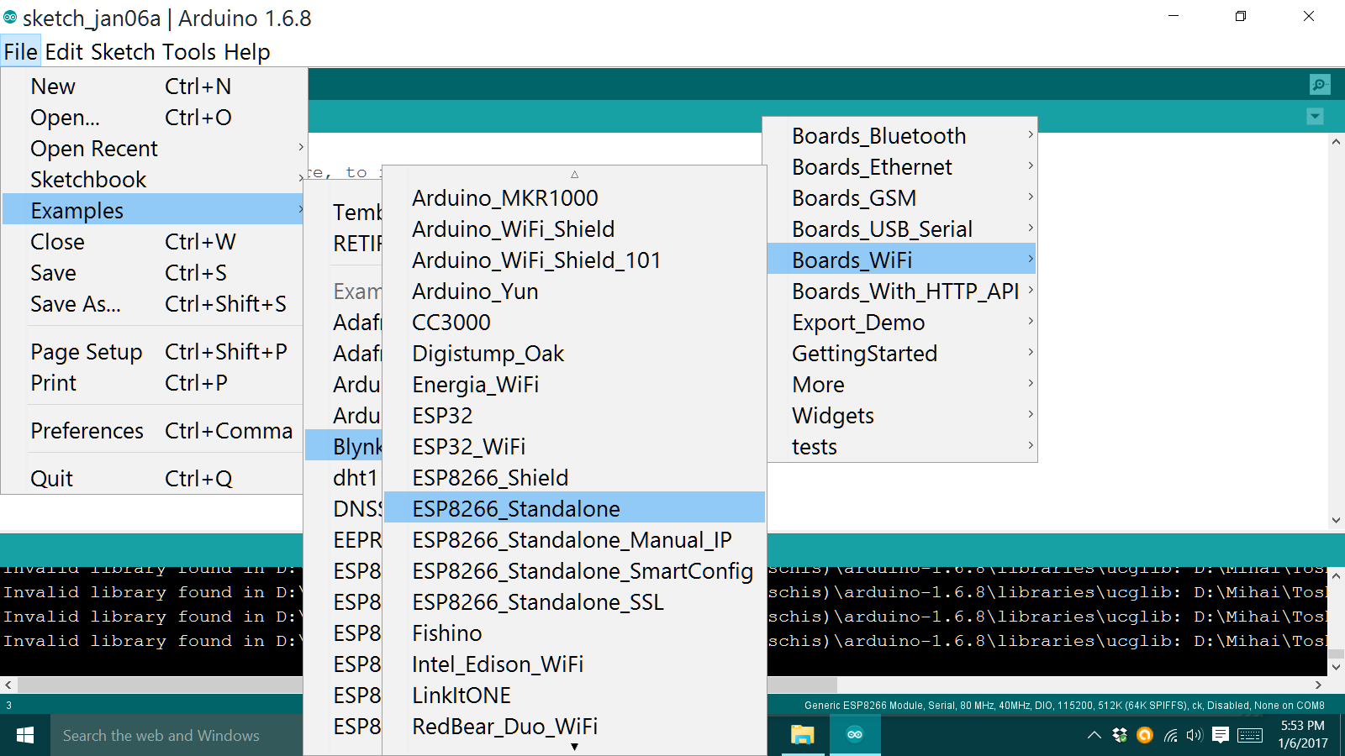
Fig. 11.

Enter into the code your Blynk auth [] = "YourAuthToken";
Enter the Wi-Fi name and password of your router in the code line

Blynk.begin (auth , "SSID", "Pass");

Alternatively you can use the code below.

The code
///////////////////////////////////////////////////////////////////////////////////////////////////////////////

#include <ESP8266WiFi.h>
#include <BlynkSimpleEsp8266.h>
// You should get Auth Token in the Blynk App.
// Go to the Project Settings (nut icon).
char auth [] = "YourAuthToken";
void setup ()
{
Serial.begin (9600 );
Blynk.begin (auth , "SSID", "Pass");
}
void loop ()
{
Blynk.run ();
}

/////////////////////////////////////////////////////////////////////////////////////////
end of code.

After charging the code, disconnect the pin GPIO 0 from the ground and connect it to the first led and GND trough 220 Ohm resistor. The second led is connected between GPIO 2 and GND trough 220 Ohm resistor, (Fig. 12). The led can be replaced by relays, (Fig. 13).
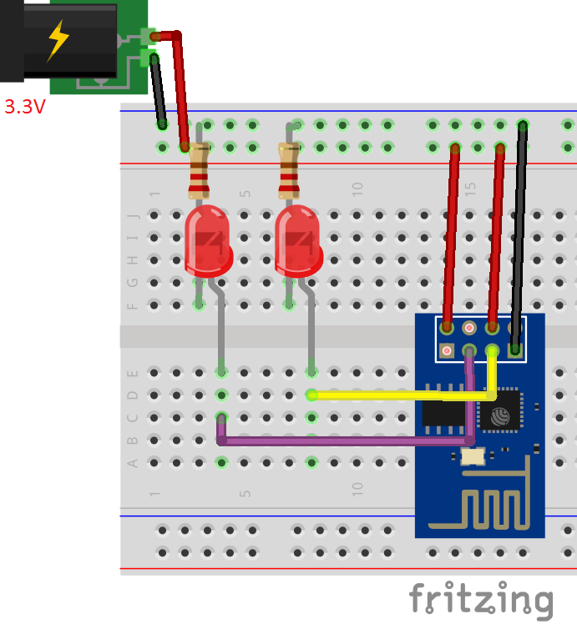
Now we are ready to receive commands from the smartphone.
Fig. 12. Connection of the led to the ESP module
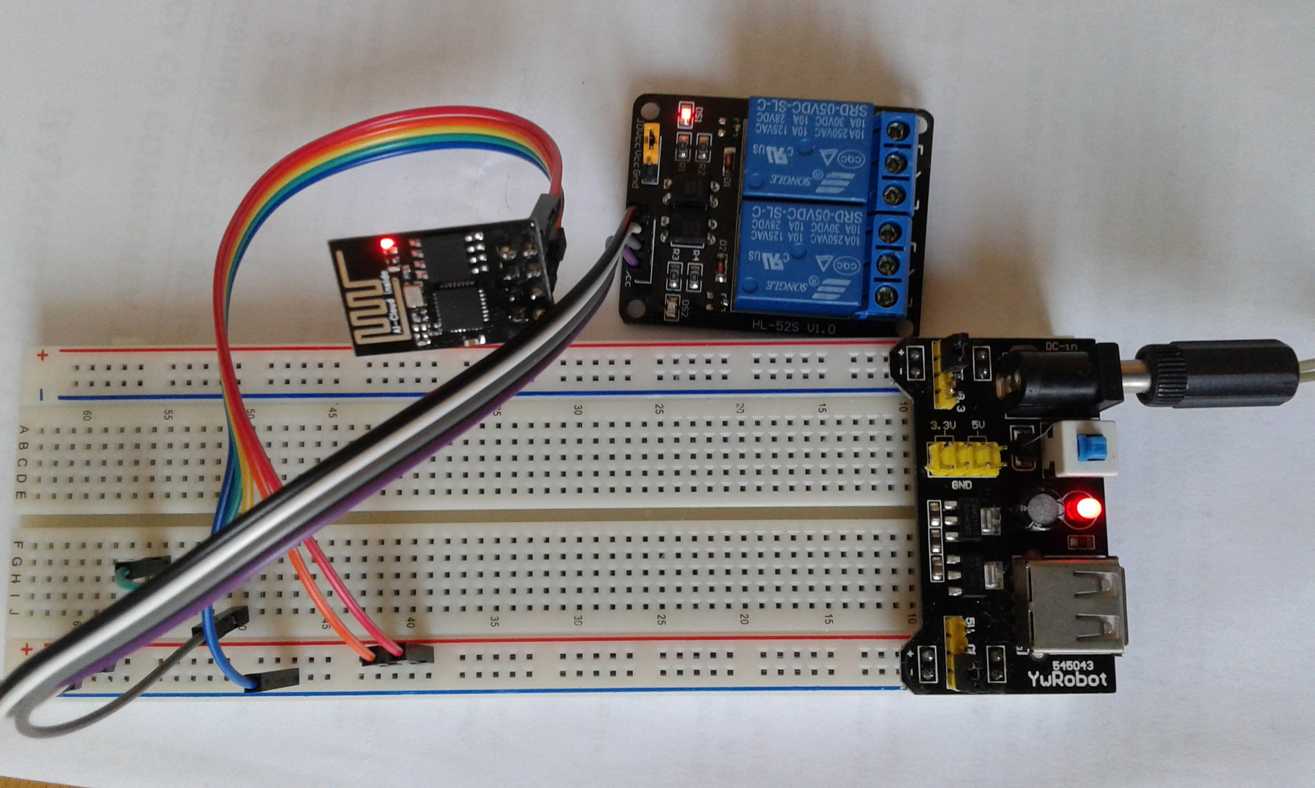
Fig. 13. Connecting two relays to ESP board

Part 2. Setting the Blynk application

On the smartphode download and install Blynk application from the link:
http://www.blynk.cc/getting-started.
Open the app, create account, enter your email and password, register, and Sign Up.
Open new project, give it a name, creates the auth. char and send it to your e-mail address. Select the ESP8266 WiFi board. Go to Widget Box, select two Buttons, and drag them into your work sketch. Attach the buttons to GPIO0 and GPIO2, then start the application pushing the flesh play on the upper right corner of the screen, (Fig. 14). If the ESP is in the network, every time we push or slide the button widget on the smartphone, the corresponding led on the ESP board will lights.

References

https://spidyhero.wordpress.com/2015/08/01/esp8266-esp-01-blynk-led-controller-thai-version/
http://www.blynk.cc/getting-started
http://db4linq.blogspot.ro/2015/03/esp8266-gpio-http-server.html
http://docs.blynk.cc/#blynk-firmware-virtual-pins-control

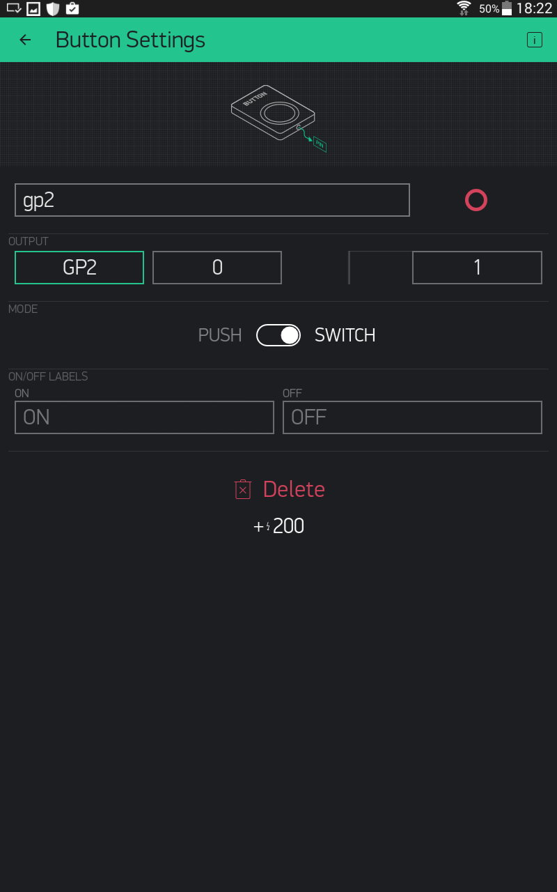
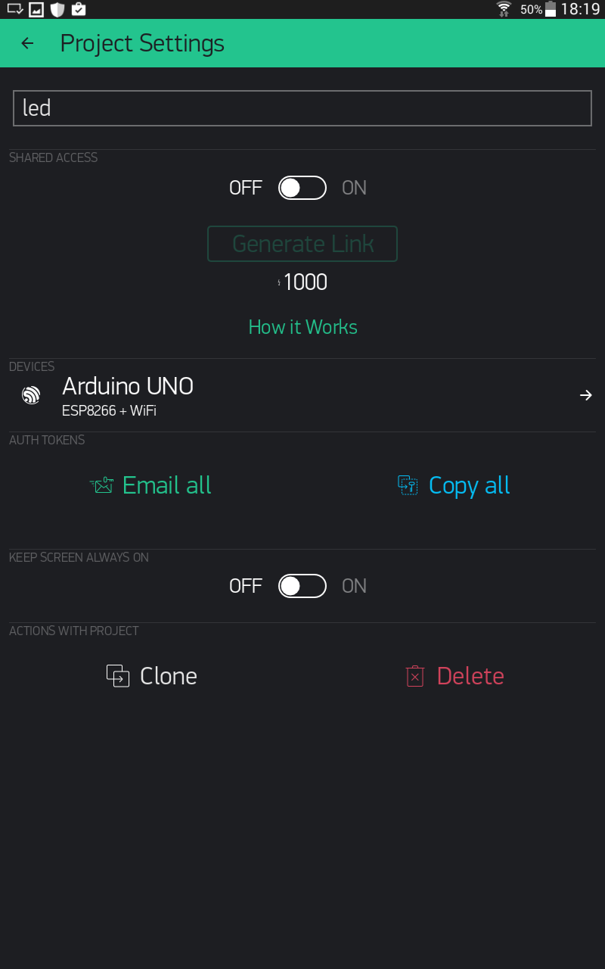
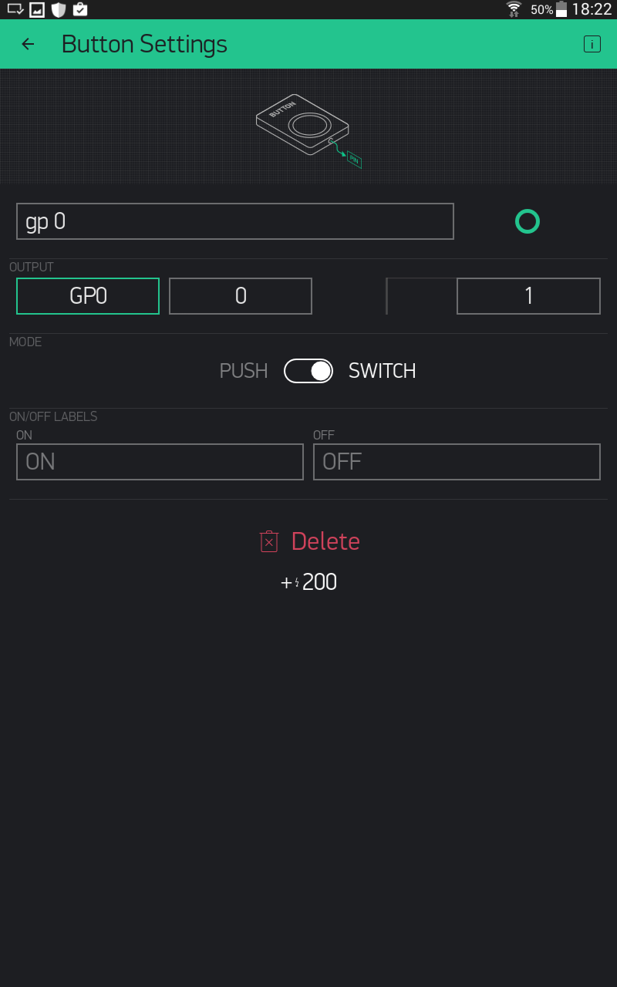
Fig. 14

