Git & GitHub Cheat Sheet for MUSOD Informatics
Purpose: A quick guide for the standard workflow: creating a feature branch, developing, and submitting a Pull Request for review.
*A Note on Branch Naming: Historically, the primary branch in Git repositories was often named 'master'. In an effort to adopt more inclusive language, the community widely transitioned to using 'main' as the default branch name. Our existing repositories might still refer to 'master' in their history or older configurations, but for all new work and naming convention practices in this document, we will use main.

1. Start a New Feature/Bugfix (Branch Creation & Checkout)
Always start your work on a new branch, based on the latest main branch.
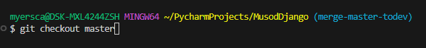
- Switch to main (if not already there):

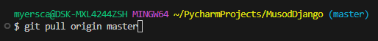
- Get the latest changes from GitHub:

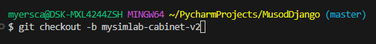
- Create and switch to your new dev branch:
  - Naming Convention: Use your-feature-name (e.g., user-login, bugfix/admin-dashboard). (‘-b’ = “create branch and then switch occurs)”
(You are now on your new feature branch, ready to code!)

2. Develop & Commit Your Changes
Work on your feature, then commit your changes frequently and logically.
- Make your code changes in your IDE (PyCharm, VS Code, etc.).
- Stage your changes:
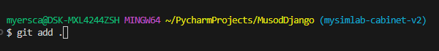
  - To stage all modified files:
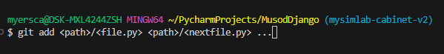
  - To stage specific files
- Commit your staged changes:
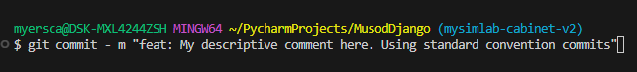
  - Write a clear, concise commit message (e.g., "feat: Implement user authentication," "fix: Resolve login button issue").
(Repeat steps 1-3 as you make progress.)

3. Push Your Branch to GitHub (Command line option)
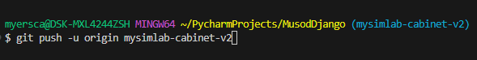
Once you have one or more commits, push your branch to the remote repository.
- Push your dev branch for the first time:
(-u sets upstream, so subsequent pushes are just git push)
- For subsequent pushes:

4. Create a Pull Request (PR)
When your feature is complete and tested locally, create a PR to main for review.
- Go to your repository on GitHub.com. (Not in your terminal!!!)
- GitHub will usually show a banner: "Compare & pull request" for your newly pushed branch. Click it.
  - If not, go to the "Pull requests" tab and click "New pull request".
- Configure the PR:
  - Base (target) branch: main
  - Compare (source) branch: dev/your-branch-name
- Fill out the PR details:
  - Title: Clear and concise (e.g., "Feat: Add User Profile Page").
  - Description: Explain what was done, why, and how to test it. Link to any related issues.
- Add Reviewers: Assign relevant team members for code review.
- Create Pull Request.

5. Address Feedback & Merge
Collaborate on the PR, make necessary adjustments, and merge once approved.
- Monitor PR comments.
- Make requested changes (commit to your dev branch and git push). The PR updates automatically.
- Once approved by [1+/-] reviewer(s), click "Squash and merge" (preferred for clean history) or "Create a merge commit" on GitHub.
- Delete your dev branch on GitHub after merging (option appears on the PR page).
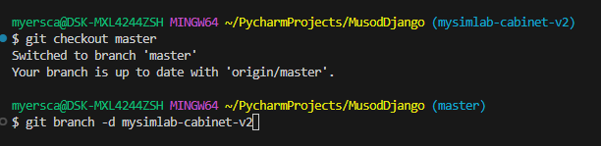
- Delete local dev branch (optional, but good practice):

(This cheat sheet is a simplified guide. Refer to the full Git & GitHub Usage Guidelines for MUSOD Informatics for comprehensive details.)

