# Stomata counting protocol

Last updated 2022-10-10 by Chris Muir

The original idea for this protocol came from Genevieve Triplett and Jacob Watts

1. Open FIJI and through it, open the image you will be working on from “stomata to be counted” folder: Google Drive > Shared Drives > muir-lab > adaptive-amphistomy > raw-data > stomata > stomata to be counted
2. **Remove scale: Select “Analyze > Set scale…”. Remove scale and click “Global”.**
3. **Set measurements: Select “Analyze > Set measurements…”. Uncheck every box except “Centroid” and “Display label” and click OK.**

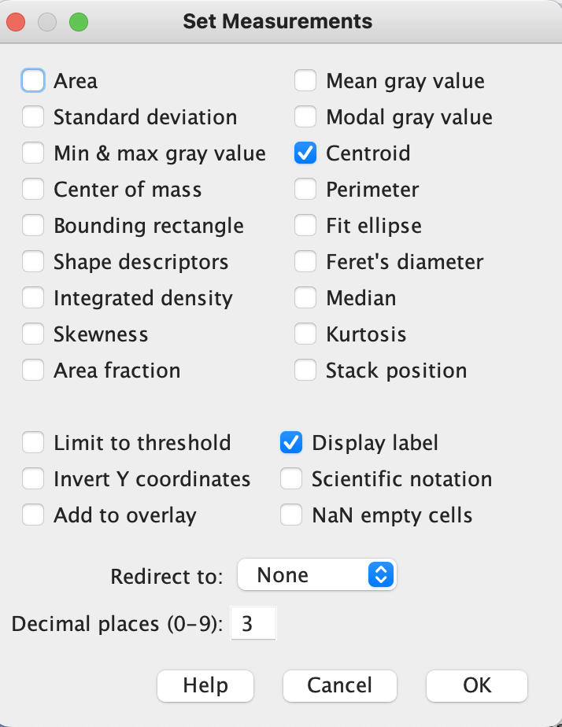

Note: (steps 2 and 3 only done at the beginning of each session)

1. Select Line tool

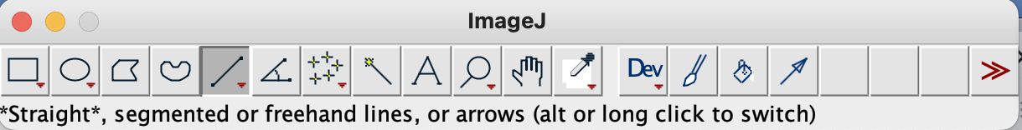

1. Open the ROI Manager by “Analyze > Tools > ROI Manager…”. Select the “Show all” button in the ROI Manager window to show all previous lines that have already been drawn.
2. Count all stomata in the “stomata to be counted” folder by drawing a straight line from one end to the other via the long axis, like in the images below. After each line, press the letter ‘t’ to add it to the ROI manager.  
   Tips: use “magnifying glass” icon to zoom, use “hand” icon to move around, and you can add grids to section up the image: Analyze > Tools > Grid…

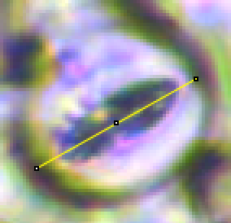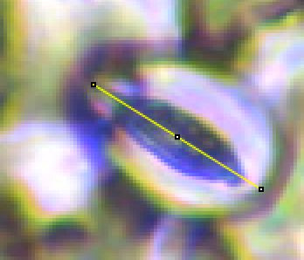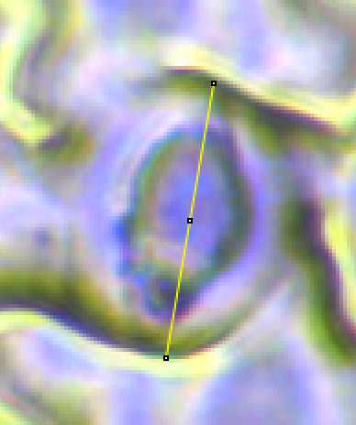

For stomata cut off by the edge of image, draw a partial line through the middle like this: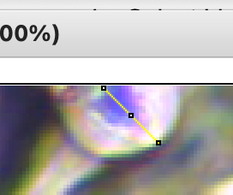

You can see when it is added to the ROI Manager

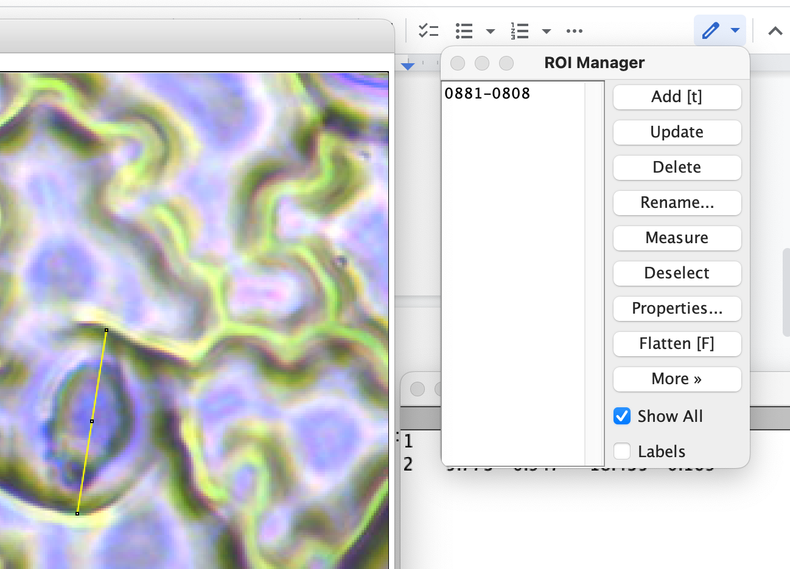

1. More examples of what to look for and what not to look for:

These are stomata:

These are not: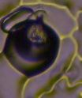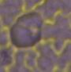

1. After you’ve drawn a line for every stomate and added it to the ROI Manager, select all (command-A in Mac) objects in the the ROI Manager (in this example, there are only 3 stomata):

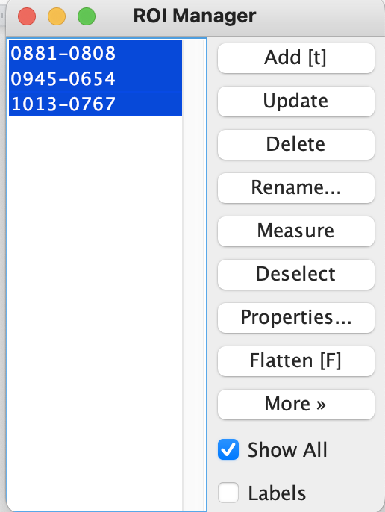

1. Then click the “Measure” button in the ROI Manager. A new window should appear with all the measurements, one row for each stomate:

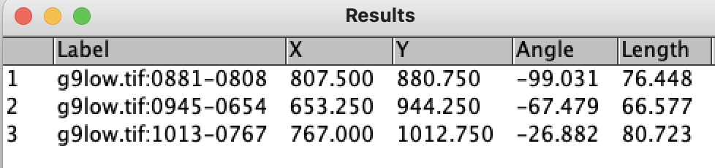

1. Copy data to Google Sheet called “stomata-count”. The full path is “muir-lab/adaptive-amphistomy/raw-data/stomata/stomata-count.gsheet”.
2. Select all data points on ROI Manager (ctrl A), click “More >>”, click “Save…” in the folder titled “stomata”, rename the zip file to the name of the original image file. (eg. original file name is “LA4117A-C-terminal-upper”)
3. Close ROI manager and click “Discard” when asked to save as an overlay. Select “Don’t Save” when closing image and “measure” window cause we just need the data from the ROI Manager

Tips: ROI Manager will not save data as a zip file if there’s only 1 data entry, select .

1. Move completed image from “stomata to be counted” folder into “stomata measured” folder (image only)

Tip: Select "Cancel" if asked to disable global calibration when opening new images as this is just letting you know that you have done Step 2 for this current session and we want to keep the global scale.

1. If having to update measurements: Open zip file for image in “stomata” through Image J
2. Open image in “stomata measured”
3. Make sure that “Global” is checked in **“Analyze > Set scale…”.**
4. Select “show all” to show previous measurements

Tip: To make the measurements more visible select “properties” in ROI manager and

change “width”