CONSERVATION AND SUSTAINABLE MANAGEMENT OF COASTAL AND MARINE ECOSYSTEMS (COSME) PROJECT.

FEATURED GROUPS:
- Amka Utsamba Conservation Group
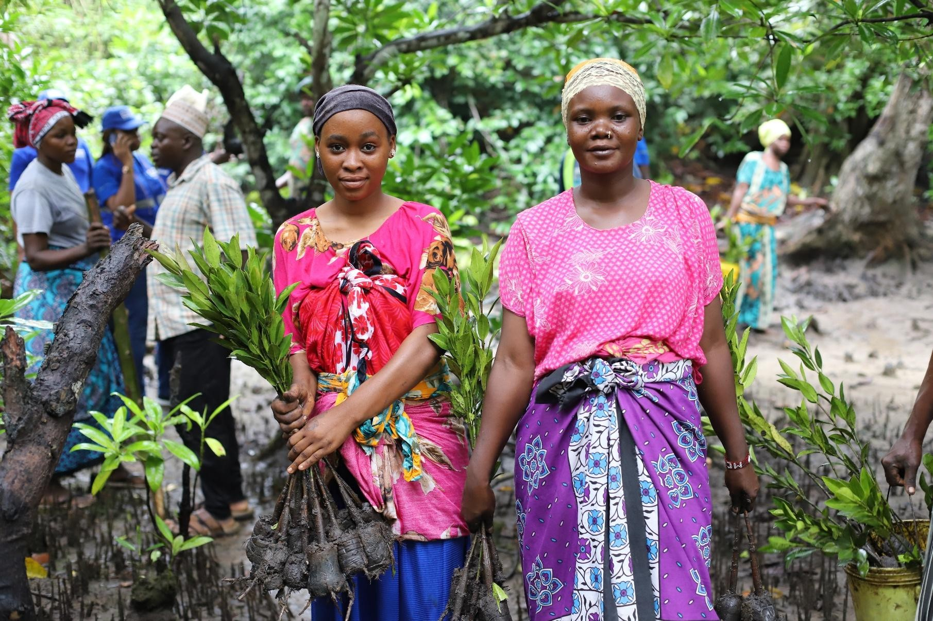
- Yungi Mwenjeni Conservation Group.

ABOUT COSME PROJECT

WHO WE ARE
The COSME Project is working closely with 3,000 women to restore vital coastal and marine ecosystems and advocate for greater inclusion in climate solutions. Additionally, through initiatives such as school clubs and training sessions, the project will reach 49,000 people—including 26,000 women and girls—across 65 coastal communities in Kenya and 45 in Tanzania as direct reach.
The project is funded by Global Affairs Canada and individual Canadian donors, and it is delivered in partnership with the Jane Goodall Institute of Canada and Cascadia Seaweed Corporation.

WHAT WE DO
The COSME Project focuses on empowering communities, particularly women, to enhance their resilience to climate change. This is achieved by:
- Promoting climate-resilient earning opportunities
- Improving the health of ecosystems that local communities rely on
WHERE WE WORK
- Kenya: 65 coastal and terrestrial communities in Kwale and Kilifi counties (project activities led by Plan International Kenya)
- Tanzania: 45 coastal and terrestrial communities Tanga and Pwani regions (project activities led by the Jane Goodall Institute)
PROJECT TIMELINE
MARCH 2023 – DECEMBER 2027

WHY WE EXIST
The COSME Project is committed to achieving three key goals:
- Women’s Climate Adaptation – Equip Women with skills and assets to build their adaptive capacity to climate change and build household and community resilience through ecological restoration and sustainable nature-based businesses.
- Strengthening governance for Community resilience; Includes school engagements (4k and Roots and Shoots clubs), Community preparedness plans and working with Women Rights Organisations and Youth Led Organizations to foster a culture of environmental stewardship and advocate for inclusion in climate response planning at regional and national levels.
- Social and Financial asset for women; Enhancing Women’s Agency to exercise their rights to participate in gender responsive NbS to increase their adaptive capacity and build household and community resilience– Women gain more influence in household and community decision-making processes.

AMKA UTSAMBA SEAWEED FARMERS GROUP PROFILE
Established: 2016, started seaweed farming in 2024
Location: Utsamba Village, Lungalunga Sub-County, Kwale County
Group leadership: Women-led
Membership: 32 (25 Women and 7 men)
Focus: Gender Responsive Seaweed farming as a nature positive enterprise that supports restoration of biodiversity and climate resilience.
COSME INTERVENTION HIGHLIGHTS:
- Site suitability assessment and mobilization and formalization of the group
- Trainings Offered: Technical training and mentorship by KMFRI on seaweed (production, marketing & regenerative practices), financial literacy through Gender Responsive Savings Groups (GRSGs), Gender Justice Journey.
- Business Support: Commercialization coaching and peer learning exchanges
- Tree Planting: 15+ Farmers received coconut and citrus seedlings as part of integrated climate-smart agroforestry initiatives.
OBSERVED CHANGES:
Improved yields attributed to adoption of Double Made Loop & Off bottom farming methods, improved planting techniques and better farm coordination. Increased savings and loan uptake in saving groups, increased gender awareness at household, community and ecological levels.

KEY GROUP STATISTICS:
 | Metric | Value
 | Current Seaweed Ropes | 600
 | Average Harvest (KG) | 247
 | Income from Seaweed | KES 54,250 (est.)
 | GRSGs Savings | KES 234,775
 | Loans Disbursed | KES 219,000
 | Loan Usage | Business, Food, School Fees & Shelter
 | Social Fund | KES 62,400

CAPACITY BUILDING & TECHNICAL TRAININGS
Training Engagement (based on records from 3 Thematic areas):
Training Engagement (based on records from 3 Thematic areas):
Seaweed Production &
Commercialization
93.0
86.0
Savings Groups (VSLA)
Training
72.0
GJJ & Emotional
Resilience (Modules 1
& 2)
Reported Impact- 92% of women trained report improved ability to make independent decisions over income 100% of trained women feel more confident engaging in public meetings 88% of trained women have started saving or investing part of their seaweed income
AGROFORESTRY INTEGRATION (FRUIT TREES):
- Seedlings Distributed: Over 130 across 17 farmers
- Survival Rate: 100% reported
- Outcomes: Farmers have gained appreciation for environmental care and the economic potential of fruit trees alongside seaweed farming
CHALLENGES AND FUTURE PLANS:
KEY CHALLENGES:

- Inadequate transport accessing the farms (need for motorbike/boats)
- Lack of drying sheds and secure storage
- Equipment and skill in value addition
GROUP ASPIRATIONS:
- Scale operations so each farmer manages at least 600 ropes
- Increase Income base to support household goals
- Create employment for youth and women
- Build permanent drying and storage infrastructure
- Launch Amka Utsamba branded seaweed product in the Market Shelves Locally and Internationally.
QUOTES FROM MEMBERS:
“Now I make suggestions in the home and people listen. Even my husband.”
— Tima Masudi Abdalla
“I’ve learned to balance seaweed farming with planting trees – both can now feed my family and the environment.” — Kassim Salim Ali

YUNGI MWENJENI CONSERVATION GROUP
Established: 2022
Location: Yungi Village, Lungalunga Sub-County, Kwale County
Group leadership: Women-led
Membership: 44 (32 Women and 12 men)
Focus: Gender Responsive Ecological Mangrove Restoration and Seaweed farming as nature positive enterprises that support restoration of biodiversity and climate resilience.
COSME INTERVENTION HIGHLIGHTS:
- Site suitability assessment, mobilization and formalization of the group
- Trainings Offered: Technical training and mentorship on mangrove restoration and seaweed (production, marketing & regenerative practices), with technical support from Kenya Forest Services (KFS) and Kenya Marine Fisheries Research Institute (KMFRI) respectively, financial literacy through Gender Responsive Savings Groups (GRSGs) and Gender Justice journey.
- Business Support: Commercialization coaching and peer learning exchanges
- Improved livelihood: Supported the groups set up community tree nurseries and later bought the seedlings back from them for restoration efforts giving them a quick source of income to meet their everyday needs.
- Tree Planting: 150+ Farmers received coconut and citrus seedlings as part of integrated climate-smart agroforestry initiatives.
OBSERVED CHANGES:
- Production: Last harvest reached 100 kg from 200 ropes, with 300 ropes replanted for the next cycle.
- Resilience: Application of sustainable practices and better-trained leadership helped reduce impacts of limited training and distance to model farms.
- GRSGs Growth: Members collectively saved KES 92,650 across 2 cycles, disbursed KES 72,000 in loans, and earned KES 5,000 in interest improving economic resilience.
- Economic Empowerment: Purchased a total of 17,500 mangrove seedlings from Yungi Mwenjeni Conservation Group at KES 50 per seedling, amounting to KES 875,000.
- Gender Justice: Increased gender awareness at household, community and ecological levels.

KEY GROUP STATISTICS:
 | Metric | Value
 | Number of Mangroves Planted | Over 35,000 Seedlings Planted (5.3ha Restored)
 | VSLA Savings to Date | KES 92,650
 | Total Loans Disbursed | KES 72,000
 | Interest Earned | KES 5,000
 | Fruit Trees Planted & Survived | 150+ (Survival rate100%)

CAPACITY BUILDING & TECHNICAL TRAINING S
- Training Engagement -GJJ

Gender Justice Journey: The group underwent 4 GE&I and economic rights sessions with a 90% average attendance—signalling strong commitment to gender-transformative change
  - Women Participation Across Sessions: 74% average attendance

  - Men Participation Across Sessions: 76% average attendance

- Training Engagement -Mangrove Restoration

Yungi Mwenjeni Conservation Group consistently demonstrated strong engagement:

  - Total Registered Members: 43 (31 women, 12 men)
  - Overall Attendance: 112 out of a possible 129 (87% average attendance rate)
  - Women: Averaged 26 participants per session (84% attendance)
CHALLENGES AND FUTURE PLANS:
KEY CHALLENGES:

- Inadequate transport accessing the farms (need for motorbike/boats)
- Lack of drying sheds and secure storage
- Equipment and skill in value addition
GROUP ASPIRATIONS:
  - Establish their own value addition facility (for seaweed powder)
  - Secure boats for safer and more efficient transport
  - Build a drying shade and storage facility
  - Increase female-led blocks and ownership
  - Scale tree planting through agroforest
MAGODI PRIMARY SCHOOL 4K CLUB
Location: Msambweni Sub-County, Kwale County
Main Water Source: Borehole (Privately owned by the school)
Membership: 110(65 Girls ,55 boys)
Trained ToT: 1Matron & Patron Trained
WATER SYSTEM SUPPORT & OUTCOMES
RAINWATER HARVESTING SYSTEM:

    - Received 1 water tank (fully installed and functional)
    - Received water 4 gutters for rain water harvesting

WATER USE IMPACT:
    - Irrigation at the school has improved
    - Community members now access the school’s water
    - Income-generation: Yes (linked to irrigation/tree nursery)
SUPPORTED SCHOOL WITH 4 K CLUB ITEMS:
      - 4 K- Club uniforms
      - Climate Cards
      - 4-K Club training manual
      - Puppetry shows on Climate change

