**PRACTICAL NO: 4C**

**Aim:** Design a web page demonstrating different Core JavaScript references (Array, Boolean, Date, Function, Math, Number, Object, String, regExp).

**Solution:**

**Array Method**

<html>

<head>

<title>Array object Demo</title>

<script>

var names=["ajay","vijay","sujay"];

document.write("Array length is: "+names.length+"<br><br>");

var c=names.join("*");

document.write(c+"<br><br>");

names.push("aviraj");

document.write("After insert: "+names.toString()+"<br><br>");

names.pop();

document.write("After delete: "+names.toString()+"<br><br>");

names.sort();

document.write("After sort: "+names.toString()+"<br><br>");

names.reverse();

document.write("After reverse: "+names.toString()+"<br><br>");

</script>

</head>

<body>

</body>

</html>

**Output:**

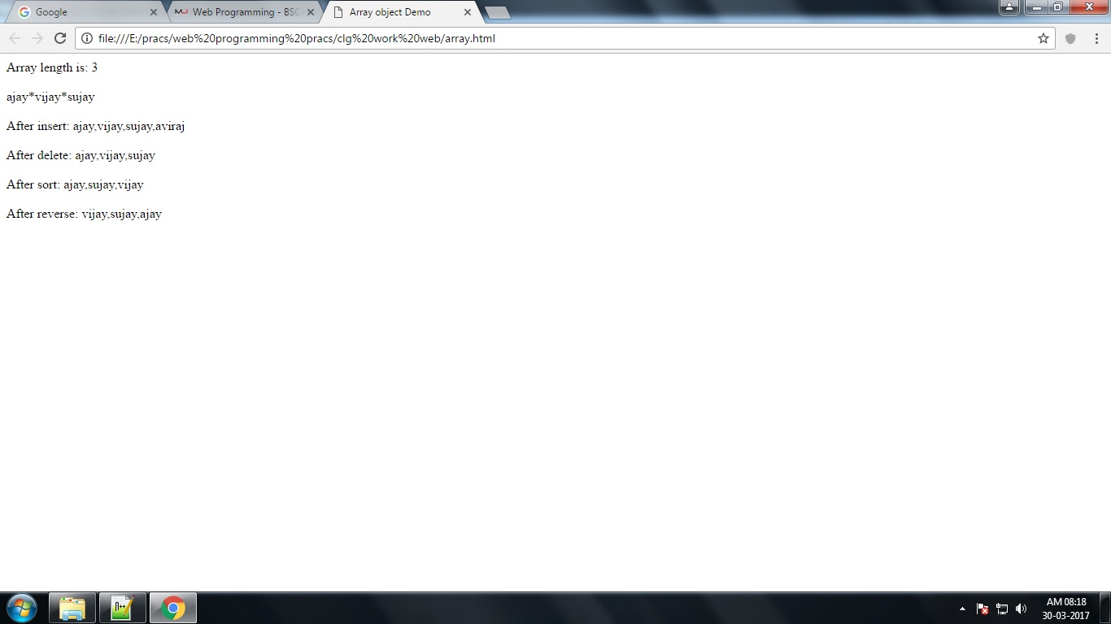

**Boolean Method**

<html>

<head>

<title>Boolean object demo</title>

<script>

function myFunction()

{

document.getElementById("demo").innerHTML = Boolean(10 > 9);

}

</script>

</head>

<body>

<p>Display the value of Boolean(10 > 9):</p>

<button onclick="myFunction()">Try it</button>

<p id="demo"></p>

</body>

</html>

**Output:**

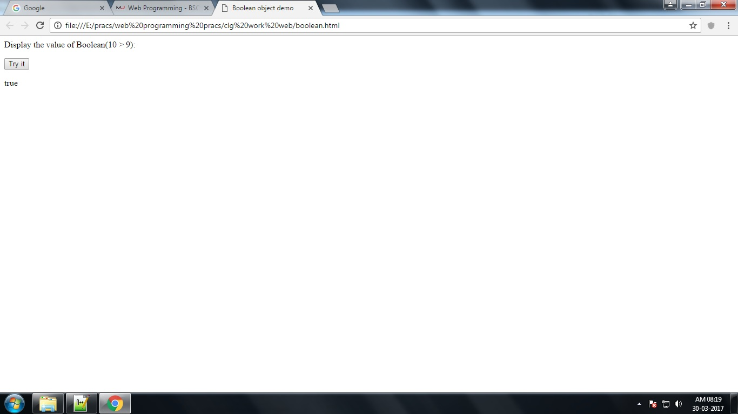

**Date Method**

<html>

<head>

<title> Date object demo </title>

<script>

var currentDate =new Date();

document.write(currentDate+"<br>");

document.write("Date is:");

document.write(currentDate.getMonth()+"/"+currentDate.getDate()+"/"+currentDate.getFullYear()+"<br>");

document.write("Time is:");

document.write(currentDate.getHours()+":"+currentDate.getMinutes()+":"+currentDate.getSeconds());

</script>

<head>

<body>

</body>

</html>

**Output:**

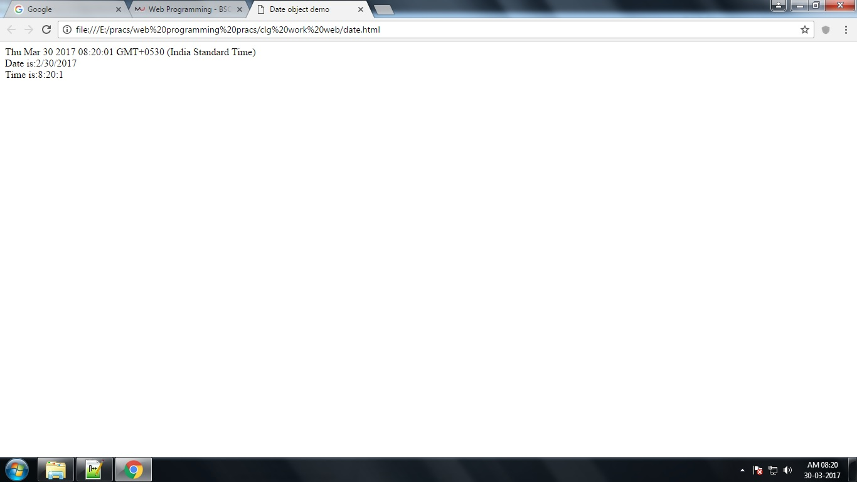

**Function Method**

<html>

<head>

<title> function object demo</title>

<script>

addBraces=new Function("s","return'['+s+']'");

document.write(addBraces("this"));

document.write(addBraces("is"));

document.write(addBraces("a"));

document.write(addBraces("test"));

</script>

</head>

<body>

</body>

</html>

**Output:**

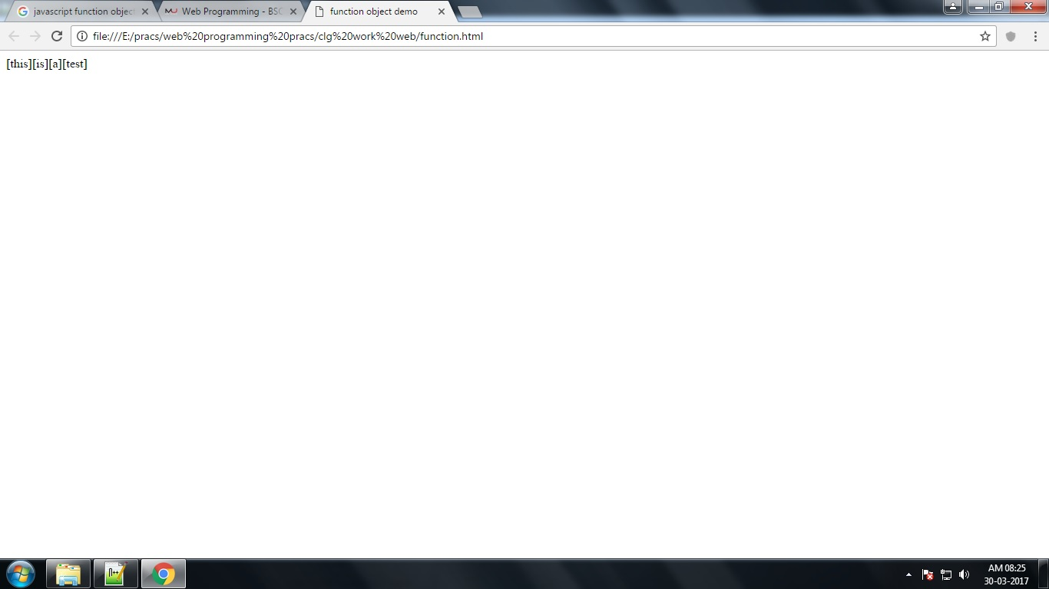

**Math Method**

<html>

<head>

<title>math object</title>

<script>

document.write("Random number: " +Math.random()+"<br>");

document.write("Minimum number: "+Math.min(10,22,55,101,02,33,-88)+"<br>");

document.write("Maximum number: "+Math.max(22,888,99,55,22,11,20)+"<br>");

document.write("Round(99.8): "+Math.round(99.8)+"<br>");

document.write("Ceil(5.5): "+Math.ceil(5.5)+"<br>");

document.write("Floor(5.5): "+Math.floor(5.5)+"<br>");

document.write("Square root of 9: "+Math.sqrt(9)+"<br>");

document.write("Square root of 64: "+Math.sqrt(64)+"<br>");

document.write("5 raise to 3: "+Math.pow(5,3)+"<br>");

</script>

</head>

<body>

</body>

</html>

**Output:**

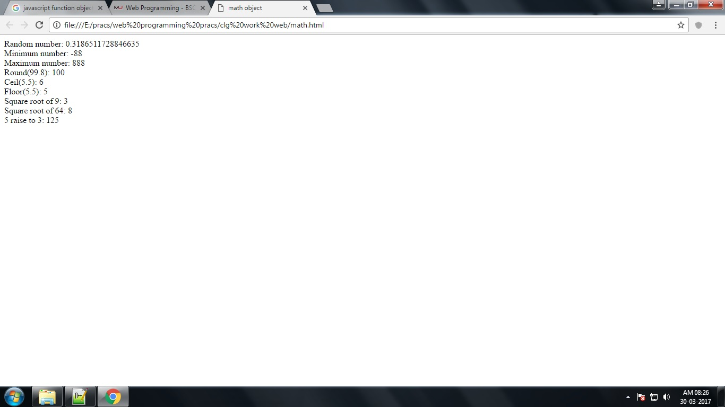

**Number Method**

<html>

<head>

<title>Number object Demo</title>

<style>

#one{

float: left;

width: 125px;

text-align:left;

margin: 2px 50px;

display: inline;

}

#two{

float: left;

text-align: left;

margin: 2px 100px;

display: inline;

}

</style>

</head>

<body>

<div id="one">

<p>toString Method<p>

<p id="toString"></p>

<p>toExponential Method<p>

<p id="toExponential"></p>

<p><p>

<p id=""></p>

<p>toFixed Method<p>

<p id="toFixed"></p>

<p>toPrecision Method</p>

<p id="toPrecision"></p>

<p>valueOf Method</p>

<p id="valueOf"></p>

</div>

<div id="two">

<p>Number Method</p>

<p id="Number"></p>

<p>parseInt Method</p>

<p id="parseInt"></p>

<p>parseFloat Method</p>

<p id="parseFloat"></p>

<p>MAX_VALUE Method</p>

<p id="MAX_VALUE"></p>

</div>

<script>

var x = 123;

document.getElementById("toString").innerHTML =

x.toString() + "<br>" +

(123).toString() + "<br>" +

(100 + 23).toString();

var x = 9.656;

document.getElementById("toExponential").innerHTML =

x.toExponential() + "<br>" +

x.toExponential(2) + "<br>" +

x.toExponential(4) + "<br>" +

x.toExponential(6);

var x = 9.656;

document.getElementById("toFixed").innerHTML =

x.toFixed(0) + "<br>" +

x.toFixed(2) + "<br>" +

x.toFixed(4) + "<br>" +

x.toFixed(6);

var x = 9.656;

document.getElementById("toPrecision").innerHTML =

x.toPrecision() + "<br>" + x.toPrecision(2) + "<br>" +

x.toPrecision(4) + "<br>" +x.toPrecision(6);

var x = 123;

document.getElementById("valueOf").innerHTML =

x.valueOf() + "<br>" +

(123).valueOf() + "<br>" +

(100 + 23).valueOf();

document.getElementById("Number").innerHTML =

Number(true) + "<br>" +

Number(false) + "<br>" +

Number(new Date()) + "<br>" +

Number(" 10") + "<br>" +

Number("10 ") + "<br>" +

Number("10 6");

document.getElementById("parseInt").innerHTML =

parseInt("10") + "<br>" +

parseInt("10.33") + "<br>" +

parseInt("10 6") + "<br>" +

parseInt("10 years") + "<br>" +

parseInt("years 10");

document.getElementById("parseFloat").innerHTML =

parseFloat("10") + "<br>" + parseFloat("10.33") + "<br>" +

parseFloat("10 6") + "<br>" + parseFloat("10 years") + "<br>" +

parseFloat("years 10");

document.getElementById("MAX_VALUE").innerHTML = Number.MAX_VALUE;

</script></body></html>

**Output:**

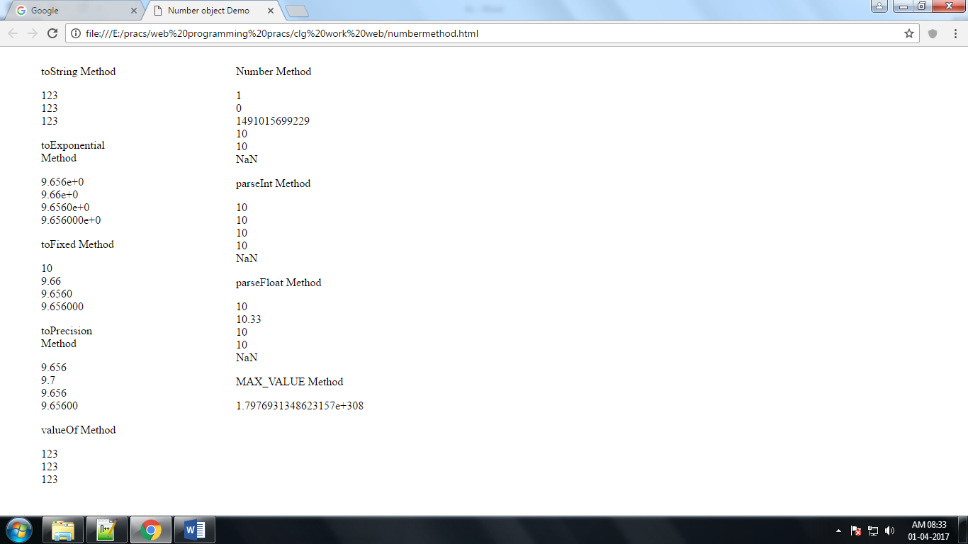

**Object Method**

<html>

<body>

<p>object method.</p>

<p id="demo"></p>

<script>

var person = {

firstName: "Ajay",

lastName : "Chavan",

id : 5566,

fullName : function() {

return this.firstName + " " + this.lastName;

}

};

document.getElementById("demo").innerHTML = person.fullName();

</script>

</body>

</html>

**Output:**

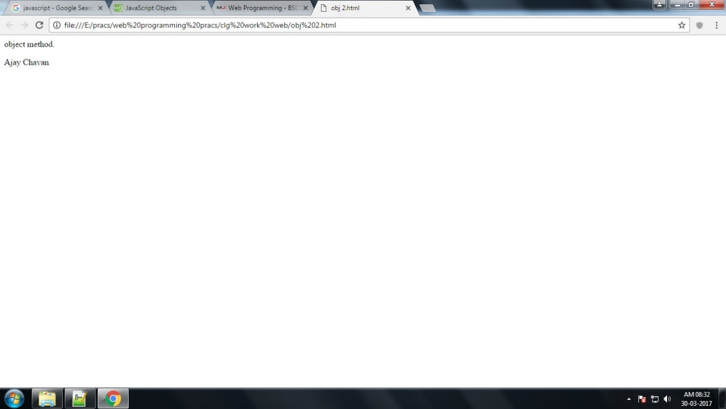

**String Method**

<html>

<head>

<title>String object Demo</title>

<script>

var txt = "ABCDEFGHIJKLMNOPQRSTUVWXYZ";

document.write(txt.length+"<br><br>");

var x = 'It\'s alright';

var y = "We are the so-called \"Vikings\" from the north.";

document.write(x + "<br>" + y+"<br><br>");

var str = "Please locate where 'locate' occurs!";

var pos = str.indexOf("locate");

document.write(pos+"<br><br>");

var str = "Please locate where 'locate' occurs!";

var pos = str.lastIndexOf("locate");

document.write(pos+"<br><br>");

var str = "Please locate where 'locate' occurs!";

var pos = str.search("locate");

document.write(pos+"<br><br>");

var str = "Apple, Banana, Kiwi";

var res = str.slice(7, 13);

document.write(res+"<br><br>");

var str = "Apple, Banana, Kiwi";

var res = str.substring(7, 13);

document.write(res+"<br><br>");

var str = "Apple, Banana, Kiwi";

var res = str.substr(7, 6);

document.write(res+"<br><br>");

var str = "Please visit Microsoft!";

var n = str.replace("Microsoft", "W3Schools");

document.write(n+"<br><br>");

var text1 = "Hello World!";

var text2 = text1.toUpperCase();

document.write(text2+"<br><br>");

var text1 = "Hello World!";

var text2 = text1.toLowerCase();

document.write(text2+"<br><br>");

var text1 = "Hello";

var text2 = "World";

text3 = text1.concat(" ", text2);

document.write(text3+"<br><br>");

var str = "HELLO WORLD";

document.write(str.charAt(0));

document.write("<br><br>")

var str = "HELLO WORLD";

document.write(str.charCodeAt(0));

document.write("<br><br>")

var str = "A,J,I,T,C,H,A,V,A,N";

var arr = str.split(",");

document.write(arr[8 ]);

</script>

</head>

<body>

</body>

</html>

**Output:**

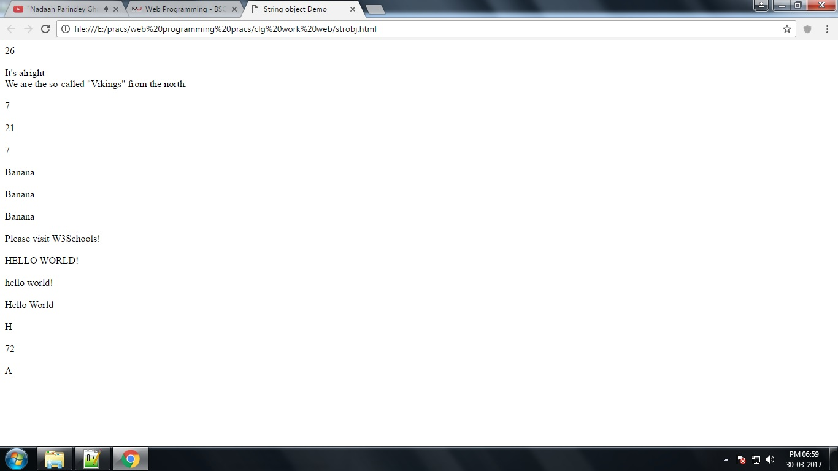

**regExp Method**

<html>

<head>

<title>RegExp object Demo</title>

<script language="javascript">

var str = "Visit W3Schools!";

var n = str.search(/w3Schools/i);

document.write(n+"<br><br>");

var str = "Visit Microsoft!";

var res = str.replace(/microsoft/i, "W3Schools");

document.write(res+"<br><br>");

text = "The best things in life are free!";

document.write(/e/.test(text)+"<br><br>");

text = "The best things in life are free!";

document.write(/e/.exec(text)+"<br><br>");

</script>

</head>

<body>

</body>

</html>

**Output:**

