**PRACTICAL NO: 5B**

**Aim:** Write a PHP program to accept a number from the user and print whether it is prime or not.

**Solution:**

**prime.html:**

<html>

<head>

<h1>PRIME NUMBER</h1>

</head>

<body>

<form method="post"action="checkPrime.php">

Enter a Number:<input type="text"name="n1"><br>

<input type="submit"value="checkPrime">

</form>

</body>

</html>

**checkPrime.php:**

<?php

$n1=(int)$_POST['n1'];

$flag=0;

for($i=2;$i<=$n1/2;$i++)

{

if($n1%$i==0)

{

$flag=1;

break;

}

}

if($flag==0)

echo"Number is Prime";

else

echo"Number is not Prime";

?>

**Output:**

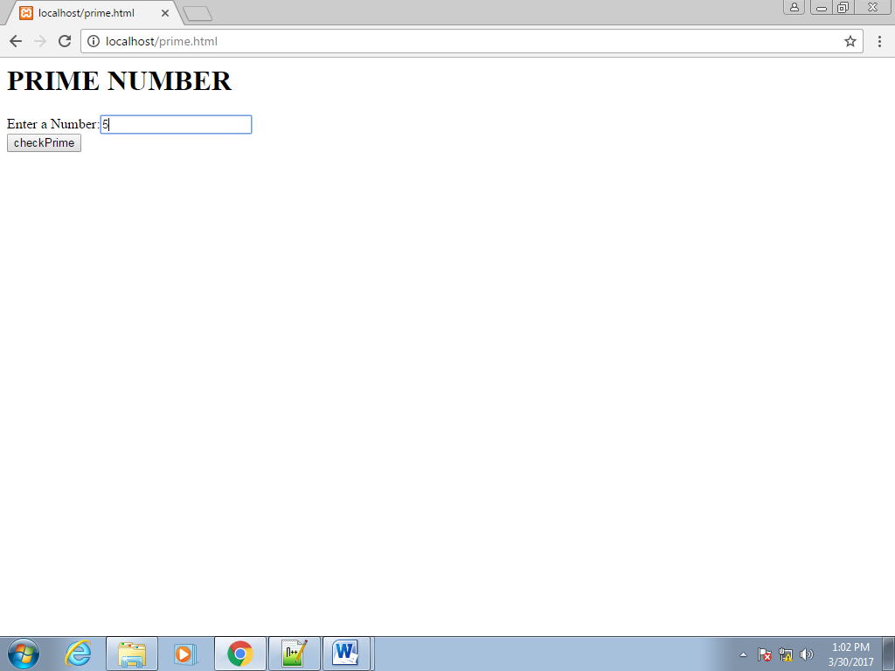

After clicking on **chekPrime** button;

