**PRACTICAL NO: 6A**

**Aim:** Write a PHP code to find the greater of 2 numbers. Accept the no. from the user.

**Solution:**

**Greater.html:**

<html>

<head>

<h1>Greater of Two Numbers</h1>

</head>

<body>

<form method="post"action="check.php">

1st number:<input type="text"name="n1"><br>

2nd number:<input type="text"name="n2"><br>

<input type="submit" value="check">

</form>

</body>

</html>

**Check.php:**

<?php

$n1=(int)$_POST['n1'];

$n2=(int)$_POST['n2'];

if($n1>$n2)

echo $n1."is greater than".$n2;

elseif($n2>$n1)

echo $n2."is greater than".$n1;

else

echo"Both the numbers are equal";

?>

**Output:**

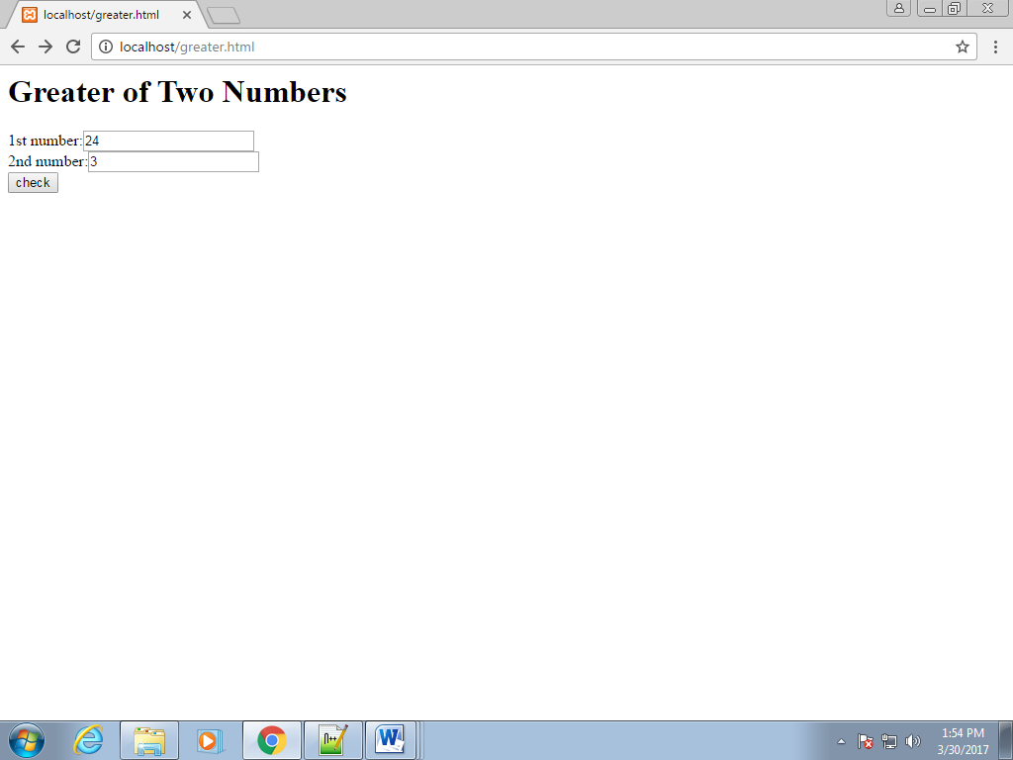

After clicking on **check** button;

