HAS INDIA'S DIGITAL REVOLUTION REACHED EVERYONE?
A data story on digital expansion, access and inequality across India

Based on the supplied analysis notebooks and their cleaned datasets

1. Executive summary
The central question of this study is: Has India's digital revolution reached everyone? The analysis looks at this question from several angles: payment behaviour, telecom access, women's internet access, rural–urban differences, gender parity, state-level inequality, statistical associations, and state-level digital-inclusion profiles.
The evidence does not support treating digital expansion and universal digital inclusion as the same thing. Payment and telecom data show broad expansion and changing digital behaviour. However, the NFHS-5 state-level analysis shows that women's internet participation varies considerably across States and Union Territories, and the rural gender gap is larger than the urban gender gap in the analysed sample.
The regression model explains 67.6% of the state-level variation in women's internet penetration. Within the four variables included in the model, women's mobile ownership has the strongest standardized association and is the only predictor statistically significant at the 5% level. This is an association, not proof that mobile ownership causes internet adoption.
The clustering analysis identifies two broad state/UT profiles. One group has higher women's internet access, gender parity and internet-to-mobile ratio, while the other has lower values. The difference between the groups is much larger for direct digital-access indicators than for bank-account ownership or electricity access.

2. What does 'reached everyone' mean?
The phrase 'reached everyone' is too broad to test directly. In this study, it is treated as a combination of four ideas: infrastructure, usage, access and equity.
These four ideas allow the project to distinguish between the growth of digital systems and the question of whether different population groups are participating equally.
- Infrastructure: Is the digital and telecom ecosystem expanding?
- Usage: Are people actually using digital payment and internet services?
- Access: Do women have access to mobile phones and the internet?
- Equity: Are these opportunities distributed similarly across gender, rural/urban areas and States/UTs?

3. Data sources and why each dataset matters
Dataset | Source/description in the notebooks | Period / unit | Why it matters
RBI payment dataset | https://rbi.org.in/Scripts/ATMView.aspx | Monthly national data; analysis covers the 2022–2026 period visible in the notebooks | Shows changes in cash withdrawals and selected digital payment values.
TRAI telecom subscription data | https://www.trai.gov.in/release-publication/reports/telecom-subscriptions-reports | Monthly telecom data | Provides a telecom-access and rural-share perspective.
NFHS-5 factsheet data | https://www.data.gov.in/resource/all-india-and-stateut-wise-factsheets-national-family-health-survey-nfhs-5-2019-2021 | State/UT indicators | Provides women's internet use, mobile ownership, bank-account ownership, literacy, electricity and rural/urban measures.
Connection dataset | connection.csv used in the project; original publisher is not documented in the supplied notebooks | State/UT-level indicators | Used for connection/QR-related digital infrastructure analysis.
Source note: the notebooks clearly identify RBI, TRAI and NFHS-5 in the cleaning/analysis workflow. The original publisher of connection.csv is not documented in the supplied notebooks.

4. Analytical approach
- Clean the raw datasets and check their structure and consistency.
- Create payment, telecom and digital-inclusion indicators.
- Measure gender parity and rural–urban gender gaps.
- Test whether the rural and urban gender gaps differ statistically.
- Fit a multiple linear regression for women's internet penetration and check VIF and Breusch–Pagan diagnostics.
- Use PCA to understand the main dimensions of variation and K-means clustering to identify broad state/UT digital-inclusion profiles.

5. Story 1 — India's payment behaviour is changing
The RBI analysis starts at the national level. Total cash withdrawal value shows a lower long-term level in the later part of the observed series, although there is substantial month-to-month and seasonal variation.
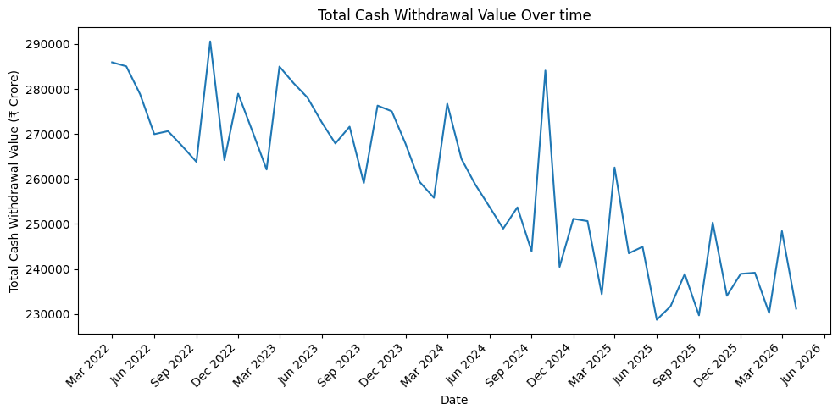
Figure 1. Total cash withdrawal value over time.
Source: RBI payment dataset used in the supplied project notebook.
The selected digital PoS/e-commerce transaction value shows an overall upward movement, with the notebook reporting growth from roughly ₹102,000 crore in the early part of the series to peaks around ₹130,000 crore later in the period.
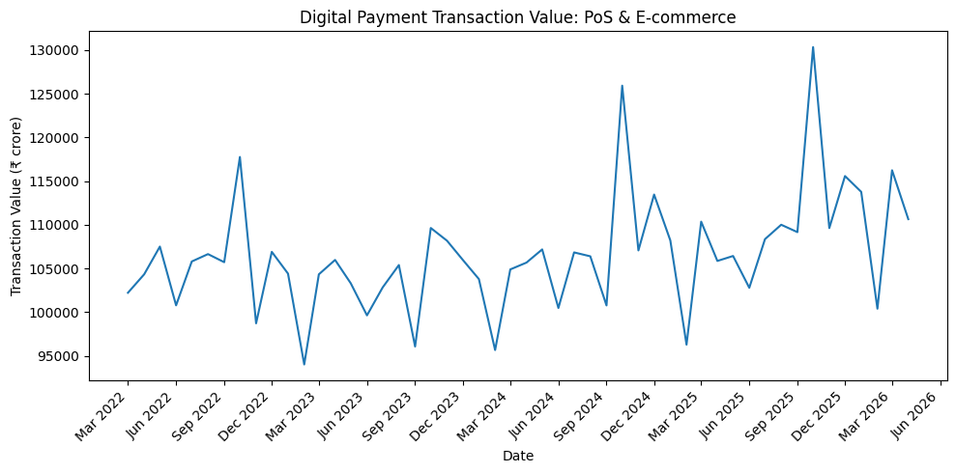
Figure 2. Selected digital payment transaction value over time.
Source: RBI payment dataset used in the supplied project notebook.

5.1 Cash-to-digital reliance
The analysis creates a cash-to-digital reliance ratio using the cash-withdrawal and selected digital-spending variables defined in the notebook. The ratio trends downward over the observed period.
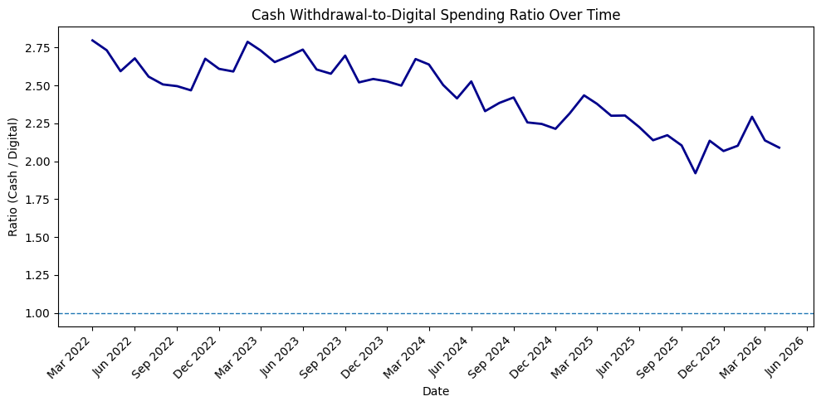
Figure 3. Cash-to-digital reliance ratio over time.
Source: RBI payment dataset and derived metrics in the supplied project notebook.
A piecewise regression/Chow-style structural-break analysis estimated January 2023 as the strongest candidate change point. The joint test was statistically significant (F = 14.71, p < 0.001). The estimated slope after the break was lower than before the break, so the result indicates a change in the trend rather than a complete reversal.
Measurement caution: the digital-spending denominator contains the selected card PoS and e-commerce categories defined in the notebook. It should not be described as a complete measure of every digital payment method in India.

6. Story 2 — Telecom access expanded, but subscriptions are not the same as people
The telecom data provide another view of digital expansion. The rural subscriber share moved around a long-run average of about 43.6%, with values in the plotted period roughly between 40.7% and 45.2%.
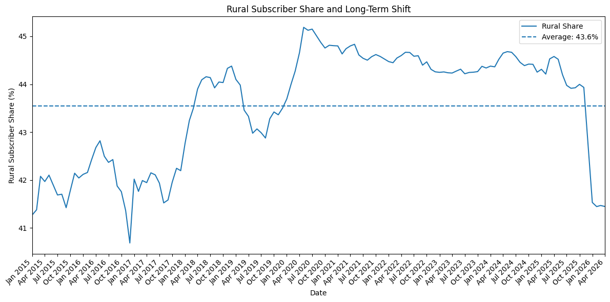
Figure 4. Rural subscriber share over time.
Source: TRAI telecom subscription dataset used in the supplied project notebook.
This supports a statement about telecom subscriptions, not a direct statement that the same percentage of rural people became digitally included. Subscriber counts can include multiple connections held by one person and do not measure internet usage by themselves.

7. Story 3 — The gender gap is a major part of the inclusion story
The NFHS-5 analysis moves from national infrastructure to state/UT-level access. It focuses especially on women because universal digital inclusion requires participation beyond the overall national average.
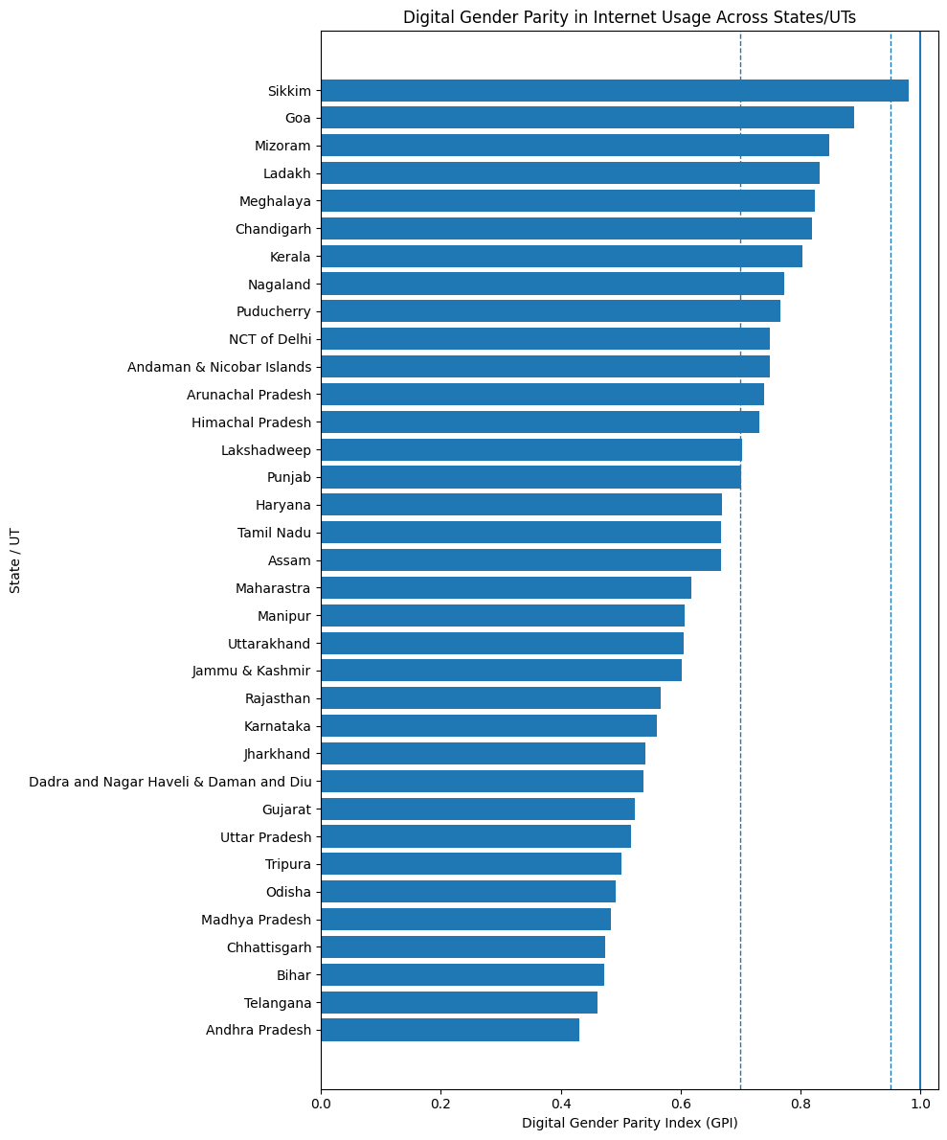
Figure 5. State/UT variation in women's internet access.
Source: NFHS-5 factsheet data used in the supplied project notebook.
The calculated Gini coefficients across States/UTs were 0.2082 for women's internet access, 0.1147 for men's internet access, and 0.0493 for women's bank-account ownership. These are measures of between-state variation, not inequality among individual people.
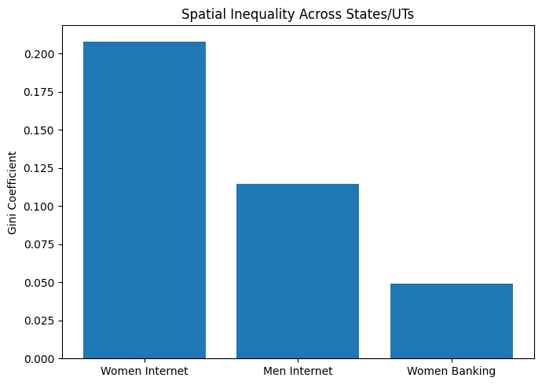
Figure 6. State-level inequality across selected indicators.
Source: NFHS-5 indicators and derived Gini calculations in the supplied project notebook.

7.1 Rural versus urban gender gap
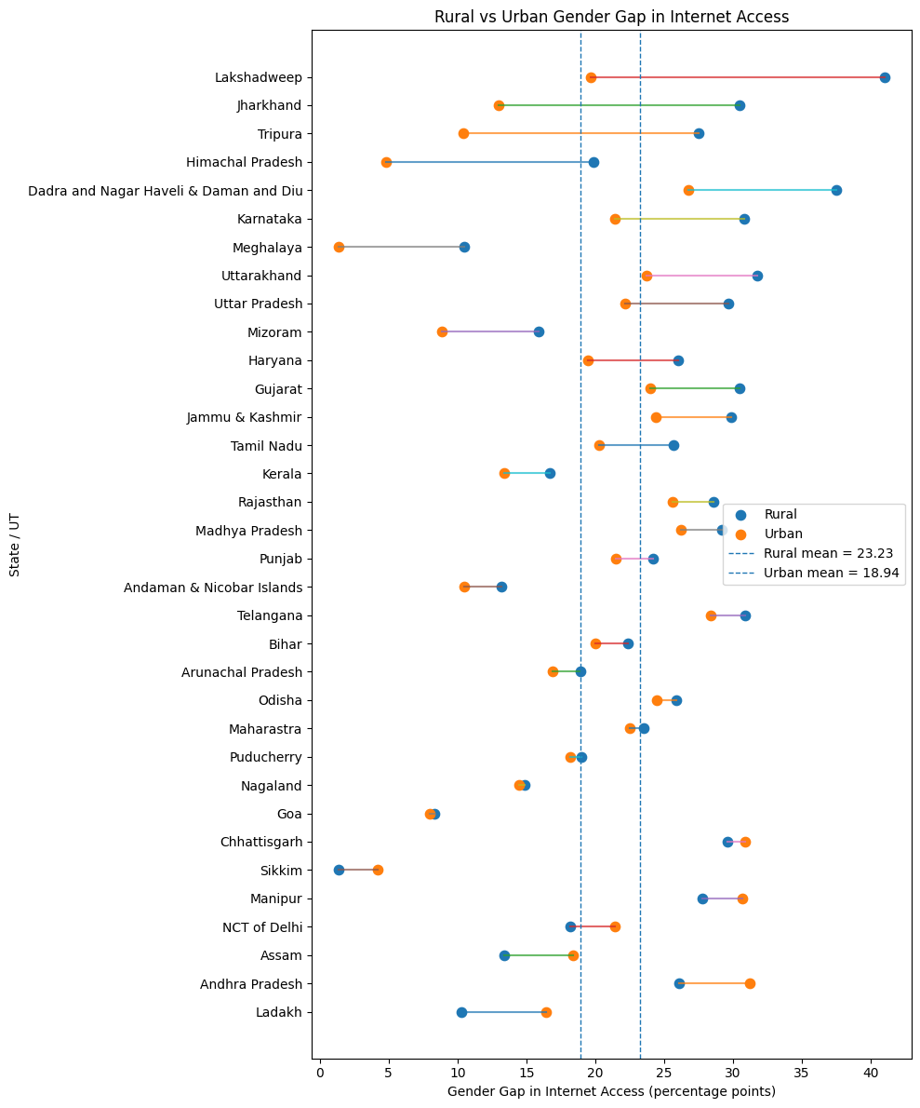
Figure 7. Rural and urban gender gaps in internet access. Chandigarh was excluded from this paired analysis because a complete rural/urban observation was unavailable.
Source: NFHS-5 data and paired rural/urban calculations in the supplied project notebook.
Across the 34 States/UTs with complete observations, the mean rural gender gap was 23.23 percentage points compared with 18.94 percentage points in urban areas. The mean difference was 4.29 percentage points, with a 95% confidence interval of 1.99 to 6.59 percentage points. The paired t-test gave t(33) = 3.79 and p < 0.001. The Wilcoxon signed-rank test also gave p < 0.001.
Interpretation: within this sample, the rural gender gap is systematically larger than the urban gender gap. The analysis does not identify the cause of that difference.

8. Story 4 — What is associated with women's internet access?
The regression asks which measured state-level factors are associated with women's internet penetration. The predictors are female literacy, women's mobile ownership, women's bank-account ownership and electricity access.
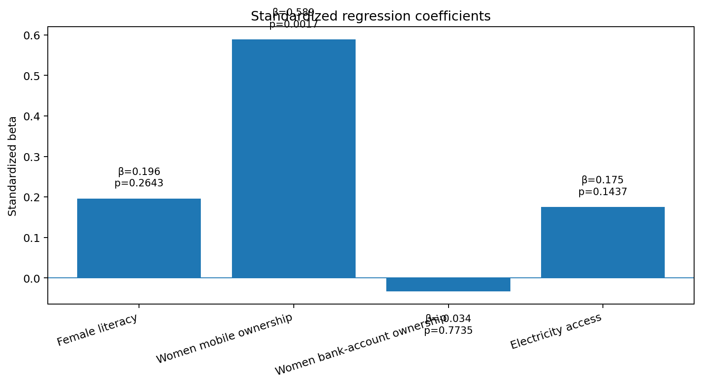
Figure 8. Standardized coefficients from the state-level OLS model.
Source: NFHS-5 state/UT indicators; standardized coefficients reported in the supplied regression notebook.
The model has R² = 0.676 and adjusted R² = 0.632. The overall F-test is F(4,30) = 15.62 with p < 0.001. The four variables jointly explain a substantial share of the variation in women's internet penetration in this state-level sample.
Women's mobile ownership has β = 0.5890 with p = 0.0017. Female literacy has β = 0.1963 (p = 0.2643), women's bank-account ownership has β = -0.0335 (p = 0.7735), and electricity access has β = 0.1752 (p = 0.1437). Thus, within this model, mobile ownership is the only predictor with a statistically significant independent association at the 5% level.
All predictor VIFs were below 5. The Breusch–Pagan test gave p = 0.786, providing no evidence of heteroskedasticity in the diagnostic used in the notebook.
These are state-level observational associations. The regression does not prove that mobile ownership causes internet adoption, and a non-significant predictor should not be interpreted as having no real-world effect.

9. Story 5 — Financial inclusion is more uniform than internet participation
Women's bank-account ownership varies much less across States/UTs than women's internet access. The banking Gini is 0.0493 compared with 0.2082 for women's internet access. The ratio is approximately 4.22, showing much greater between-state variation in women's internet participation than in women's bank-account ownership.
The internet-to-mobile indicator is useful for comparing states, but it should not be treated as a literal individual-level conversion funnel. A value above 100% can occur because the two survey measures are not necessarily identical individual-level population measures.

10. Story 6 — States do not all have the same digital-inclusion profile
PCA was used before clustering to understand the structure of the indicators. The first two principal components explain 76.80% of the total variance.
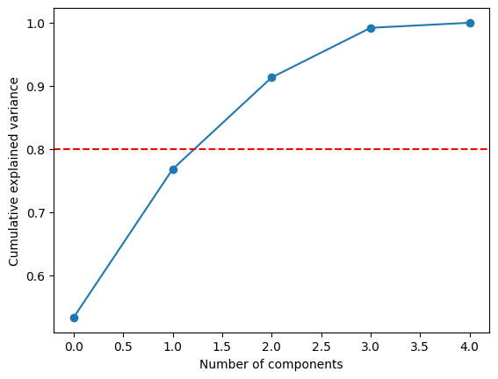
Figure 9. Cumulative variance explained by PCA components.
Source: State/UT digital-inclusion indicators from the supplied segmentation notebook.
The notebook interprets PC1 mainly as a digital-access and gender-equity dimension and PC2 as a financial/infrastructure dimension. The remaining components were retained for clustering rather than discarded solely because they are not needed for a two-dimensional plot.

10.1 Two broad digital-inclusion profiles
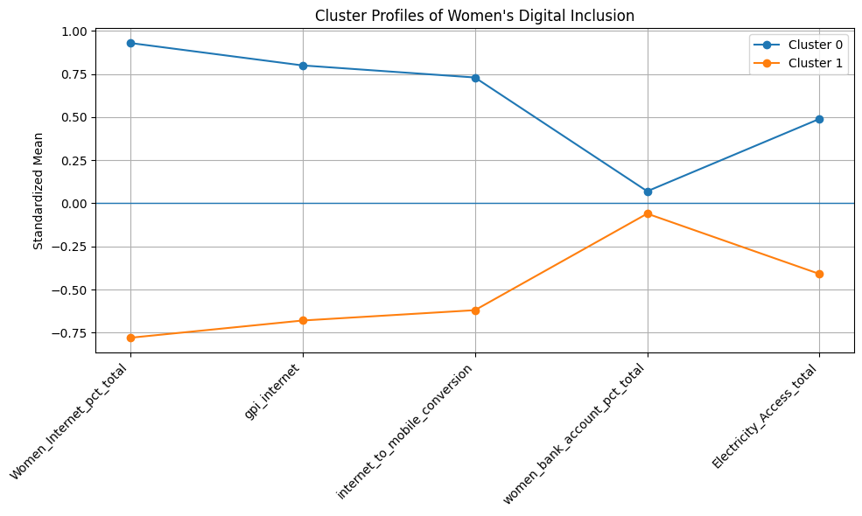
Figure 10. Cluster profiles for women's digital inclusion.
Source: K-means clustering results from the supplied segmentation notebook.
K = 2 had the highest silhouette score among the tested solutions at 0.3069 and the highest Calinski–Harabasz score at 20.69. The resulting clusters contain 16 and 19 States/UTs.
Cluster | States/UTs | Women's internet | GPI | Internet/mobile | Bank accounts
0 | 16 | 58.78% | 0.767 | 77.50% | 80.25%
1 | 19 | 31.30% | 0.559 | 56.42% | 79.37%
Cluster 0 has substantially higher average women's internet access, gender parity and internet-to-mobile ratio. Bank-account ownership is much closer between the two groups, and electricity access differs by only about 2.1 percentage points. The strongest separation therefore comes from direct digital-access indicators.
The silhouette score of 0.3069 indicates moderate rather than perfect separation, so the clusters are best treated as a broad segmentation.

11. Putting the evidence together
- Payment behaviour is changing: cash withdrawals show a lower long-term level in the later part of the observed series, while the selected digital transaction categories show overall growth.
- Telecom subscriptions provide evidence of widespread infrastructure/access, but subscriptions are not the same as unique people or active internet users.
- Women's internet access has much greater between-state variation than women's bank-account ownership.
- The rural gender gap in internet access is significantly larger than the urban gender gap in the analysed paired sample.
- Women's mobile ownership has the strongest statistically significant association with women's internet penetration among the four variables included in the OLS model.
- States/UTs form two broad digital-inclusion profiles, with a large difference in women's internet access and gender parity but a much smaller difference in bank-account ownership and electricity access.

12. Answer to the research question
The evidence supports a qualified answer: India's digital revolution has reached a broad part of the country, but the evidence does not show uniform digital inclusion across everyone.
The key distinction is between expansion and distribution. National payment and telecom indicators show broad digital expansion, while the NFHS-5 state-level indicators show that women's internet participation remains uneven. The rural gender gap is also larger than the urban gender gap, and clustering reveals different digital-inclusion profiles across States/UTs.
The central message of the analysis is therefore: digital expansion and equal digital participation are different outcomes.

13. Limitations
- Different datasets have different time periods and units of analysis; they are complementary evidence rather than one unified panel dataset.
- The RBI cash-to-digital ratio covers only the transaction categories defined in the notebook and is not a complete measure of all digital payments.
- Telecom subscriber counts are not identical to unique people or active internet users.
- The NFHS analysis is primarily state/UT-level and therefore does not measure inequality among individuals directly.
- The regression is observational and cross-sectional and identifies associations, not causal effects.
- The internet-to-mobile ratio is an aggregate indicator and should not be interpreted as an individual conversion funnel.
- The clustering solution has moderate, not strong, separation.
- The original publisher of connection.csv is not documented in the supplied notebooks.

14. Key statistical results
Analysis | Result | Meaning
Structural break | Jan 2023; F = 14.71; p < 0.001 | Evidence of a change in the trend of the selected cash-to-digital ratio.
Rural vs urban gender gap | 23.23 pp rural vs 18.94 pp urban; difference 4.29 pp; p < 0.001 | Rural gender gap is larger in the paired sample.
OLS model | R² = 0.676; adjusted R² = 0.632; overall p < 0.001 | The four predictors jointly explain substantial state-level variation.
Mobile ownership | β = 0.589; p = 0.0017 | Strongest statistically significant association in the specified model.
Women's internet Gini | 0.2082 | Higher between-state variation than men's internet Gini of 0.1147.
Women's bank-account Gini | 0.0493 | Much lower between-state variation.
PCA | First two PCs = 76.80% | Two dimensions capture most variance for visualization.
K-means | K = 2; silhouette = 0.3069 | Strongest tested separation by silhouette.

End of report

