**Research Problem:**

Gain insights of Quantified-Selfers by Understanding their Practices inCollecting and Exploring Personal Data because Q-Selfers offer us a useful perspective from which to re-examine the **current design of self-tracking technologies and ways to improve them.** (General view)

**Proposed Solution:**

Variability should be defined and limited (limited features).

They conducted qualitative and quantitative analysis of 52 video recordings of quantified Selfers which worked as a dataset for their whole experiments or analysis.

1. They created a profile for each speaker by systematically capturing their following information:

* Location
* Gender
* Job description
* Health condition
* Type of data collected
* Self-tracking duration
* Data collection tool
* Data exploration tool
* Type of tool (user generated versus commercial)
* Data sharing aspects

Percentage of the Quantified Selfers tracking different attributes

* Activity (40 %)
* Food (31 %)
* Weight (29 %)
* Sleep (25 %)
* Mood (13 %)

1. They conducted an affinity analysis

* Video transcripts were broken into 400 approximately
* Each of the quote contained one main idea
* They were organized into categories on basis of key themes in bottom up fashion

1. Motivation of self-tracking
2. Self tracking methods and tools
3. Insights gained
4. Outcome of tracking
5. Common pitfalls of self-tracking
6. They captured 188 screen shots which included personal data visualization and analyzed them by categorizing the visualization type.

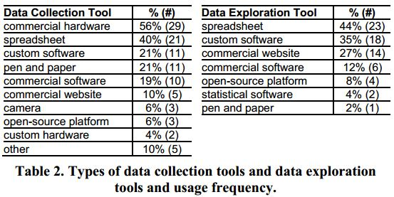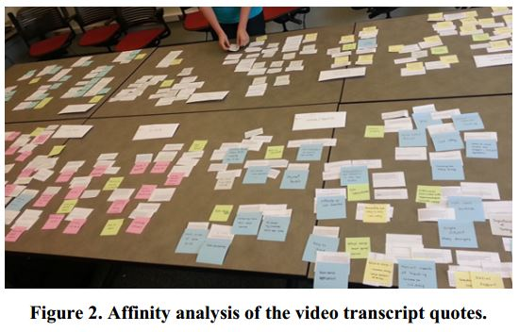

**Contributions:**

Answering the three prime questions

* What they did?
* How did they do it?
* What did they learn?

Highlight several common challenges and pitfalls:

* Tracking too many things leads to tracking fatigue
* not tracking triggers and context leads to not gaining proper insight
* lacking scientific rigor leads to inconclusive result

**Assumptions:**

**Limitations:**

Personal analytic tool user must not rely completely on these tools.

Spontaneous and monotonous tracking causes frustration, tracking fatigue, or relapse

The open challenge remains: difficulty in interpretation of the data collected.

Data import/export support of the tool

**Evaluation Criteria:**

Based on experimentation, outcome and effect of the Quantified Selfers’ tracking activities on themselves.