Before
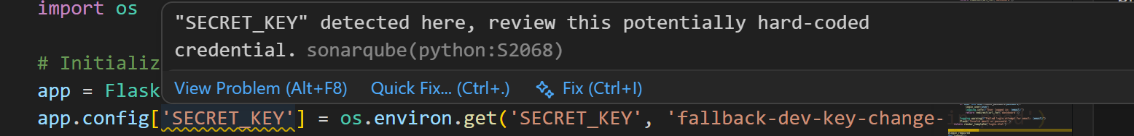
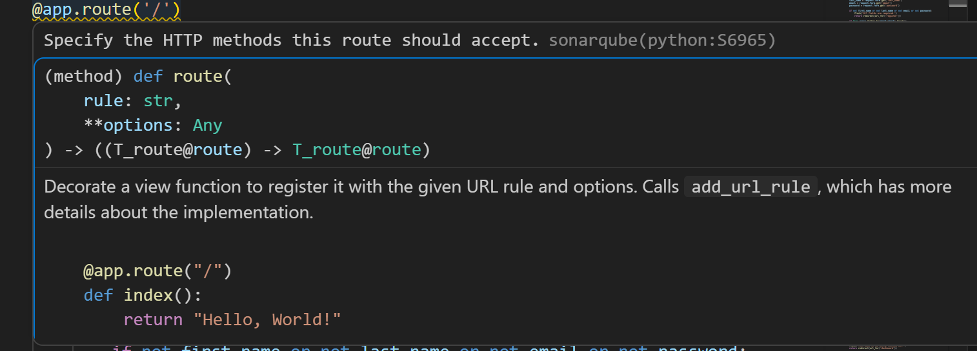

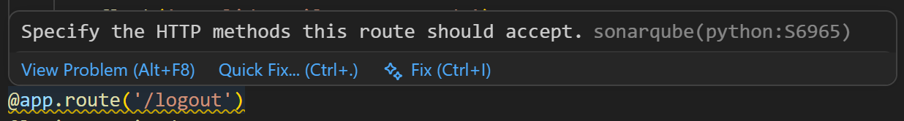

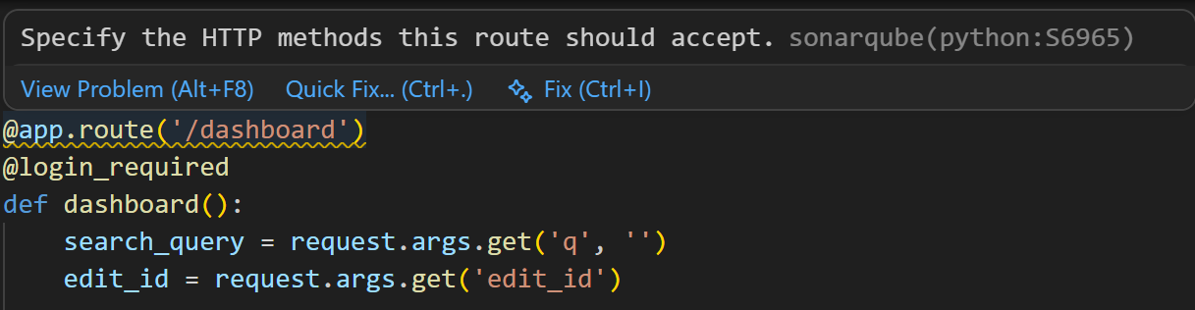

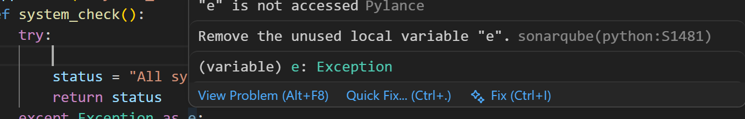
Resolved:
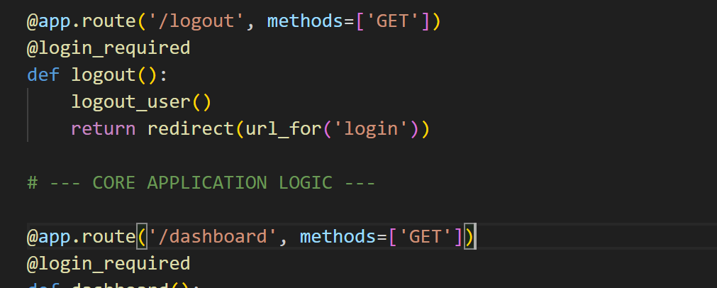
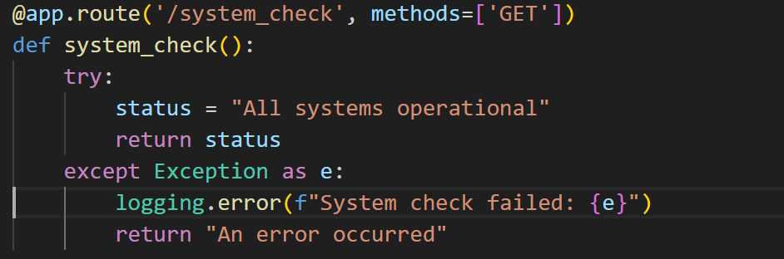

ZAP:
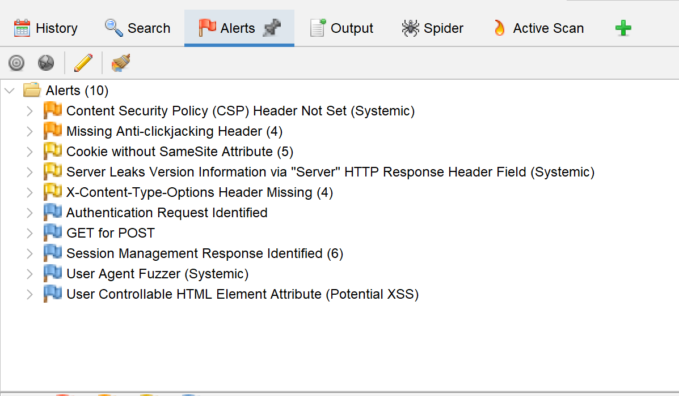

# --- DAST SECURITY FIXES: Adding global HTTP security headers ---
@app.after_request
def apply_security_headers(response):
# Fix 1: Missing Anti-clickjacking Header
response.headers['X-Frame-Options'] = 'SAMEORIGIN'

# Fix 2: X-Content-Type-Options Header Missing
response.headers['X-Content-Type-Options'] = 'nosniff'

# Fix 3: Content Security Policy (Basic)
response.headers['Content-Security-Policy'] = "default-src 'self'; style-src 'self' 'unsafe-inline'"

return response

2.
app.config['SESSION_COOKIE_SAMESITE'] = 'Lax'

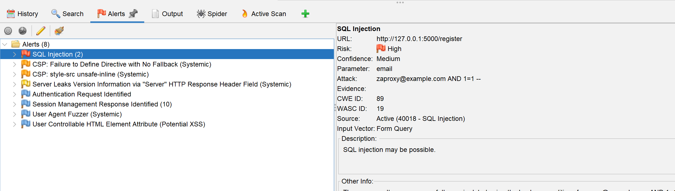

# 1. Defense in Depth: Validate email format FIRST
if not email or not re.match(r"^[^@\s]+@[^@\s]+\.[^@\s]+$", email):
flash('Please enter a valid email address format.')
return redirect(url_for('login'))

# FIX: Defense in Depth - Validate email format to block malicious payloads
if not re.match(r"^[^@\s]+@[^@\s]+\.[^@\s]+$", email):
flash('Please enter a valid email address format.')
return redirect(url_for('register'))

