Title
Jenkins + Terraform + Maven CI/CD Setup with Parameterized Pipeline Automation
Objective
The main objective of this setup is to integrate Terraform and Maven projects with Jenkins to automate infrastructure provisioning and application build processes. Using Jenkins pipelines, we created jobs to execute Terraform workflows like init, validate, plan, apply, and also created Maven jobs for building Java applications. Additionally, we implemented a parameterized pipeline job where users can provide inputs like Git repository URL, branch name, and Maven goals during runtime to make the builds dynamic and reusable.
Prerequisites
To complete this setup successfully, the following prerequisites are required:
- A working Jenkins server with admin access.
- Required plugins installed in Jenkins such as Terraform Plugin and Maven Integration Plugin.
- Terraform installed on Jenkins server and accessible in PATH (example: /usr/bin/terraform).
- Maven installed and configured in Jenkins Global Tool Configuration.
- A GitHub repository containing required files like main.tf, variables.tf, provider.tf, and Jenkinsfile.
- Jenkins job permissions to create Pipeline and Maven projects, and access to Git repository credentials if it is private.
Errors Faced
During implementation, a few common errors were observed while executing Terraform and Jenkins jobs:
- Inconsistent dependency lock file error in Terraform due to missing or outdated .terraform.lock.hcl.
- Terraform variable prompt issues when variables were not passed properly in configuration.
- Jenkins build failures when Terraform binary path was not configured correctly in Jenkins tools.
- Pipeline execution issues when Jenkinsfile was not properly structured or missing required steps.
- Maven build failures when goals were not provided or Maven tool was not configured properly in Jenkins.
How I Fixed the Errors
The issues were resolved using the following fixes:
- For Terraform lock file issue, I executed:
- terraform init
This regenerated the provider lock file and installed required plugins.
- Variables prompting issue was fixed by setting values using:
  - -var option in CLI OR
  - environment variables like TF_VAR_filename and TF_VAR_content.
- Terraform tool issue in Jenkins was fixed by installing Terraform in server and setting correct path in Jenkins:
Manage Jenkins → Tools → Terraform Installations → /usr/bin
- Pipeline script errors were fixed by validating braces, stages, and making sure terraform init runs before plan/apply.
- Maven build issues were fixed by installing Maven Integration plugin and configuring Maven goals properly like:
clean compile or clean package.
Conclusion
By completing this setup, Jenkins was successfully integrated with Terraform and Maven to automate both infrastructure and application build tasks. Terraform execution was enabled through Jenkins pipelines with proper tool configuration and plugin installation. Maven builds were automated using both Maven jobs and parameterized pipelines for flexible execution. This end-to-end automation improves consistency, reduces manual effort, supports faster deployments, and provides a scalable CI/CD workflow for real-time DevOps implementation.

Execute the script shown in the video.

- By using varibles.tf file
- Create a file named main.tf
- Add this Terraform code inside main.tf:
- resource "local_file" "msg" {
- filename = var.filename
- content = var.content
- }
- Save the file.

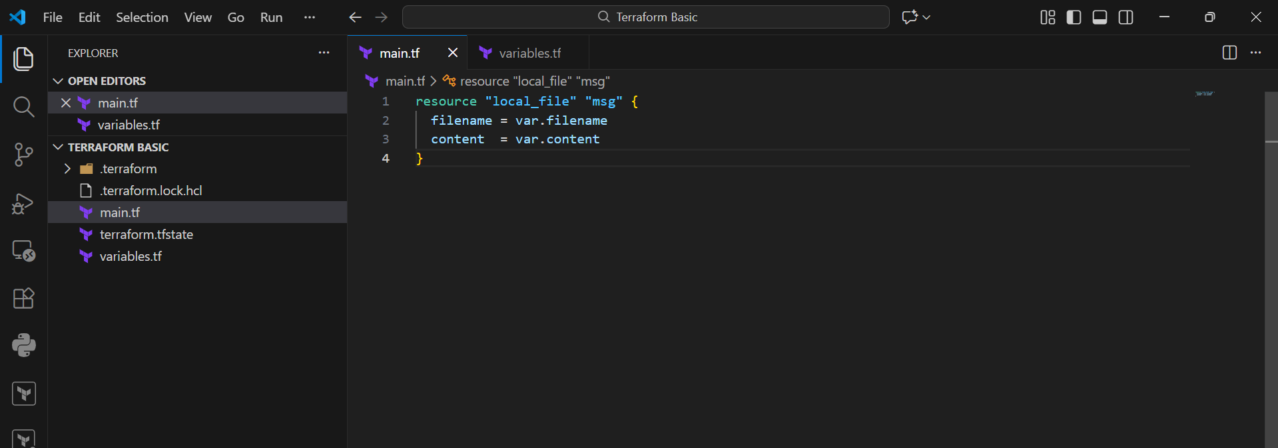
- Create a new file named variables.tf
- Add filename variable:
- variable "filename" {
- type = string
- default = "/root/message.txt"
- }
- Add content variable:
- variable "content" {
- type = string
- default = "Terraform is awesome!"
- }
- Save the file.

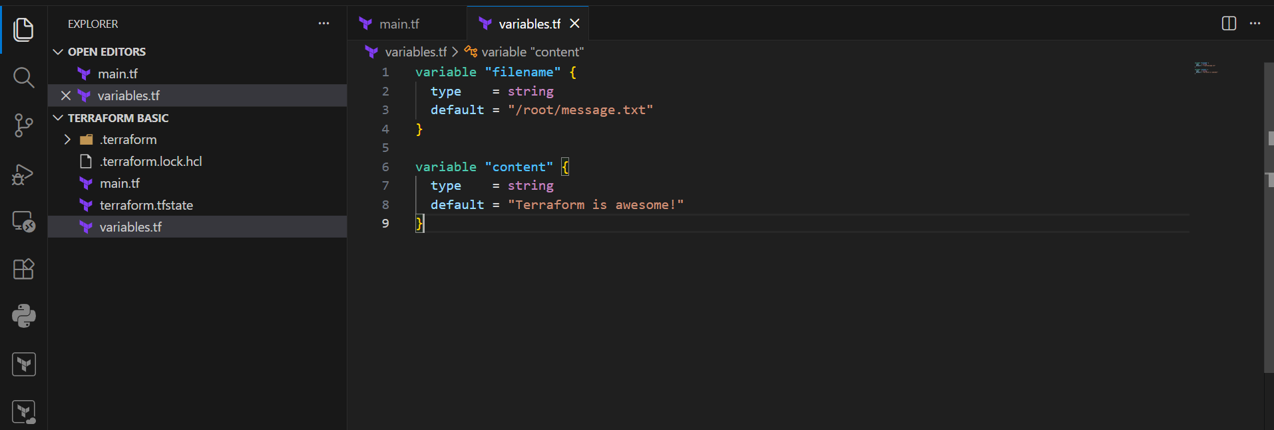
- Open Terminal in VS Code.
- Go to your Terraform project folder.
- Run:
  - terraform init
- Terraform will download required provider plugins.

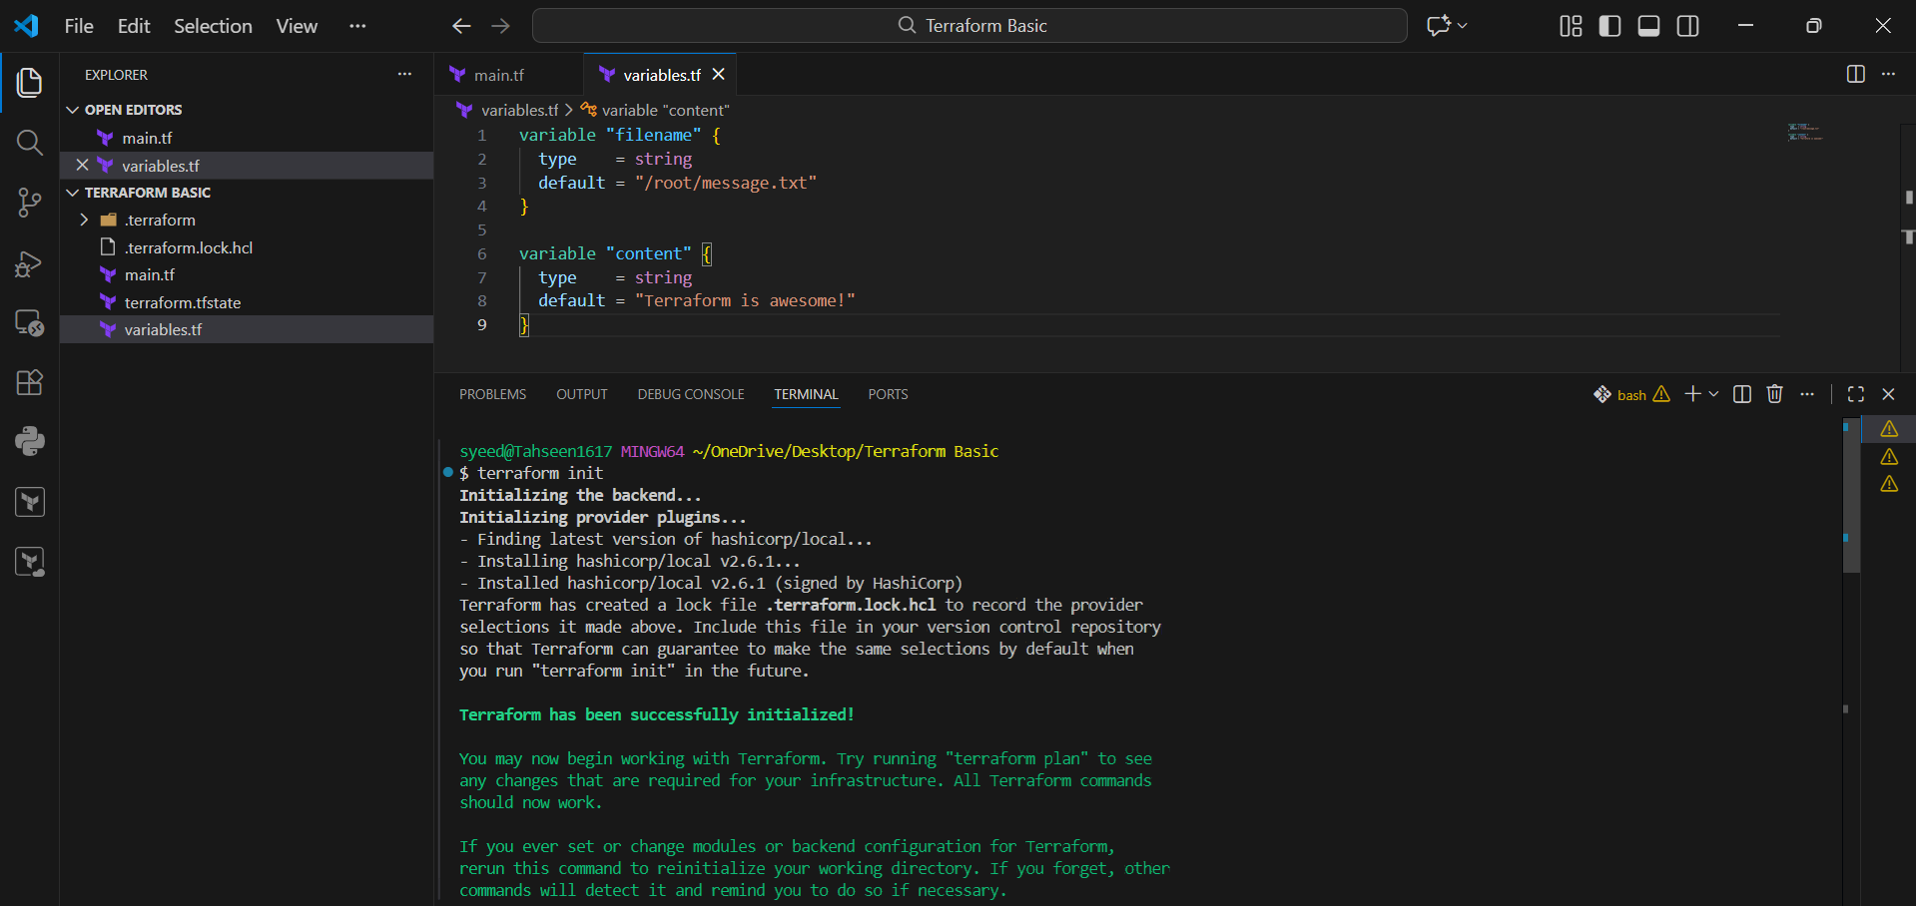
- Run the apply command:
  - terraform apply
- Terraform will generate an execution plan.
- You will see output like:
- local_file.msg will be created
- filename and content details
- Terraform will ask for confirmation to continue

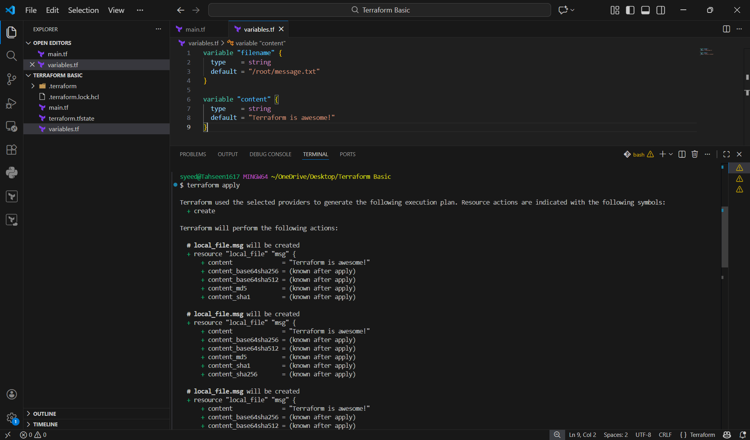
Final output shows:
Apply complete! Resources: 1 added, 0 changed, 0 destroyed.
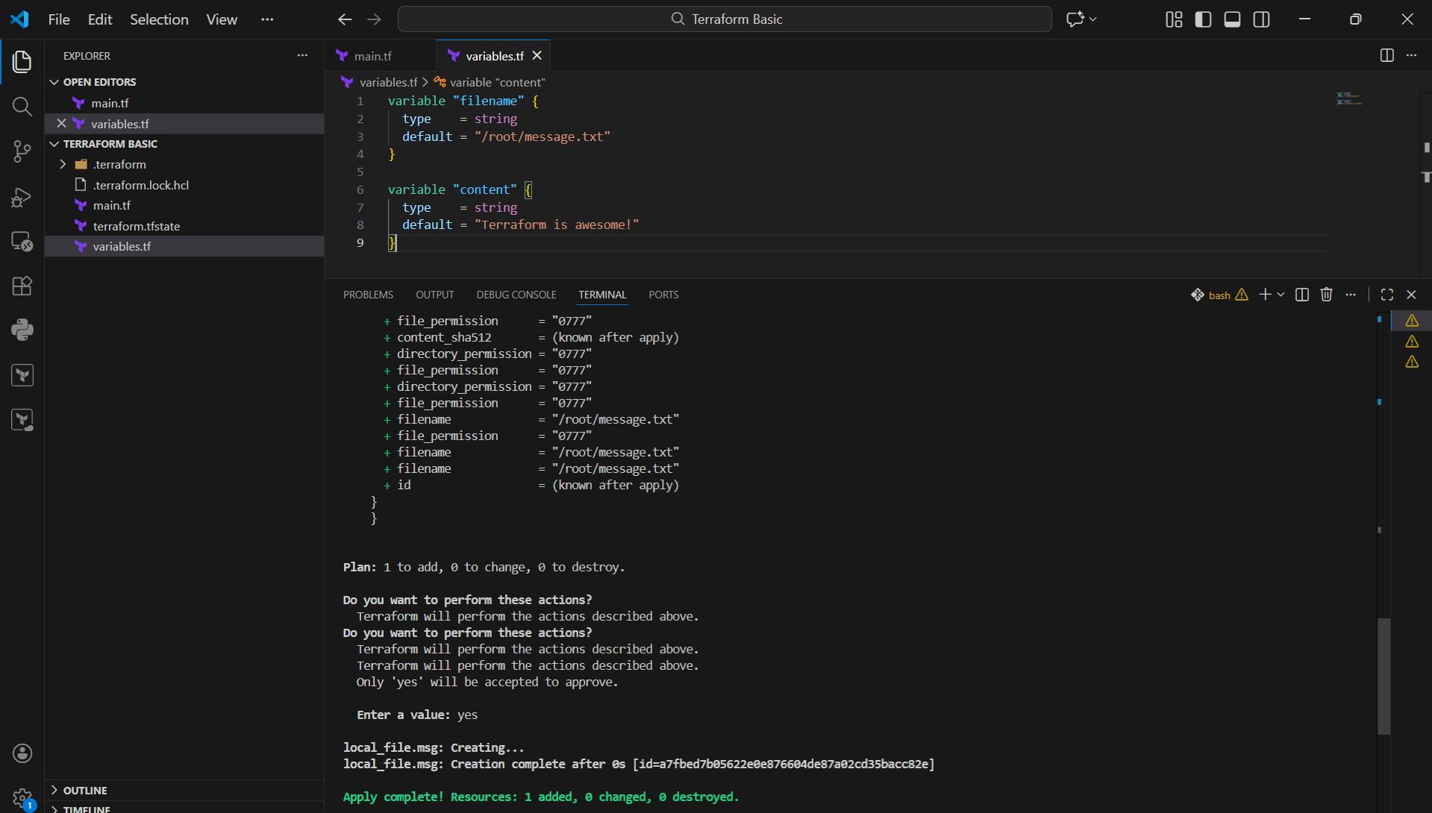

- By using interactive mode.
- Open main.tf in VS Code.
- Add the Terraform local_file resource code:
- resource "local_file" "msg" {
- filename = var.filename
- content = var.content
- }
- This means Terraform will take values from variables.tf (or from user input).
- Save

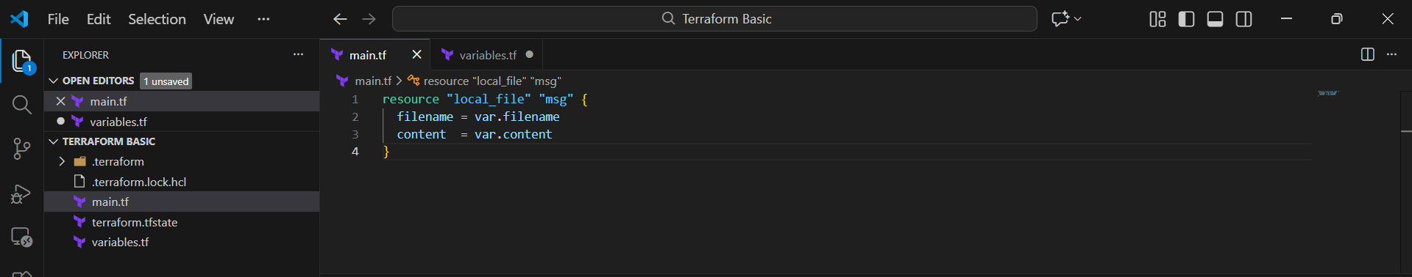
- Open variables.tf
- Define variable for filename:
- variable "filename" {
- type = string
- }
- Define variable for content:
- variable "content" {
- type = string
- }
- Here no default value is given, so Terraform will ask during apply.
- Save the file.

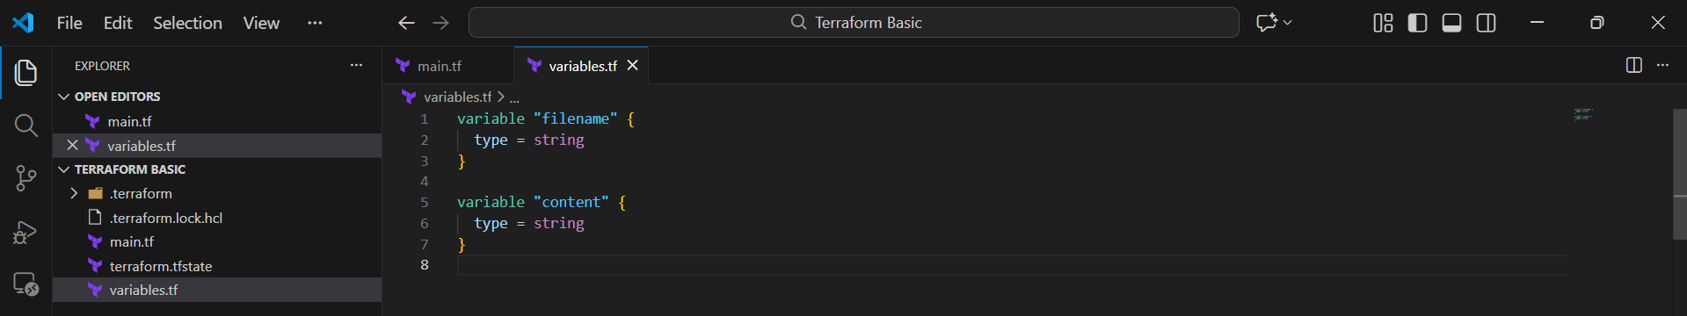
- Open terminal and run:
- terraform apply
- Terraform asks for content, enter value (example):
- Enter a value: hello mujju
- Terraform asks for filename, enter value (example):
- Enter a value: /root/message.txt
- Terraform refreshes current state and shows plan.
- It shows local_file.msg must be replaced because content changed → triggers replacement.

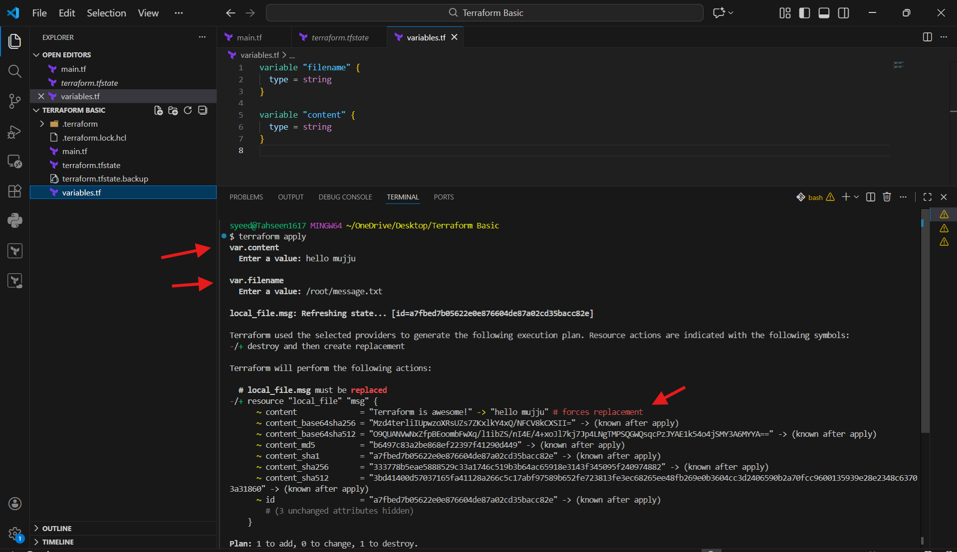
- After plan output Terraform asks:
  - Do you want to perform these actions?
  - Enter a value:
- Type:
  - yes
- Terraform will destroy the old file resource and then create a new one.
- Output shows:
destroying → Creating → Apply complete

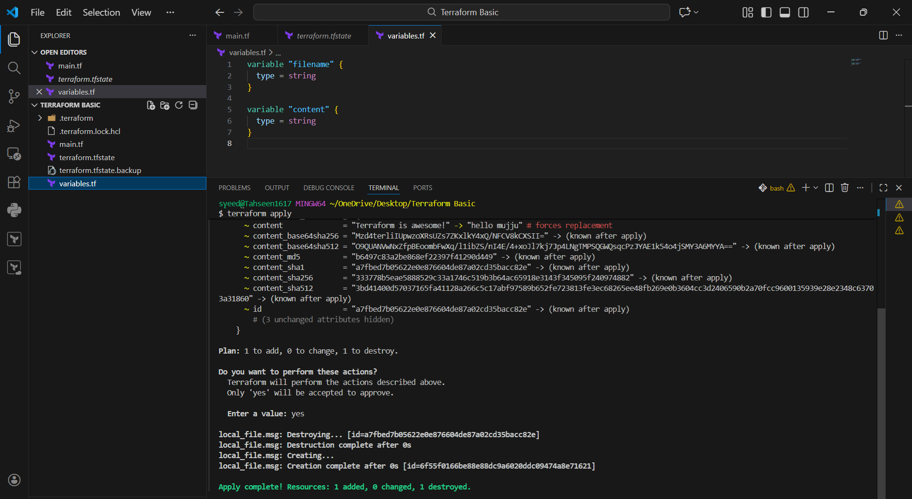
- Open the file terraform.tfstate
- You can see stored attributes for local_file.msg.
- The updated content appears inside state file like:
- "content": "hello muju"
- This proves Terraform stored the latest applied values in state

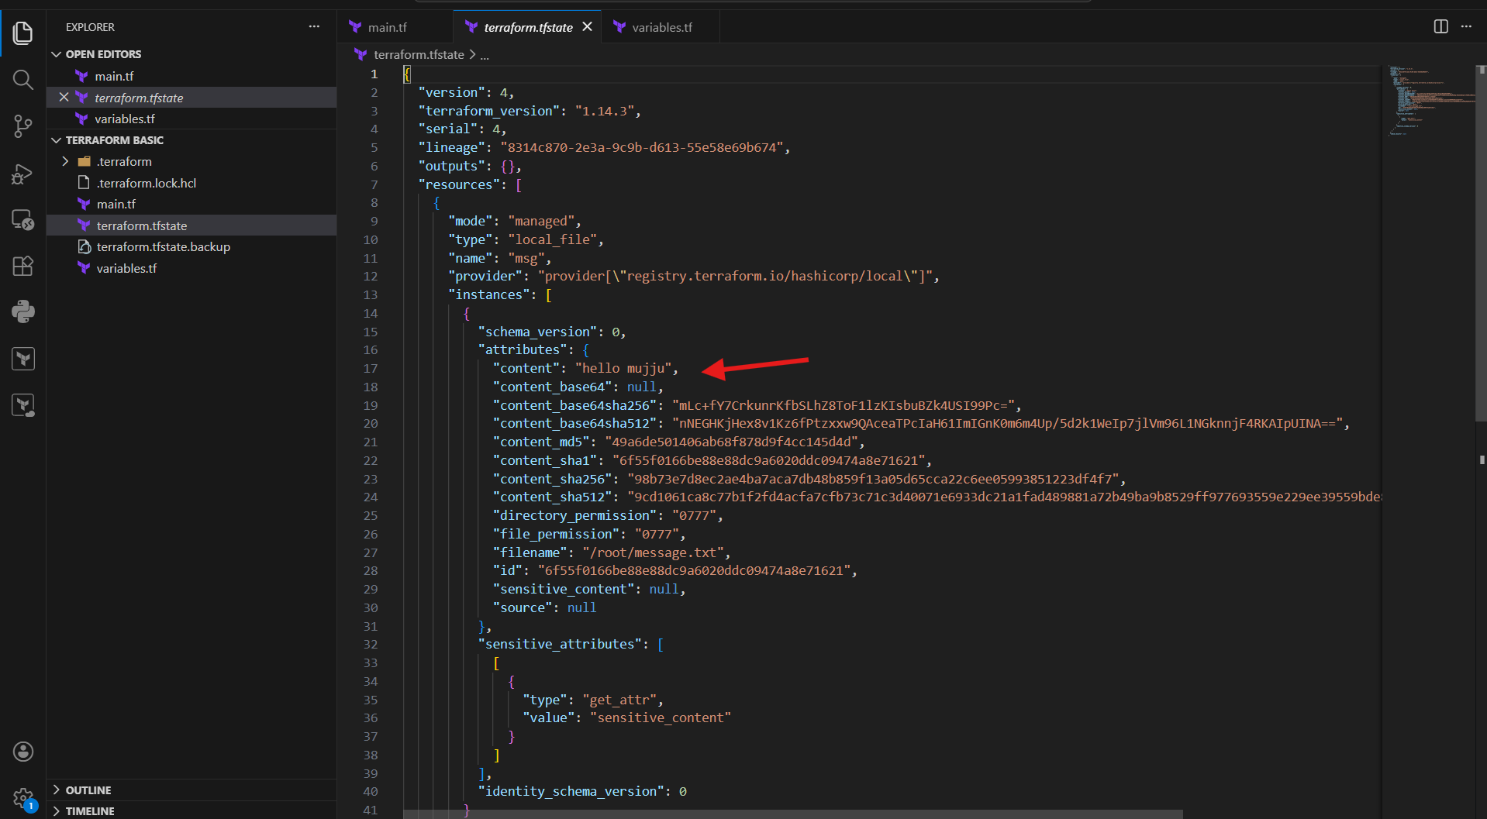

- Command line flags
- Open main.tf in VS Code.
- Create the local file resource with variable values:
- resource "local_file" "pets" {
- filename = var.filename
- content = "Prefix value is ${var.prefix}"
- }
- Here ${var.prefix} will dynamically print the prefix value.
- Save the file.

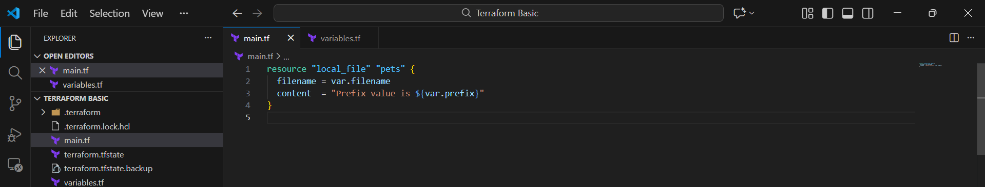
- Open variables.tf
- Define filename variable:
  - variable "filename" {
  - type = string
  - }
- Define prefix variable:
  - variable "prefix" {
  - type = string
  - }
- Save the file

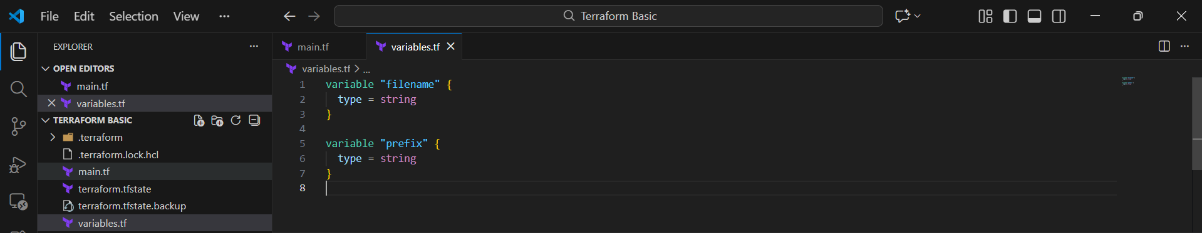

- Open terminal inside the same Terraform folder.
- Run Terraform apply by passing values directly:
- terraform apply -var="filename=./pets.txt" -var="prefix=MR"
- Terraform will show the execution plan (local_file.pets will be created).
- When it asks confirmation, type:
- yes
- Terraform creates the resource and shows Apply complete.

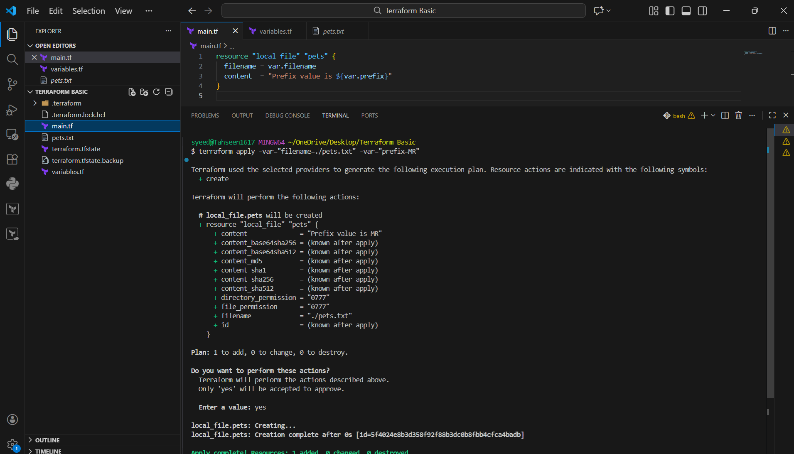
- After apply, you will see a new file created: pets.txt
- Open the file in VS Code.
- It contains the generated content like:
  - Prefix value is MR
- This confirms Terraform successfully created the file with the passed variable valu

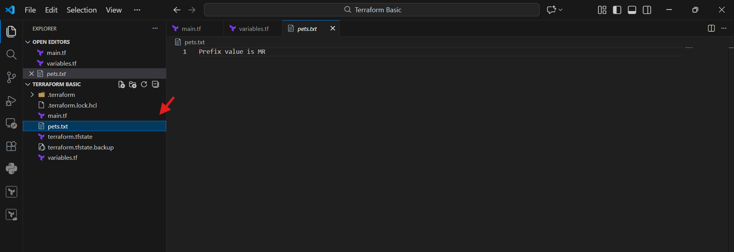

- Environment variables
- Open main.tf in VS Code.
- Add Terraform code to create local file using variables:
- resource "local_file" "msg" {
- filename = var.filename
- content = var.content
- }
- Save the file

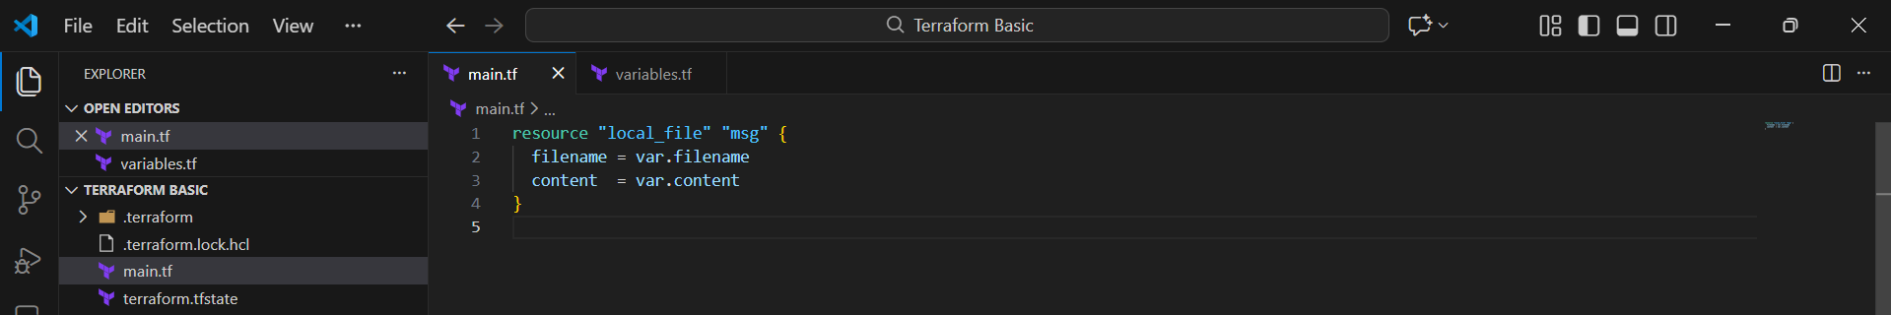
- Open variables.tf
- Define filename variable:
- variable "filename" {
- type = string
- }
- Define content variable:
- variable "content" {
- type = string
- }
- No default values given, so Terraform will take values from CLI/env/input.
- Save the file.

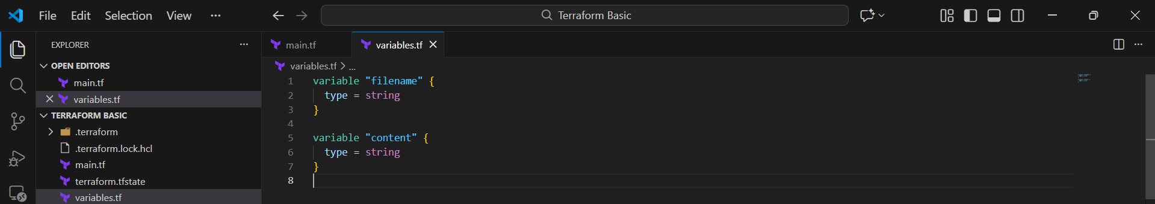

- Open PowerShell terminal in VS Code.
- Set Terraform input variables using environment variables:
- Set-Item -Path env:TF_VAR_filename -Value "wild.txt"
- Set-Item -Path env:TF_VAR_content -Value "Hello from Environment Variable"
- Run Terraform apply:
- terraform apply
- It shows error Inconsistent dependency lock file because provider lock is missing/old.
- Fix it by running:
- terraform init
- Terraform initializes and downloads provider plugins successfully.

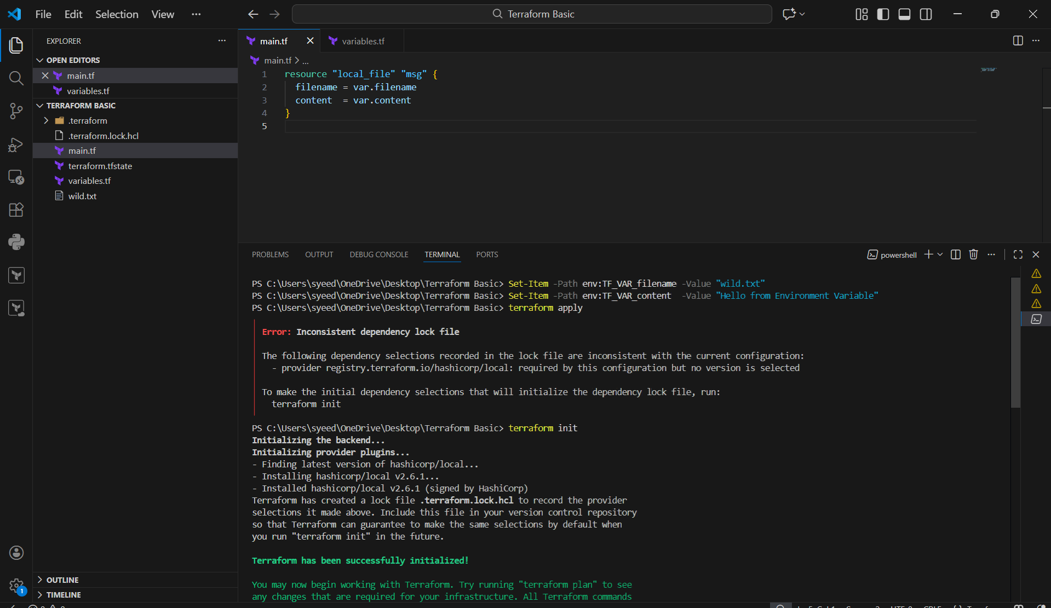

- Run again:
- terraform apply
- Terraform creates execution plan:
  - local_file.msg will be created
  - filename → wild.txt
  - content → Hello from Environment Variable
- Terraform asks confirmation to proceed.

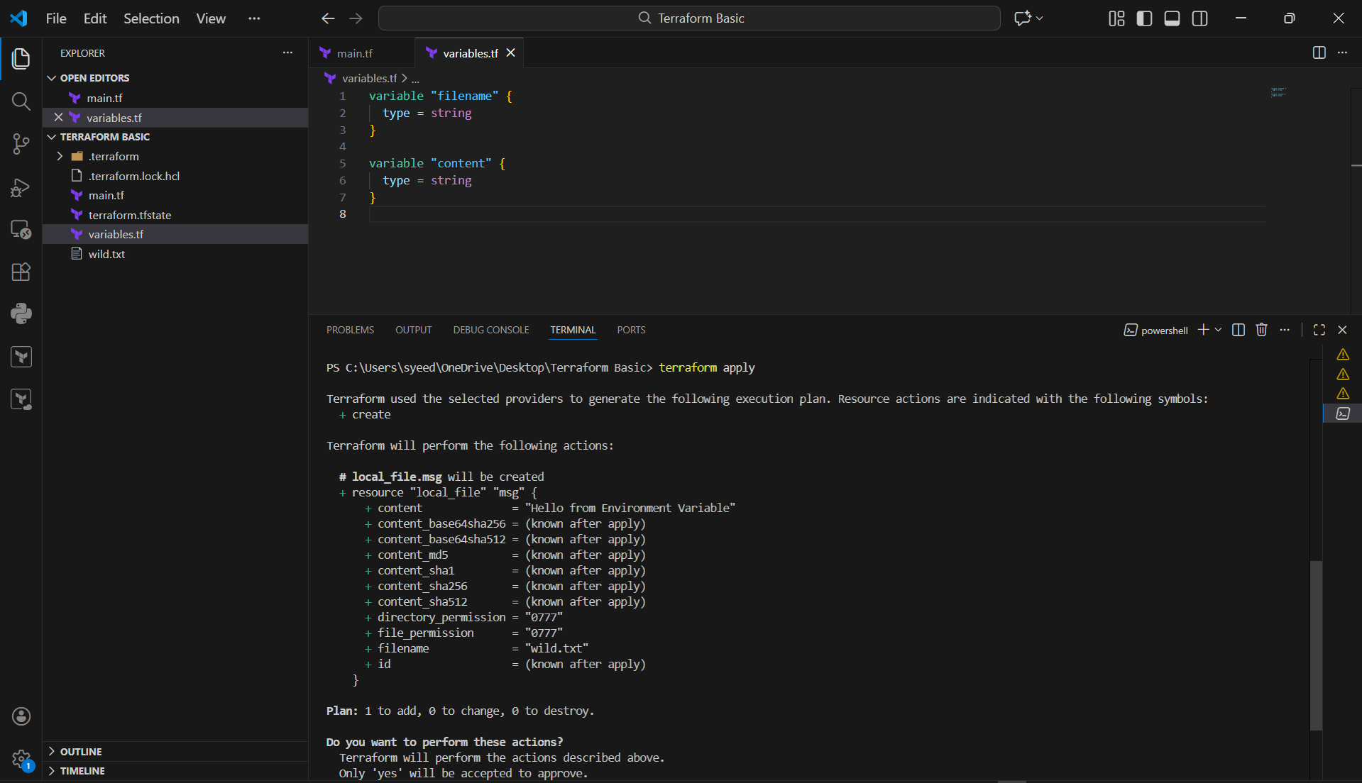
- When it prompts:
- Enter a value:
- type:
- yes
- Terraform creates the file and shows:
Apply complete! Resources: 1 added, 0 changed, 0 destroyed.
- Open the generated file wild.txt
- Verify output inside file:
- Hello from Environment Variable

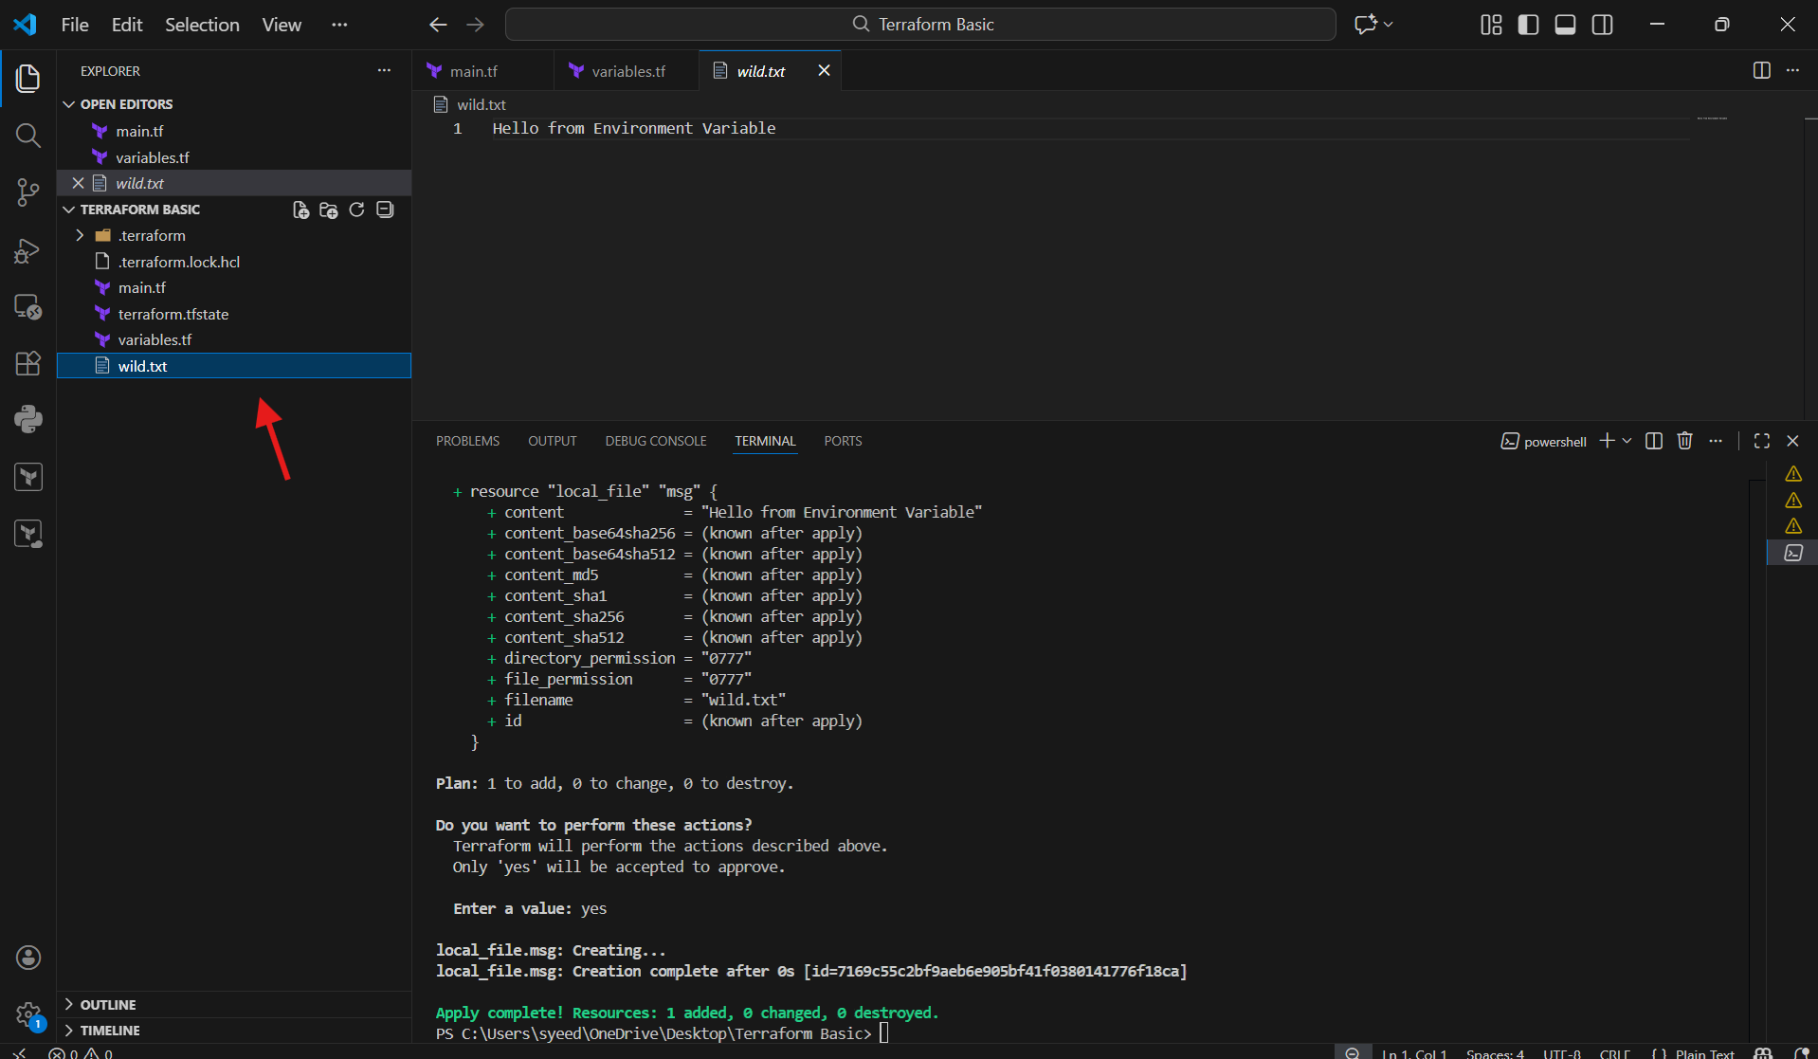

Integrate Terraform in Jenkins using the Terraform plugin.
- Login to Jenkins Dashboard
- Go to: Manage Jenkins → Plugins
- Click Installed plugins / Available plugins
- Search for Terraform
- Install/Enable Terraform Plugin
- Confirm plugin status is Enabled

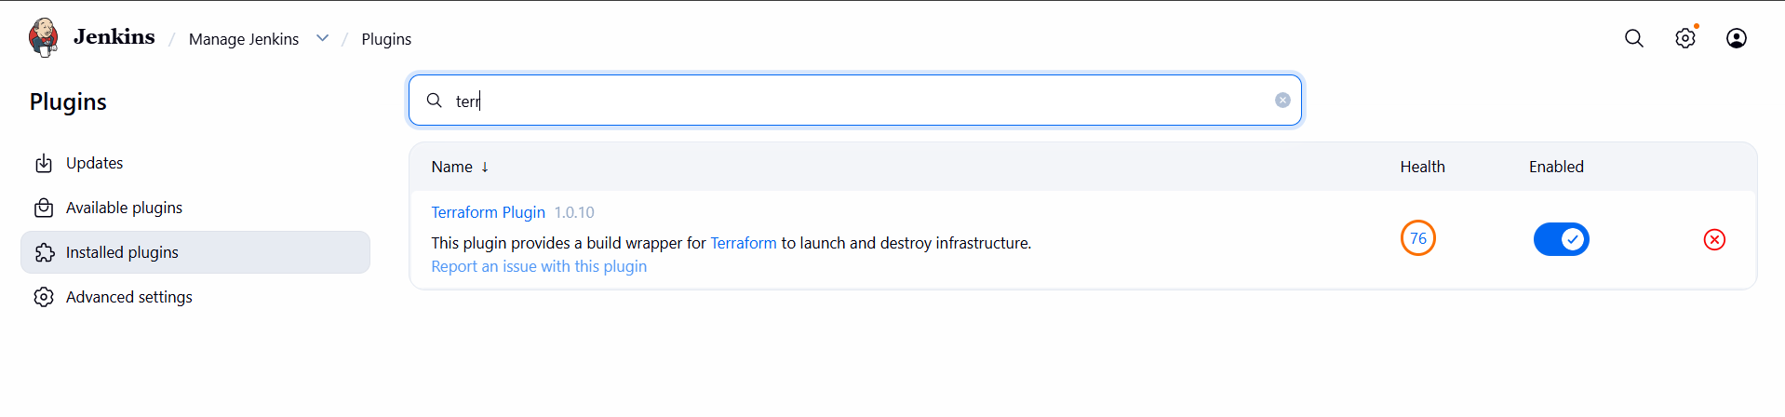
- Login to Jenkins server using SSH (root/user)
- Download Terraform binary (zip) inside /opt or required path
- Unzip the terraform package:
- unzip terraform_<version>_linux_amd64.zip
- Move terraform binary to /usr/bin:
- mv terraform /usr/bin/
- Verify installation:
- terraform version
- Confirm terraform path:
- which terraform
- ls -l /usr/bin/terraform

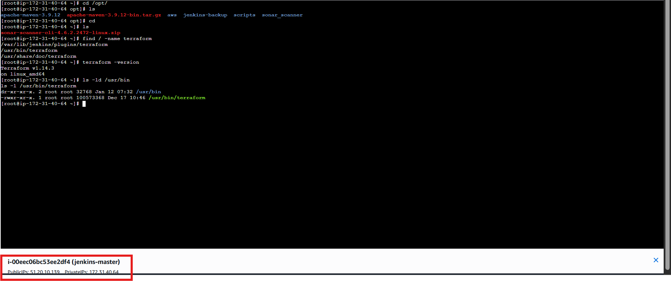
- Go to Jenkins Dashboard
- Navigate: Manage Jenkins → Tools
- Under Terraform installations, click Add Terraform
- Enter Name: terraform
- Set Install directory as:
- /usr/bin
- Click Save / Apply

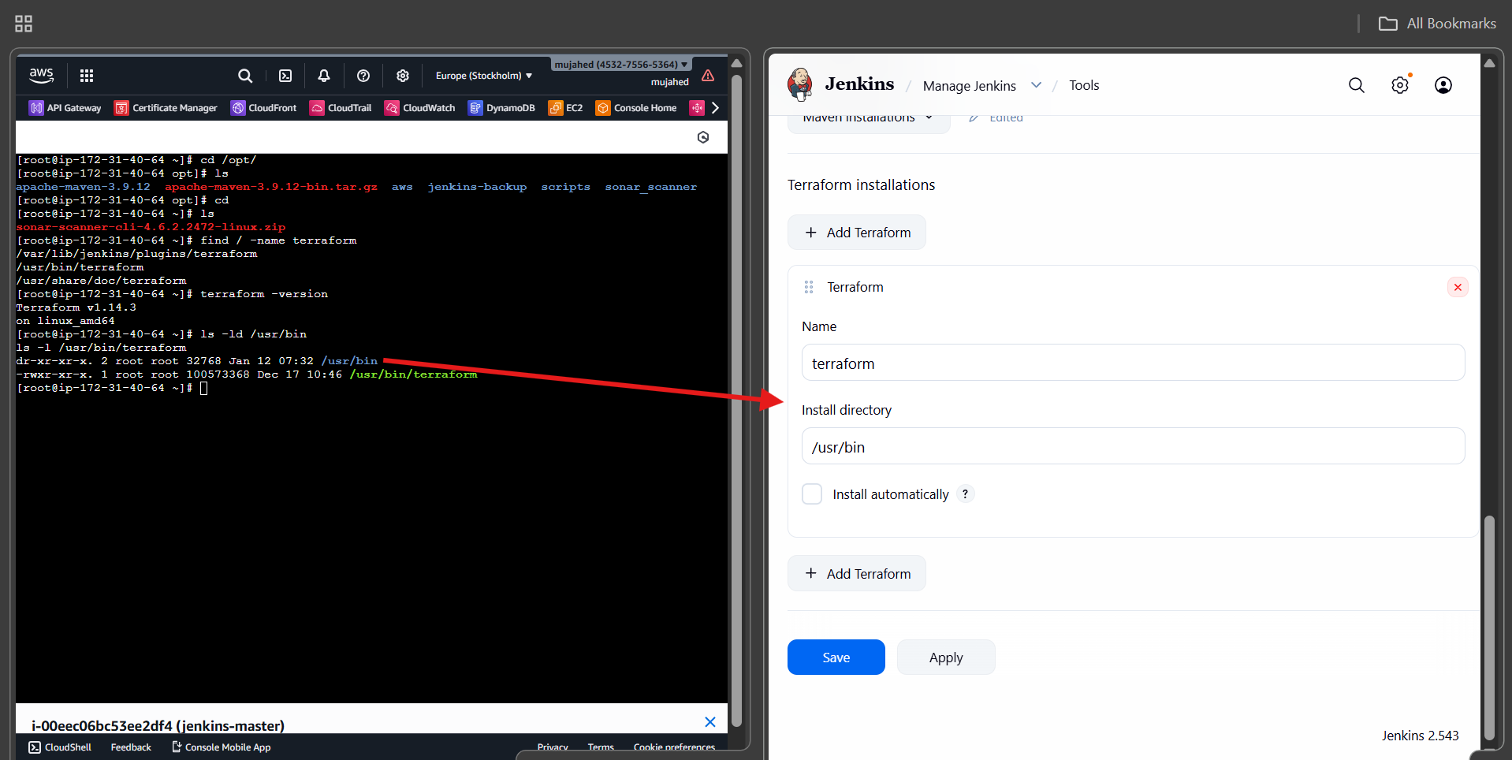
- Open your GitHub repo (Terraform project)
- Edit/Create file provider.tf
- Add required providers block (example):
- terraform {
- required_providers {
- local = {
- source = "hashicorp/local"
- }
- random = {
- source = "hashicorp/random"
- }
- }
- }

- provider "local" {}
- provider "random" {}
- Commit and push the changes to repository

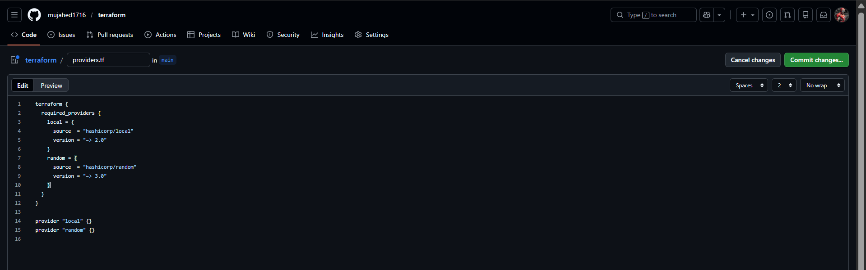
- Open main.tf inside repo
- Add resources like local_file + random_pet:
- resource "local_file" "pet" {
- filename = var.pet_filename
- content = var.pet_content
- }

- resource "random_pet" "mypet" {
- prefix = var.random_pet_prefix
- separator = var.random_pet_separator
- length = var.random_pet_length
- }
- Save changes
- Commit and push

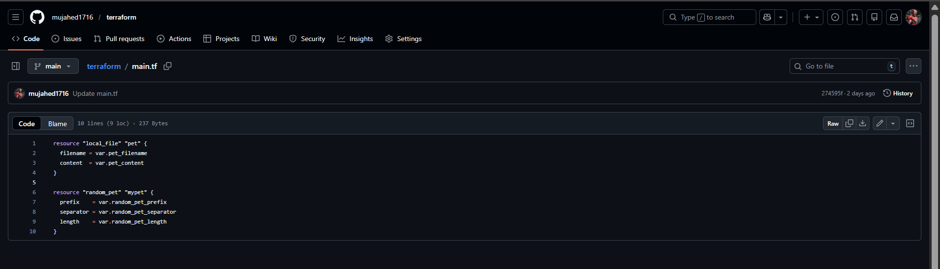
- Open variables.tf in your Terraform repo
- Define variables with type and defaults:
- variable "pet_filename" {
- type = string
- default = "/tmp/pets.txt"
- }

- variable "pet_content" {
- type = string
- default = "my horse is black in colour!"
- }

- variable "random_pet_prefix" {
- type = string
- default = "MR"
- }

- variable "random_pet_separator" {
- type = string
- default = "."
- }

- variable "random_pet_length" {
- type = number
- default = 1
- }
- Save and commit changes

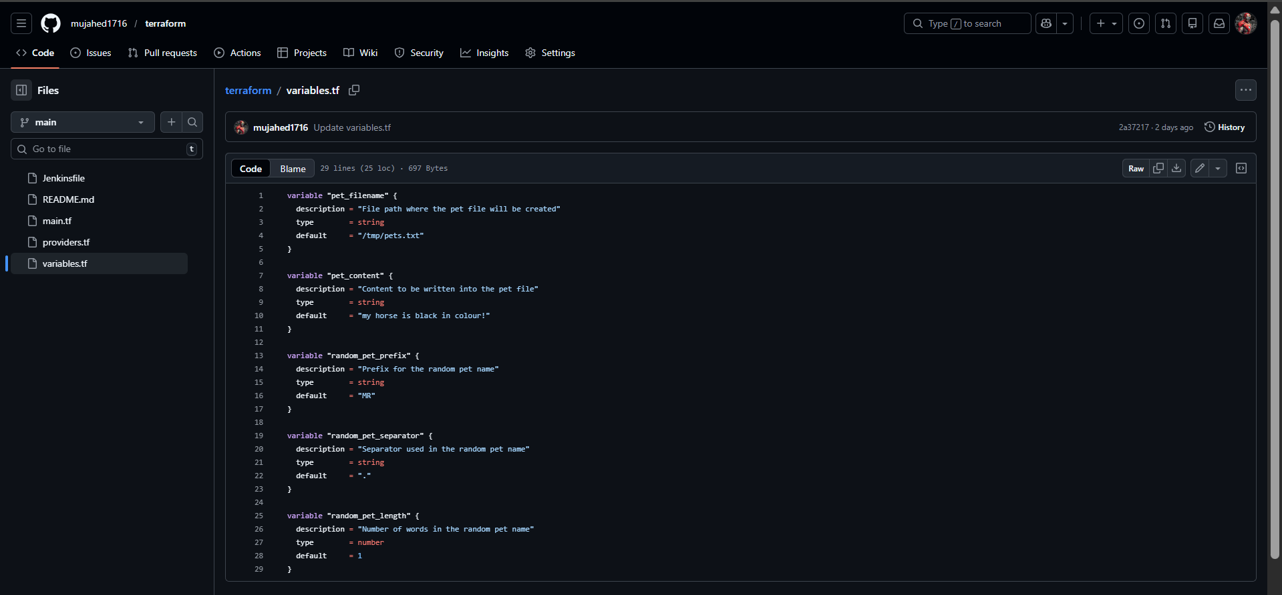
- Create a file in repo called Jenkinsfile
- Add pipeline stages for Terraform:
  - Checkout
  - Terraform Init
  - Terraform Plan
  - Terraform Apply
- Example Jenkinsfile flow shown in screenshot uses:
  - terraform init
  - terraform plan -out=tfplan
  - terraform apply --auto-approve tfplan
- Commit Jenkinsfile into GitHub

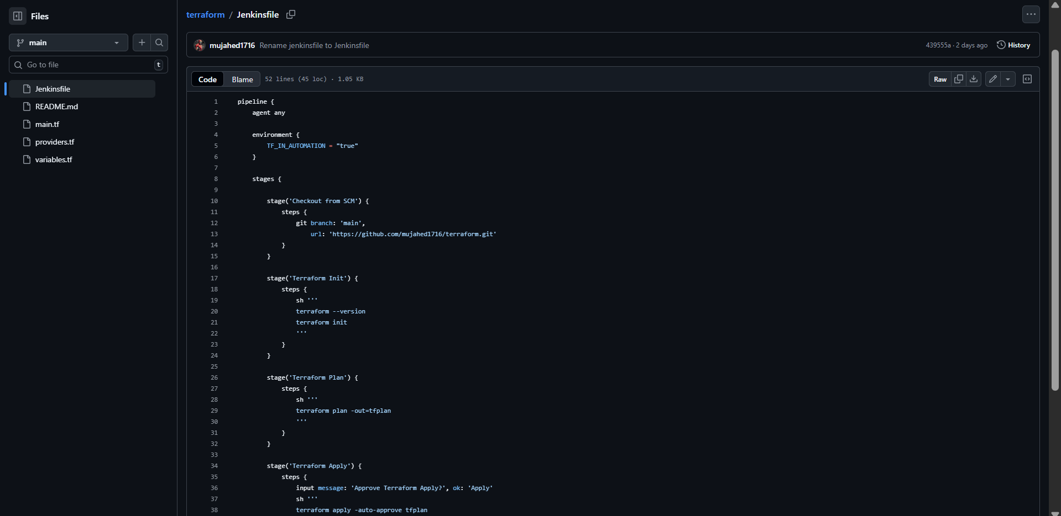

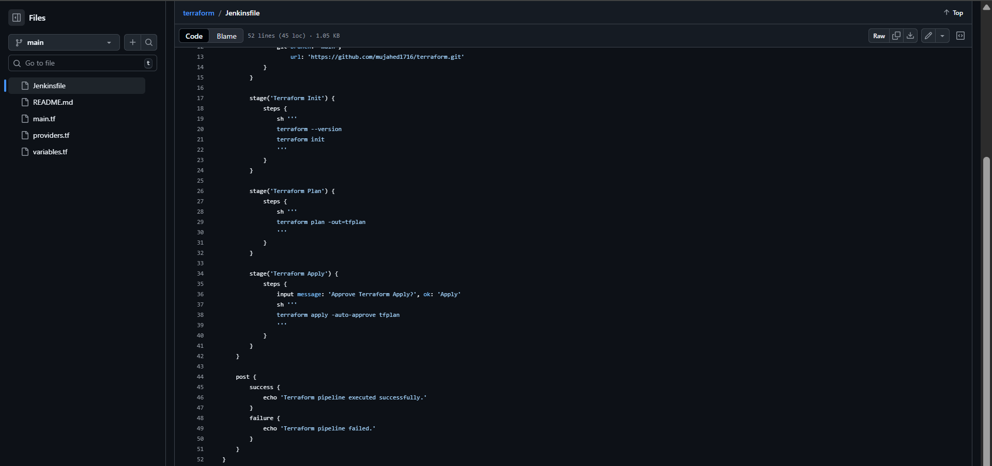
- Create a new Jenkins job: New Item → Pipeline
- Job name: terraform-task-03
- Go to Configure → Pipeline section
- Paste the Jenkins pipeline script inside the script box
- Ensure Git repo URL is correct in checkout stage
- Click Save

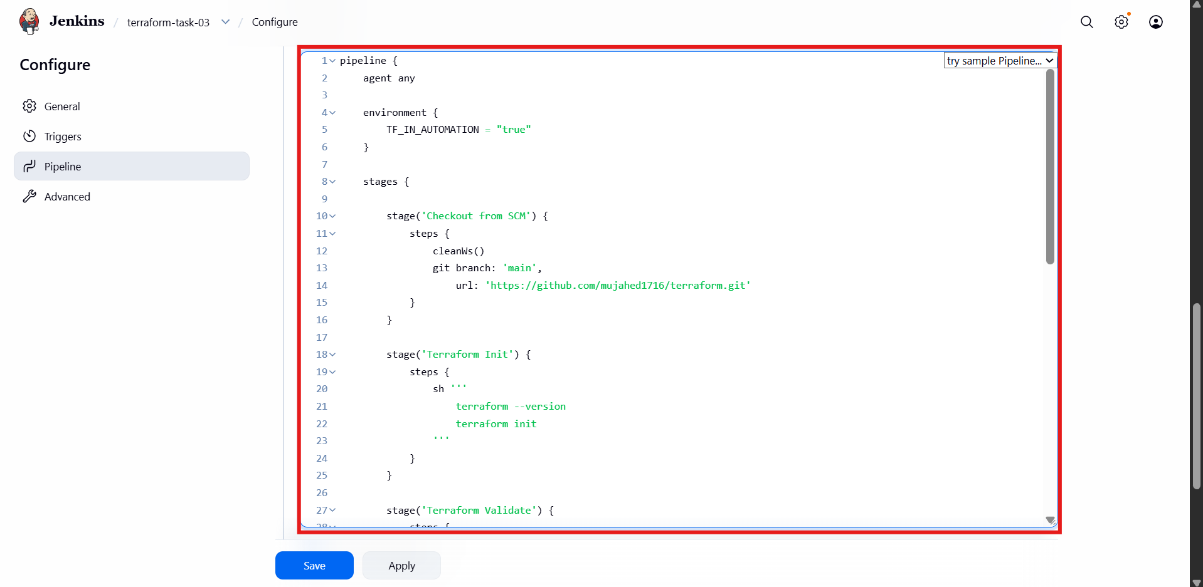

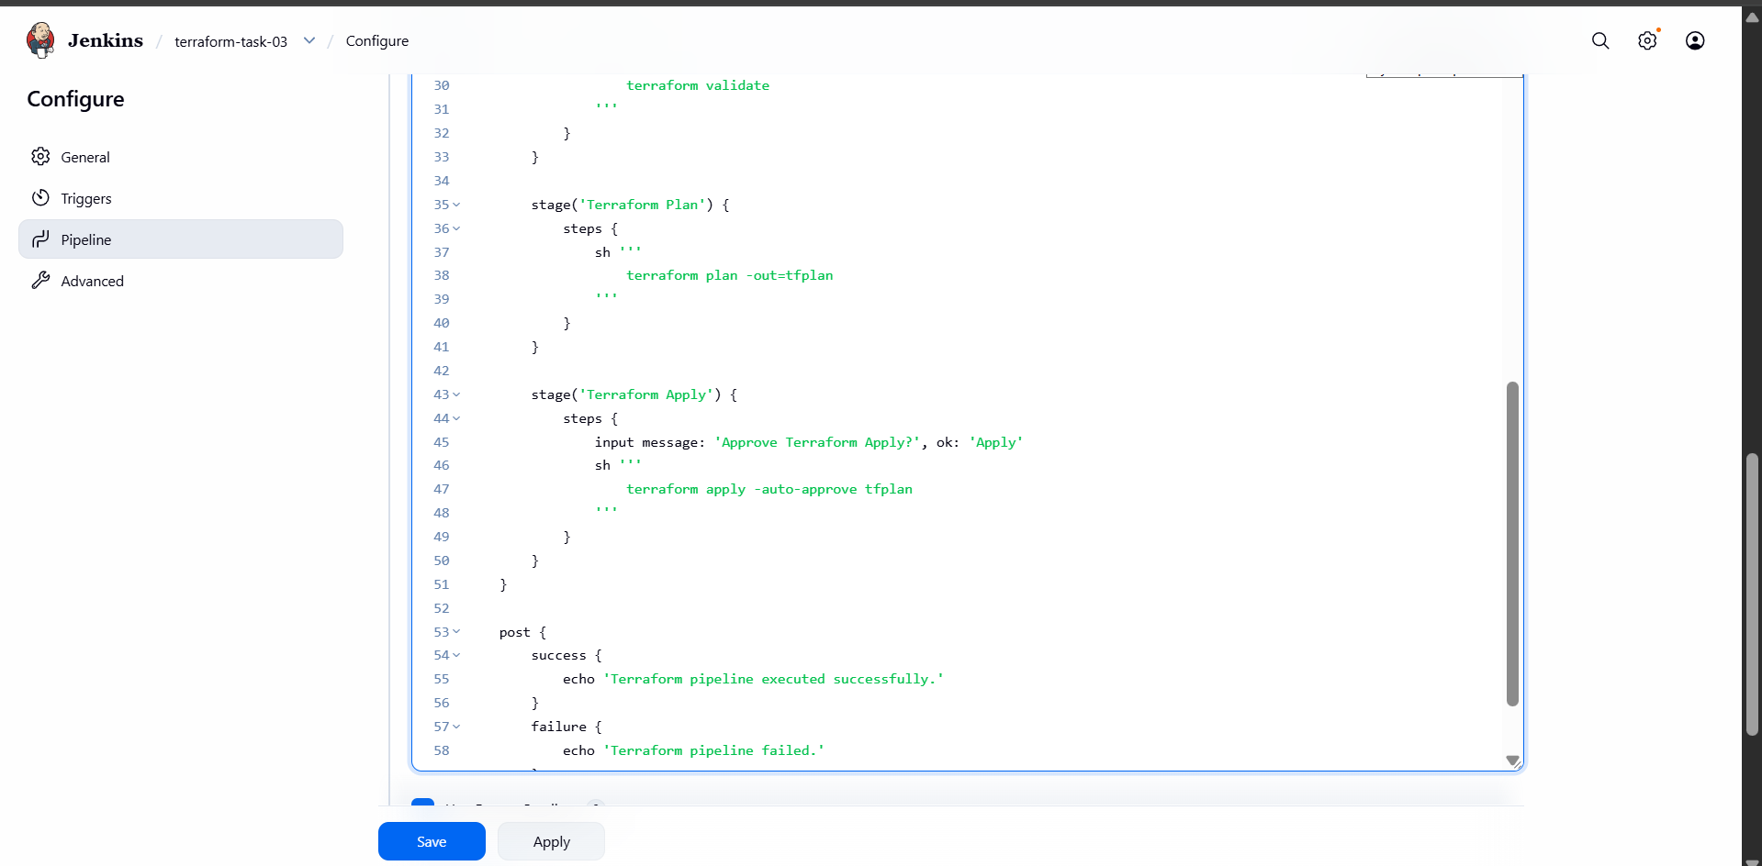
- Build success
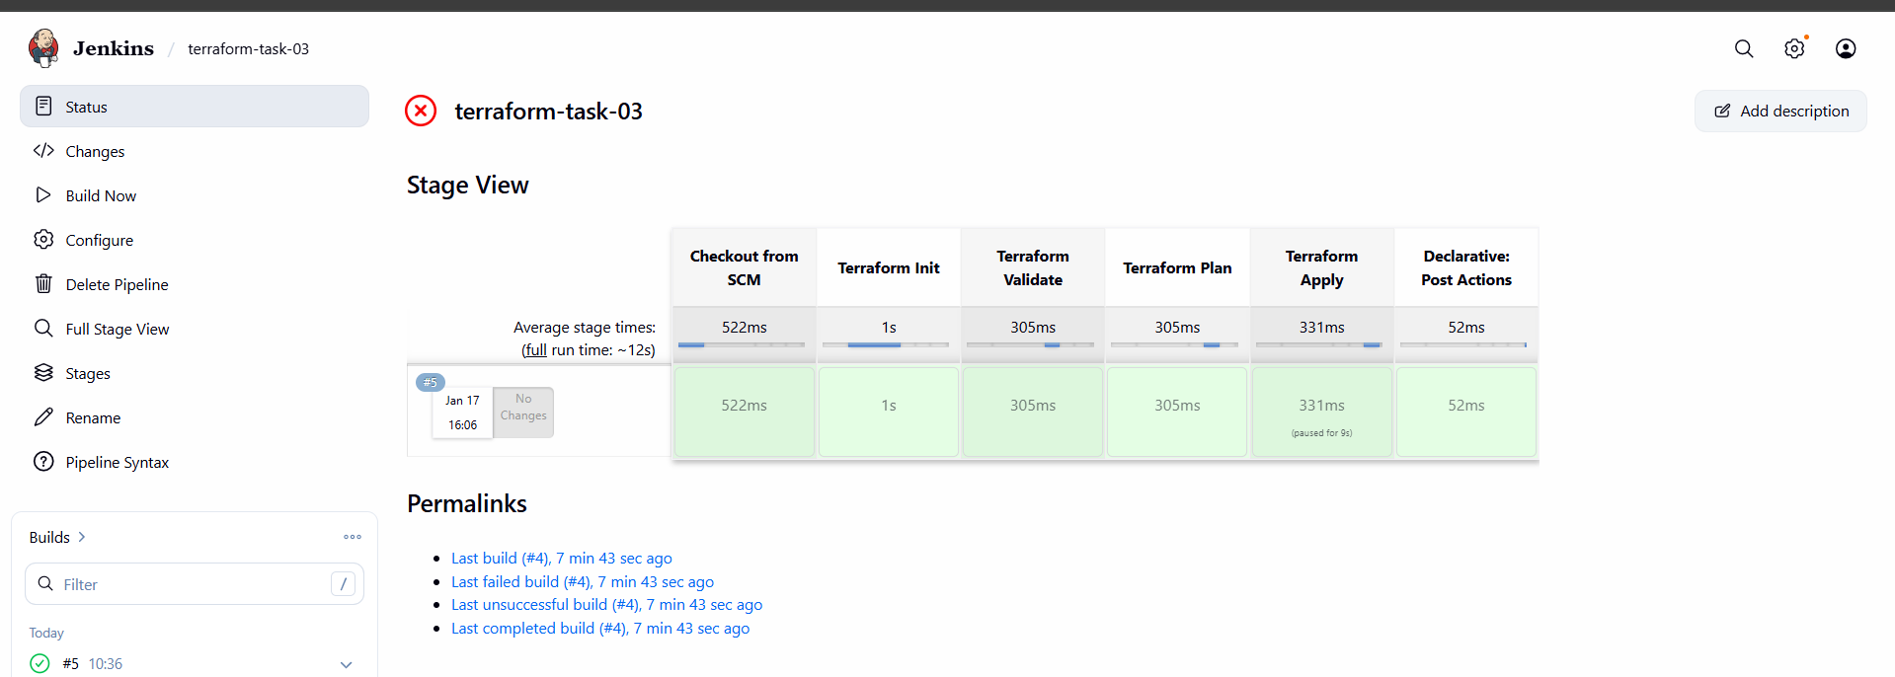

- Create one Jenkins job using Maven Project for the code below with two stages:
- Stage 1: Git clone

Stage 2: Maven Compilation Code: https://github.com/betawins/java-Working-app.git

- Login to Jenkins Dashboard
- Go to Manage Jenkins → Plugins
- Click Available plugins
- Search for mav
- Select Maven Integration
- Click Install (top-right)

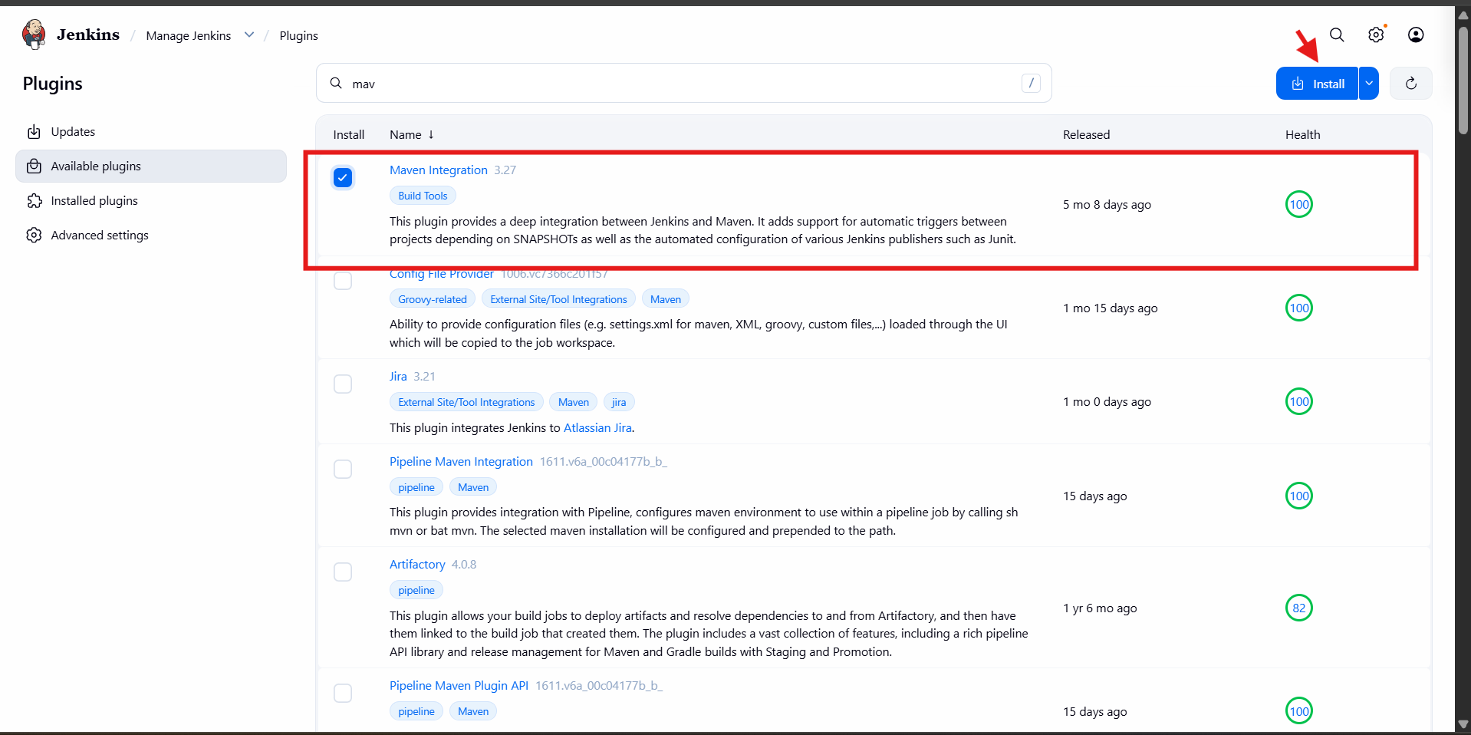

- From Jenkins dashboard click New Item
- Enter job name: maven-project
- Select job type: Maven project
- Click OK

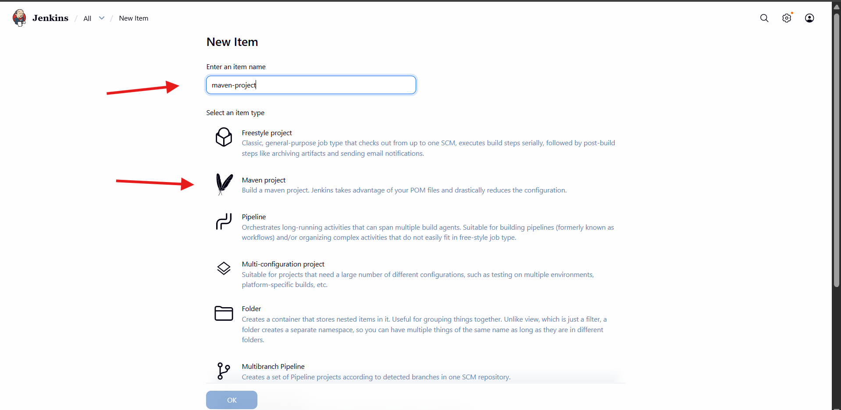
- Select Git
- Paste your GitHub repo URL in Repository URL
- If repo is private, add Credentials
- In Branch Specifier, enter:
- */main

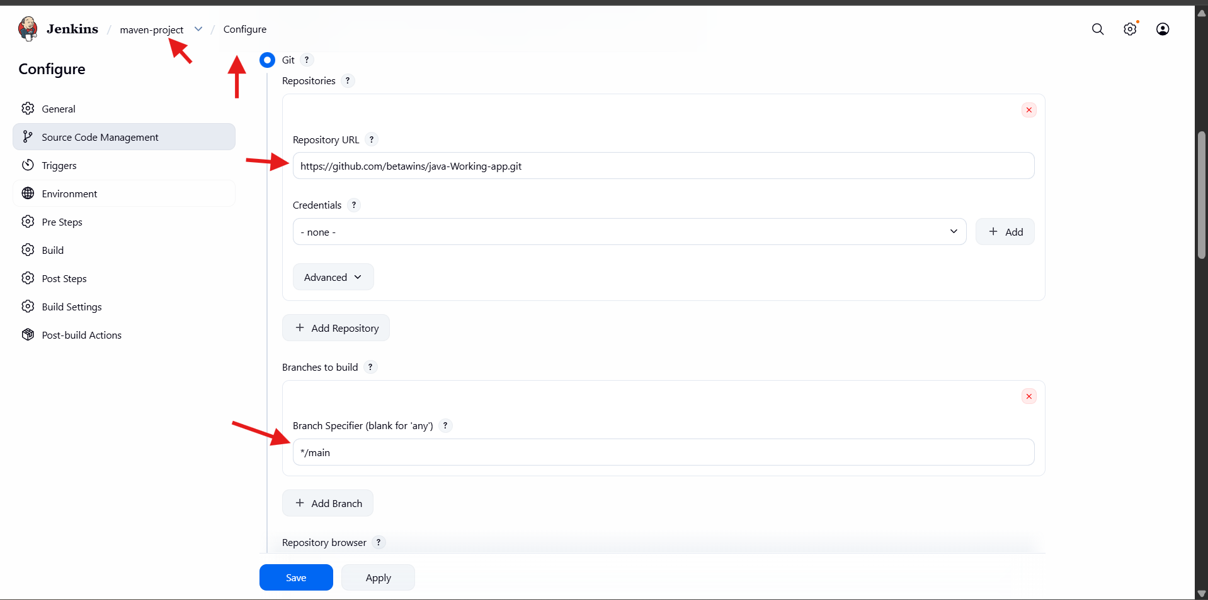

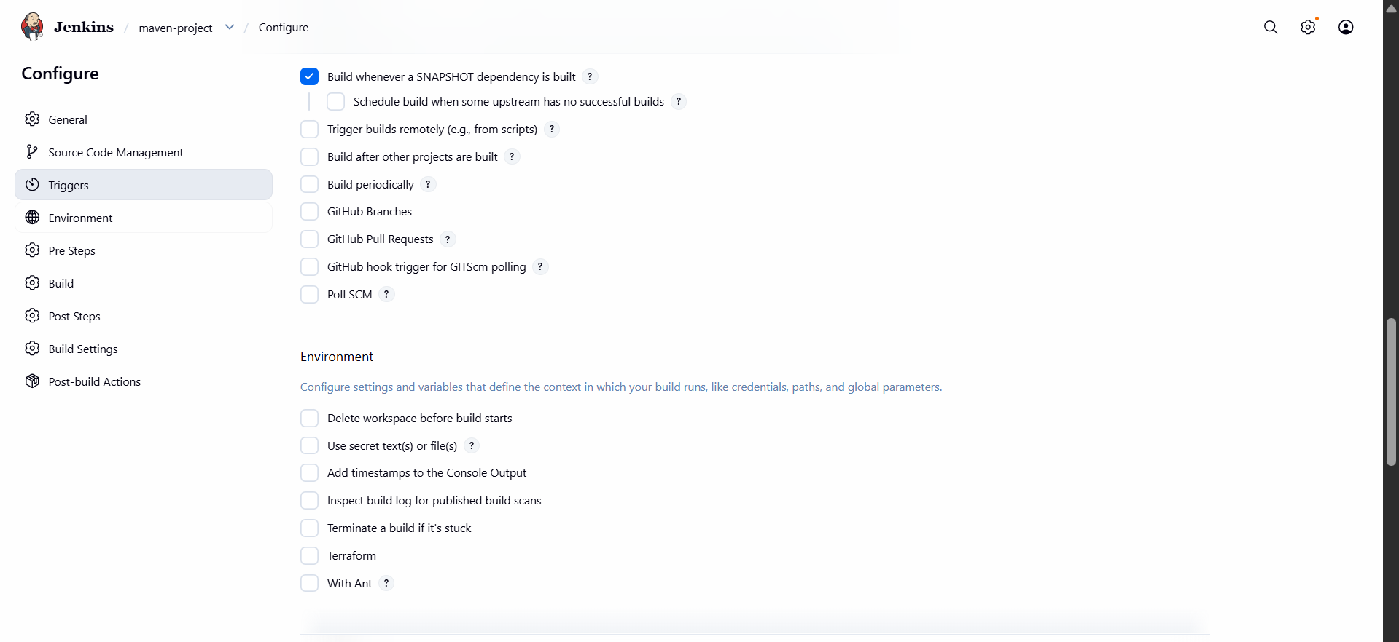
- Go to Build section in job configuration
- In Root POM, keep:
- pom.xml
- In Goals and options, enter Maven goals:
- clean compile
- (or clean package if you want jar/war output)
- Click Save

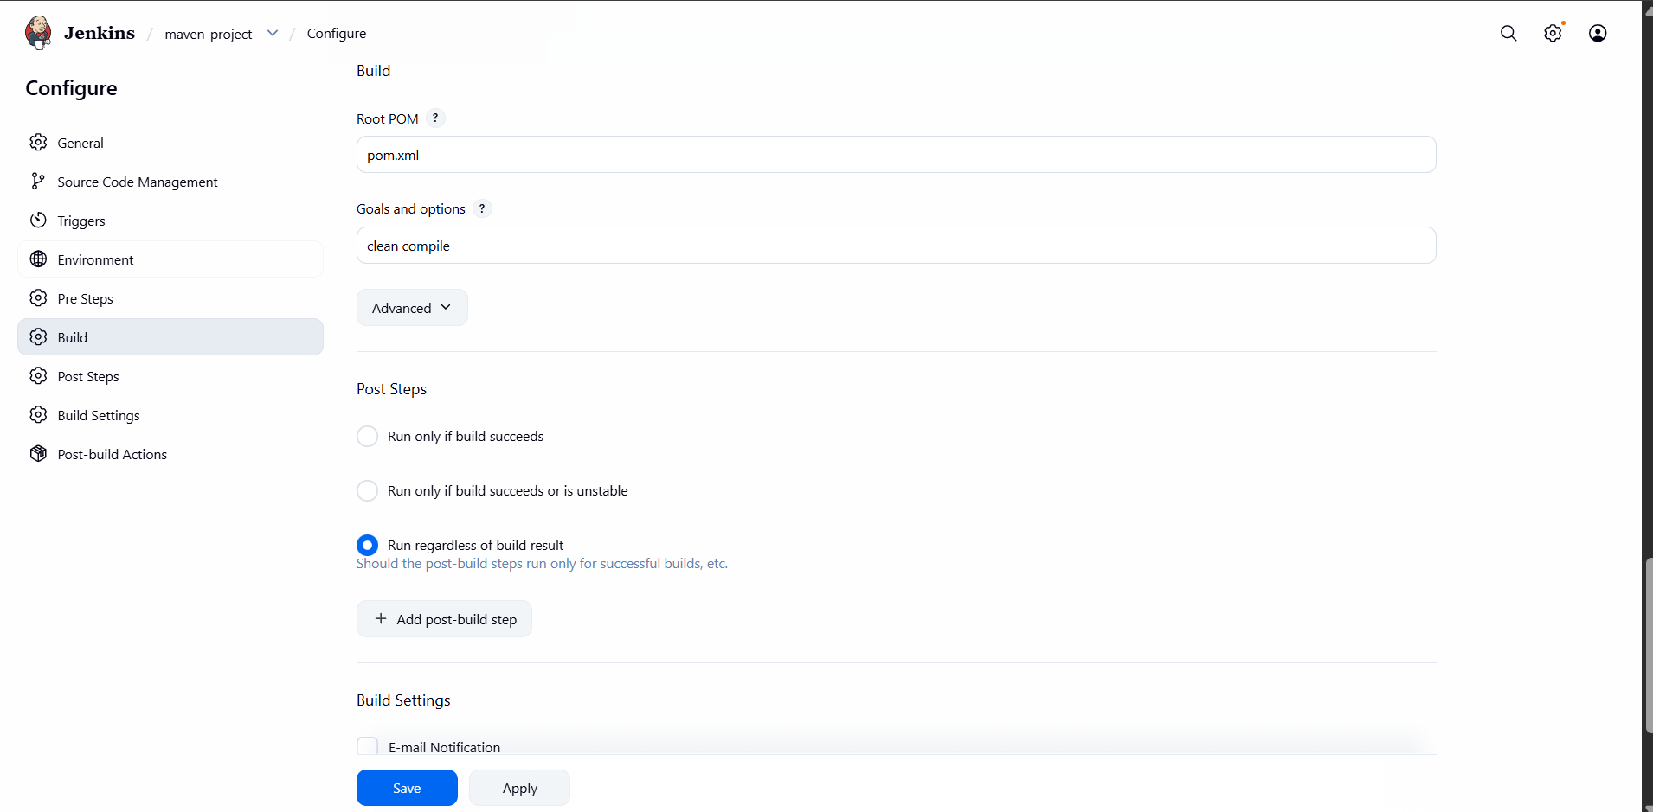
- Click Build Now
- Check Build History on the left side
- Open build number → Console Output to confirm success

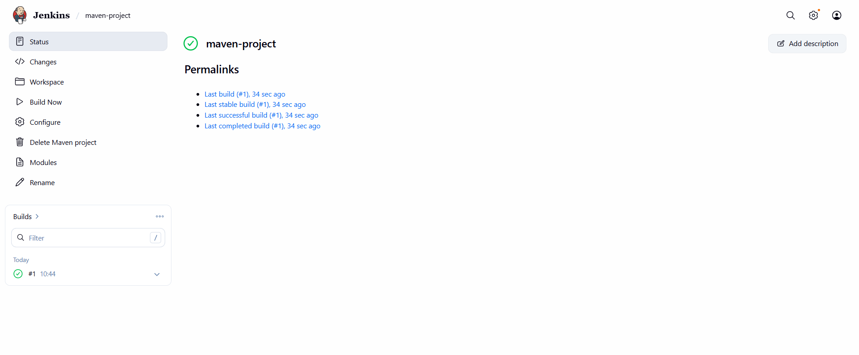
- Use the same code and create a parameterized job in Jenkins with:
- Stage 1: Git clone
Stage 2: Maven Compilation Code: https://github.com/betawins/java-Working-app.git
- Go to Jenkins Dashboard
- Click New Item
- Enter Job name: parameterized-job-maven
- Select Pipeline
- Click OK

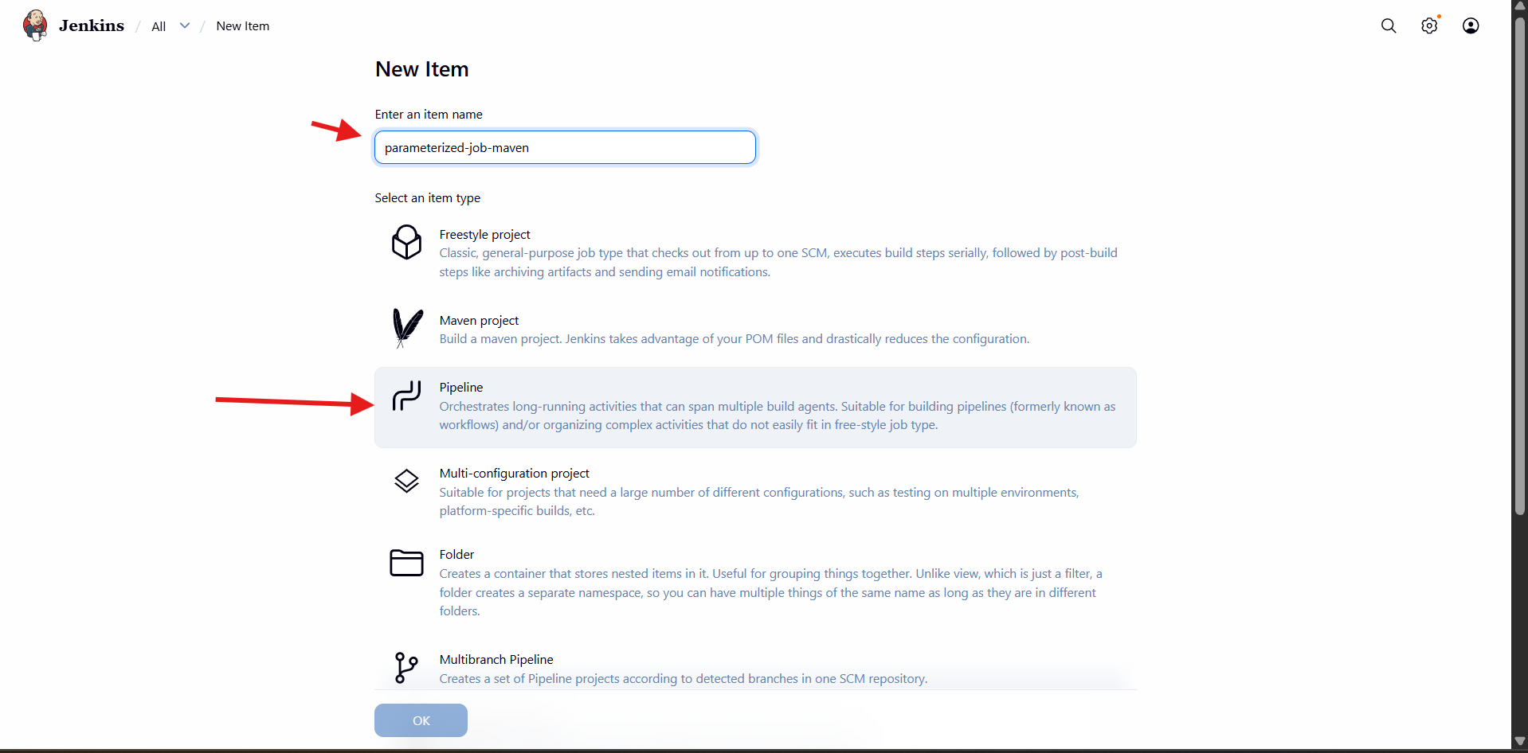
- Go to Configure of the pipeline job
- Tick This project is parameterized
- Click Add Parameter → String Parameter
- Set Name as:
- GIT_REPO
- Add Default Value (GitHub repo URL), example:
- https://github.com/betawins/java-Working-app.git
- Add Description:
Git repository URL to clone the source code from.

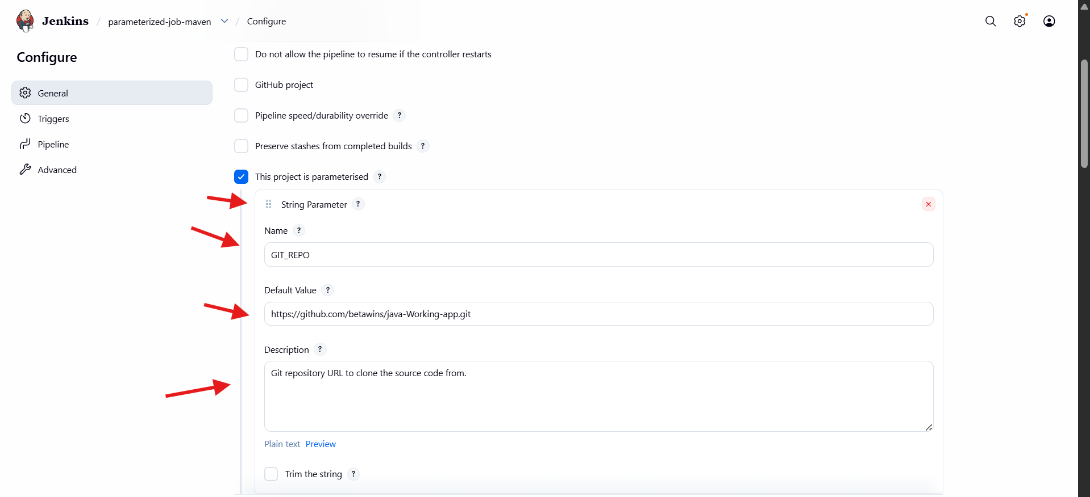
- Click Add Parameter → String Parameter
- Set Name:
- BRANCH
- Default Value:
- main
- Description:
Git branch to build.
- Add another String Parameter
- Set Name:
- MVN_GOAL
- Default Value:
- clean compile
- Description:
Maven goals/commands to run during build.

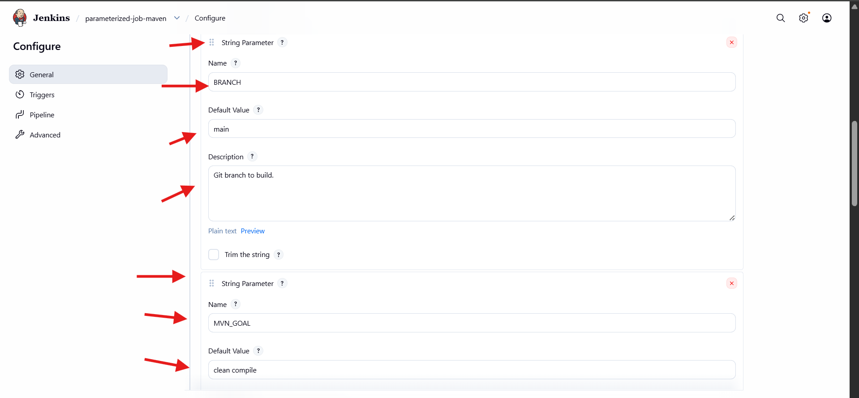
- Scroll to Pipeline → Definition
- Choose Pipeline script
- Paste the script in the text box (example):
- pipeline {
- agent any

- tools {
- maven 'MVN_HOME'
- }

- parameters {
- string(name: 'GIT_REPO', defaultValue: 'https://github.com/betawins/java-Working-app.git', description: 'Git Repository URL')
- string(name: 'BRANCH', defaultValue: 'main', description: 'Branch Name')
- string(name: 'MVN_GOAL', defaultValue: 'clean compile', description: 'Maven Goals')
- }
stages {
- stage('Git Clone') {
- steps {
- git url: "${params.GIT_REPO}", branch: "${params.BRANCH}"
- }
- }

- stage('Maven Compilation') {
- steps {
- sh "mvn ${params.MVN_GOAL}"
- }
- }
- }
- }
- Click Save

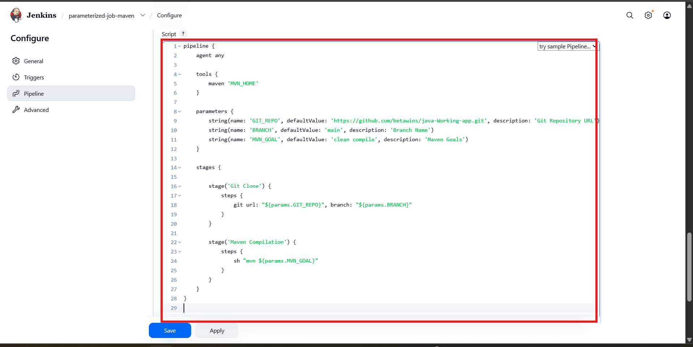
- Open your Jenkins job parameterized-job-maven
- Click Build with Parameters
- Verify parameters are visible:
  - GIT_REPO
  - BRANCH
  - MVN_GOAL
- Update values if needed
- Click Build

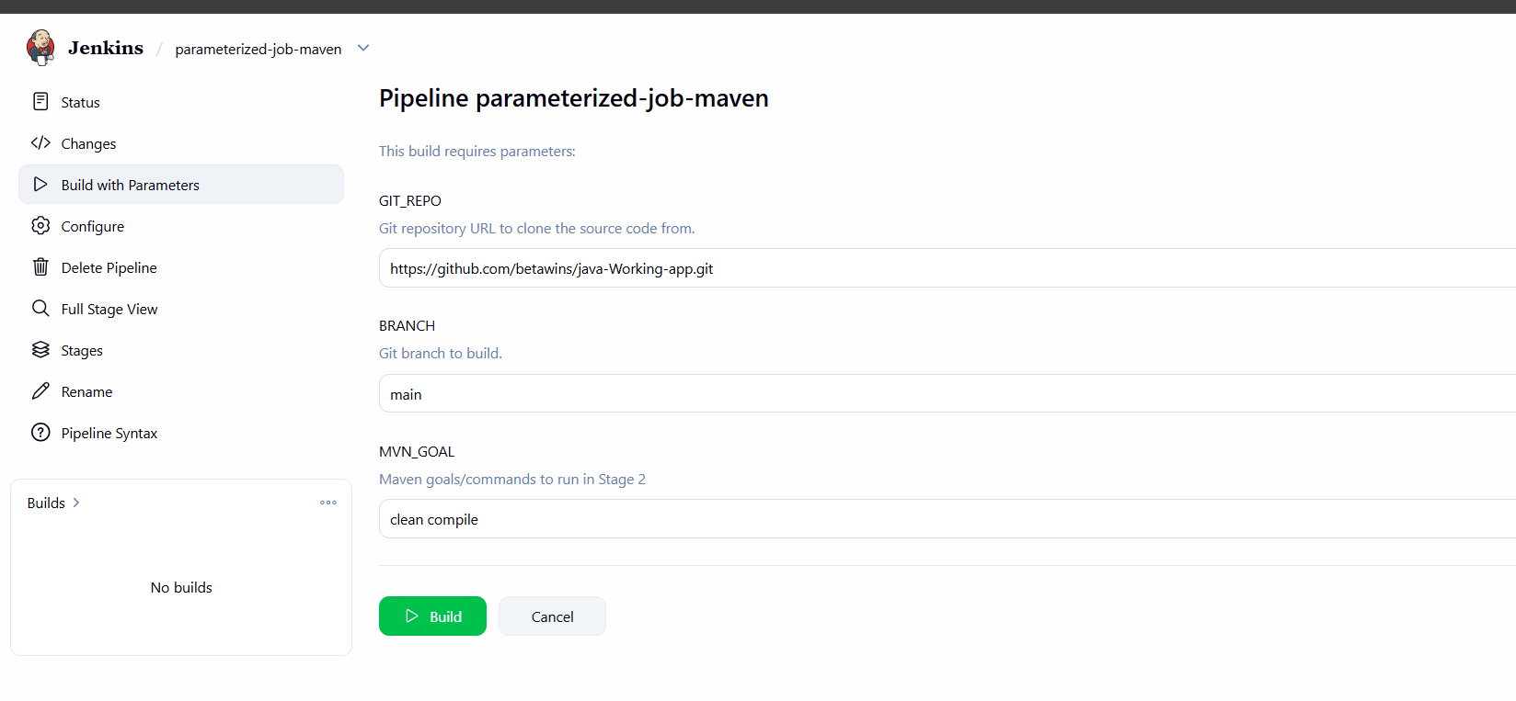
- After build starts, go to Stage View
- Verify stages executed successfully:
Declarative Tool Install
Git Clone
Maven Compilation
- Green boxes indicate the pipeline completed successfully

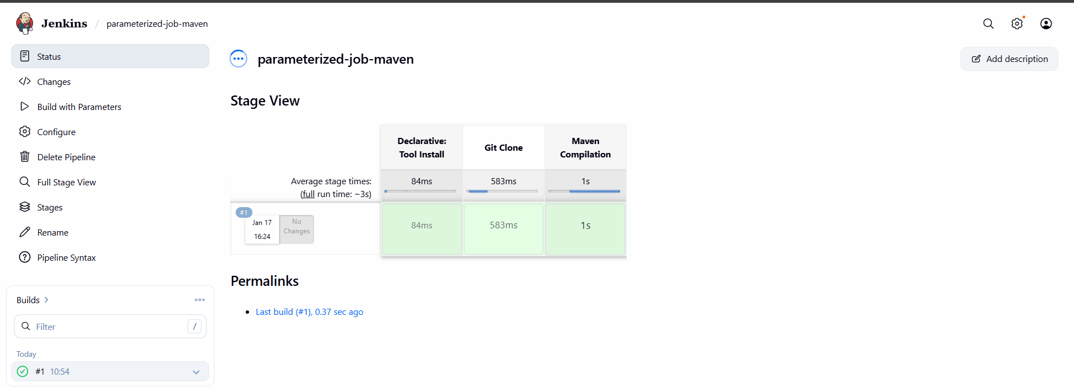
- What are the global variables in Jenkins?

In Jenkins, global variables are the predefined variables that are available across the Jenkins pipeline to access job, build, and environment related information.
Common Jenkins global variables are:
- env → Gives access to environment variables like env.BUILD_NUMBER, env.JOB_NAME.
- params → Access parameters passed to the job like params.BRANCH, params.GIT_REPO.
- currentBuild → Provides current build details like currentBuild.result, currentBuild.number.
- scm → Refers to source code management configuration used in the pipeline.
- steps / sh / bat → Pipeline steps used to execute commands.
- node / workspace → Helps access agent node and workspace location

