ANSIBLE - TASK – 03
==========================================================================

- Write a single ansible playbook which will install apache and nginx. Note: Playbook should not be hardcoded and pass the variables from different file.

- created a variables file for Ansible.
- Steps:
- Open the file in editor:
- vi vars.yml
- Add variables:
- web_servers:
- - apache2
- - nginx
- nginx_port: 81

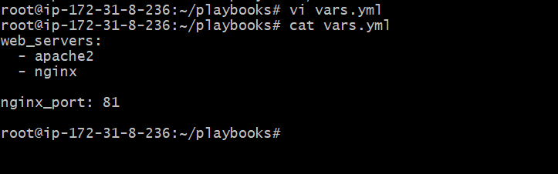

- wrote an Ansible playbook to install Apache & Nginx and fix port conflict.
- Steps:
- Open file:
- vi installation.yml
- Define play:
  - Target: all
  - Use sudo: become: yes
  - Load variables:
  - vars_files:
  - - vars.yml
- Add tasks:
  - Update cache (for Ubuntu/Debian)
  - Install packages using variable
  - Change Nginx port
  - Test config
  - Restart services
  - Start Apache and Nginx



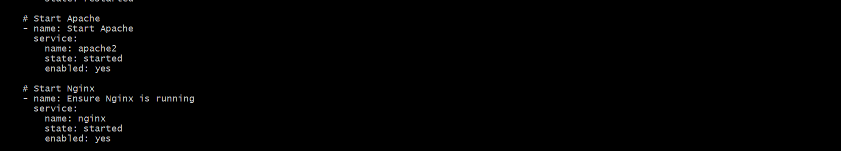
- Syntax Check
- ansible-playbook installation.yml --syntax-check
- Checks for YAML errors.
- 2. Run Playbook
- ansible-playbook installation.yml

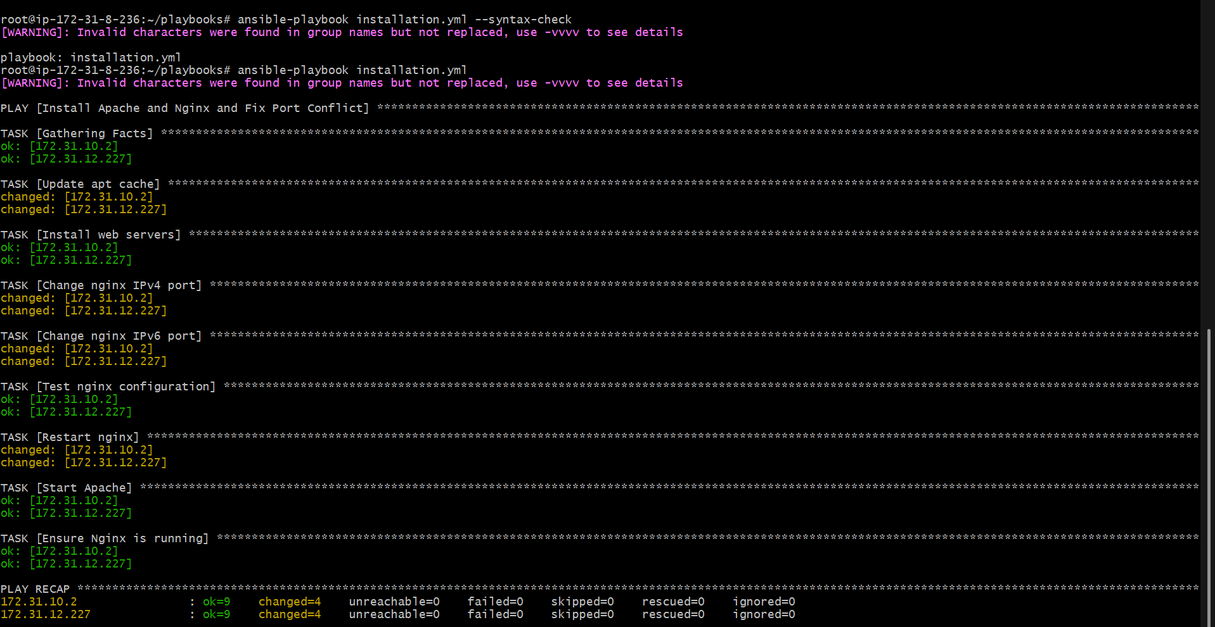
- Open browser.
- Visit:
- http://13.48.204.20
- Apache default/custom page loads:
- hello this is from ansible controller

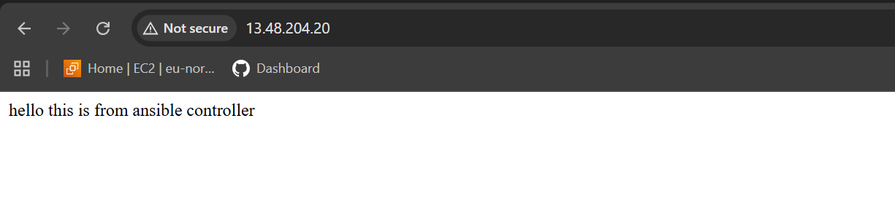
- tested Nginx on custom port.
- Steps:
- Open browser.
- Visit:
- http://13.48.204.20:81
- Nginx welcome page appears.

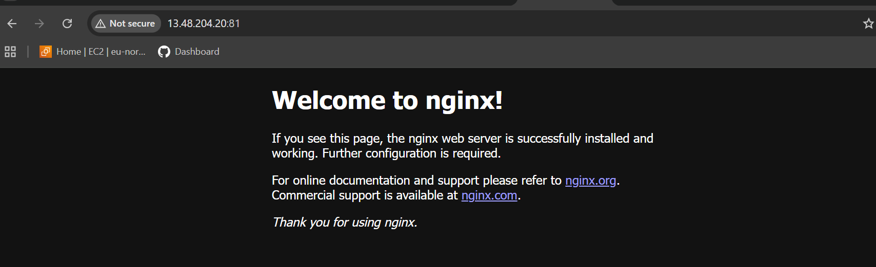

- Ansible playbook to create 10 different directories with minimal code and directory names should be passed as variables.
- Create a file to store directory names.
- vi vars.yml
- Add:
- dir_list:
- - /opt/app1
- - /opt/app2
- - /opt/app3
- - /opt/app4
- - /opt/app5
- - /opt/app6
- - /opt/app7
- - /opt/app8
- - /opt/app9
- - /opt/app10
- Save and exit.
- Step 2: Create Playbook (create_dirs.yml)
- Create the playbook:
- vi create_dirs.yml
- Add:
---
- name: Create multiple directories
hosts: all
become: yes

vars_files:
- vars.yml

tasks:
- name: Create directories
ansible.builtin.file:
path: "{{ item }}"
state: directory
mode: '0755'
loop: "{{ dir_list }}"
- Save and exit.
- This playbook reads directories from vars.yml and loops through them.

- Step 3: Check Syntax
- Before running:
- ansible-playbook create_dirs.yml --syntax-check
- If no error → YAML is correct
- Step 4: Run the Playbook
- Execute:
- ansible-playbook create_dirs.yml
- You will see output like:
- changed: [172.31.x.x] => (item=/opt/app1)
- changed: [172.31.x.x] => (item=/opt/app2)
- ...
- Each directory is created.
- Step 5: Verify on Target Server
- Login to any worker node:
- ssh ubuntu@<worker-ip>
- cd /opt
- ls -l
- You will see:
- app1 app2 app3 ... app10

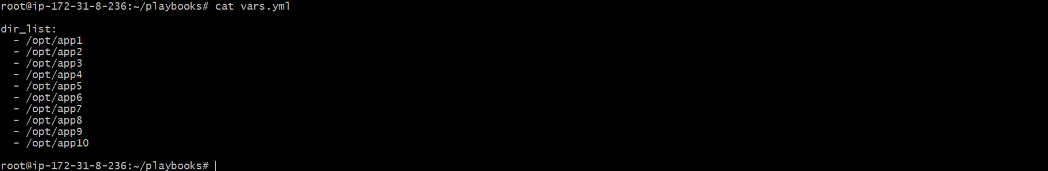

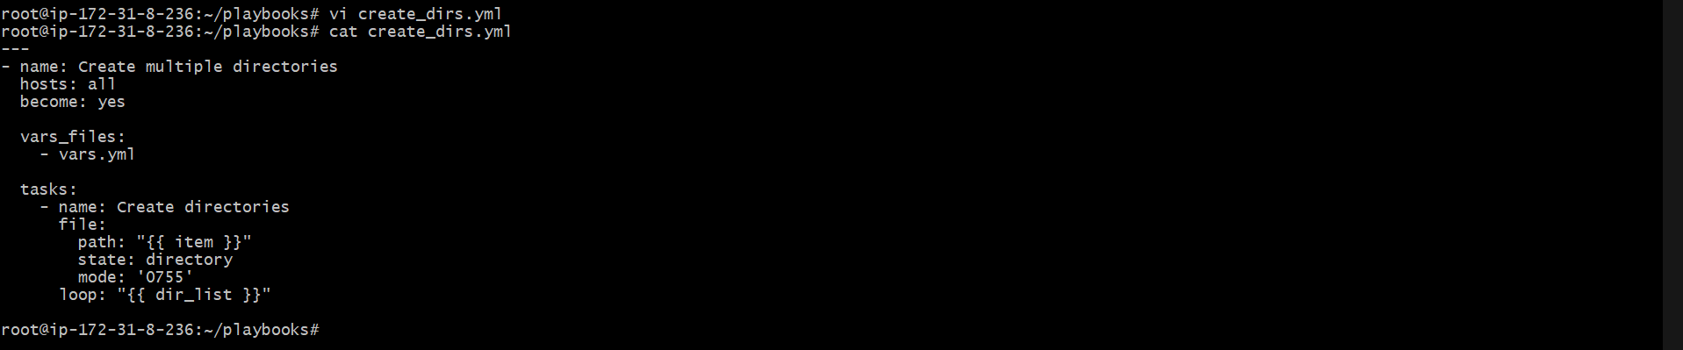

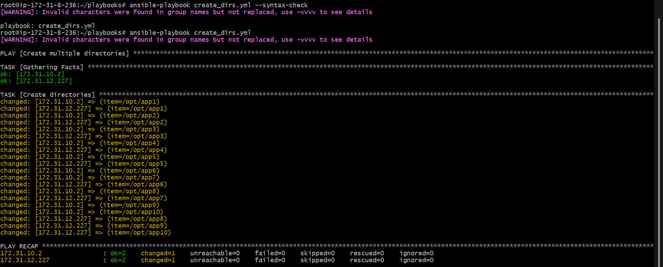

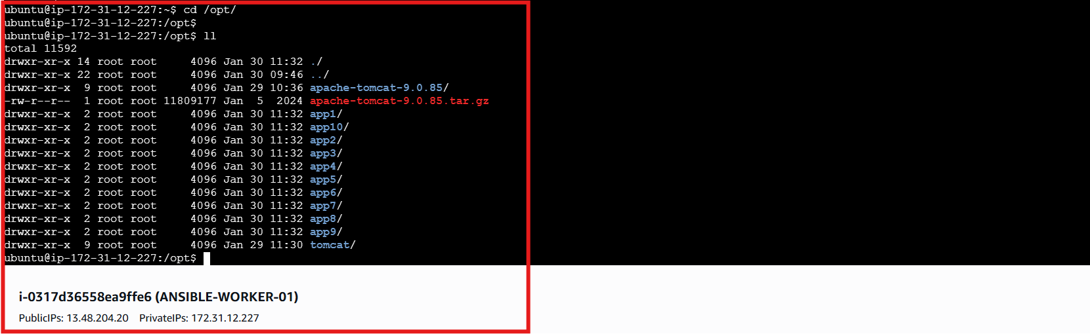

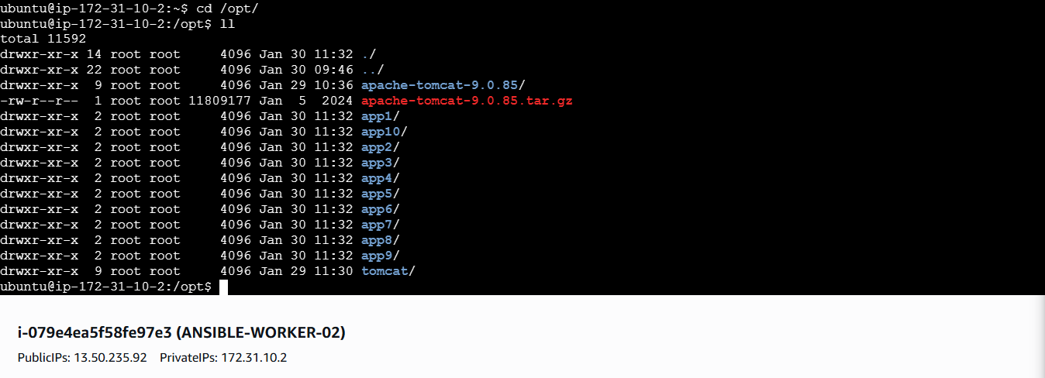

- Ansible playbook to copy ssh-keygen from master to worker nodes. Note: a)Provision new 3 ec2 machines, one master and two worker nodes

---
- name: Create EC2 and Build Inventory
hosts: localhost
connection: local
gather_facts: no

vars:
region: eu-north-1
ami: ami-073130f74f5ffb161 # Ubuntu 22.04 AMI (example)
instance_type: t3.micro
key_name: linux # Your AWS key pair name

nodes:
- name: master
group: masters

- name: worker1
group: workers

- name: worker2
group: workers

tasks:

- name: Create EC2 instances
amazon.aws.ec2_instance:
name: "{{ item.name }}"
region: "{{ region }}"
image_id: "{{ ami }}"
instance_type: "{{ instance_type }}"
key_name: "{{ key_name }}"
wait: yes

tags:
Name: "{{ item.name }}"

loop: "{{ nodes }}"
register: ec2_output

- name: Add instances to dynamic inventory
add_host:
name: "{{ item.instances[0].network_interfaces[0].association.public_ip }}"
groups: "{{ item.item.group }}"

loop: "{{ ec2_output.results }}"

- Added this yml file in ec2_create.yml
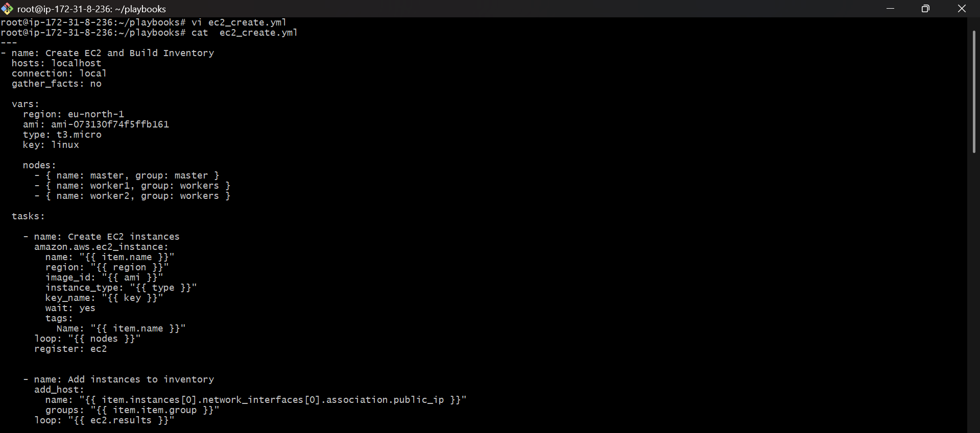
- Executed the playbook by using ansible-playbook ec2_create.yml command
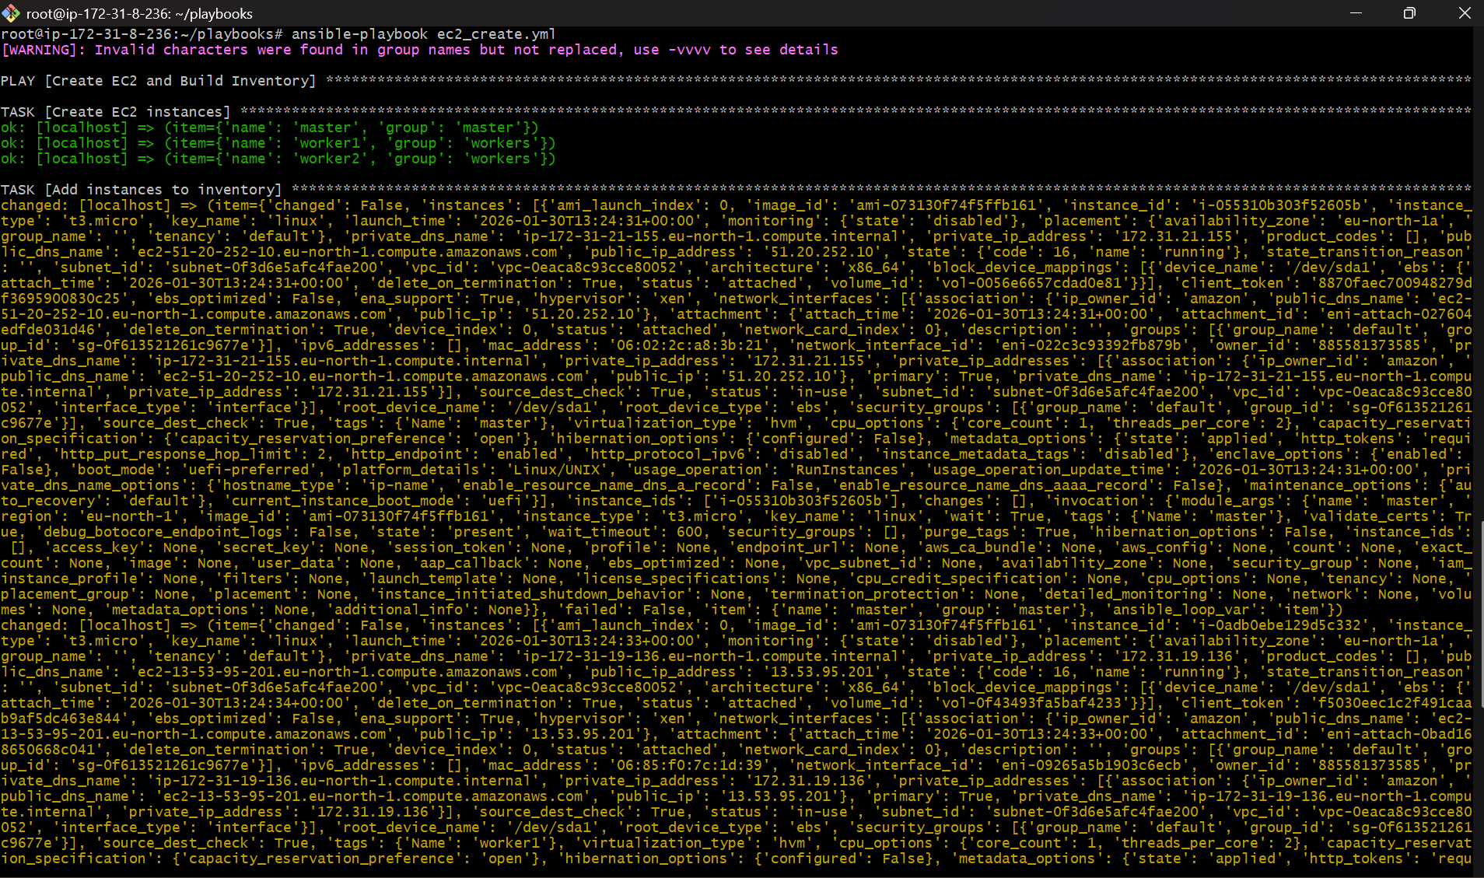
- Logged into aws console and confirmed that the three instances were launched.
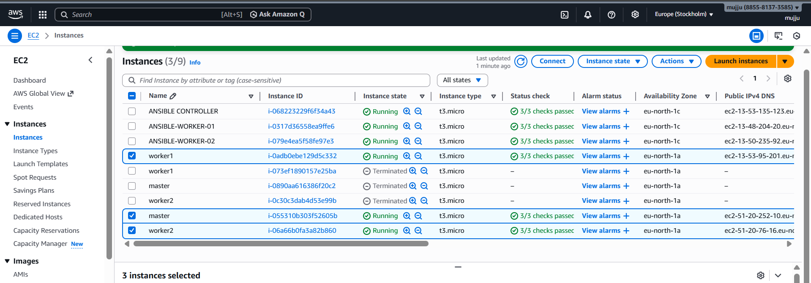
b) Create common user called ansadm and provide sudo priviliges on 3 ec2 instances.
- Go to the hosts directory in controller
- Add private ips of newly created instances naming them as master and workers
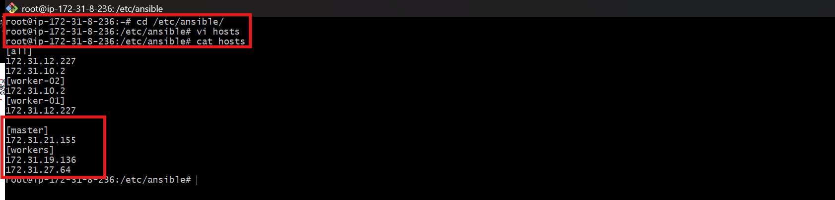
- Created a file named create_user.yml
---
- name: Setup ansadm user and Sudo
hosts: all
become: yes

tasks:

- name: Create ansadm user
ansible.builtin.user:
name: ansadm
shell: /bin/bash
groups: sudo
append: yes

- name: Grant passwordless sudo to ansadm
ansible.builtin.lineinfile:
path: /etc/sudoers.d/ansadm
line: "ansadm ALL=(ALL) NOPASSWD:ALL"
validate: "/usr/sbin/visudo -cf %s"
create: yes
mode: "0440"
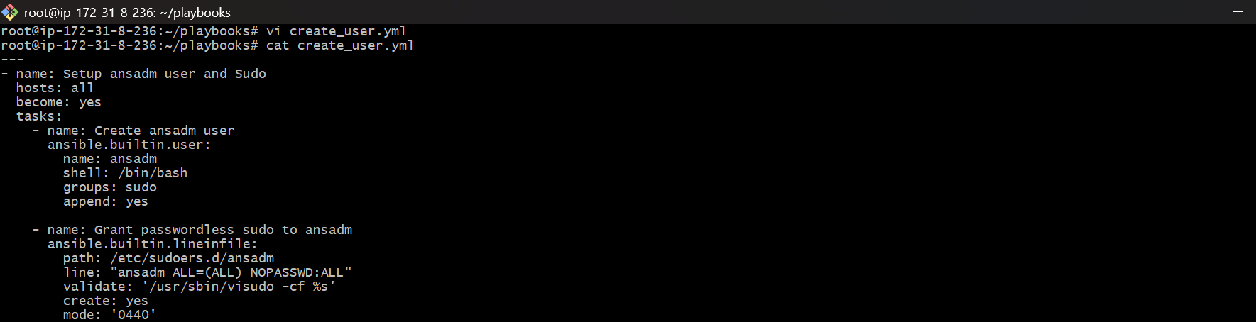
- Cat the pemkey which is used to launch the instance
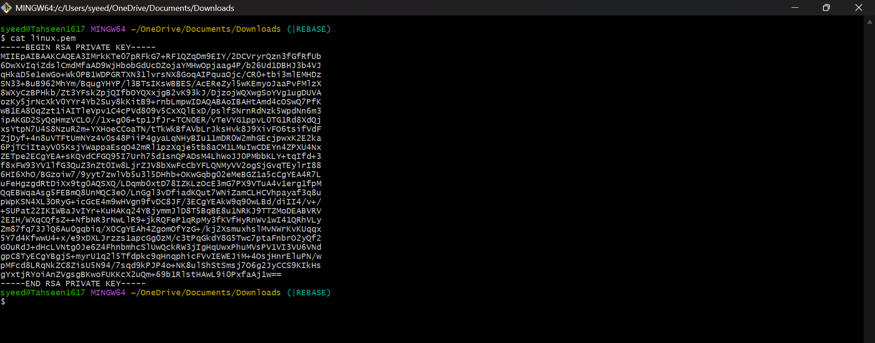
- create a new file in controller named sshless.pem and add the pem key in it
- give 400 permission to file by using chmod 400 sshless.pem command


- run the playbook using
- ansible-playbook -i /etc/ansible/hosts create_user.yml -u ubuntu –private-key=sshless.pem
- this command gives sudo access to the user
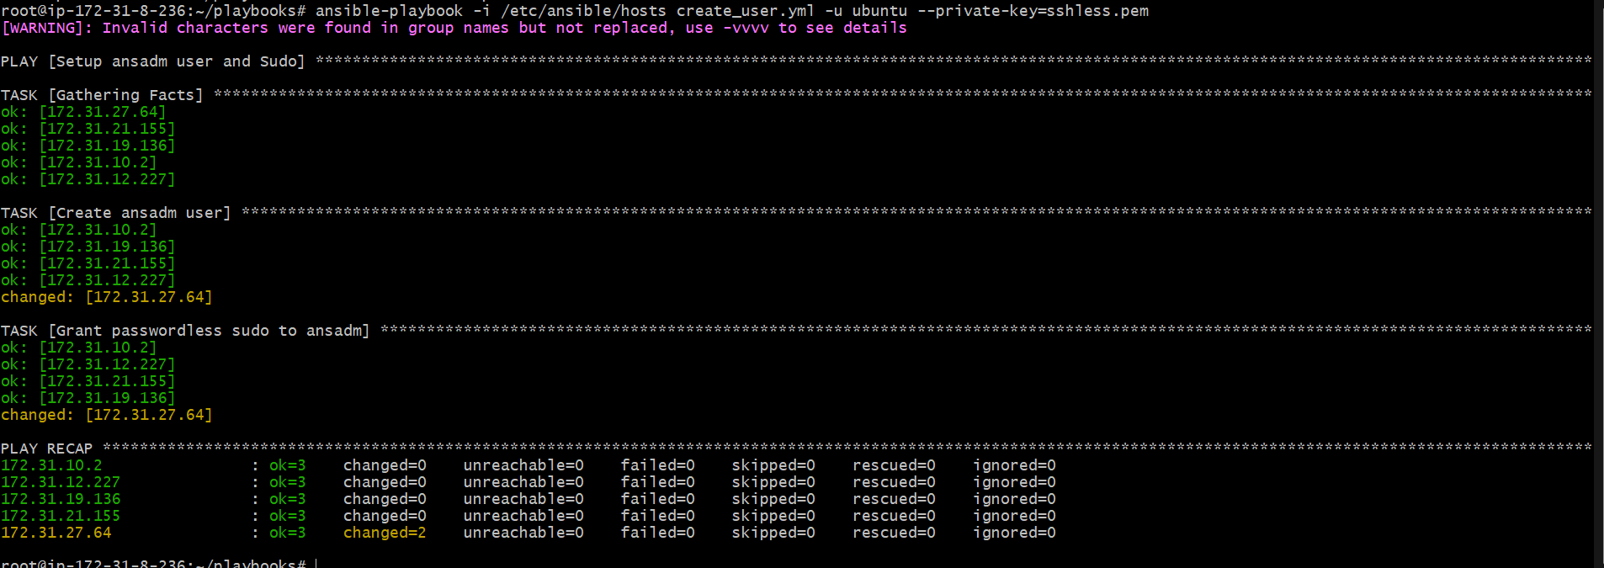
Create ssh-keygen in master and your playbook should copy the keygen making it password less authentication.
- Created a new file named sshkey.yml
---
- name: Phase 2 - Generate Key on Master
hosts: master
tasks:
- name: Ensure .ssh directory exists
become: yes
ansible.builtin.file:
path: /home/ansadm/.ssh
state: directory
owner: ansadm
group: ansadm
mode: '0700'
- name: Generate SSH Key for ansadm on New Master
become: yes
become_user: ansadm
ansible.builtin.openssh_keypair:
path: /home/ansadm/.ssh/id_rsa
type: rsa
size: 4096
- name: Read Master public key
become: yes # FIX: Run slurp as root to read the file regardless of owner
ansible.builtin.slurp:
src: /home/ansadm/.ssh/id_rsa.pub
register: master_pub_key
- name: Phase 3 - Copy Master Key to Workers
hosts: workers
tasks:
- name: Add Master public key to Worker authorized_keys
become: yes
become_user: ansadm
ansible.posix.authorized_key:
user: ansadm
state: present
key: "{{ hostvars[groups['master'][0]]['master_pub_key']['content'] | b64decode }}"
- This file generates ssh key and distributes among workers.

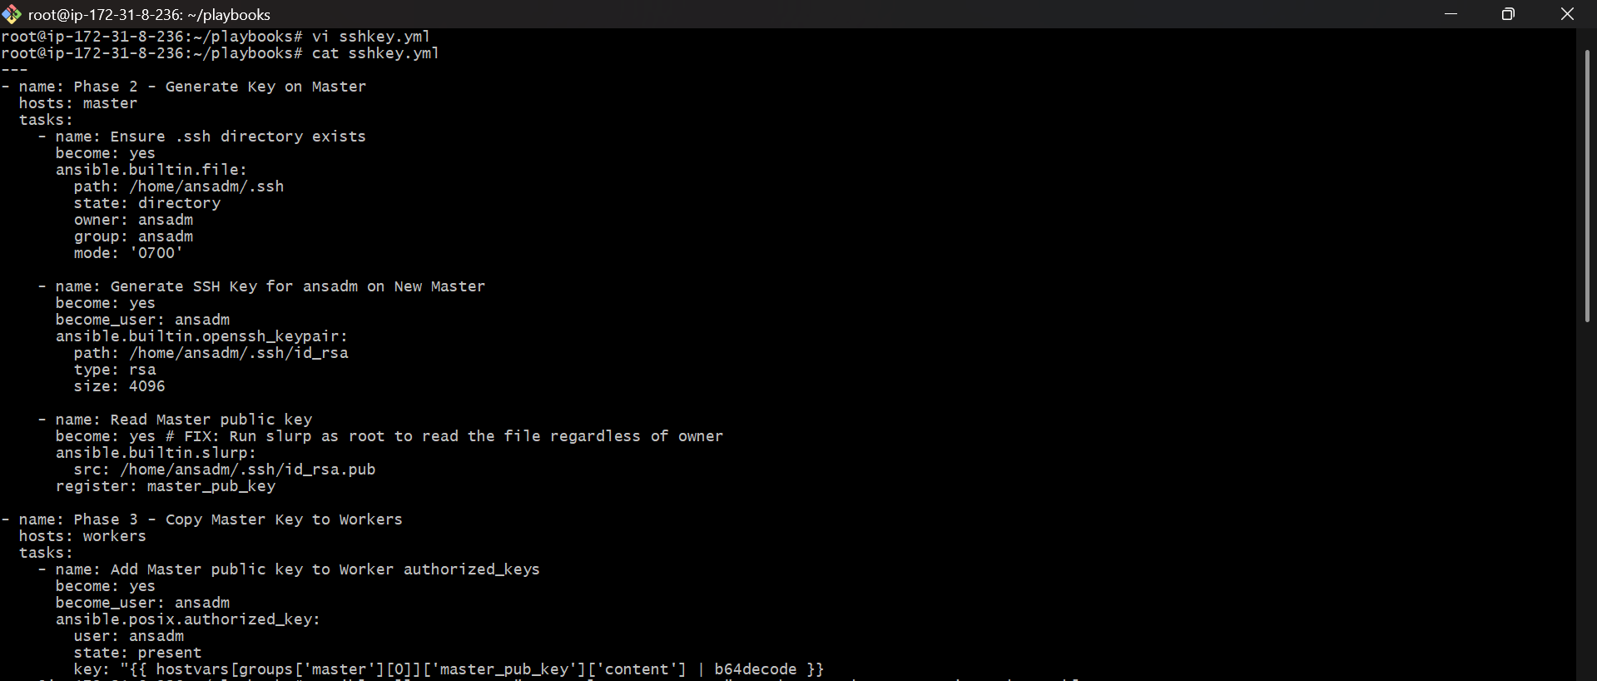

- ansible all -m apt -a "name=acl state=present" -u ubuntu --become --private-key=sshless.pem
- This command uses Ansible ad-hoc mode to install a package (acl) on all managed nodes
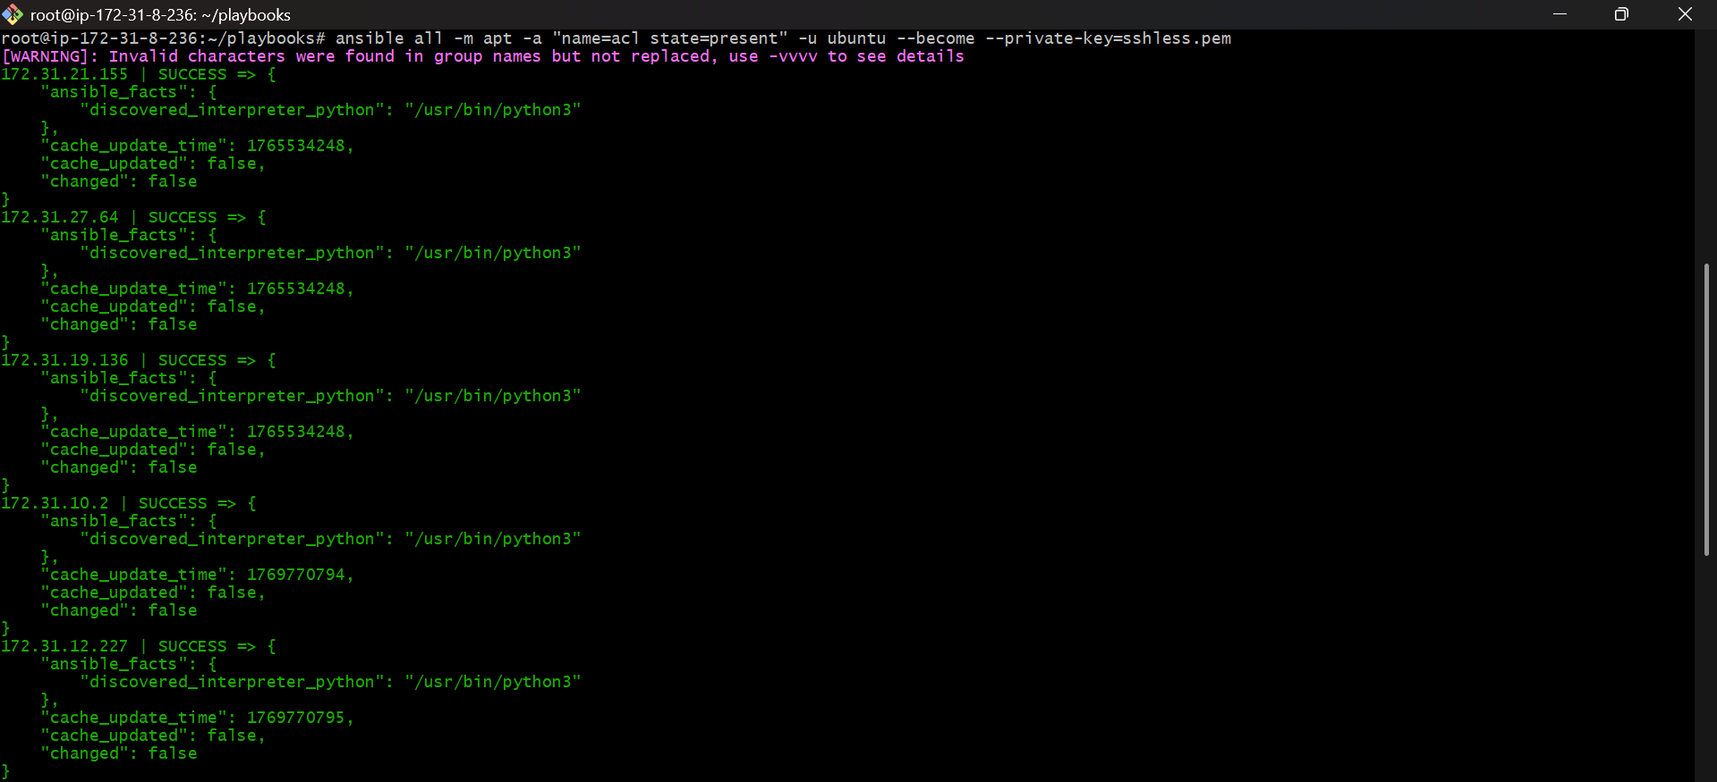
- This command runs an Ansible playbook (sshkey.yml) to set up SSH key–based (passwordless) authentication on your servers.
- ansible-playbook -i /etc/ansible/hosts sshkey.yml -u ubuntu --private-key=sshless.pem
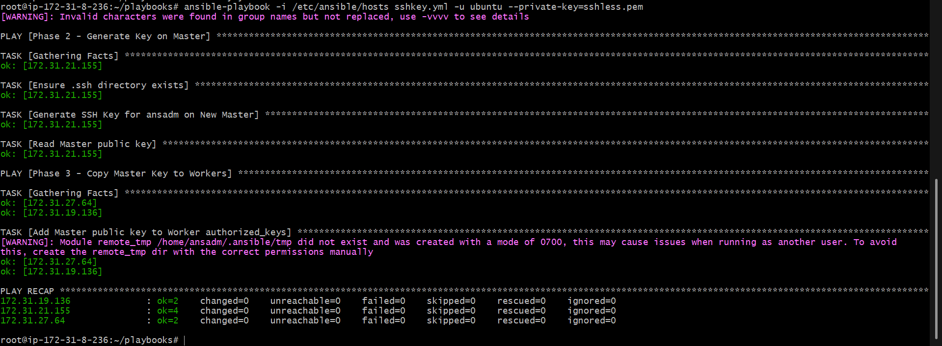

*validation :
- using ssh command connected to the newly created master private ip
- switched to the created user ansadm sudo su – ansadm
- then after for passwordless authentication
- ssh privateip of workers connected

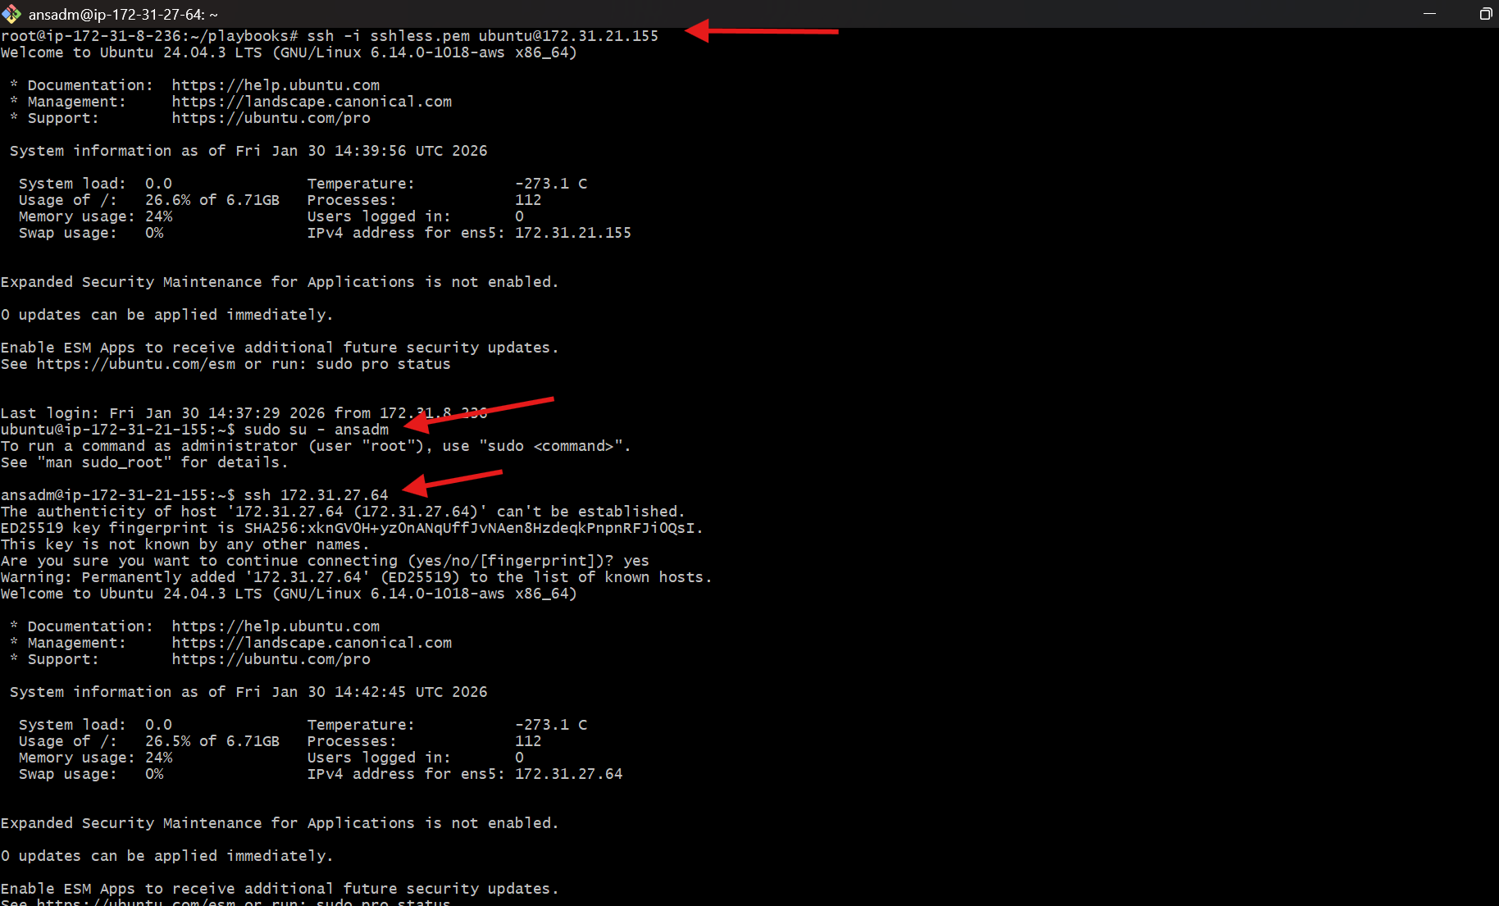

- Ansible playbook to inject ansible vault variables.

- Step 1: Create a variables file
- vi password.yml
- Add variables:
- db_user: admin
- db_password: admin@123
- Save and exit.
- Step 2: Encrypt the variables file using Ansible Vault
- ansible-vault encrypt password.yml
- Enter vault password
- Confirm vault password
- File is now encrypted
- Step 3: Verify encrypted content
- cat password.yml
- Output will look like:
- $ANSIBLE_VAULT;1.1;AES256
- 6362346d333432...
- (This confirms encryption)
- Step 4: View encrypted file (Optional)
- ansible-vault view password.yml
- Enter vault password → original content is shown.
- Step 5: Create playbook to use vault variables
vi use_vault.yml
Add:
---
- name: Use Ansible Vault variables
hosts: all
become: yes

vars_files:
- password.yml

tasks:
- name: Print vault variables (for practice)
debug:
msg: "DB User is {{ db_user }} and DB Password is {{ db_password }}"
- Save and exit.
- Step 6: Run playbook with vault password
- ansible-playbook use_vault.yml --ask-vault-pass
- Enter vault password
- Playbook decrypts variables at runtime
- Step 7: Verify Output
- Successful output:
- TASK [Print vault variables (for practice)]
- ok: [host]
- msg: DB User is admin and DB Password is admin@123

