JENKINS - 03 – TASK -02

Title
End-to-End CI Integration Using Jenkins, SonarQube (Docker), GitHub, and Slack Notifications

Objective
The objective of this activity is to set up a complete Continuous Integration (CI) pipeline using Jenkins, where application source code from GitHub is analyzed using SonarQube running inside a Docker container, and build results are communicated through Slack notifications. This ensures automated code quality checks, visibility of build status, and immediate feedback to the development team.
Prerequisites
- AWS EC2 instance with internet access
- Jenkins installed and running
- Docker installed on the SonarQube server
- SonarQube Community Edition Docker image
- Java 17 (Amazon Corretto)
- GitHub repository with application source code
- SonarQube Scanner installed on Jenkins server
- Slack workspace and Jenkins Slack plugin installed
- SonarQube authentication token
Errors Faced and How They Were Fixed
Error 1: Branch Not Found
- Issue: Jenkins build failed with “Couldn't find any revision to build”
- Cause: Git repository used main branch instead of master
- Fix: Updated branch specifier in Jenkins from */master to */main
Error 2: SonarQube Authentication Failure
- Issue: Jenkins could not authenticate with SonarQube
- Cause: SonarQube requires token-based authentication
- Fix: Generated SonarQube token and configured it as a Jenkins Secret Text credential
Error 3: Java Version Compatibility
- Issue: SonarQube Scanner requires Java 17
- Cause: Default Java version was incompatible
- Fix: Explicitly configured JAVA_HOME and PATH to use Amazon Corretto Java 17 in Jenkins build step
Error 4: No Build Notifications
- Issue: No visibility of build results
- Cause: Notifications not configured
- Fix: Configured Slack Notifications under Jenkins Post-build Actions
Conclusion
A complete CI pipeline was successfully implemented using Jenkins integrated with SonarQube and GitHub. SonarQube was deployed using Docker, enabling scalable and isolated code quality analysis. Jenkins was configured to perform automated code scanning during builds, and Quality Gate results were validated successfully. Slack notifications were enabled to provide real-time build status updates. This setup ensures improved code quality, faster feedback, and better collaboration within the development workflow.

Task 2
Create one Jenkins job using the below code and create three stages:
- stage1: Git clone to download the source code.
- stage2: Sonarqube Integration to check the quality of code.
- stage3: Slack Integration to send the alerts to slack.
URL: https://github.com/betawins/hiring-app.git
Job Creation
- Created a Freestyle Project in Jenkins
- Job name: Betawins
- Purpose: Connect Jenkins with a GitHub repository
Job created successfully
Job Configuration
- Added description: Betawins repo
- Left default options unchanged
- Job kept Enabled
Basic configuration completed
GitHub Integration
- Selected Git under Source Code Management
- Added repository URL:
https://github.com/betawins/hiring-app.git
- Credentials: None (public repository)
Repository linked successfully

Initial Build Issue
- Configured branch as:
*/master
- Triggered build
- Build FAILED
Error observed:
Couldn't find any revision to build
Reason: Repository does not have a master branch
Fix Applied
- Edited job configuration
- Updated branch specifier to:
*/main
- Saved configuration
Branch mismatch issue fixed
Successful Build
- Triggered build again
- Jenkins fetched code from GitHub
- Checked out main branch
- Commit message detected: Update README.md
Build completed successfully
Console output showed SUCCESS

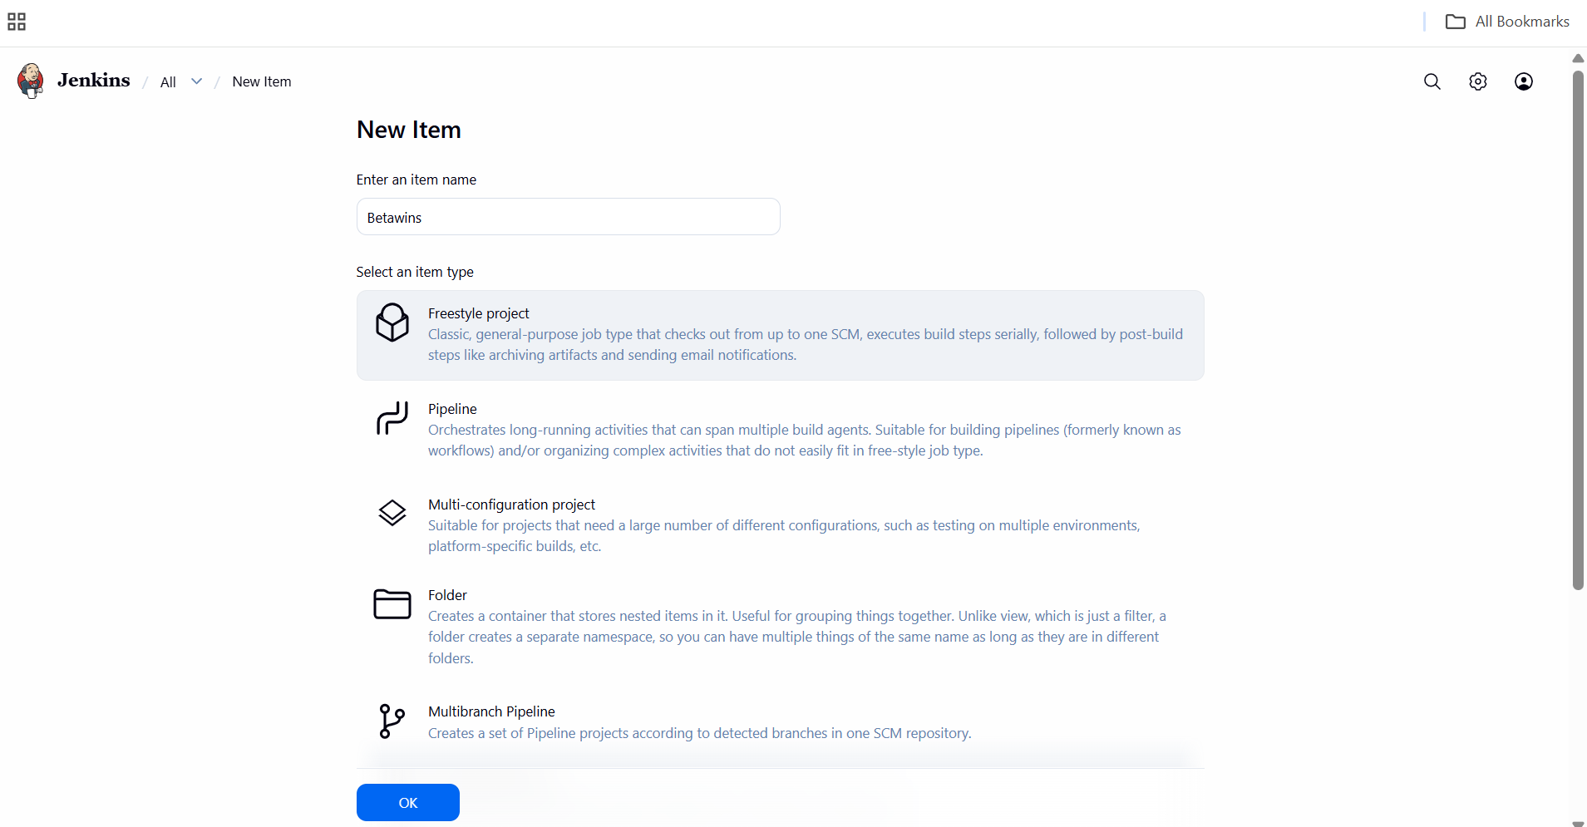

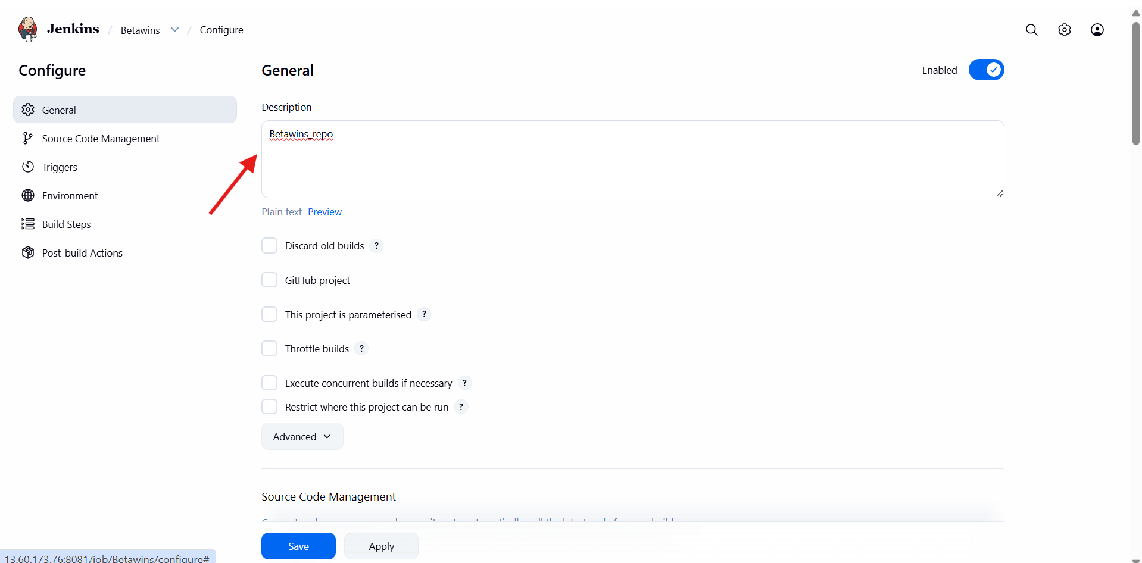

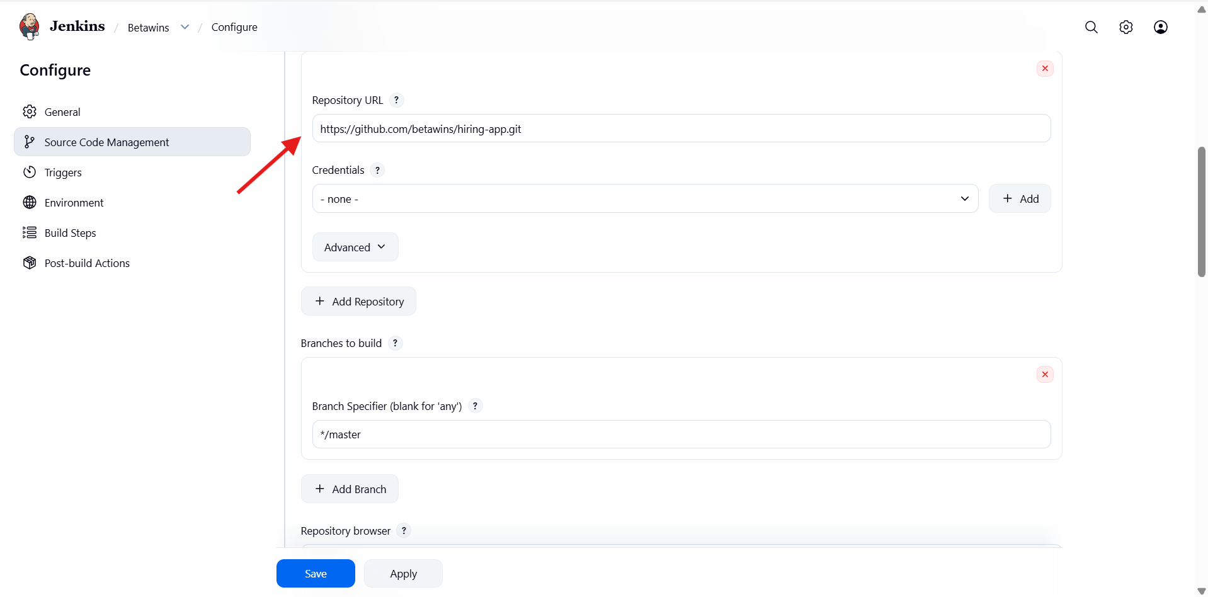

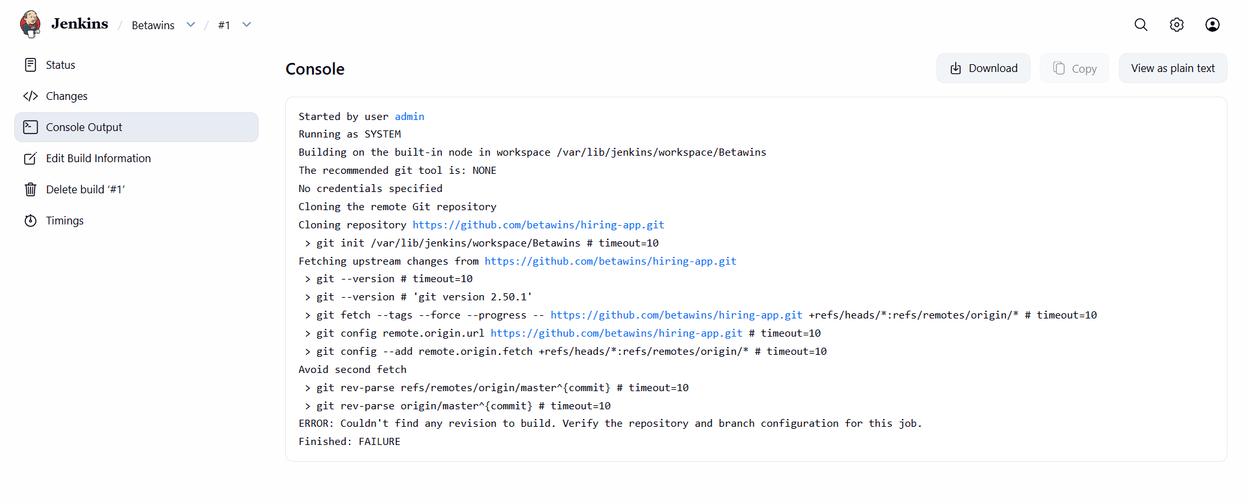
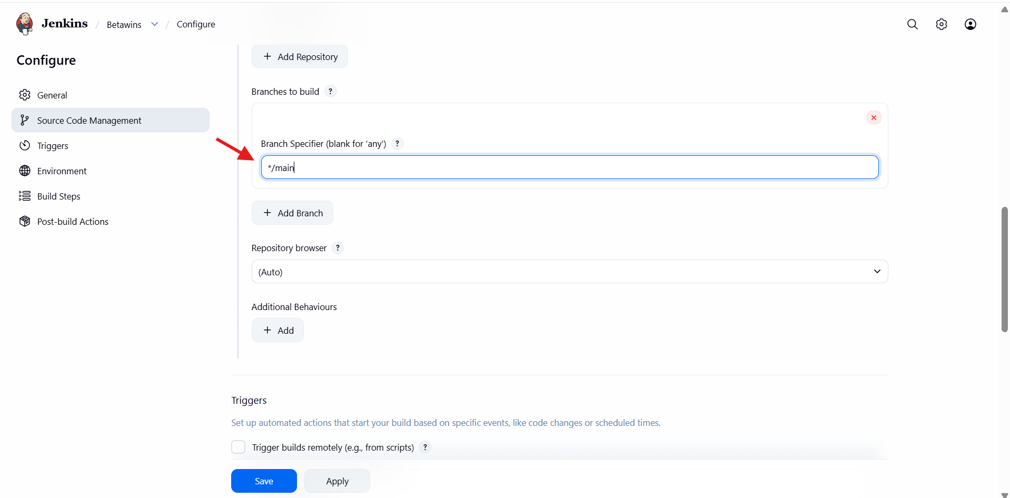

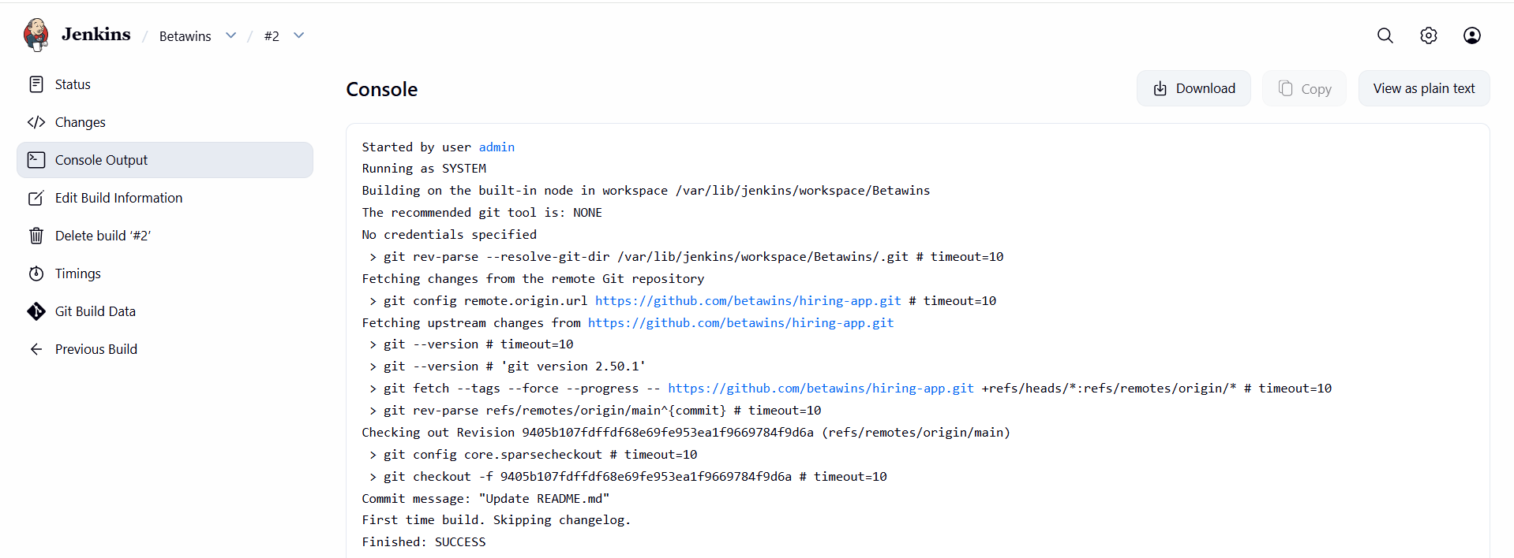

- stage2: Sonarqube Integration to check the quality of code.
End-to-End Jenkins + SonarQube Integration (Docker)
SonarQube Server Setup (Docker)
Docker installation
yum install docker -y
Docker installed successfully
▶ Start Docker service
systemctl start docker
systemctl status docker
Docker daemon running
Pull SonarQube image
docker pull sonarqube
Official SonarQube image downloaded
Run SonarQube container
docker run -d \
--name sonarqube-server \
-p 9003:9000
sonarqube
SonarQube container running
Access URL:
http://<PUBLIC-IP>:9003
Verify Docker status
docker ps
docker images
Container and image verified
SonarQube Web Configuration
Login & project setup
- Opened SonarQube in browser
- Logged in as admin
- Created local projects
- Embedded DB warning observed (expected)
SonarQube UI working
Generate SonarQube token
Location:
SonarQube → Administrator → Security → Tokens
- Token name: sonarqube-container
- Token copied immediately
Token visible only once
Token ready for Jenkins
Jenkins Global Configuration (SonarQube)
Configure SonarQube server
Location:
Jenkins → Manage Jenkins → System
- Name: sonarqube-server
- Server URL:
http://<PUBLIC-IP>:9003
Add Jenkins credentials
- Type: Secret Text
- Secret: SonarQube token
- ID: sonarqube-container
- Scope: Global
Jenkins ↔ SonarQube authentication configured
GitHub Repository
Repository details
- Repo: betawins/hiring-app
- Branch: main
- Files present:
  - pom.xml
  - Dockerfile
  - Jenkinsfile
  - Source code
  - Sonar properties in README
Repository ready for analysis
Jenkins Job Configuration
Job creation
- Job name: hiring_app
- Type: Freestyle project
- SCM: Git
- Repo URL added
- Branch:
*/main
Source code checkout configured
Java & Sonar Scanner Setup
Configure Java 17 (Build step)
export JAVA_HOME=/usr/lib/jvm/java-17-amazon-corretto.x86_64
export PATH=$JAVA_HOME/bin:$PATH

Verify Java
java -version
Correct Java version confirmed
Sonar Scanner Configuration (Server)
Edit scanner config
cd /opt/
cd sonar_scanner/conf
vi sonar-scanner.properties
sonar.host.url=http://<PUBLIC-IP>:9003
sonar.sourceEncoding=UTF-8
Scanner configured
Run SonarQube Analysis (Jenkins Build)
/opt/sonar_scanner/bin/sonar-scanner \
-Dsonar.host.url=http://<PUBLIC-IP>:9003 \
-Dsonar.login=<SONAR_TOKEN> \
-Dsonar.projectKey=sabear \
-Dsonar.projectName=Sabear \
-Dsonar.projectVersion=1.0 \
-Dsonar.sources=src/ \
-Dsonar.java.binaries=target/classes \
-Dsonar.projectBaseDir=$WORKSPACE
Code analysis triggered
Results & Validation
Jenkins
- Build: SUCCESS
- SonarQube Quality Gate: PASSED
SonarQube Dashboard
- Projects visible
- Metrics calculated:
  - Security
  - Reliability
  - Maintainability
- Quality Gate: Passed
End-to-end validation complete

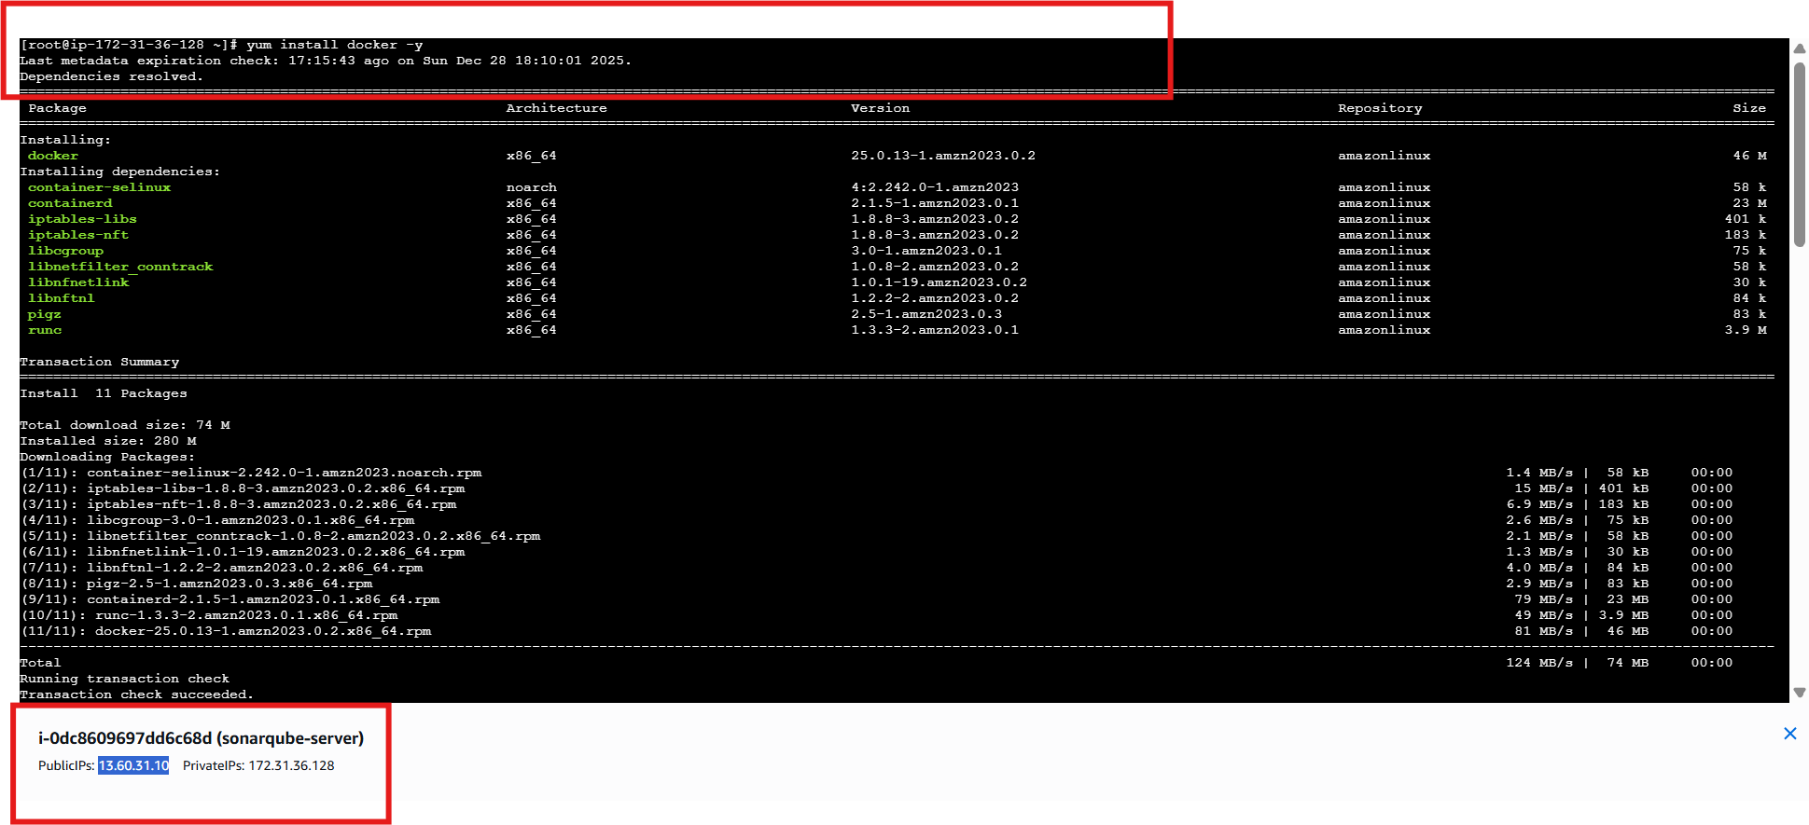

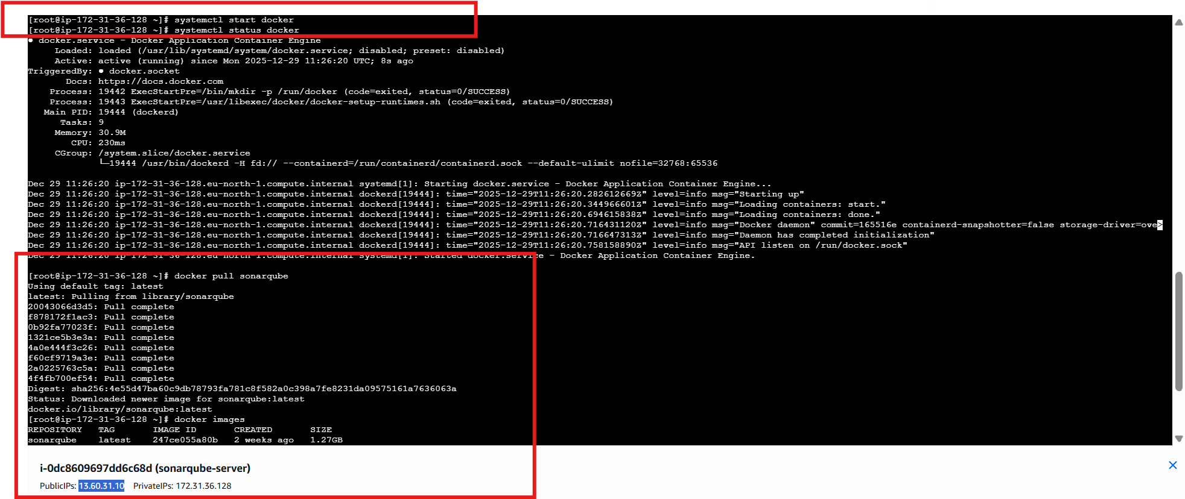

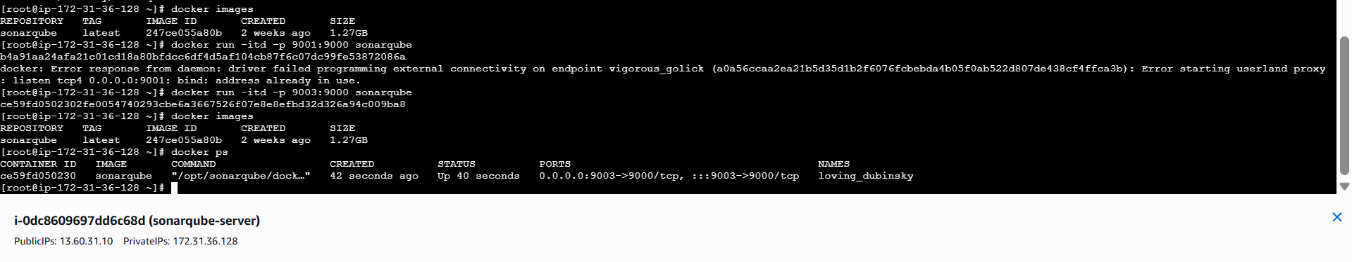

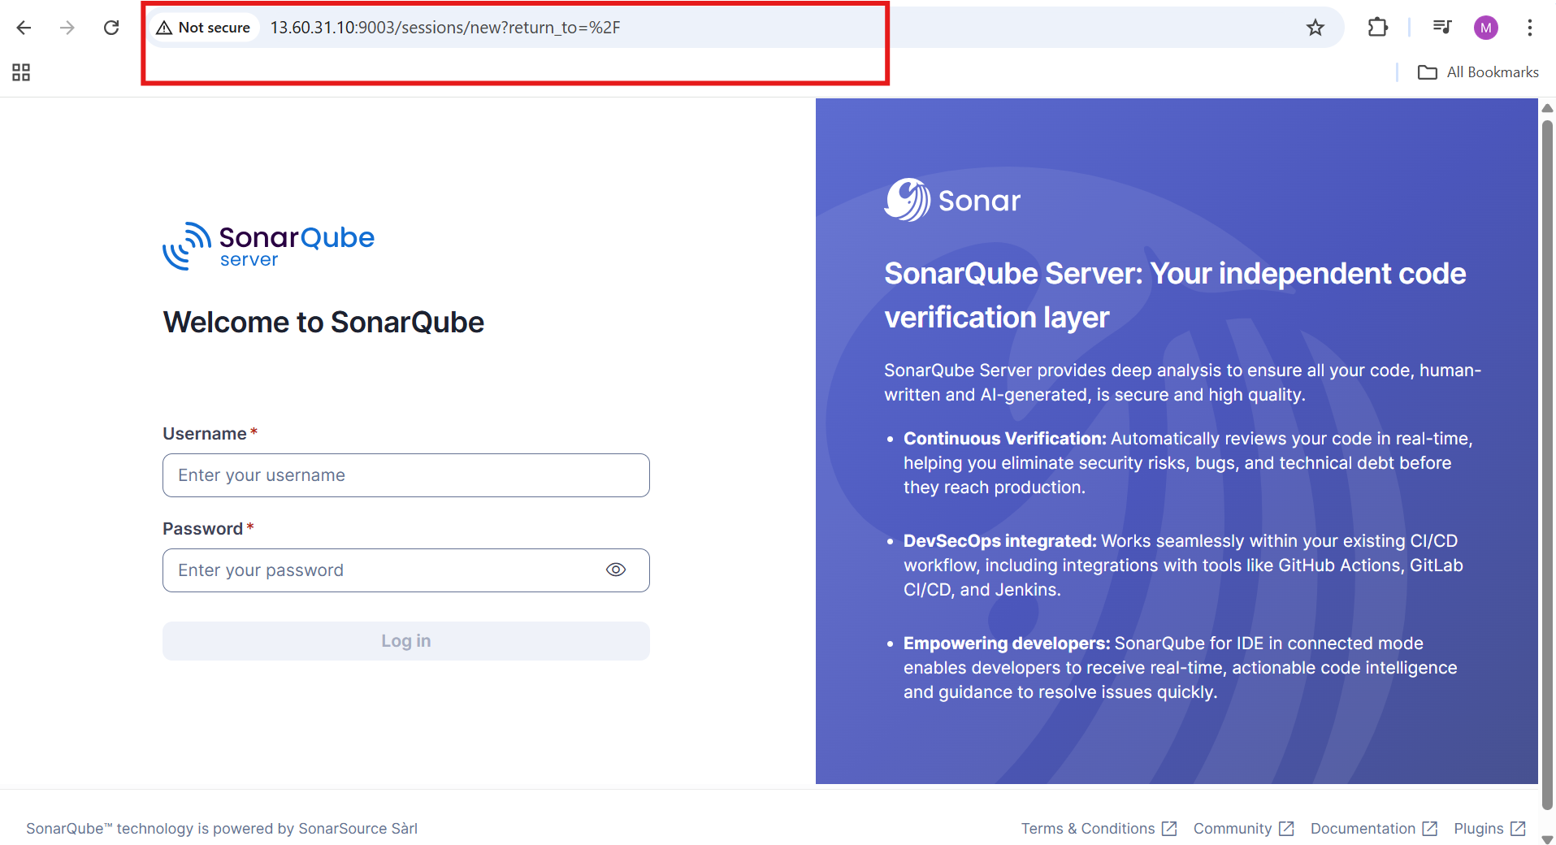

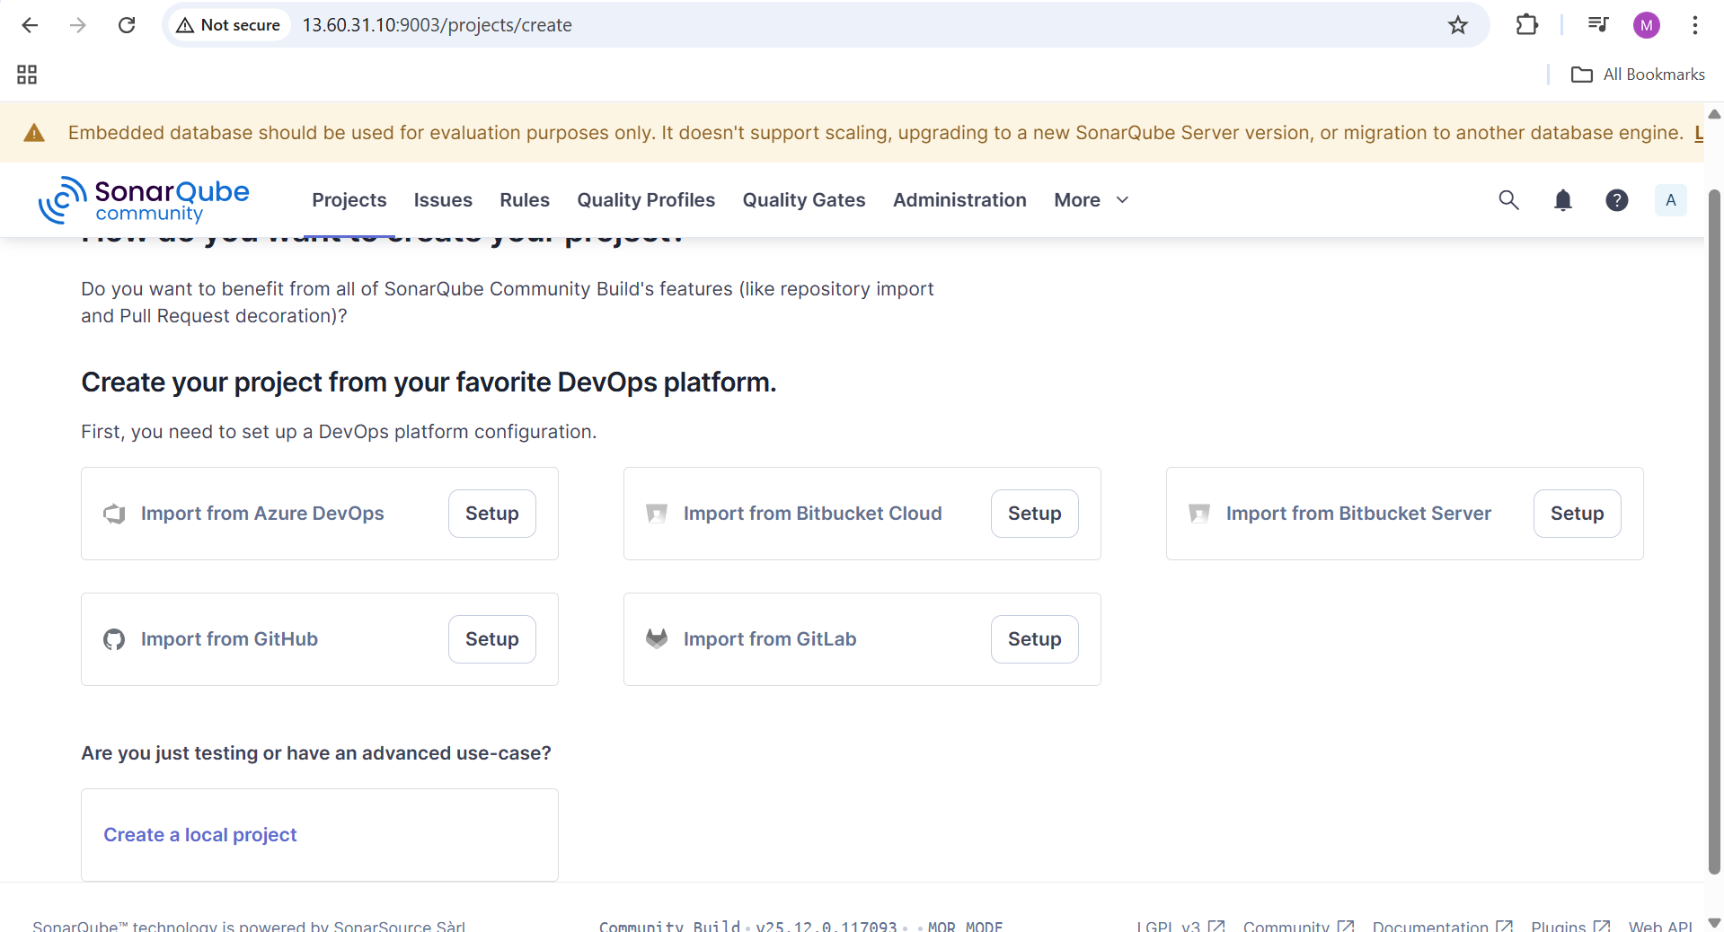

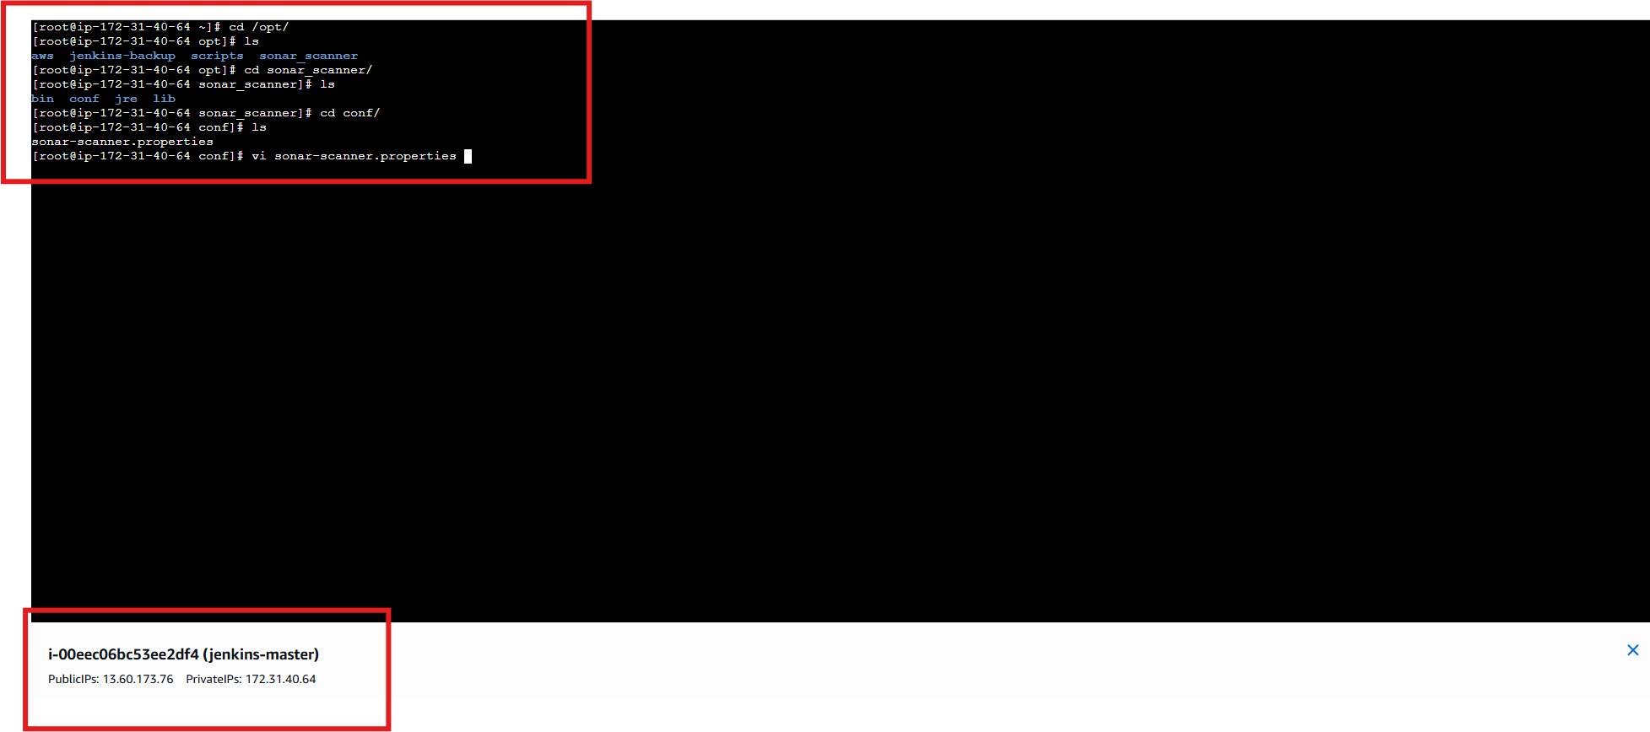

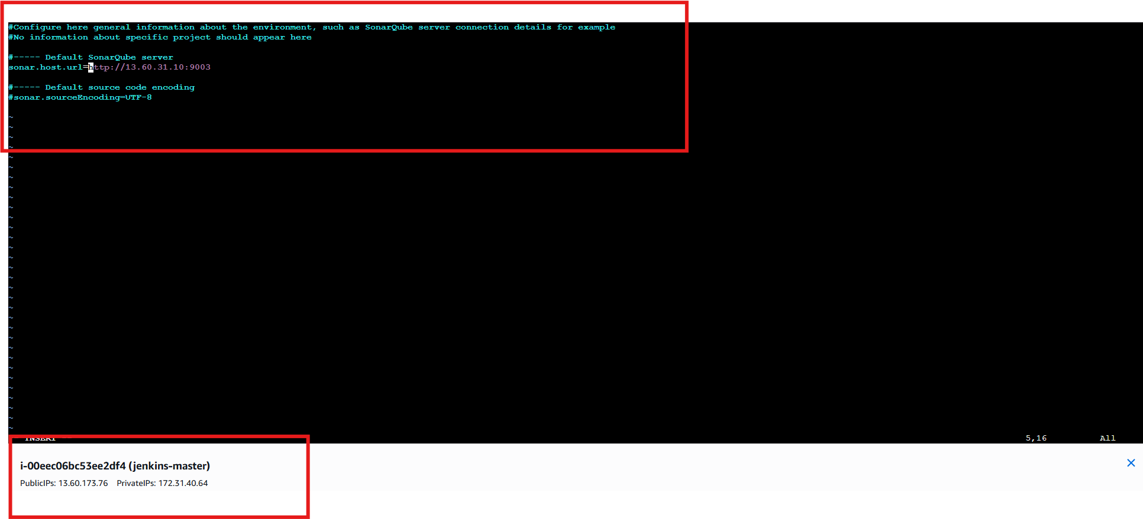

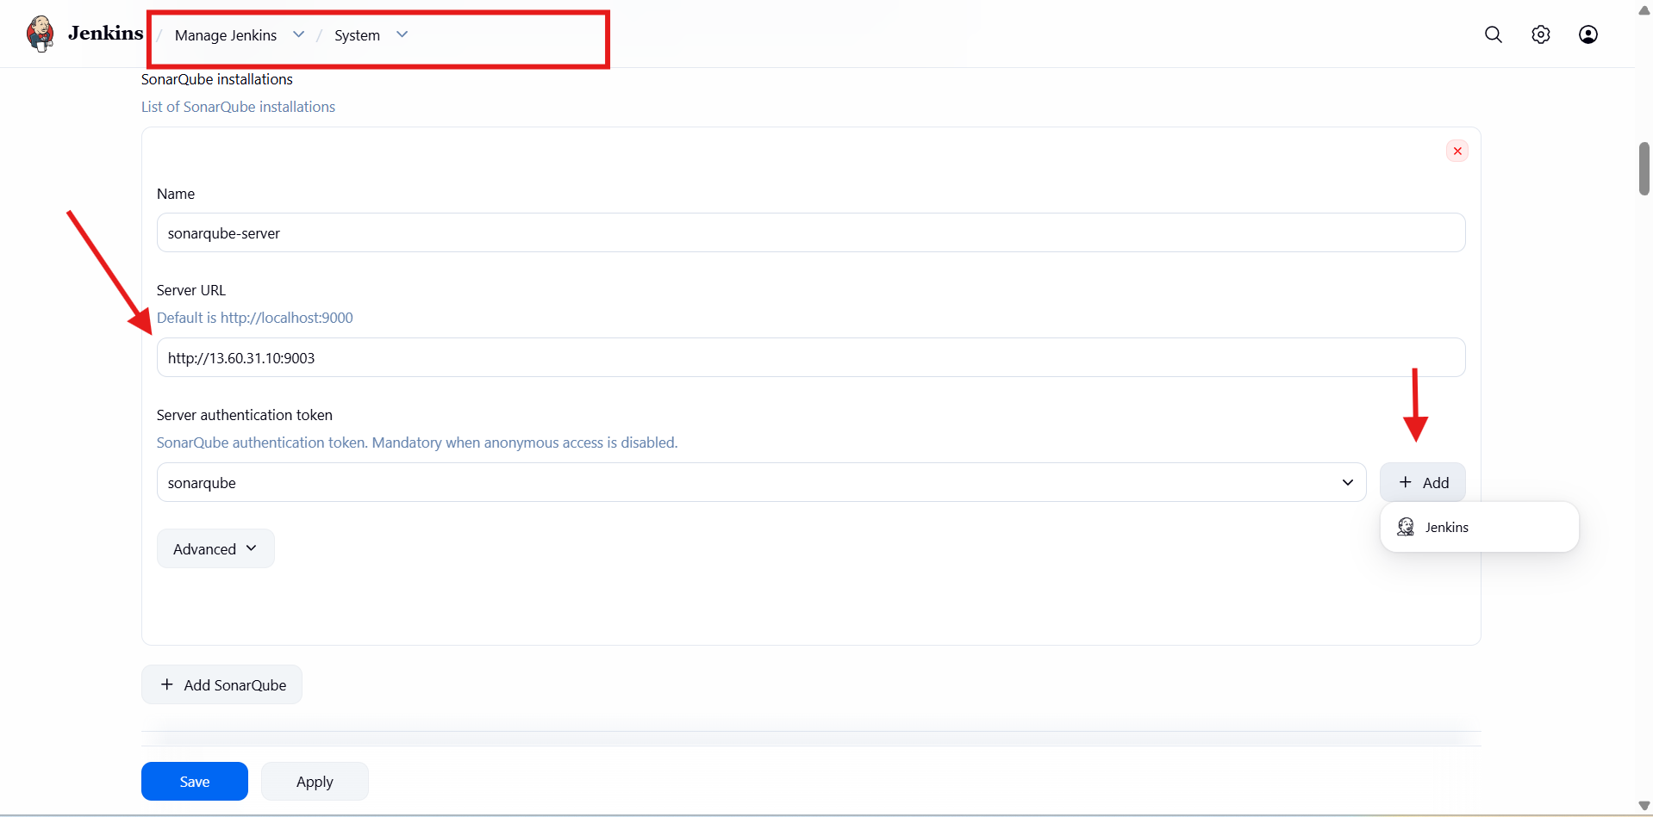
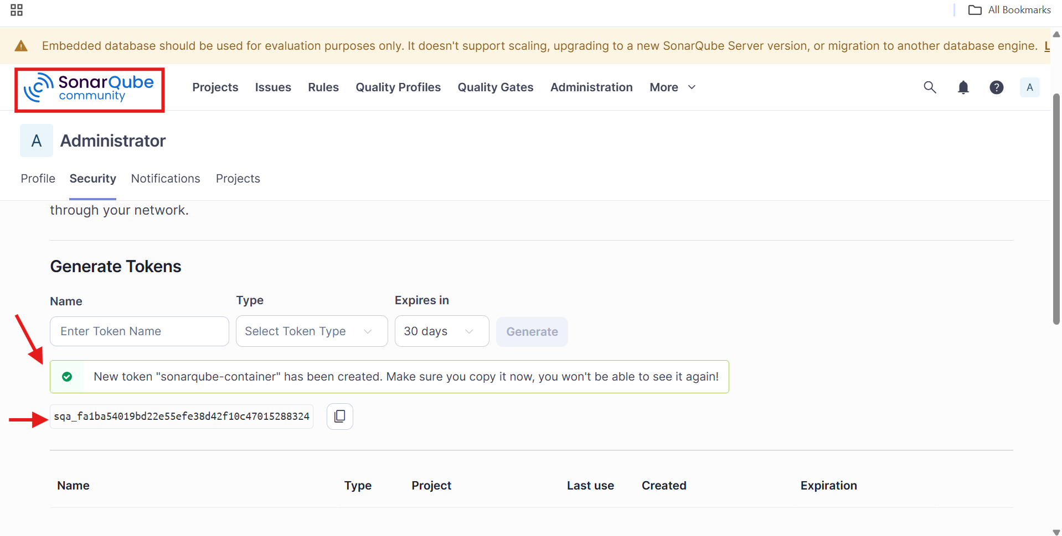

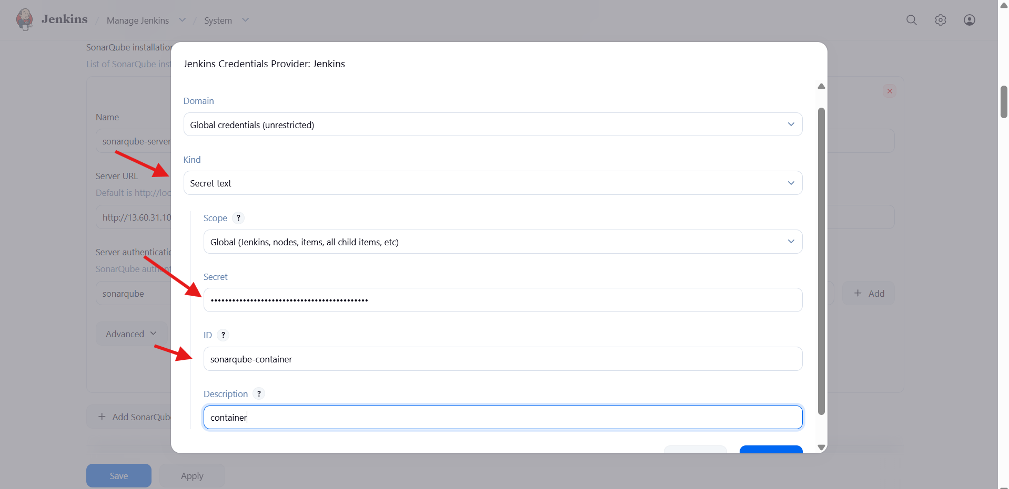
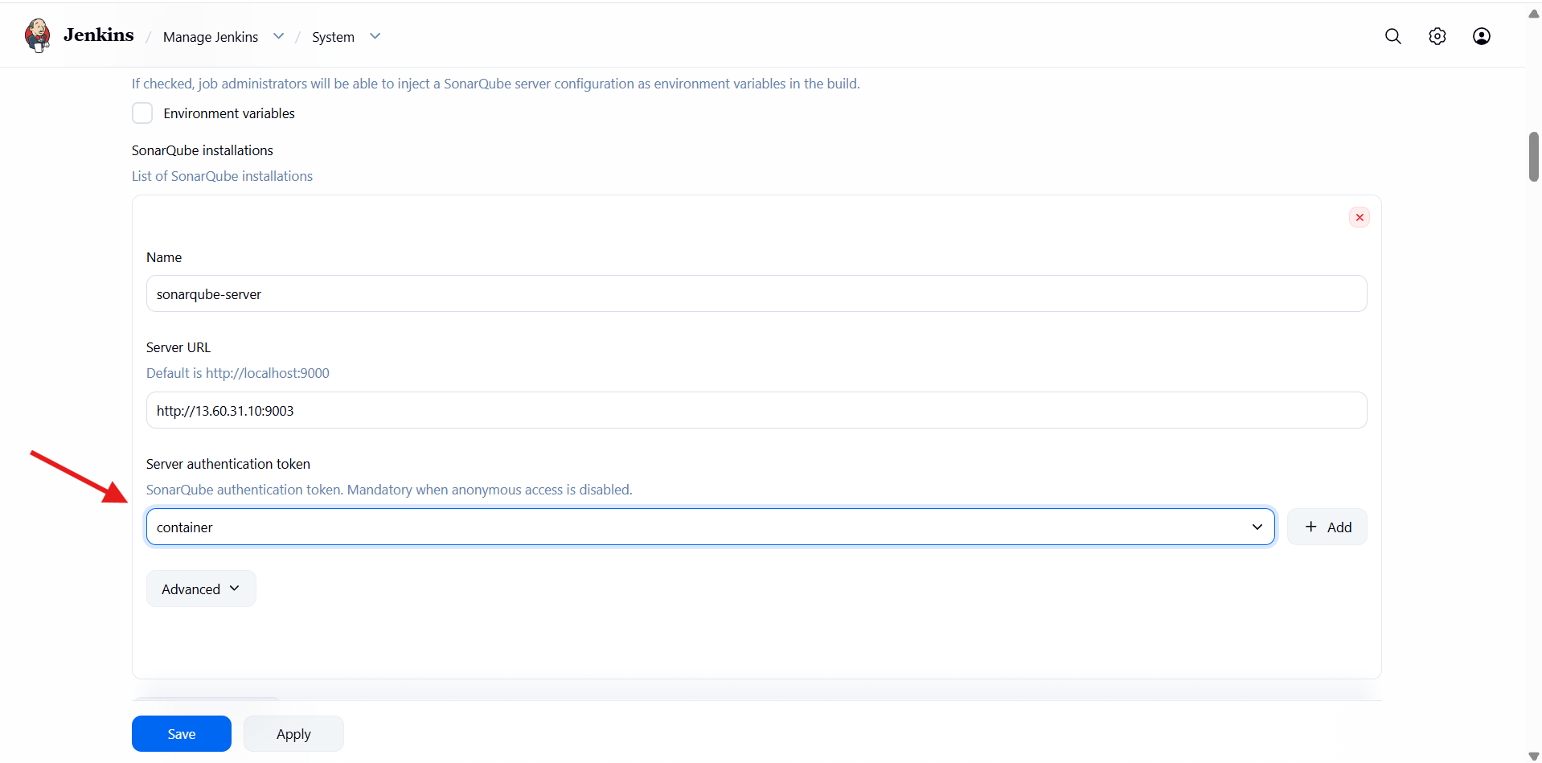

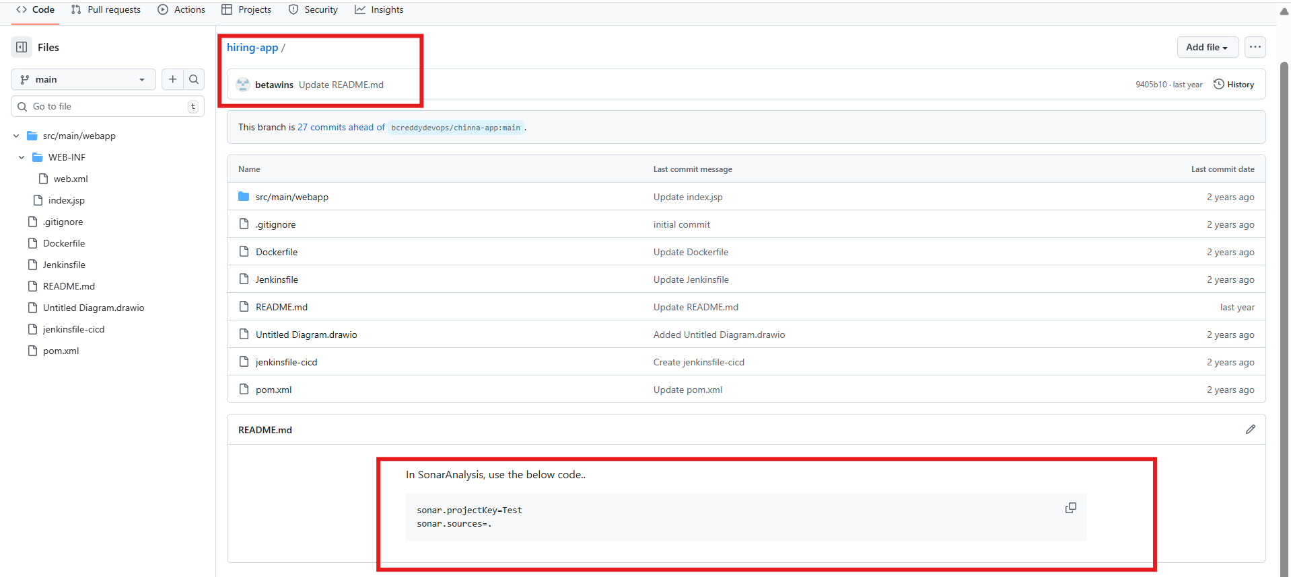

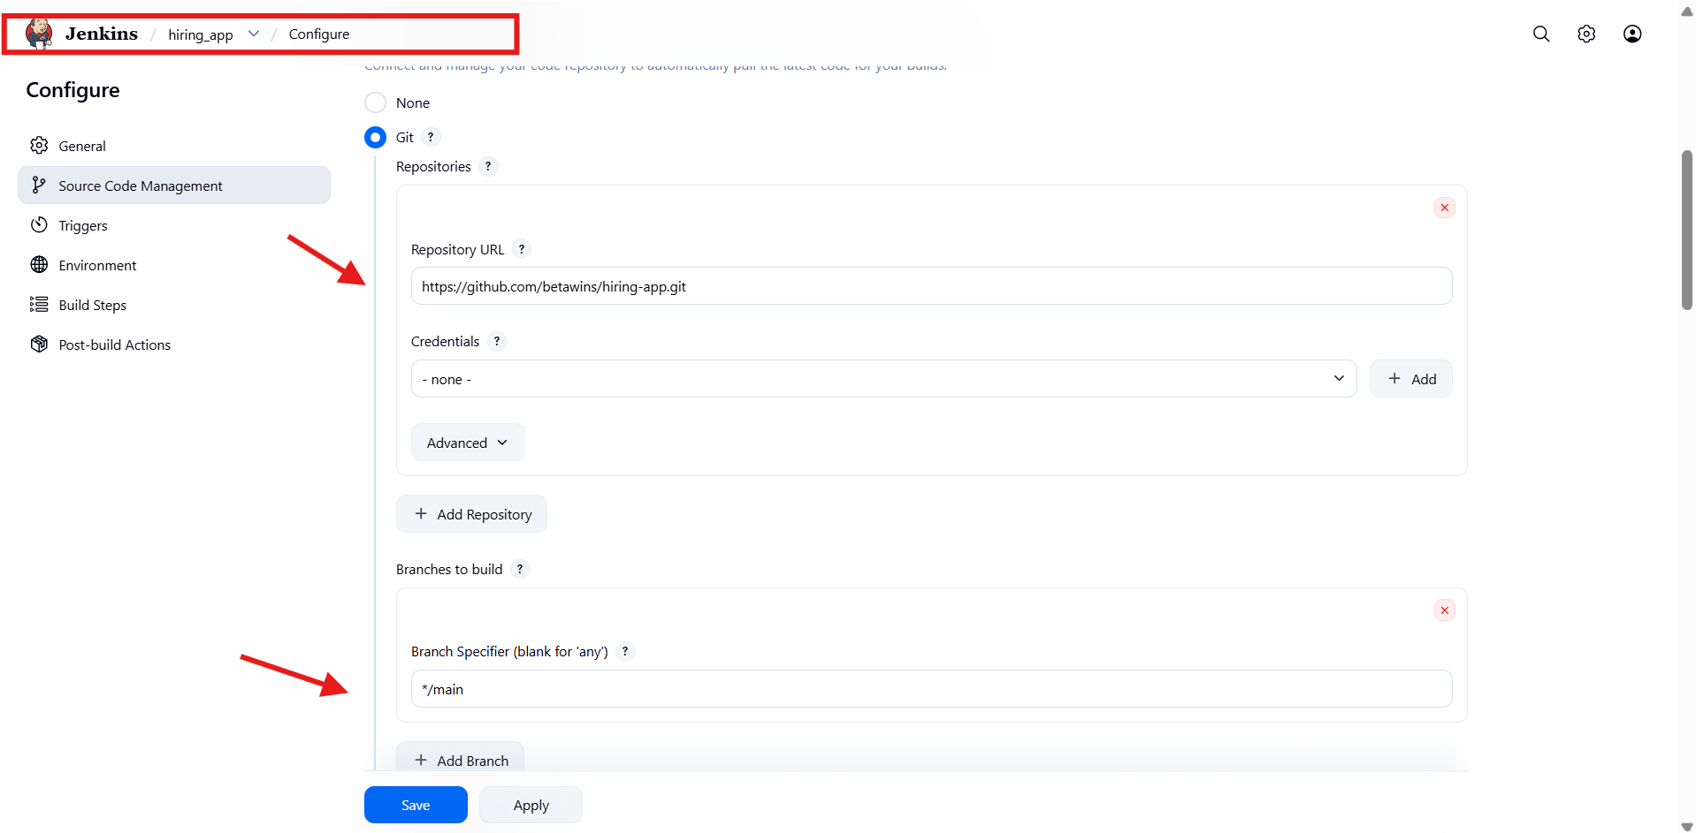

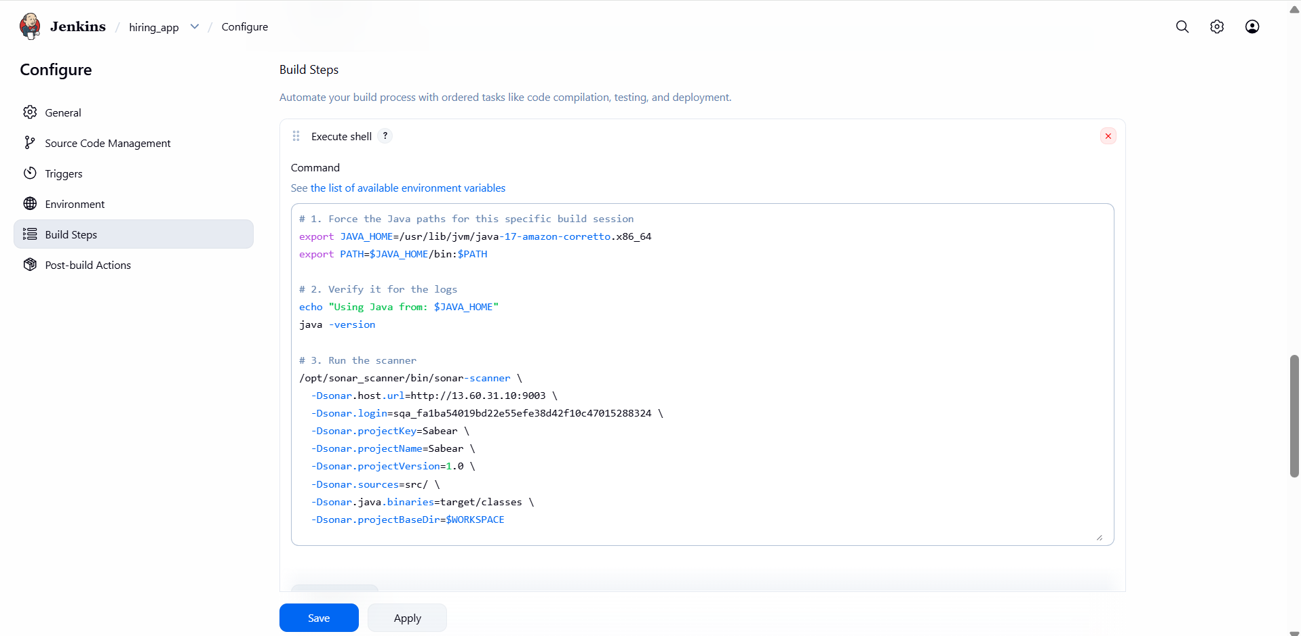
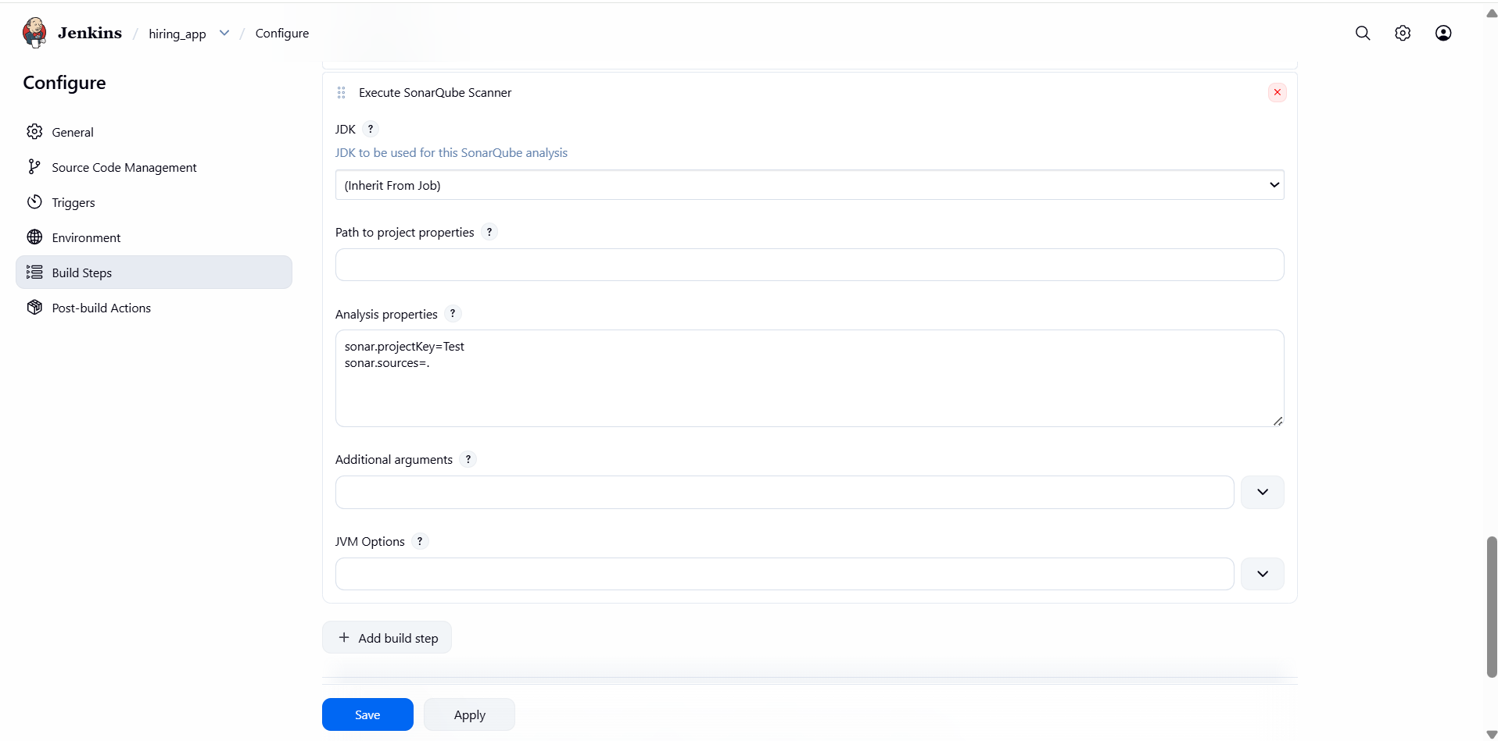

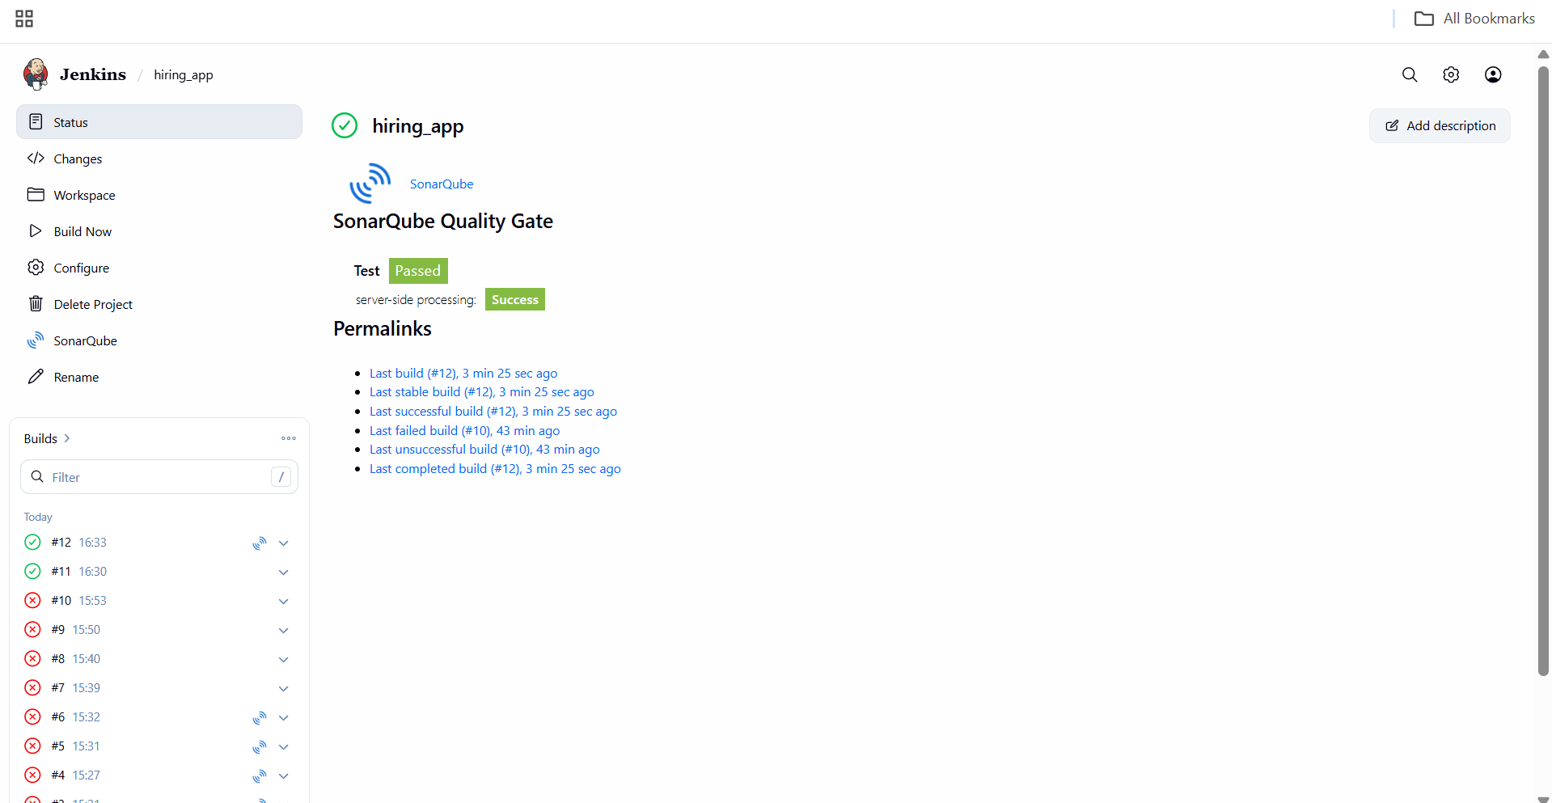

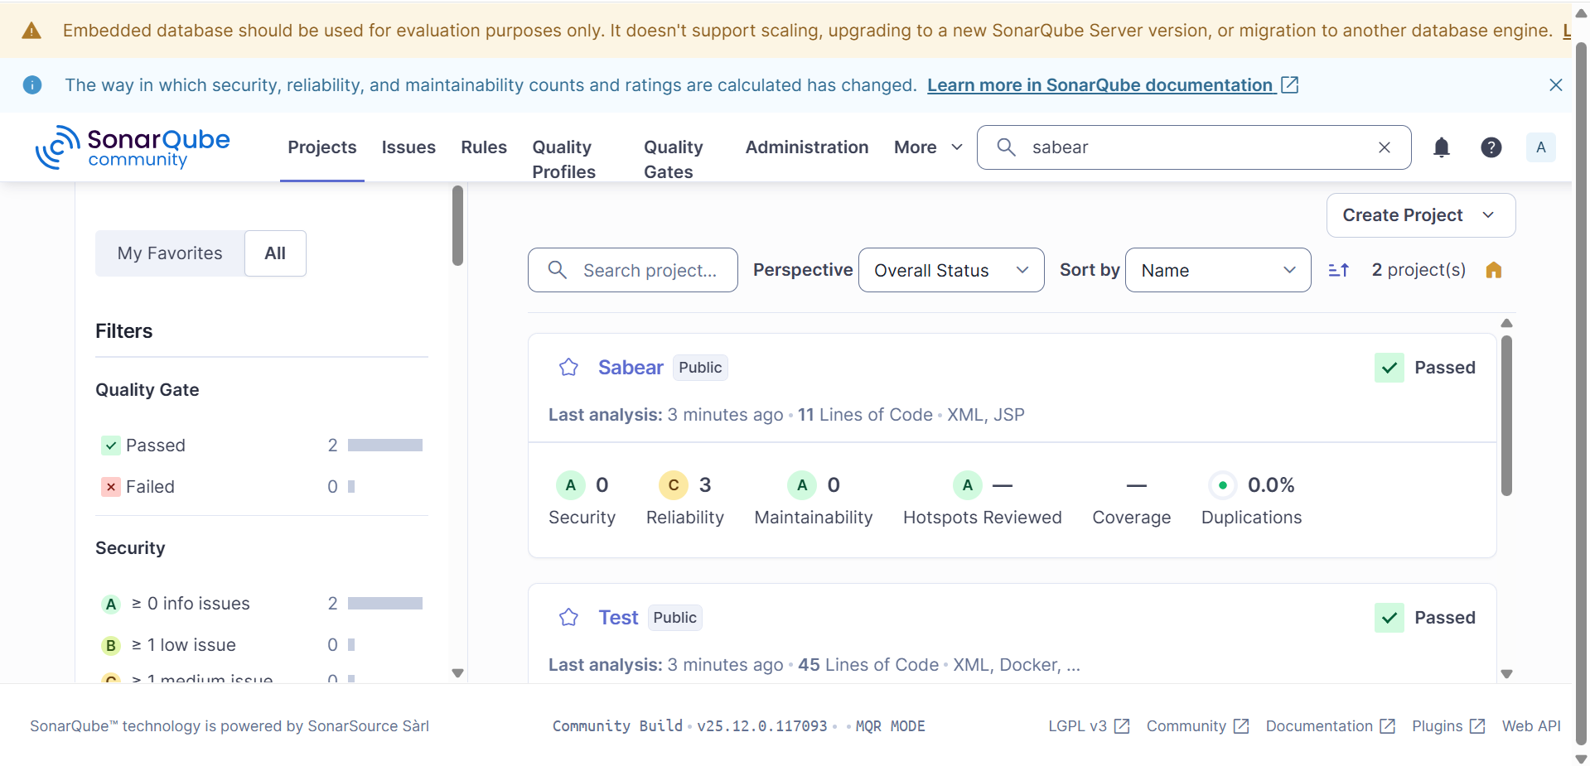

- stage3: Slack Integration to send the alerts to slack.

Jenkins Job Configuration Access
- Opened Jenkins job: hiring_app
- Clicked Configure
- Navigated to Post-build Actions
Reached post-build configuration section
Add Slack Notification
- Clicked Add post-build action
- Selected Slack Notifications from the list
Slack notification plugin added to the job
Notification Options Selected
- Enabled Notify Build Start
- Enabled Notify Success
- Left other options unchecked
Notifications configured for build start & success events
Save Configuration
- Clicked Save
Jenkins job configuration updated
▶ Trigger Build
- Clicked Build Now
- Build executed successfully
Build completed without errors
Slack Verification
- Slack channel received message:
  - Build started notification
  - Build success notification
- Message included:
  - Job name: hiring_app
  - Build number: #13
  - Status: Success
Slack integration working correctly

