

**AMERICAN INTERNATIONAL UNIVERSITY-BANGLADESH**

# Faculty of Engineering

Lab Report

# Experiment # 02

## Experiment Title: Familiarization with an STM32 Microcontroller Board, the study of an LED blink test, and implementation of a traffic light control system using an STM32 microcontroller board

|  |  |  |  |
| --- | --- | --- | --- |
| **Date of Perform:** | Date Month 2023 | **Date of Submission:** | 26 June 2023 |
| **Course Title:** | MICROPROCESSOR AND EMBEDDED SYSTEM LAB | | |
| **Course Code:** | COE3104 | **Section:** | N/A |
| **Semester:** | Summer 2022-23 | **Degree Program:** | BSc in CSE/EEE |
| **Course Teacher:** | **Prof. Dr. Engr. Muhibul Haque Bhuyan** | | |

**Declaration and Statement of Authorship:**

1. I/we hold a copy of this Assignment/Case-Study, which can be produced if the original is lost/damaged.
2. This Assignment/Case-Study is my/our original work and no part of it has been copied from any other student’s work or from any other source except where due acknowledgment is made.
3. No part of this Assignment/Case-Study has been written for me/us by any other person except where such collaboration has been authorized by the concerned teacher and is clearly acknowledged in the assignment.
4. I/we have not previously submitted or currently submitting this work for any other course/unit.
5. This work may be reproduced, communicated, compared, and archived for the purpose of detecting plagiarism.
6. I/we give permission for a copy of my/our marked work to be retained by the Faculty Member for review by any internal/external examiners.
7. I/we understand that Plagiarism is the presentation of the work, idea, or creation of another person as though it is your own. It is a form of cheating and is a very serious academic offense that may lead to expulsion from the University. Plagiarized material can be drawn from, and presented in, written, graphic and visual forms, including electronic data, and oral presentations. Plagiarism occurs when the origin of the source is not appropriately cited.
8. I/we also understand that enabling plagiarism is the act of assisting or allowing another person to plagiarize or copy my/our work.

*\* Student(s) must complete all details except the faculty use part.*

** Please submit all assignments to your course teacher or the office of the concerned teacher.

|  |  |  |  |  |
| --- | --- | --- | --- | --- |
| **Group #** | | | | |
| **Sl No** | **Name** | **ID** | **PROGRAM** | **SIGNATURE** |
|  |  | | |  |

|  |  |  |
| --- | --- | --- |
| ***Faculty use only*** | | |
| FACULTY COMMENTS | **Marks Obtained** |  |
|  |
| **Total Marks** |  |

# Table of Contents

|  |  |
| --- | --- |
| Experiment Title | 3 |
| Objectives | 3 |
| Equipment List | 3 |
| Circuit Diagram | 3 |
| Code/Program | 3 |
| Hardware Output Results | 4 |
| Experimental Output Results | 6 |
| Simulation Output Results | 9 |
| Discussion | 12 |
| References | 12 |

**Experiment Title:** Familiarization with an STM32 Microcontroller Board, the study of an LED blink test, and implementation of a traffic light control system using an STM32 microcontroller board.

## Objectives:

The objectives of this experiment are to –

1. Familiarization with the STM32 Microcontroller Board
2. Study of an LED blink test
3. Implementation of a traffic light control system

## Equipment List:

1. STM32 Cube
2. STM32 Microcontroller Board
3. LED Lights (Red, Green, yellow)
4. Three 100  resistors
5. Jumper Wires

## Circuit Diagram:

The Arduino platform is made up of the following components.

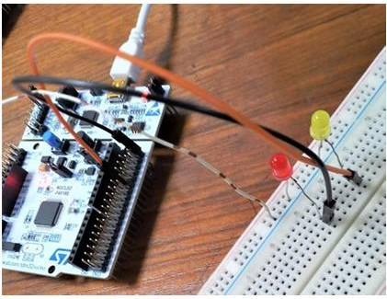

Fig. 1 Connection diagram of the LEDs with the STM32 Nucleo-F401RE Board

## Code/Program:

Here is the code of the LED blink test and the necessary explanation of the implementation:

HAL_GPIO_TogglePin(GPIOA, GPIO_PIN_5); //Selecting Pin to Toggle HAL_Delay(1000); //Delay operation

Here is the code of the LED blink test and the necessary explanation of the implementation: HAL_GPIO_WritePin(GPIOA,GPIO_PIN_5,GPIO_PIN_SET);//turn on green led HAL_Delay(3000); //Keep green led on for 3s HAL_GPIO_WritePin(GPIOA,GPIO_PIN_5,GPIO_PIN_RESET); //turn off green led

for(int i = 0; i < 3; i++){

HAL_GPIO_WritePin(GPIOA,GPIO_PIN_6,GPIO_PIN_SET);//turn on yellow led

HAL_Delay(1000); //Keep yellow led on for 1s HAL_GPIO_WritePin(GPIOA,GPIO_PIN_6,GPIO_PIN_RESET);//turn off

yellow led

}

HAL_GPIO_WritePin(GPIOA,GPIO_PIN_7,GPIO_PIN_SET);//turn on red led HAL_Delay(5000); ////Keep red led on for 5s HAL_GPIO_WritePin(GPIOA,GPIO_PIN_7,GPIO_PIN_RESET); //turn off red led

## Hardware Output Results:

Here is the hardware implementation of the LED blink test and the necessary explanation of the implementation:

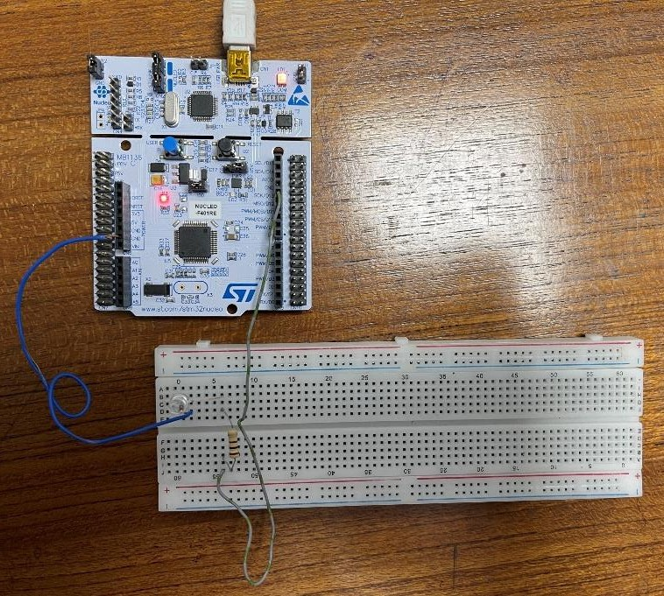

Fig 2 Hardware implementation for the blink test

Explanation: In the following implementation, a jumper wire was connected at the D11 pin of the STM32 Microcontroller board. The wire was connected to the breadboard. The anode of an LED light was connected with 100  resistor. The cathode of the LED light was connected with GND pin of the STM32 Microcontroller board. The STM32 Microcontroller Board was connected to a PC to compile and import necessary codes.

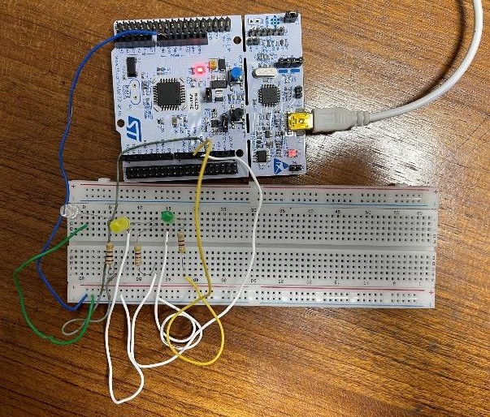Here is the hardware implementation of the Traffic Light System and the necessary explanation of the implementation:

Fig 3 Hardware circuit diagram for the traffic light system

Explanation: In the following experiment, jumper wires were connected from D11, D10 and D12 of the STM32 Board microcontroller to the anodes of the RED, YELLOW and GREEN LED consecutively. Three 100 Ω resistors were connected at each cathode of all the LEDs. Jumper wires were then connected at the negative common row of the breadboard. A jumper wire was connected then with the Ground (GND) of the STM32 Microcontroller board from the common negative of the breadboard. The STM32 board was connected with a PC to compile and import necessary codes.

## Experimental Output Results:

Here are results of the light blink test and the necessary explanation of the results:

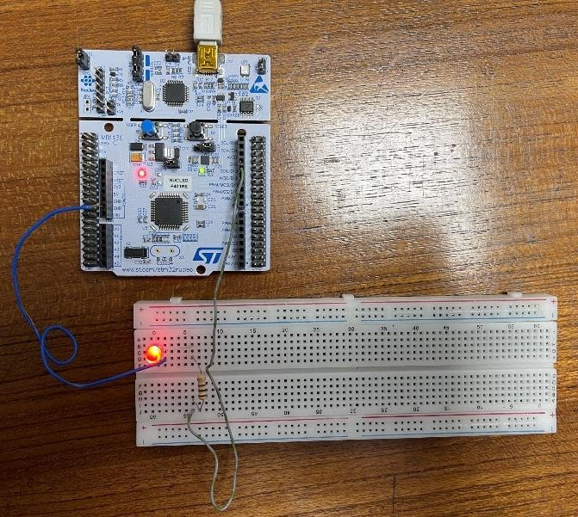

Fig 4 LED is ON in Light Blink test

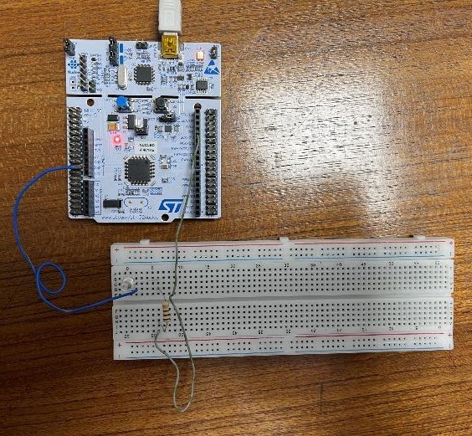

Fig 5 LED is OFF in Light Blink Test

Explanation: When the code is implemented and the while() function starts, the code implements a digital write operation on the microcontroller and provides a high voltage at the pin 2 as output. Hence, the LED that was connected at pin 2 turns ON (Fig. 4). A delay occurs afterwards for a certain time. This time was defined in milliseconds. According to the code that was implemented, a 1000 millisecond delay occurs after the light is turned ON. Then, another digital write operation occurs and the pin 5 was set to LOW as

output. Therefore, the LED turns OFF (Fig. 5). Another 1000 millisecond delay occurs after the LED was set to low. The above operations were in a loop. Thus, these results were happening one by one until the microcontroller was turned off or removed from the power source.

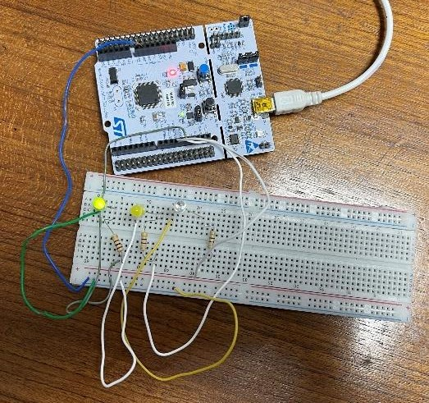Here are results of the Traffic Light System and the necessary explanation of the results:

Fig 6 GREEN LED is ON in Traffic Light System

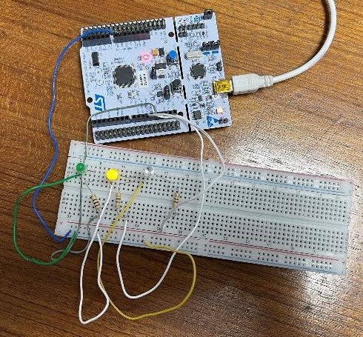

Fig 7 YELLOW LED is ON in Traffic Light System

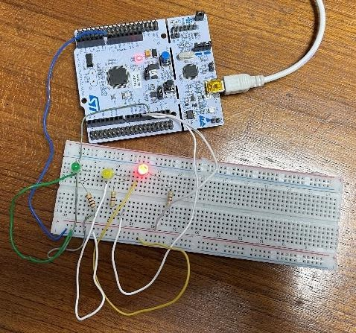

Fig 8 RED LED is ON in Traffic Light System

Explanation: When the code is implemented and the while() function starts, the code implements a digital write operation on the microcontroller and provides a high voltage at the pin 12 as output. As a result, the green light turns ON (Fig. 6). Then the light stayed on for 3000 milliseconds due to the delay function called ‘green_on’. After that, the light turned off as a digital write was performed on the microcontroller 10 and output at pin 12 was low. Then, a for loop was introduced in the code which made the microcontroller blink the yellow light 4 times with an interval of 500 milliseconds (Fig. 7) for the delay caused by the value set on ‘yellow_blink’. When the yellow LED blinked for 4 times, then the red LED turns on (Fig. 8). It turned off after 6000 millisecond which was set in the ‘red_on’ variable and was used a delay function. All the operations kept occurring as all of the codes were performed in a loop

## Simulation Output Results:

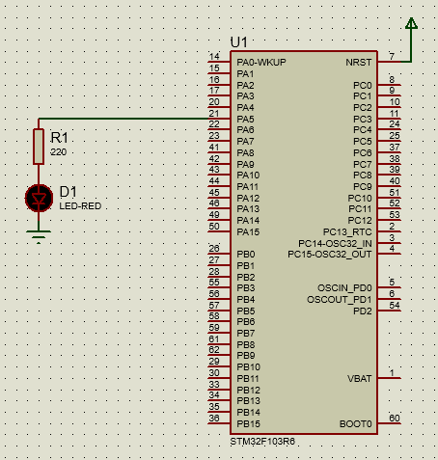Here are simulation results of the light blink test using Proteus simulation software and the necessary explanation of the results:

Fig 9 LED is OFF in LED Blink Test in Proteus Simulation

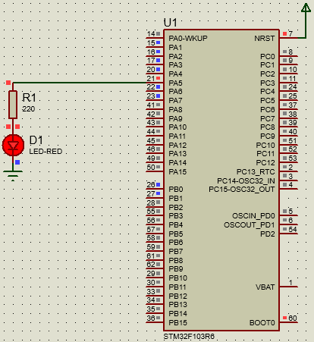

Fig 10 LED is ON in LED Blink Test in Proteus Simulation

Explanation: In this simulation, an STM32F401RE Board, Resistor and a LED was configured according to the hardware implementation that was performed. The program was made in the STM IDE and at first

the pins were selected properly. Then, the HEX file was generated. The following HEX file was implemented in the Proteus simulation for operation related instructions of the simulation. Afterwards, the simulation was performed and the results that were obtained were noted and compared with the hardware results.

Here are the simulation results of the Traffic Light System using Proteus Simulation Software and the necessary explanation of the results:

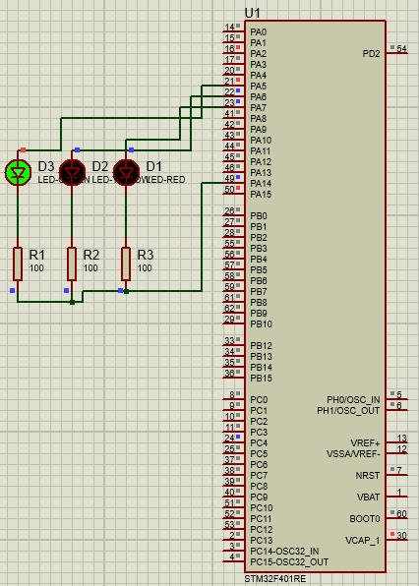

Fig 11 GREEN LED is ON in Traffic Light System in Proteus Simulation

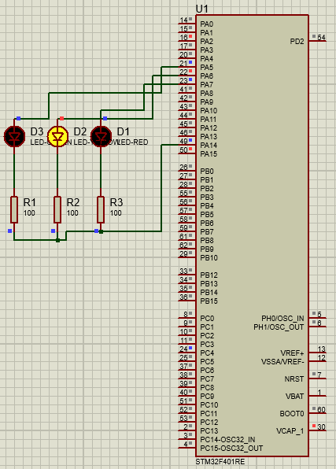

Fig 12 Yellow LED is ON in Traffic Light System in Proteus Simulation

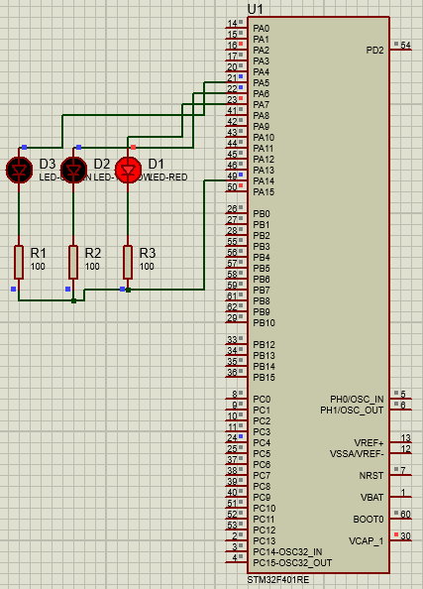

Fig 13 RED LED is ON in Traffic Light System in Proteus Simulation

Explanation: In this simulation, a STM32F401RE Board, Resistors, RED, GREEN and YELLOW LEDs were configured according to the hardware implementation that was performed. The program was made in the STM IDE and at first the pins were selected properly. Then, the HEX file was generated and the following HEX file was implemented in the Proteus simulation for operation related instructions of the

simulation. Afterwards, the simulation was performed and the results that were obtained were noted and compared with the hardware results.

## Discussion:

The experiment conducted was aimed to familiarize with an STM32 Microcontroller Board, study an LED blink test, and implement a traffic light control system using the STM32 microcontroller board. The objectives of the experiment were successfully achieved, and several key insights and findings were obtained. The process of familiarization with the STM32 Microcontroller Board proved to be crucial in understanding its architecture, features, and capabilities. Through exploration and study, knowledge was gained about the various components, such as the pin configurations, input/output functionalities, and communication interfaces. This understanding provided a solid foundation for further experimentation and programming tasks. The study of the LED blink test served as a practical exercise to apply the acquired knowledge and programming skills. By programming the STM32 microcontroller board, the state of an LED was successfully controlled, and its blinking at a desired frequency was observed. This exercise helped grasp the fundamentals of coding syntax specific to the microcontroller and improved proficiency in working with GPIO pins. The most significant aspect of this experiment was the implementation of a traffic light control system using the STM32 microcontroller board. Through careful planning and programming, the behavior of a traffic light was simulated, including the timing and sequencing of different signal states. This exercise provided valuable hands-on experience in utilizing the board's capabilities to create a functional system. Hence it can be said that all the objectives of the experiment were obtained.

**References**:

1. Predictable Designs, *Introduction to Programming STM32 ARM Cortex-M 32-bit Microcontrollers* [Online: October 12, 2022], [Cited: June 23, 2023] Available: https://predictabledesigns.com/introduction-to- programming-stm32-arm-cortex-m-32-bit-microcontrollers/
2. STMicroelectronics Data-sheet Portal, [Online] [Cited: June 25, 2023] Available: https://[www.google.com/url?sa=t&rct=j&q=&esrc=s&source=web&cd=&ved=2ahUKEwjDsMzvp-](http://www.google.com/url?sa=t&rct=j&q&esrc=s&source=web&cd&ved=2ahUKEwjDsMzvp-) H_AhVS1zgGHf7nB3cQFnoECBYQAQ&url=https%3A%2F%2Fwww.st.com%2Fresource%2Fen%2Fdata sheet%2Fstm32f401re.pdf&usg=AOvVaw02QBOdC9JEsY7_FkFyLxHD&opi=89978449
3. AIUB Microprocessor and Embedded Systems Lab Manual 2