preAdvising

This software project is just a part of Student Management System. The software is used by the students to register their courses in the semester through Internet and/or LAN. Remote Method Invocation (RMI) and JDBC technologies are involved here. It supports multiple login and registration status anytime and from ANY part of the WORLD.

Compile :
From the folder ‘server’, double click on ‘CompileAll.bat’ file to run.

Run :
Server Side:
- From the folder ‘server’ open ‘runServer.bat’ file using Notpad or any other editor.
- Change the path as required in the first line:
set PATH=D:\jdk\bin
- Save and exit from the editor.
- Double click on ‘runServer.bat’ file to run.

Client Side:
- From the folder ‘client’ open ‘run.bat’ file using Notpad or any other editor.
- Change the path as required in the first line:
set PATH=D:\jdk\bin
- Change the second line:
java ClientLogin 127.0.0.1
replace the 127.0.0.1 with the server IP. Say:
java ClientLogin 123.123.123.123
or if you want to test it locally in the same machine leave it as it is.
- Save and exit from the editor.
- Double click on ‘run.bat’ file to run.
- When username and password asks, try the following:
Username: zim
Password: 123

Username: admin
Password: 1234
- You may see a window like the following:

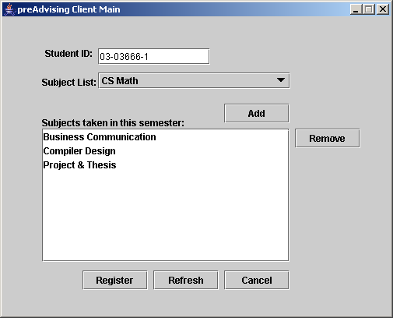

- Try the following student IDs and press Enter:
03-03666-1, 01-01111-1, 02-02222-2, 03-03333-3
- Now use however you like.

