**Breakdown of the system**

**Backend**

As per requirement PHP & its framework *CodeIgniter* is used as backbone of the system.

Design pattern MVC is followed

Events controller is used to perform multiple functions

Such as fetch events details which is being shown at home page.

Load stands details (dimensions,price,free/available company… ).

Being used to download company documents.

To save stand reservation including company registration along their marketing documents.

To keep track of users visit to stand

To generate report about the users who visited company stand on the event after it is over

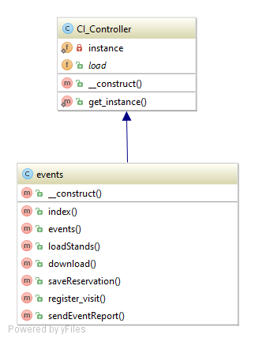

Event Model

Event model is being used with event controller back to back. Providing data access to controller for its all functions

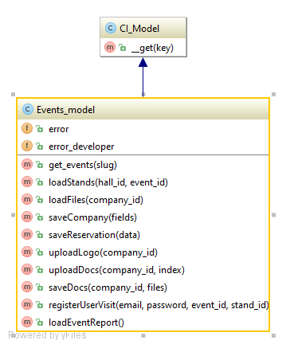

**Front End**

As per requirement front end framework AngularJs ver 1.6.2 is being used.

Angular app name is ‘evnts’ & available at assets/js/events/module.evnts.js

Two directive fileUpload & filesUpload are created to upload company logo & multiple marketing documents.

Controller named ‘evntsController’ handling all front end navigation & operations such as

load data from server by consuming angular data service including events details, stand details. Stand Reservation feature, uploading company information such as logo & documents. Individual stand detail view in popup, feature by which user can visit stand. Which stand need to be marked as free or reserved. & so on…

**Directory Structure**

**MVC**

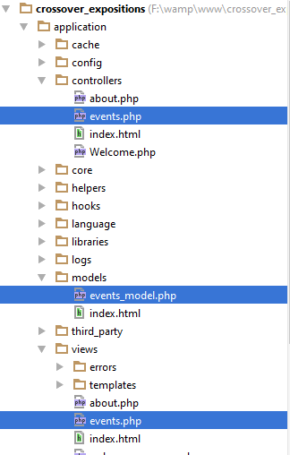

**Assest & Upload directory**

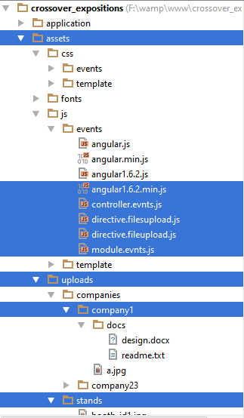

**ER Diagram**

