# Project Title: Enchanted Wings: Marvels of Butterfly Species

Team ID: LTVIP2025TMID42172

## Technology Stack (Architecture & Stack)

Date: 26 JUNE 2025

Team ID: LTVIP2025TMID42172

Project Name:Enchanted Wings Marvels of Butterfly Species

Maximum Marks: 4 Marks

### Technical Architecture:

The Deliverable shall include the architectural diagram as below and the information as per the Table 1 & Table 2.

Example: Order processing during pandemics for offline mode

Note: Actual architectural diagrams should be created using diagramming tools like Lucidchart, Draw.io, or PowerPoint.

Insert Architectural Diagram Here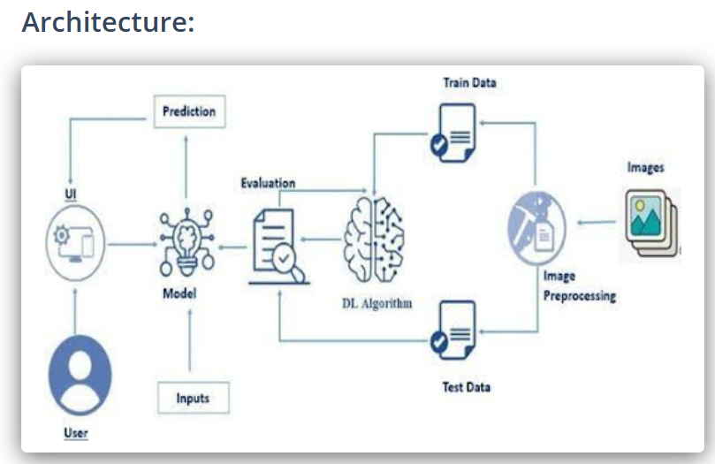

**Table-1 : Components & Technologies:**

|  |  |  |  |
| --- | --- | --- | --- |
| **S.No** | **Component** | **Description** | **Technology** |
|  | User Interface | How user interacts with application e.g.  Web UI, Mobile App, Chatbot etc. | HTML, CSS, JavaScript / Angular Js / React Js etc. |
|  | Application Logic-1 | Logic for a process in the application | Java / Python |
|  | Application Logic-2 | Logic for a process in the application | IBM Watson STT service |
|  | Application Logic-3 | Logic for a process in the application | IBM Watson Assistant |
|  | Database | Data Type, Configurations etc. | MySQL, NoSQL, etc. |
|  | Cloud Database | Database Service on Cloud | IBM DB2, IBM Cloudant etc. |
|  | File Storage | File storage requirements | IBM Block Storage or Other Storage Service or Local Filesystem |
|  | External API-1 | Purpose of External API used in the application | IBM Weather API, etc. |
|  | External API-2 | Purpose of External API used in the application | Aadhar API, etc. |
|  | Machine Learning Model | Purpose of Machine Learning Model | Object Recognition Model, etc. |
|  | Infrastructure (Server / Cloud) | Application Deployment on Local System / Cloud  Local Server Configuration:  Cloud Server Configuration : | Local, Cloud Foundry, Kubernetes, etc. |

**Table-2: Application Characteristics:**

| **S.No** | **Characteristics** | **Description** | **Technology** |
| --- | --- | --- | --- |
|  | Open-Source Frameworks | List the open-source frameworks used | Technology of Opensource framework |
|  | Security Implementations | List all the security / access controls implemented, use of firewalls etc. | e.g. SHA-256, Encryptions, IAM Controls, OWASP etc. |
|  | Scalable Architecture | Justify the scalability of architecture (3 – tier, Micro-services) | Technology used |
|  | Availability | Justify the availability of application (e.g. use of load balancers, distributed servers etc.) | Technology used |
|  | Performance | Design consideration for the performance of the application (number of requests per sec, use of Cache, use of CDN’s) etc. | Technology used |