

24320124 FangJiahui 484009
24320109 LiYUqian 483689
24320219 WangYicheng 484429

Information systems
Report

2026
Contents
Task1 3
Results1 5

Task
Date:3.26

1. Create ER model for your Information system
2. Show and discourse your ER model with the teacher - if necessary, then correct it according to teacher's advice
3. Upload approved ER model to gitlab - this will be your first commit
4. Describe Business Logic of your Information System
5. Describe requirements analysis (as in Software Requirement Specification)
6. Describe ER Database diagram
7. Create DB according to your ER model from subtask 3

Results

Student Training Course Management System - Business Logic Description
1. Core objectives of the system
This system provides information management services for student training courses, with the core being:
Let teachers publish and maintain their own courses;
Allow all users to browse, view course information, and download syllabuses;
Let administrators manage user roles to ensure controllable system permissions.
II. Roles and Authority Boundaries
The system comprises three types of roles, with permissions adhering to the principle of inheritance + extension:
student
You can access the "User Center" for registration, login, logout, and password modification;
Access to "Course Content": Browse the course directory, view course details, browse by pages, and download the syllabus;
No permissions for course management or member management.
teacher
Inherit all the permissions of the student;
Additional access to "Course Management": add courses, modify personal course information, and delete personal courses;
You are not allowed to operate other teachers' courses, nor do you have member management permissions.
administrator
Inherit all the permissions of the teacher;
Additional access to "Member Management": Convert students to teachers and teachers to students;
We do not directly participate in the editing of course content, but only manage user identities and permissions.
III. Core Business Process Logic
1. User Center
Registration system: User fills in account information → System verifies the uniqueness of the account → Creates a "student" role account;
Login system: User submits account and password → System verifies validity → Generates login status; already logged-in users cannot log in again, and the system intercepts duplicate requests;
Logout system: Destroy current login status → Users need to log in again to perform restricted operations;
Change password: Verify original password → Update password → Maintain login status or request to log in again.
Note: The above use cases are all sub-use cases of the "User Center". Any user operation on the account will trigger the corresponding process.
2. Course content
View course information: User clicks on course entry → displays course name, duration, description text, and syllabus file → supports downloading of syllabus;
Paging browsing: When the number of courses is too large, automatic paging display is triggered to optimize the browsing experience (extended use case, only effective when the data volume is large);
All users can access it without requiring special permissions.
3. Course management
Add course: The teacher submits course information (name, duration, description, syllabus) → the system verifies required fields → associates it with the current teacher's account and stores it in the database;
Modify course information: Only course publishing teachers can operate → Verify identity → Update course data (without changing ownership);
Deleting course information: Only course publishers can perform this operation → Verify identity → Remove the course, and users will no longer be able to view it.
Note: The above use cases are all sub-use cases of "Course Management". Teachers can only manage the courses they have published.
4. Member management
Convert student to teacher: Administrator selects target student → verifies identity → upgrades user role to teacher and simultaneously grants course management permissions;
Convert teacher to student: The administrator selects the target teacher → verifies the identity → downgrades the user role to student and revokes the course management permissions.
Note: The above use cases are all sub-use cases of "Member Management" and can only be executed by administrators.
IV. Rules and Constraints
Permission constraints
Teachers can only manage their own courses and are unable to operate courses belonging to others;
Already logged-in users cannot log in again, and unlogged-in users cannot perform course management or role changes;
Administrators cannot modify or delete course content, and can only manage user roles.
data constraint
The course must include the name, duration, and description, with the outline file being optional;
User accounts are unique and cannot be registered repeatedly;
After role change, the user's historical operation records will be retained, with only the scope of authority changing.
Business constraints
The pagination function is automatically triggered only when the number of courses exceeds a certain threshold;
Before deleting a course, a prompt should be given to the teacher for confirmation, and the course cannot be restored after deletion.
V. Summary of Business Circulation
Register as a new user → Log in as a student → Browse courses;
Teacher login → Add/Modify/delete own courses → Course information updated is visible to all users;
Administrator login → Adjust user roles → Synchronize and update permissions;
All operations undergo identity verification and permission verification to ensure system security and data consistency.
Technical specification: Student training course management system

Document version: V1.0
1 Introduction
1.1 Document purpose
This document clarifies the development objectives, scope of application, functional and non-functional requirements of the student training course management system. It serves as the core basis for the development team, testers, and course reviewers throughout the entire process of system development, testing, and acceptance.
1.2 System Objectives and Purposes
Objective (Macro): To establish a lightweight platform for course information display and permission management, addressing issues such as scattered training course information, inconvenient course maintenance for teachers, and chaotic user role management.
Objectives (quantifiable): Achieve permission isolation for three types of roles; ensure course browsing and loading time is ≤4 seconds; support course addition, deletion, modification, and query, as well as one-click role switching; all core operations should be accessible within 1 step.
1.3 System Overview
This system is a Web application designed for three types of users: students, teachers, and administrators. It provides functions such as course browsing, account management, course maintenance, and role allocation. Students can view and download course materials, teachers can manage their own courses, and administrators can adjust user roles. The system performs permission verification and data validity verification throughout the entire process.
2 Competitive product analysis
Competitive product 1: A simple internal course notification system for schools
Brief description: It is only used for publishing course announcements and does not have the authority to distinguish and manage courses.
Shortcomings: No user registration and login, no role differentiation, no support for teachers to independently maintain courses, and no material download.
Competitive product 2: Comprehensive online education platform (simplified version)
Brief description: Fully functional but redundant, including modules for learning, examination, and interaction.
Weaknesses: Complex deployment, excessive permissions, lack of support for quick role switching, and failure to meet lightweight training course management requirements.
Analysis conclusion
This system is designed for lightweight vertical scenarios, focusing on three core functions: training course display, teacher course maintenance, and administrator role control. It features minimalist operation, clear permissions, and convenient deployment, making it suitable for small training scenarios.
3 Business value analysis
3.1 Problem statement
Traditional training course management relies on manual organization and notification, resulting in delayed updates of course information. Teachers are unable to independently maintain courses. User permissions are chaotic, making it prone to misoperations. Material search and download are cumbersome, leading to low overall efficiency and high management costs.
3.2 Target users
Core users: students participating in the training, and instructors
Managing user: System administrator
3.3 Core Value Proposition
For students: With one click, you can browse courses, view details, and download syllabuses. The process is simple and hassle-free.
For teachers: independently publish/modify/delete courses without relying on administrators, efficiently maintaining content.
For administrators: Visual role management, quick adjustment of user permissions, and reduced operation and maintenance costs.
4 Functional requirements
4.1 Identity authentication and permission module
FR1: The system should support user registration using an account and password.
FR2: The system should support login for registered users.
FR3: The system should prevent a logged-in user from logging in again.
FR4: The system should support user logout and destroy the login status.
FR5: The system should support the logged-in user to change their password.
FR6: The system should assign corresponding permissions to students, teachers, and administrators, and prohibit unauthorized operations.
4.2 Course content module
FR7: The system should enable all users to view course information.
FR8: The system should automatically paginate and browse when there are too many courses.
FR9: The system should support users in downloading course outline files.
4.3 Course management module
FR10: The system should enable teachers to add course information.
FR11: The system should allow teachers to modify their own course information.
FR12: The system should enable teachers to delete their own course information.
FR13: The system should verify operation permissions and only allow teachers to manage their own courses.
4.4 Member management module
FR14: The system should enable administrators to convert student roles to teacher roles.
FR15: The system should enable administrators to convert a teacher role to a student role.
FR16: The system should synchronously update user permissions after role changes.
5 User interface requirements
Interface 1: Course List Page
Core elements: course directory, paging control, search entry, and jump to details button.
Interface 2: Course Details Page
Core elements: course name, duration, description, outline download button, and return to list button.
Interface 3: User Center Page
Core elements: registration/login entry, password change button, logout button.
Interface 4: Teacher's course management page
Core elements: Add course form, course list, modify/delete buttons.
Interface 5: Administrator Member Management Page
Core elements: user list, role switching button, permission status prompt.
6 Non-functional requirements
6.1 Performance requirements
Under a regular network, the loading time of core pages is ≤2 seconds.
Support the simultaneous online usage of at least 200 users.
The response time for operations such as paging, logging in, and password modification is ≤1 second.
6.2 Security requirements
All data transmission is encrypted using HTTPS.
User passwords are stored encrypted, and plaintext storage is prohibited.
The system is designed to prevent common vulnerabilities such as SQL injection and unauthorized access.
Unauthenticated users are prohibited from accessing management pages.
6.3 Reliability requirements
The system uptime is not less than 99.5%.
The submission, modification, and deletion operations require secondary confirmation to prevent accidental operations.
6.4 Usability requirements
The interface is simple and unified, conforming to the operating habits of basic computer users.
The core functional entries are clear and can be used without training.
6.5 Compatibility requirements
Supports the latest versions of Chrome, Firefox, Edge, and Safari browsers.
Adapt for desktop access.
7 Development stages and steps
Requirements confirmation and use case diagram design
Interface prototype drawing
Database structure design
Backend REST API development (CRUD)
Front-end page implementation
Integration testing and acceptance
8 Testing and acceptance process
Functional testing: Cover all functional requirements and verify them item by item.
Performance testing: verifying page loading and response time.
Security testing: verifying permission control and data encryption.
Acceptance: If all requirements are met and there are no blocking bugs, it is considered passed.

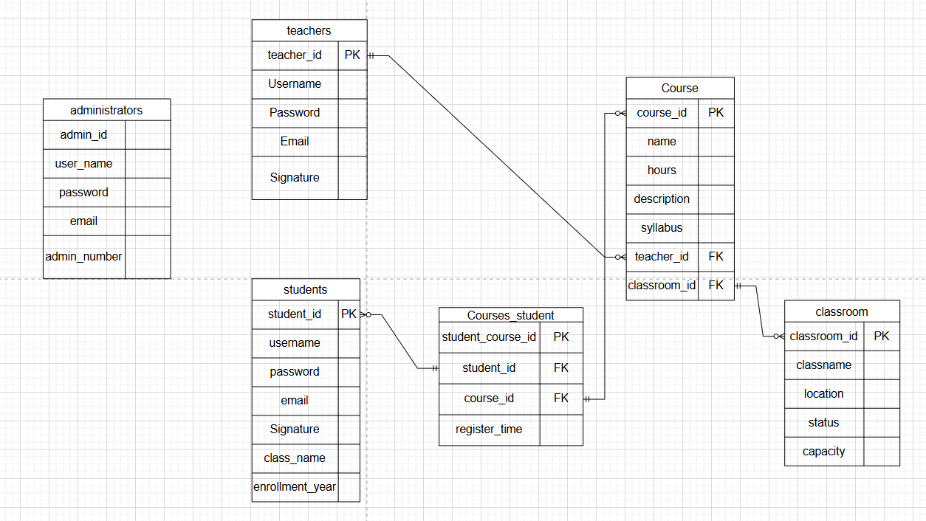

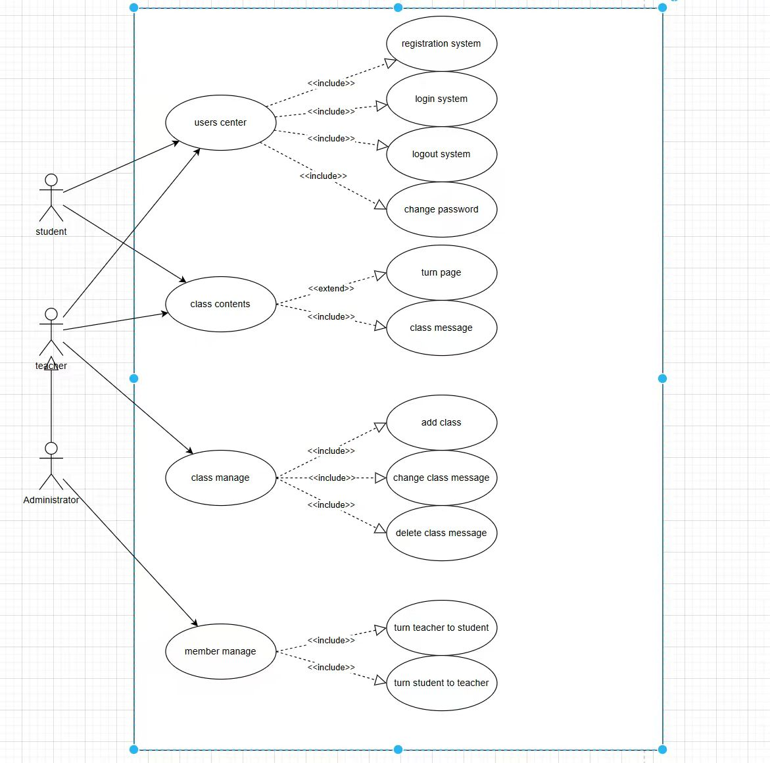

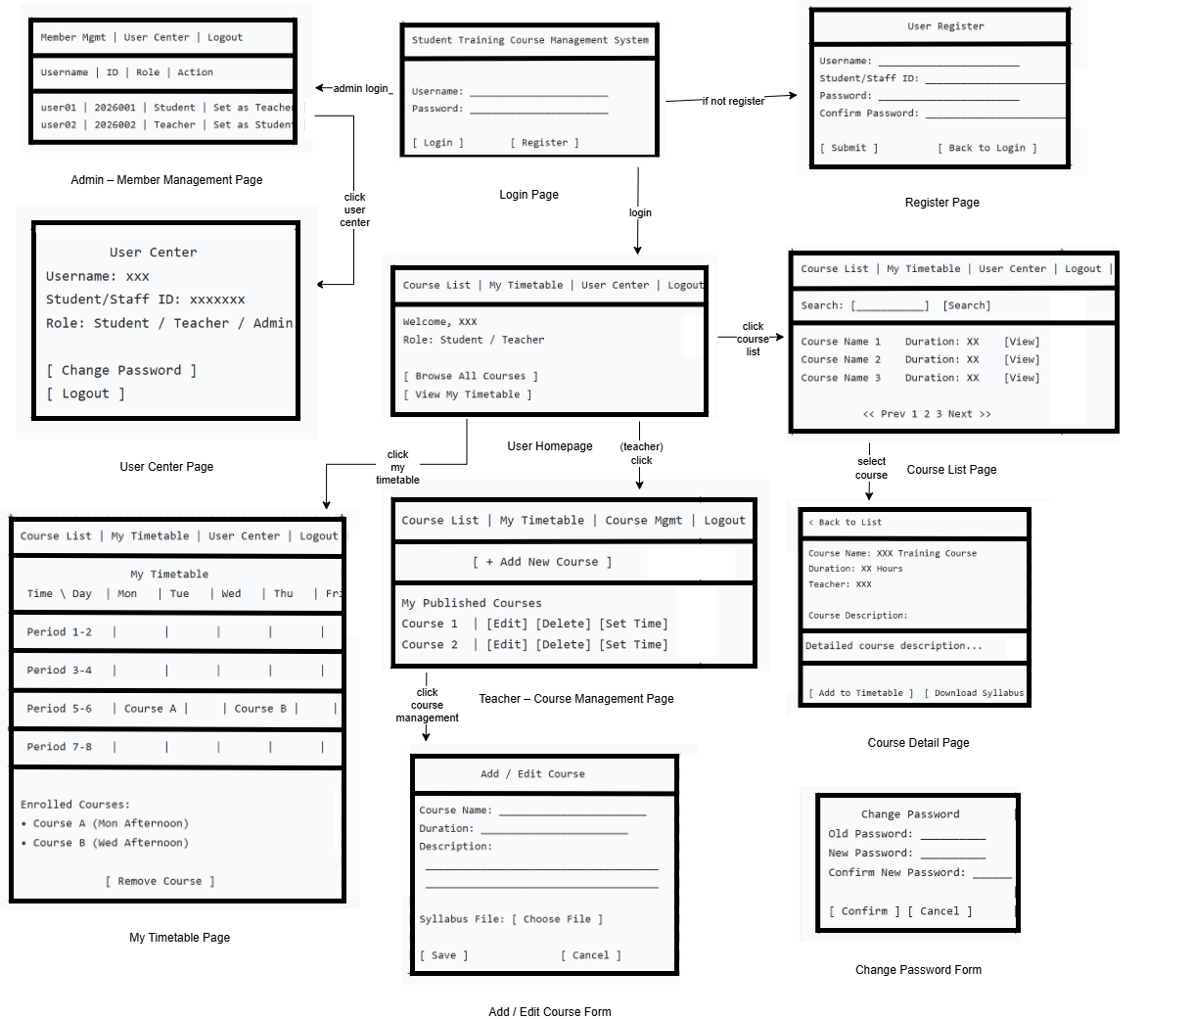

This is an ER model for a course teaching directory system, designed to manage the relationships between administrators, teachers, students, courses, and classrooms. The specific details are as follows:
Entity | PK | Core Attributes | Functional Description
administrators | admin_id | user_name, password, email, admin_no, department, create | Manage system permissions, can modify teacher/student roles
teachers | teacher_id | Username, Password, Email, Signature, course, department, create_at | Create and manage courses, grade student courses
students | student_id | username, password, email, Signature, class_name, enrollment_year | Browse courses, enroll in courses
classroom | classroom_id | address | Record the location of the course
Course | course_id | name, hours, description, syllabus | Stores core course information (name, hours, introduction, syllabus file path
Courses_student | student_course_id | - | Realize many-to-many association between students and courses

II. Relationships between entities
1. Administrator ↔ Teacher / Student: One-to-many management relationship, where the administrator can modify the roles of teachers and students.
2. Teachers ↔ Courses: A one-to-many relationship, where one teacher can create multiple courses
3. Students ↔ Course: A many-to-many relationship, implemented through an intermediary table named Courses_student. This means that a student can enroll in multiple courses, and a course can be selected by multiple students.
4. Course ↔ classroom: Many-to-one relationship, where one course is taught in one classroom
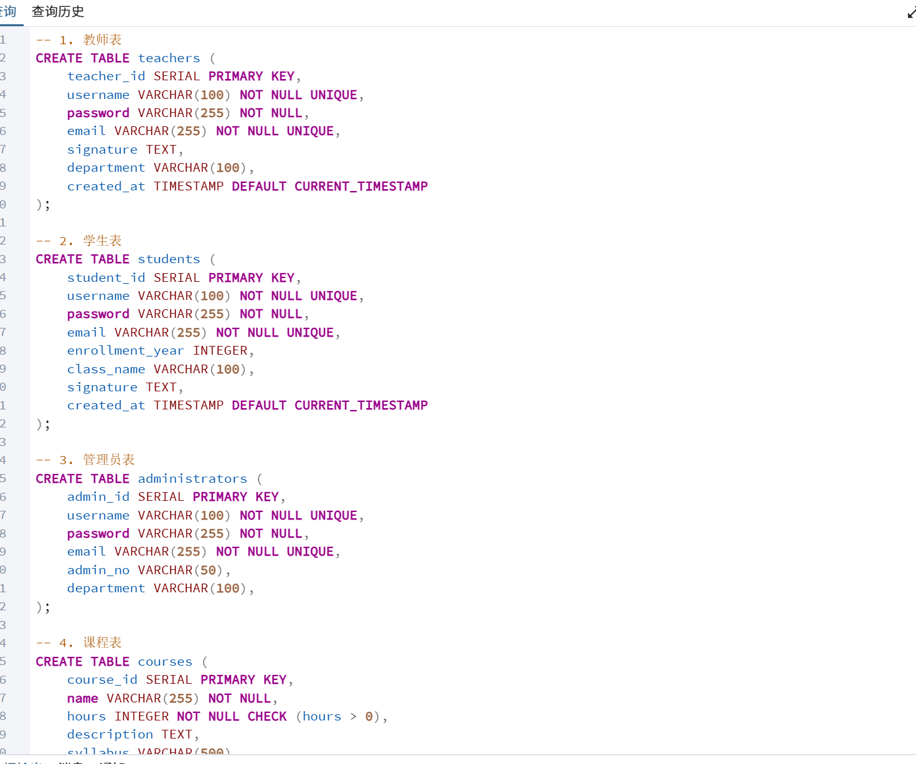
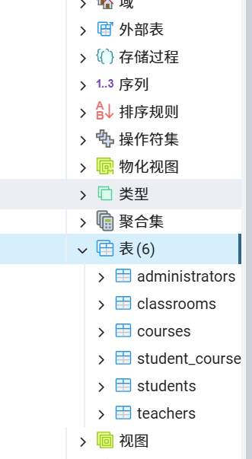
code：-- 1. 教师表
CREATE TABLE teachers (
teacher_id SERIAL PRIMARY KEY,
username VARCHAR(100) NOT NULL UNIQUE,
password VARCHAR(255) NOT NULL,
email VARCHAR(255) NOT NULL UNIQUE,
signature TEXT,
department VARCHAR(100),
created_at TIMESTAMP DEFAULT CURRENT_TIMESTAMP
);

-- 2. 学生表
CREATE TABLE students (
student_id SERIAL PRIMARY KEY,
username VARCHAR(100) NOT NULL UNIQUE,
password VARCHAR(255) NOT NULL,
email VARCHAR(255) NOT NULL UNIQUE,
enrollment_year INTEGER,
class_name VARCHAR(100),
signature TEXT,
created_at TIMESTAMP DEFAULT CURRENT_TIMESTAMP
);

-- 3. 管理员表
CREATE TABLE administrators (
admin_id SERIAL PRIMARY KEY,
username VARCHAR(100) NOT NULL UNIQUE,
password VARCHAR(255) NOT NULL,
email VARCHAR(255) NOT NULL UNIQUE,
admin_no VARCHAR(50),
department VARCHAR(100),
created_at TIMESTAMP DEFAULT CURRENT_TIMESTAMP
);

-- 4. 课程表
CREATE TABLE courses (
course_id SERIAL PRIMARY KEY,
name VARCHAR(255) NOT NULL,
hours INTEGER NOT NULL CHECK (hours > 0),
description TEXT,
syllabus VARCHAR(500),
created_by INTEGER NOT NULL,
created_at TIMESTAMP DEFAULT CURRENT_TIMESTAMP,
updated_at TIMESTAMP DEFAULT CURRENT_TIMESTAMP,

FOREIGN KEY (created_by) REFERENCES teachers(teacher_id) ON DELETE CASCADE
);

-- 5. 学生选课表 (学生-课程 多对多)
CREATE TABLE student_course (
student_course_id SERIAL PRIMARY KEY,
student_id INTEGER NOT NULL,
course_id INTEGER NOT NULL,
enrolled_at TIMESTAMP DEFAULT CURRENT_TIMESTAMP,

FOREIGN KEY (student_id) REFERENCES students(student_id) ON DELETE CASCADE,
FOREIGN KEY (course_id) REFERENCES courses(course_id) ON DELETE CASCADE,
UNIQUE (student_id, course_id)
);

-- 6. 教室表
CREATE TABLE classrooms (
classroom_id SERIAL PRIMARY KEY,
class_name VARCHAR(100) NOT NULL,
department VARCHAR(100),
capacity INTEGER,
address VARCHAR(255),
created_at TIMESTAMP DEFAULT CURRENT_TIMESTAMP
);

