1. Create one IAM user and assign EC2 and S3 full access roles.
I just created one IAM user in the name of gopi and shared the credentials to my team member as well. He created the new password for IAM user account.
I gave the EC2 and S3 full access. I didn’t given any other permissions to him.
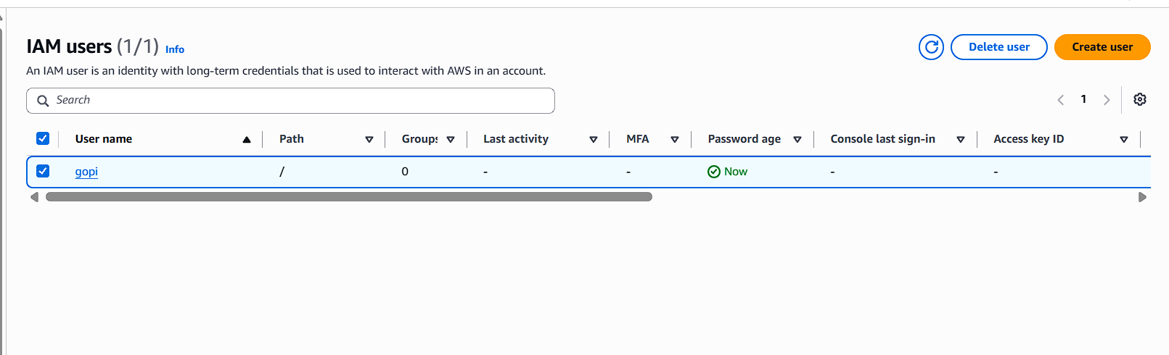
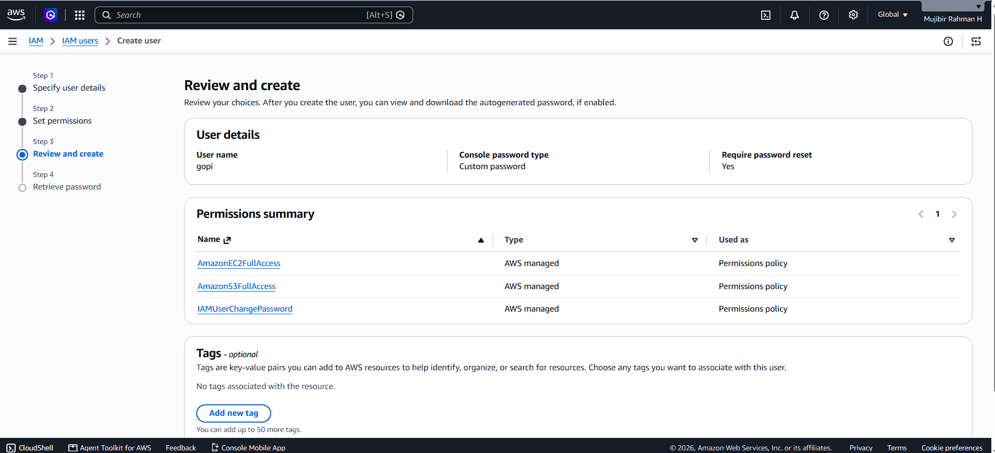
2. Create one group in IAM and assign read access for EC2.
I created one group in IAM and particularly gave the read only permissions for EC2 to that group.
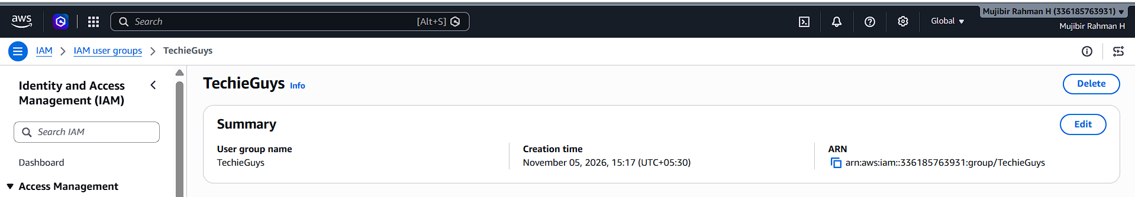
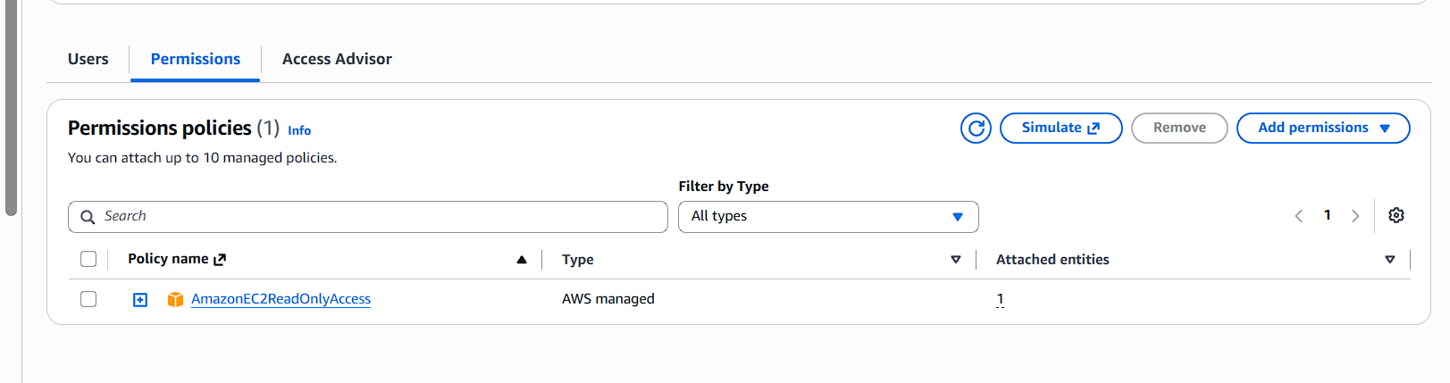
3. Create a new user named "Devops" and add to the group created in task 2.
Again I created one user in the name of devops as per the requirement and added the user into previously existed group TechieGuys.
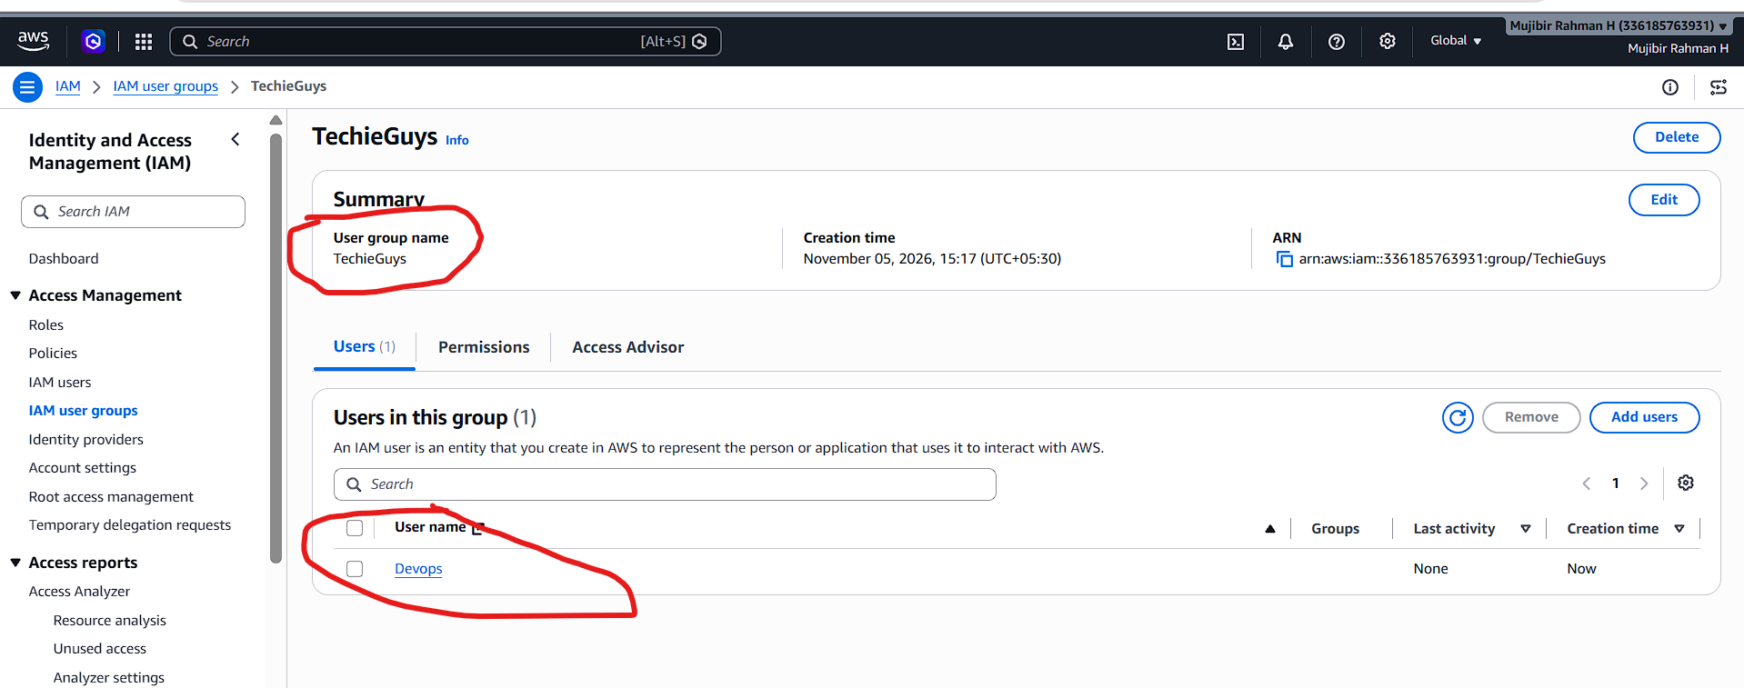
4. Write a bash script to create an IAM user with VPC full access.
I just launched one instance, and I created one file for bash script.
I written the script for creating one IAM user using AWS CLI and gave require file permissions.
After scripting, I executed the script and given user input as IAM user name. It’s successfully created.
I crosschecked my AWS IAM console, it’s created.
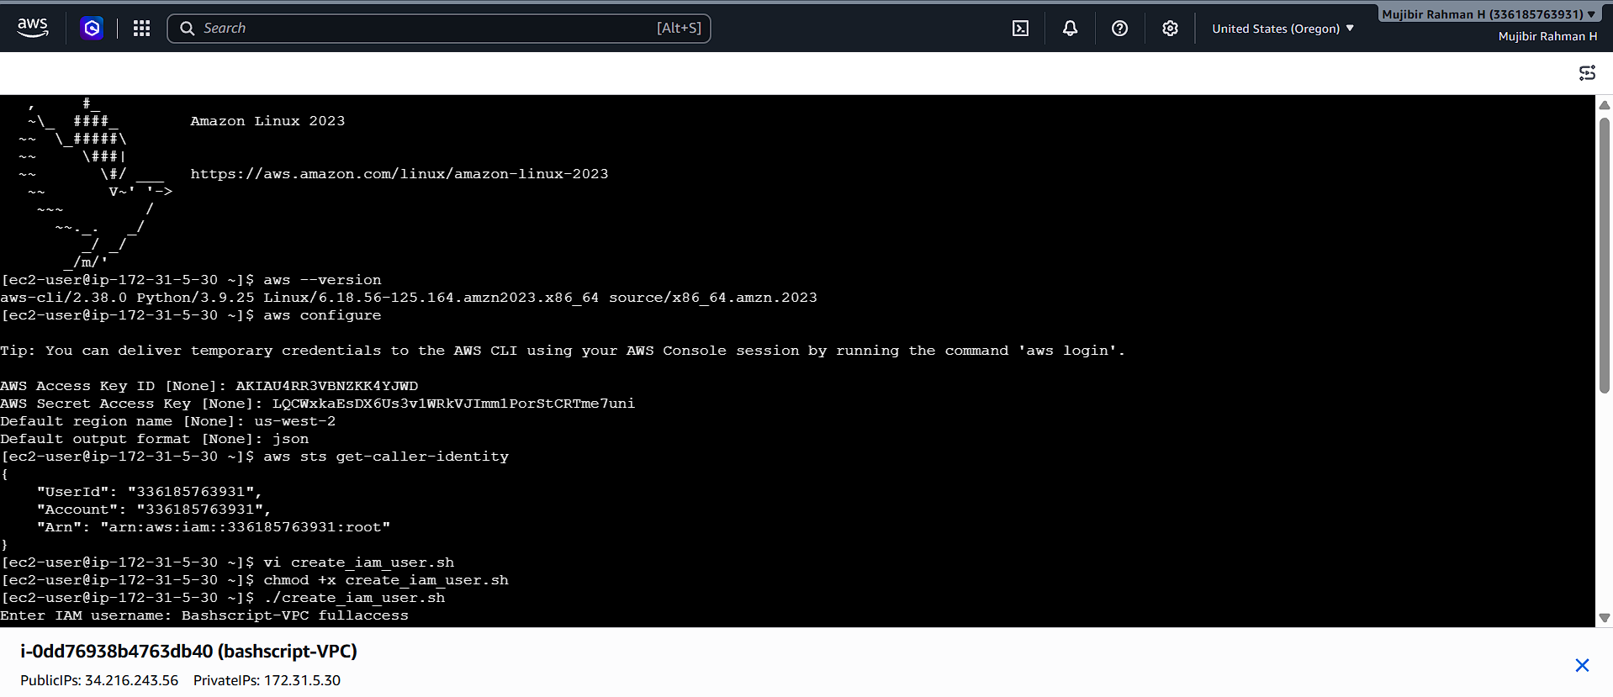
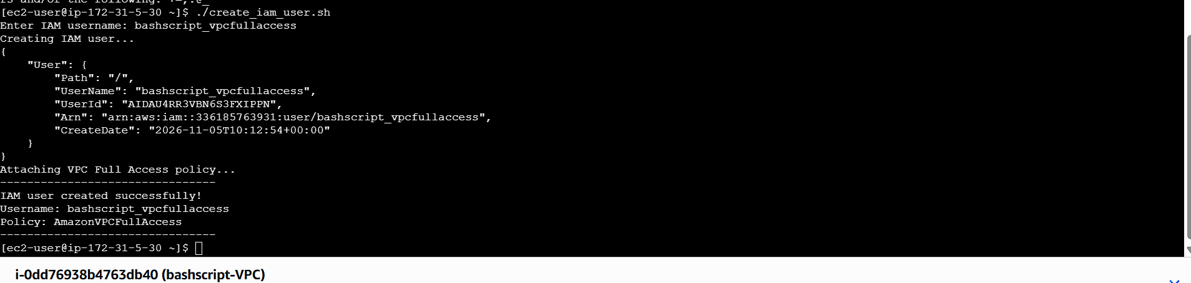
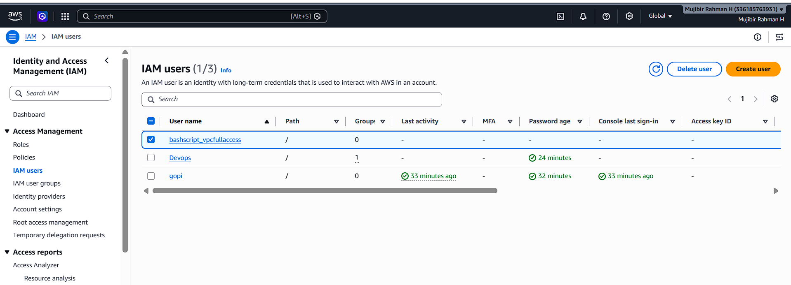
5. Create an IAM policy to allow EC2 access for a specific user in specific regions only.
we can go to policies click on create policy.
Then click on the Json there I have allowed the allow EC2 access in specific region policies.
After I have attached a specific user to the policy.
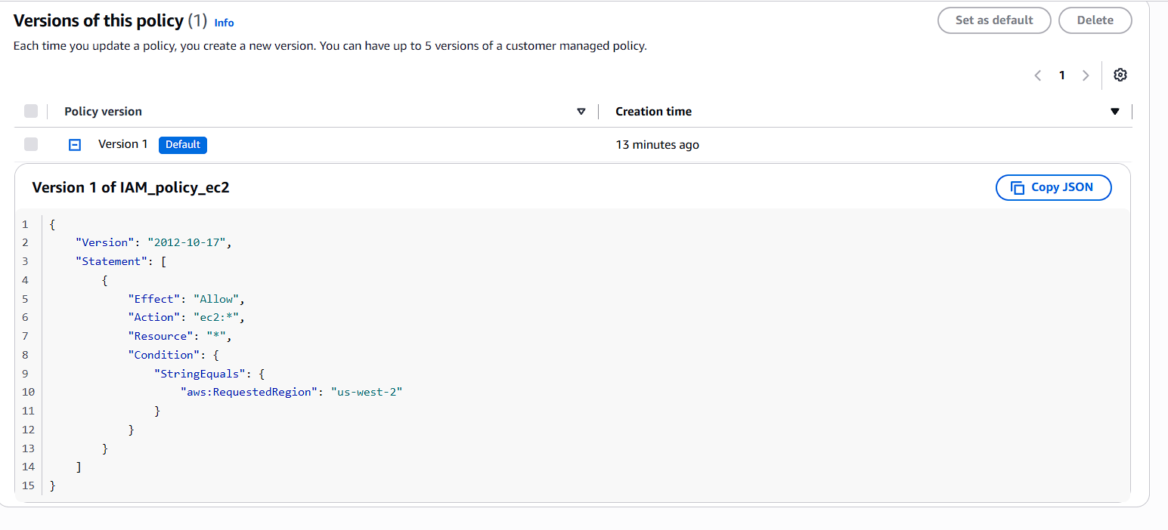
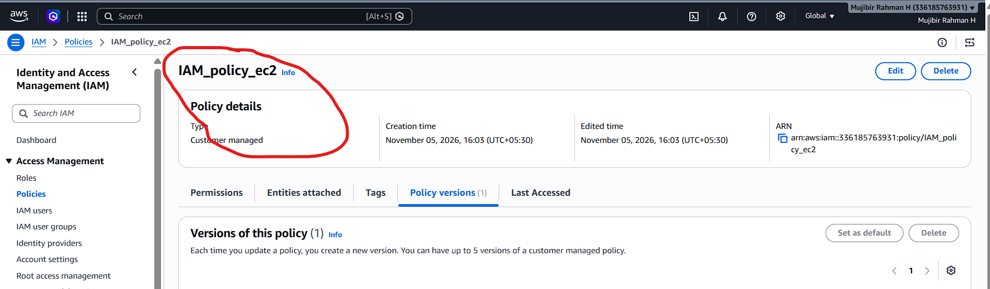
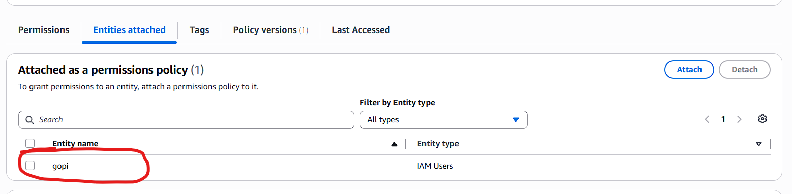
6. We have two accounts: Account A and Account B. Account A user should access an S3 bucket in Account B.
(Collaborate with a team member and execute this. This is mostly asked in every interview.)
I created IAM user and created a policy for accessing another account s3 bucket.
Same, in another side, my friend in his account, he created one s3 bucket it contains one files in it and bucket policy for others can access the bucket.
Now, I just tried to create access key for gopi IAM user. I configured AWS with that access key.
I am able to see the S3 bucket and it files.


