BANK LOAN REPORT

Key Performance Indicators (KPIs) Requirements:
Total Loan Applications
SELECT count(id) as total_loan_application FROM finance;
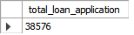

Month-to-Date (MTD) Loan Applications:
SELECT count(id) as total_loan_application_mtd FROM finance
where month(issue_date)=12;
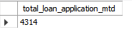

Month-over-Month (PMTD) Loan Applications:
SELECT count(id) as total_loan_application_pmtd FROM finance
where month(issue_date)=11;
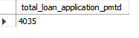
Month-over-Month (MoM) Loan Applications:
SELECT monthname(issue_date) as month_name,year(issue_date) as years,count(id) as total_loan_application_pmtd FROM finance
group by year(issue_date),month(issue_date);
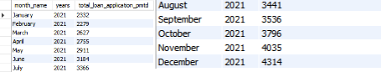

Percentage of Applications MTD from PMTD:
select ((SELECT count(id) as total_loan_application_mtd FROM finance
where month(issue_date)=12)-(SELECT count(id) as total_loan_application_pmtd FROM finance
where month(issue_date)=11))/(SELECT count(id) as total_loan_application_mtd FROM finance
where month(issue_date)=12)*100 as percentage;
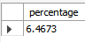

Total Funded Amount:
SELECT sum(loan_amount) FROM finance;
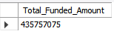

MTD_Total Funded Amount:
SELECT sum(loan_amount) as MTD_Total_Funded_Amount FROM finance
where month(issue_date)=12 and year(issue_date)=2021;
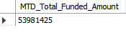

MOM_Total Funded Amount:
SELECT YEAR(issue_date) as YEAR,monthname(issue_date) AS MONTH,sum(loan_amount) as MOM_Total_Funded_Amount FROM finance
group by YEAR(issue_date),month(issue_date);
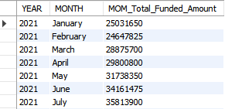
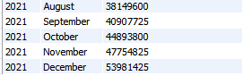

-- Total Amount Received:
SELECT sum(total_payment) as Total_Amount_Recived FROM finance;
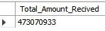
MTD_Total_Amount_Recived:
SELECT sum(total_payment) as MTD_Total_Amount_Recived FROM finance
where month(issue_date)=12;
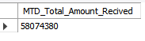
MOM_Total_Amount_Recived:
SELECT YEAR(issue_date) as YEAR,monthname(issue_date) AS MONTH,sum(total_payment) as MOM_Total_Amount_Recived FROM finance
group by YEAR(issue_date),month(issue_date);
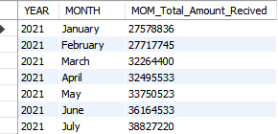
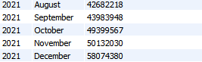

Average Interest Rate:
SELECT round(avg(int_rate),2)*100 as Average_Interest_Rate FROM finance;
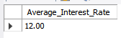
MTD_Average_Interest_Rate:
SELECT round(avg(int_rate),2)*100 as MTD_Average_Interest_Rate FROM finance
where month(issue_date)=12;
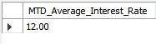
MoM_Average_Interest_Rate:
SELECT YEAR(issue_date) as YEAR,monthname(issue_date) AS MONTH,round(avg(int_rate),2)*100 as MoM_Average_Interest_Rate FROM finance
group by YEAR(issue_date),month(issue_date);
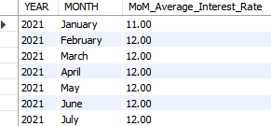
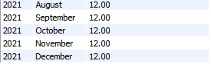
Total_Average_DTI:
SELECT round(avg(dti),4)*100 as Average_DTI FROM finance;
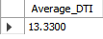
MTD_DTI:
SELECT round(avg(dti),4)*100 as MTD_DTI FROM finance
where month(issue_date)=12;
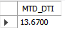
MoM_DTI FROM finance
SELECT YEAR(issue_date) as YEAR,monthname(issue_date) AS MONTH,round(avg(dti),4)*100 as MoM_DTI FROM finance
group by YEAR(issue_date),month(issue_date);
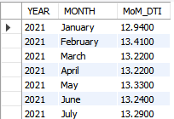
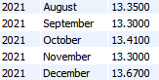

Good Loan Application Percentage:
select (count(case when loan_status='Fully Paid' or loan_status='Current' then id end)*100)/
count(id) as good_loan_application from finance;
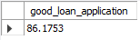

Good Loan Applications:
SELECT count(id) as good_loan_application FROM finance
where loan_status='Fully Paid' or loan_status='Current';
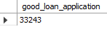
Good Loan Funded Amount:
SELECT sum(loan_amount) as total_funded_amount FROM finance
where loan_status='Fully Paid' or loan_status='Current';
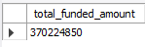

Good Loan Total Received Amount:
SELECT sum(total_payment) as total_amount_recived FROM finance
where loan_status='Fully Paid' or loan_status='Current';
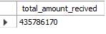
Bad Loan KPIs:
Bad Loan Application Percentage:
select (count(case when loan_status='Charged Off' then id end)*100)/
count(id) as bad_loan_percentage from finance;
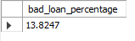

Bad Loan Applications:
SELECT count(id) as bad_loan_application FROM finance
where loan_status='Charged Off';
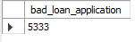
Bad Loan Funded Amount:
SELECT sum(loan_amount) as total_funded_amount FROM finance
where loan_status='Charged Off';
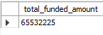
Bad Loan Total Received Amount:
SELECT sum(total_payment) as total_amount_recived FROM finance
where loan_status='Charged Off';
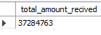

Loan Status Grid View
Loan Status by 'Total Loan Applications,' 'Total Funded Amount,' 'Total Amount Received,''Average Interest Rate,' and 'Average Debt-to-Income Ratio (DTI).
SELECT
loan_status,
count(id) as total_loan_application,
sum(loan_amount) as total_funded_amount,
sum(total_payment) as total_amount_recived,
avg(int_rate)*100 as average_intereset_rate,
avg(dti)*100 as average_dti FROM finance
group by loan_status;
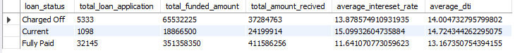

(MTD)Loan Status by 'Total Loan Applications,' 'Total Funded Amount,' 'Total Amount Received,''Average Interest Rate,' and 'Average Debt-to-Income Ratio (DTI).
SELECT
loan_status,
count(id) as total_loan_application,
sum(loan_amount) as total_funded_amount,
sum(total_payment) as total_amount_recived,
avg(int_rate)*100 as average_intereset_rate,
avg(dti)*100 as average_dti FROM finance
where month(issue_date)=12
group by loan_status;

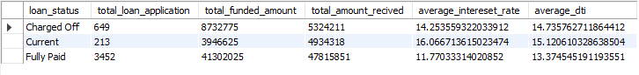

DASHBOARD 2
Monthly Trends by Issue Date (Line Chart):
Metrics: 'Total Loan Applications,' 'Total Funded Amount,' and 'Total Amount Received':
SELECT monthname(issue_date) as month_name,count(id) as total_loan_application,sum(loan_amount) as total_funded_amount,sum(total_payment) as total_amount_recived FROM finance
group by month(issue_date);
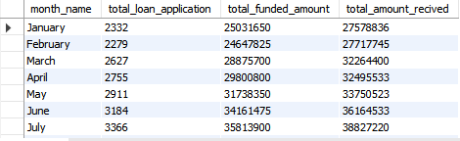
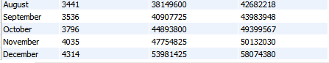

Regional Analysis by State (Filled Map):
Metrics: 'Total Loan Applications,' 'Total Funded Amount,' and 'Total Amount Received':
SELECT address_state,count(id)as total_loan_application,sum(loan_amount) as total_funded_amount,sum(total_payment)
as total_amount_recived FROM finance
group by address_state;
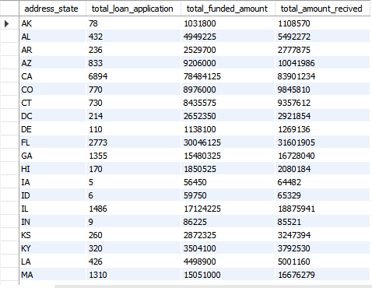
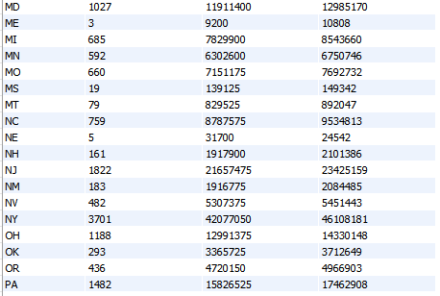
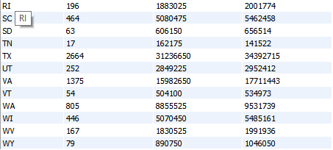

Loan Term Analysis (Donut Chart):
Metrics: 'Total Loan Applications,' 'Total Funded Amount,' and 'Total Amount Received'

SELECT term,count(id) as total_loan_application,sum(loan_amount)as total_funded_amount,sum(total_payment)
as total_amount_recived FROM finance
group by term;

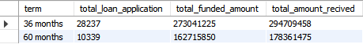

Employee Length Analysis (Bar Chart)
Metrics: 'Total Loan Applications,' 'Total Funded Amount,' and 'Total Amount Received'
SELECT emp_length,count(id) as total_loan_application,sum(loan_amount) as total_funded_amount,sum(total_payment)
as total_amount_recived FROM finance
group by emp_length
order by emp_length asc;
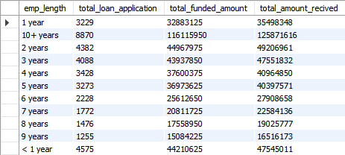

Loan Purpose Breakdown (Bar Chart):
Metrics: 'Total Loan Applications,' 'Total Funded Amount,' and 'Total Amount Received'
SELECT purpose,count(id) as total_loan_application,sum(loan_amount) as total_funded_amount,sum(total_payment)
as total_amount_recived FROM finance
group by purpose;
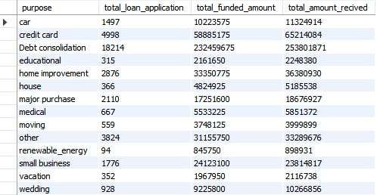
Home Ownership Analysis (Tree Map):
Metrics: 'Total Loan Applications,' 'Total Funded Amount,' and 'Total Amount Received'
SELECT home_ownership,count(id) as total_loan_application,sum(loan_amount) as total_funded_amount,sum(total_payment)
as total_amount_recived FROM finance
group by home_ownership;
