智能语音助手

亚马逊Alexa
- 智能语音交互
智能语音交互（Intelligent Speech Interaction），是基于语音识别、语音合成、自然语言理解等技术，为企业在多种实际应用场景下，赋予产品“能听、会说、懂你”式的智能人机交互体验。适用于多个应用场景中，包括智能问答、智能质检、法庭庭审实时记录、实时演讲字幕、访谈录音转写等场景。

智能语音交互，包括语音识别、语音合成、语义理解三个部分。
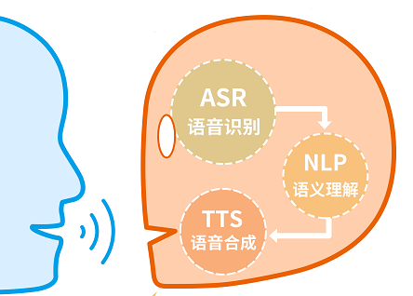
而集成亚马逊Alexa我们就需要实现的是对话管理和数据/服务的这两部分。
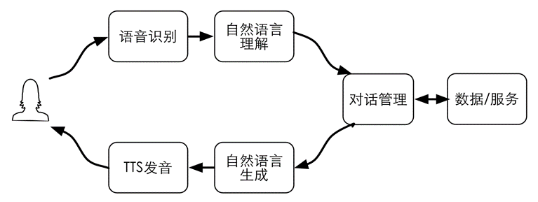

- Alexa
Utterance: The words the user says to Alexa to convey what they want to do, or to provide a response to a question Alexa asks. For custom skills, you provide a set of sample utterances mapped to intents as part of your custom interaction model.

Skill: A capability or ability of Alexa. Alexa provides a set of built-in skills (such as playing music), and developers can use the Alexa Skills Kit to give Alexa new skills. A skill includes both the code (in the form of a cloud-based service) and the configuration provided on the developer portal. See also custom skill and smart home skill.

Intent: The main request or action associated with the user’s command for a custom skill. For example: “Alexa, ask History Buff what happened on June third.” In this statement, “what happened on June third” maps to a specific intent that can be handled by a particular Alexa ability. This tells Alexa that the user wants “History Buff” to get historical information on a specific date.

Slot: an argument to an intent that gives Alexa more information about that request. For example: “Alexa, ask History Buff what happened on June third”. In this statement, “June third” is the value of a date slot that refines the request. For a given intent, slots can be required or optional.

AWS Lambda: An AWS compute service that runs your code in response to events and automatically manages the compute resources for you. This lets you run code (referred to as a Lambda function) in the cloud without managing servers.

AWS Lambda function: The code uploaded to AWS Lambda. Lambda supports coding in Node.js, Java, and Python. You can also choose to use a Lambda function for the service for a custom skill. See also AWS Lambda.

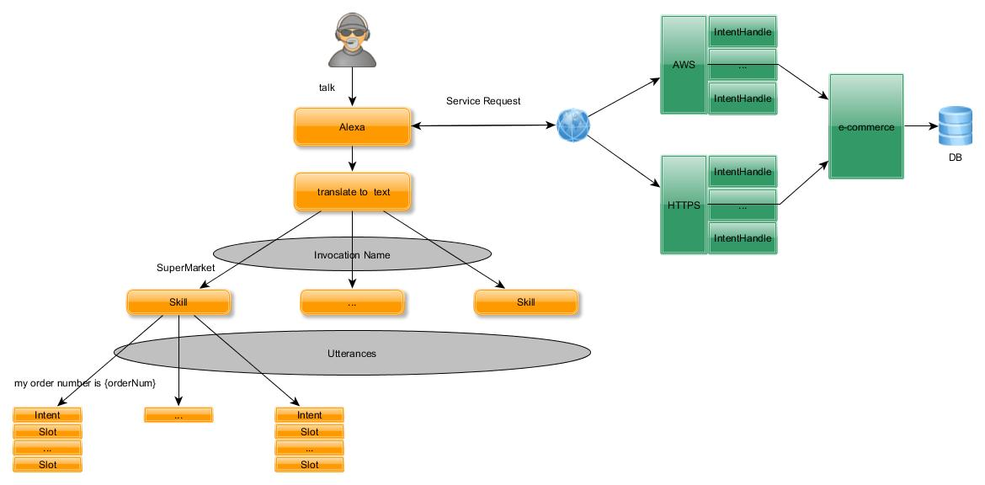
The following are examples of utterances corresponding to the intent
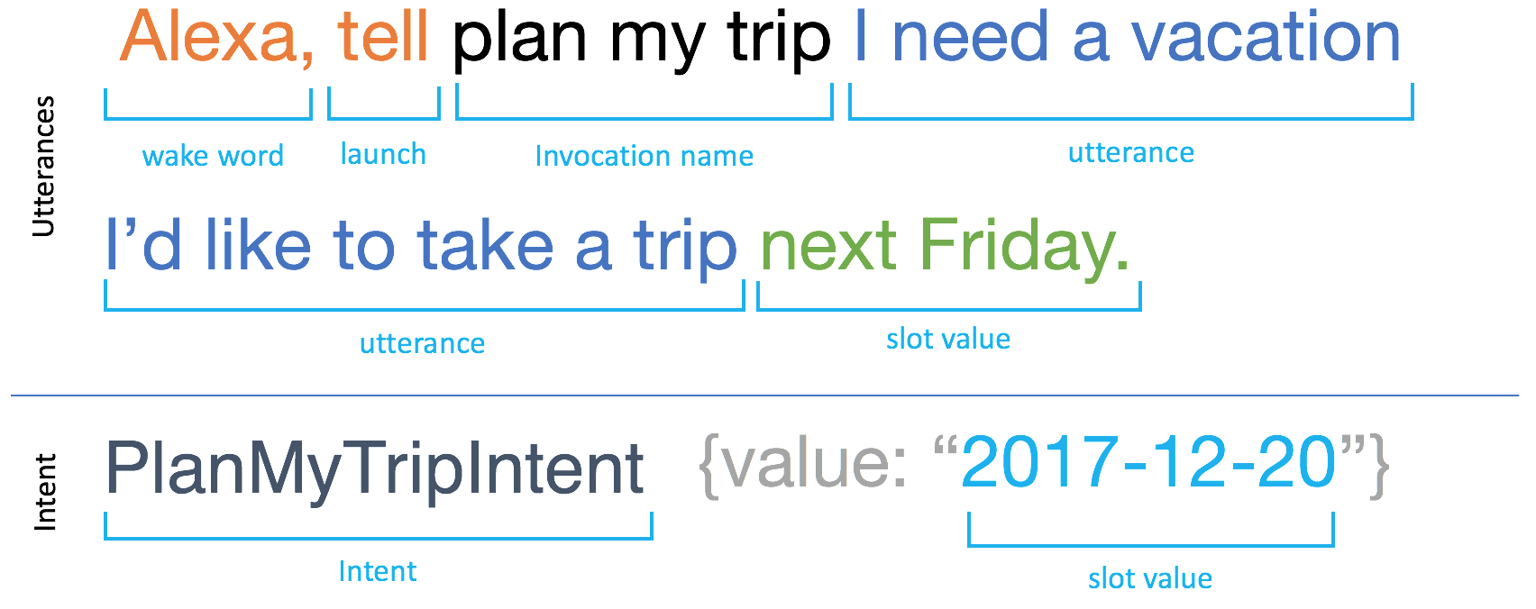

Service request:

{
"session": {
"new": true,
"sessionId": "SessionId.a784f9e6-b4ce-41bb-bfe8-1a278e88a454",
"application": {
"applicationId": "amzn1.ask.skill.874cced7-9dcd-4798-95e4-ac0dccb1728b"
},
"attributes": {},
"user": {
"userId": "amzn1.ask.account.*** "
}
},
"request": {
"type": "IntentRequest",
"requestId": "EdwRequestId.dcdb6425-f5ab-41b2-ba13-acdba9f964d9",
"intent": {
"name": "searchOrder",
"slots": {
"orderNum": {
"name": "orderNum"
},
"orderDate": {
"name": "orderDate"
}
}
},
"locale": "en-US",
"timestamp": "2017-12-15T03:15:04Z"
},
"context": {
"AudioPlayer": {
"playerActivity": "IDLE"
},
"System": {
"application": {
"applicationId": "amzn1.ask.skill.874cced7-9dcd-4798-95e4-ac0dccb1728b"
},
"user": {
"userId": "amzn1.ask.account.***"
},
"device": {
"supportedInterfaces": {}
}
}
},
"version": "1.0"
}

Service Response:
{
"version": "1.0",
"response": {
"shouldEndSession": true,
"outputSpeech": {
"type": "SSML",
"ssml": "<speak> ok !the order number is zero zero zero 1 it contains5 for milk total money is NaN dollar </speak>"
}
},
"sessionAttributes": {},
"userAgent": "ask-nodejs/1.0.23 Node/v6.10.3"
}

