REFERENCES

For icons : [https://www.flaticon.com](https://www.flaticon.com/)

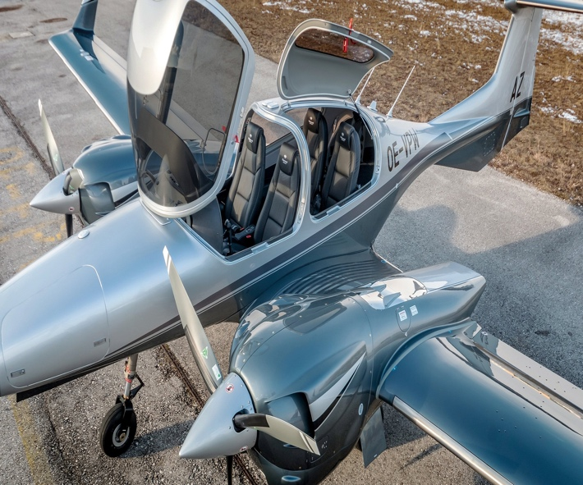 <https://www.diamondaircraft.com/en/private-owners/aircraft/da42/overview/>

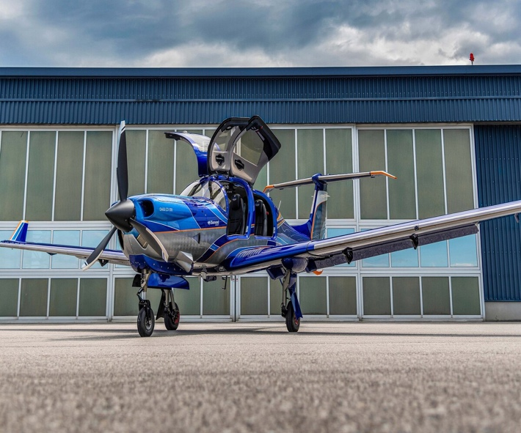 <https://www.diamondaircraft.com/en/private-owners/aircraft/da50/overview/>

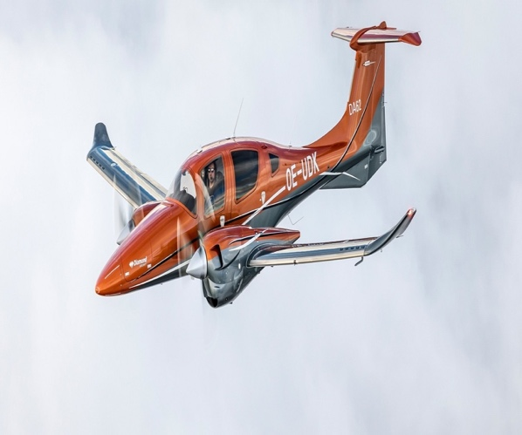 <https://www.diamondaircraft.com/en/private-owners/aircraft/da62/overview/>

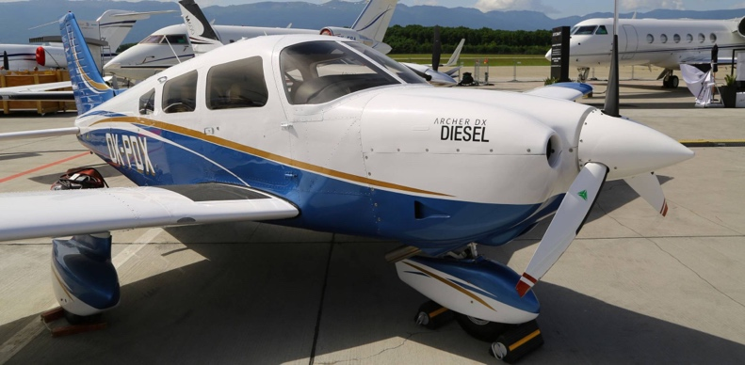 <https://www.ainonline.com/aviation-news/business-aviation/2018-05-29/piper-sales-hit-flight-training-sweet-spot>

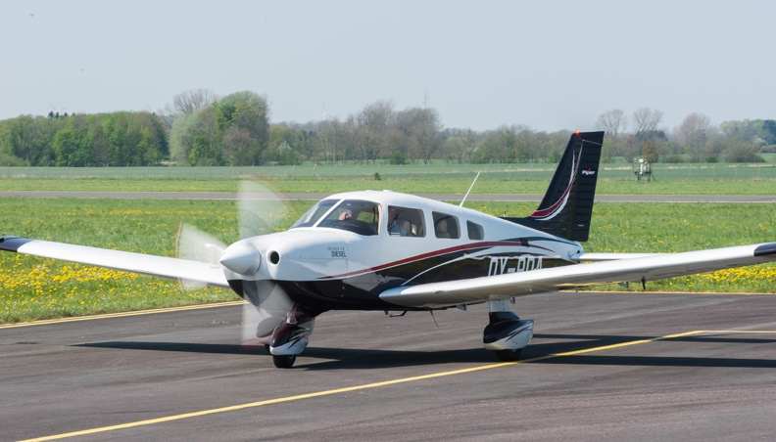 <https://europeanaircraftsales.com/piper-dealer/piper-archer-lx-dx/>

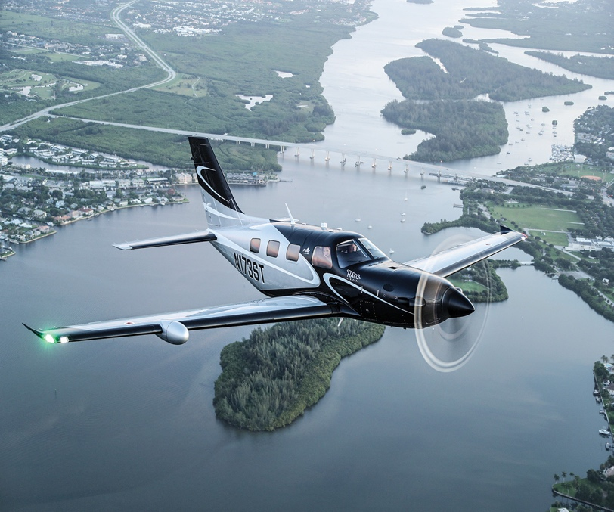 <https://www.flyingmag.com/we-fly-piper-m600-sls-halo/>

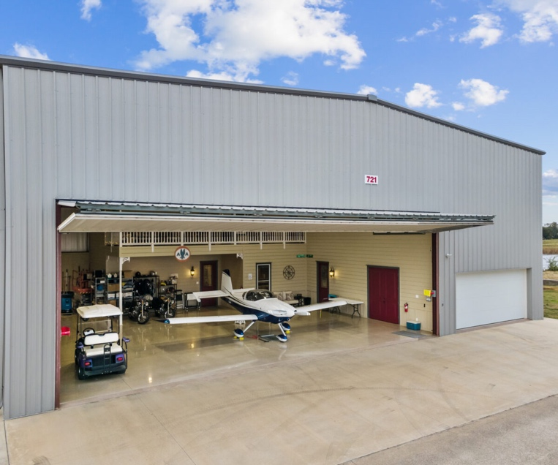 <https://airspacetexas.com/listings/721-aviator-drive-fort-worth-texas-76179/>

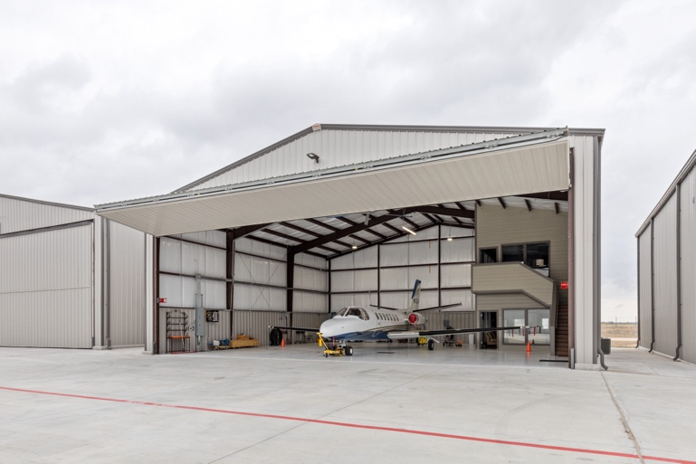<https://airspacetexas.com/listings/1500-industrial-blvd-hangar-1105-mckinney-tx-75069/>

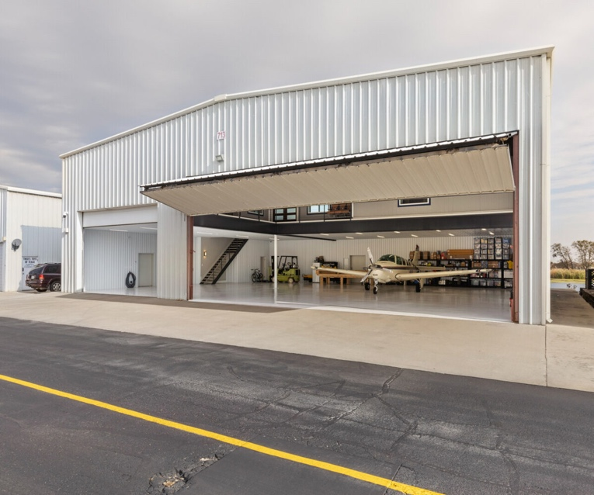 <https://airspacetexas.com/listings/713-aviator-drive-fort-worth-texas-76179/>

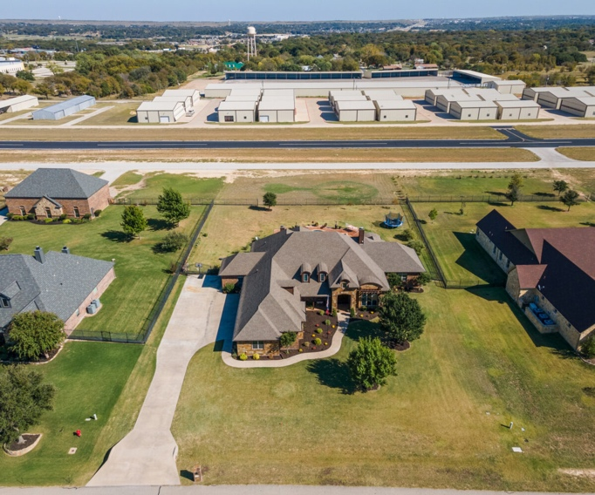 <https://airspacetexas.com/listings/401-addison-dr/>

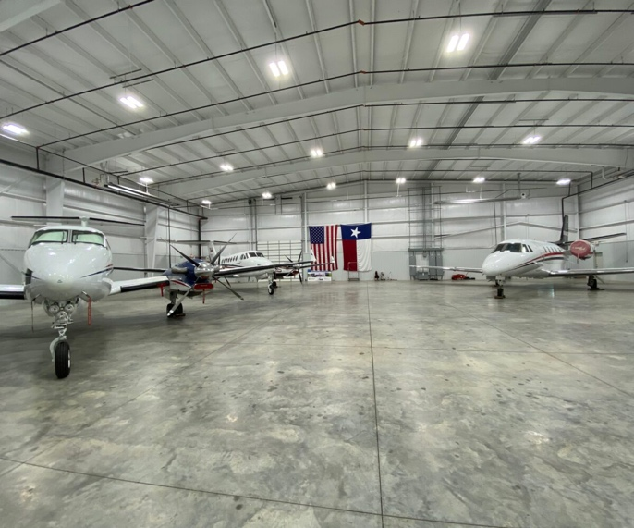 <https://airspacetexas.com/listings/west-court-drive-denton-texas-76207/>

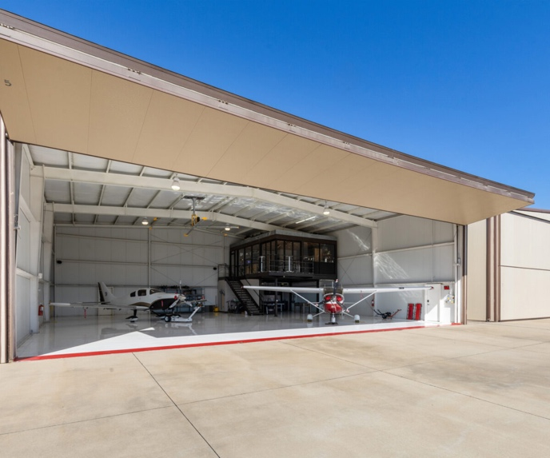 <https://airspacetexas.com/listings/1500-industrial-blvd-hangar-5-mckinney-texas-75069/>

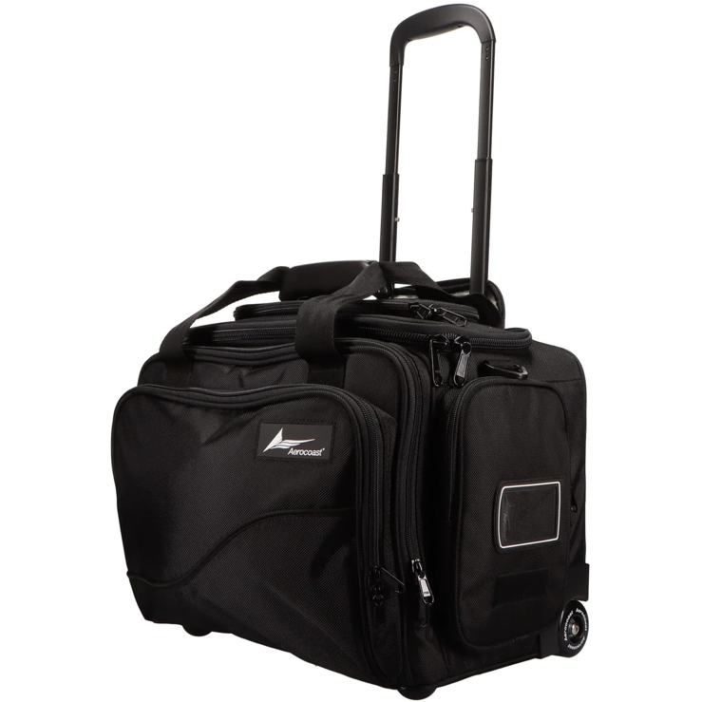 <https://www.pilotmall.com/products/aerocoast-pro-crew-i-w>

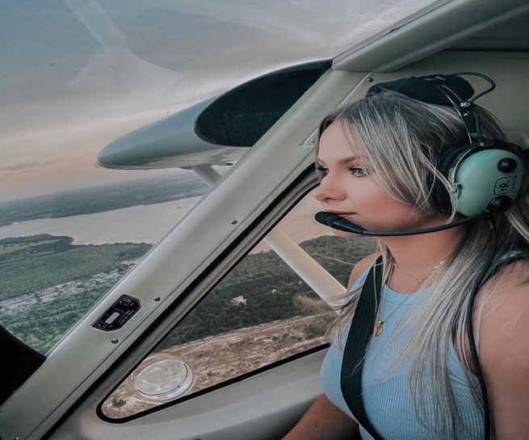 <https://www.instagram.com/p/CPOZGi4JnVF/>

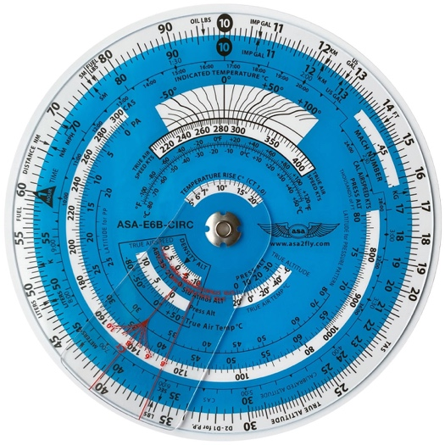 <https://asa2fly.com/circular-e6b-flight-computer/>

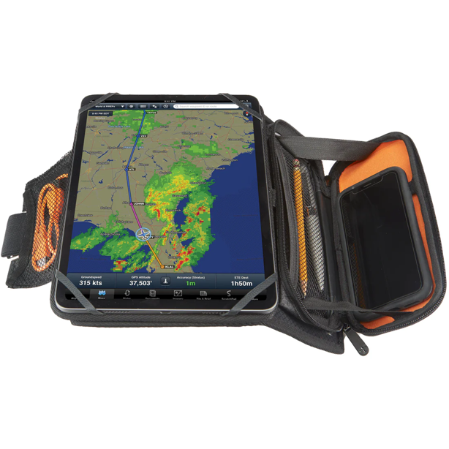 <https://www.pilotmall.com/products/flight-outfitters-slimline-kneeboard>

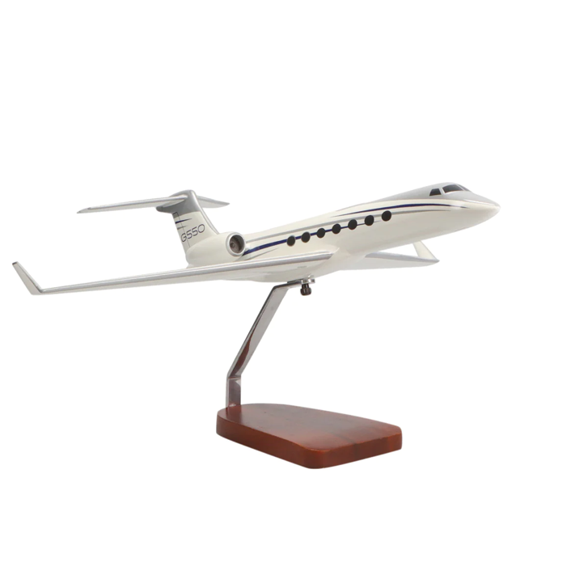<https://www.pilotmall.com/products/gulfstream-g550-mahogany-model-high-flying-models>

 <https://www.instagram.com/p/Cdtb-5yrhOY/>