coordinating conjunction 并列连接词

subordinating ...从属连接词

conjunctive adverbs连接性副词

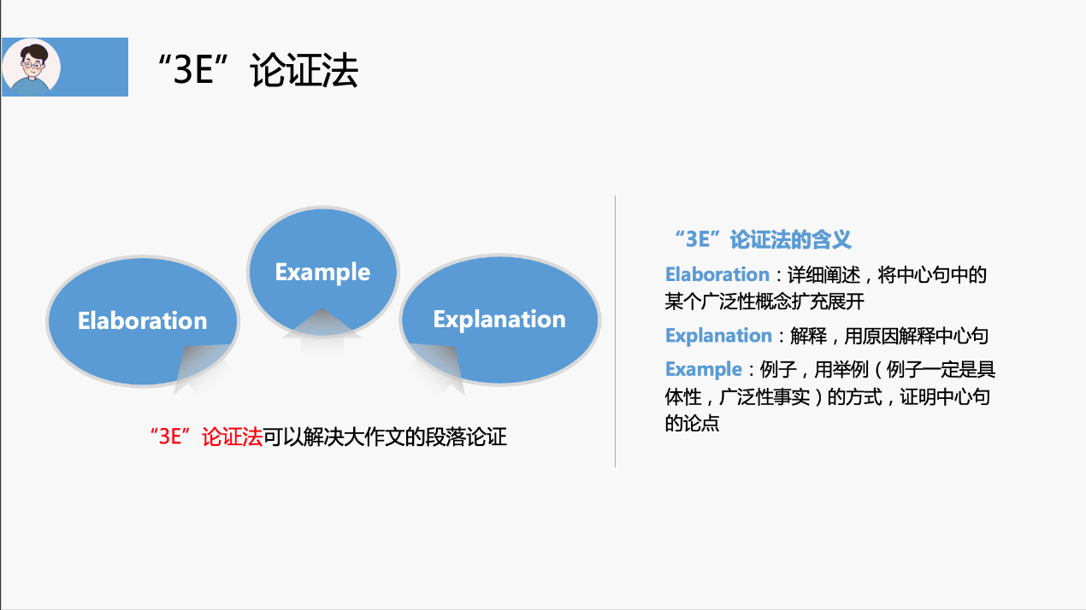

拆分,原因,例子



physical illness：obesity/hypertension

mental illness：anxiety/depression/bipolar

写:more specifically ,it is so easy to appear obesity , hypertension ,anxiety and depression if people live in big cities ,such as Beijing ,Shanghai and Shenzhen

改: more specifically ,it is so easy for people appear obesity ,hypertension ,anxiety and depression if people live in big cities.

More specifically,

Citizens ,city dwellers ,residents ,inhabitants

medical resources

educational resources

more job opportunities

more accessible public transport

写:more specifically ,city dwellers are more likely to enjoy a number of benefits which are medical resources ,educational resources and more job opportunities .

改:more specifically ,city residents are more likely to benefit from medical resources ,educational resources and more job opportunities .

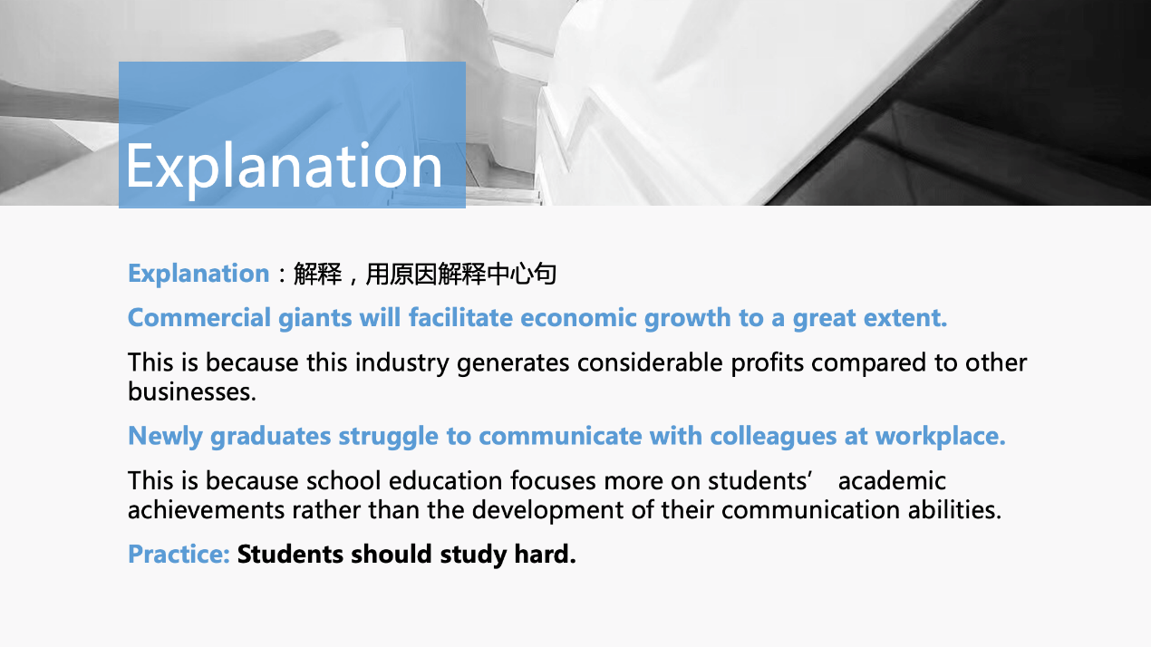

写后改:students should study hard . This is because the more time students spend on learning the more job opportunities you get .

政府三个原因：省钱 赚钱 省事

Parents should read or tell stories to children.

写: This is because tell stories to children in person can improve the relation about children.

改: This is because telling stories to children in person can improve the bond with children.

雅思常见三种跑题模式：

1. 不要忽略动作主体

Sending young people to universities may lead to graduate unemployment.

写:This is because the knowledge young people study in university can’t adapt the requirements which society need

改: This is because the knowledge young people gain in university can’t meet the requirements which job’s need

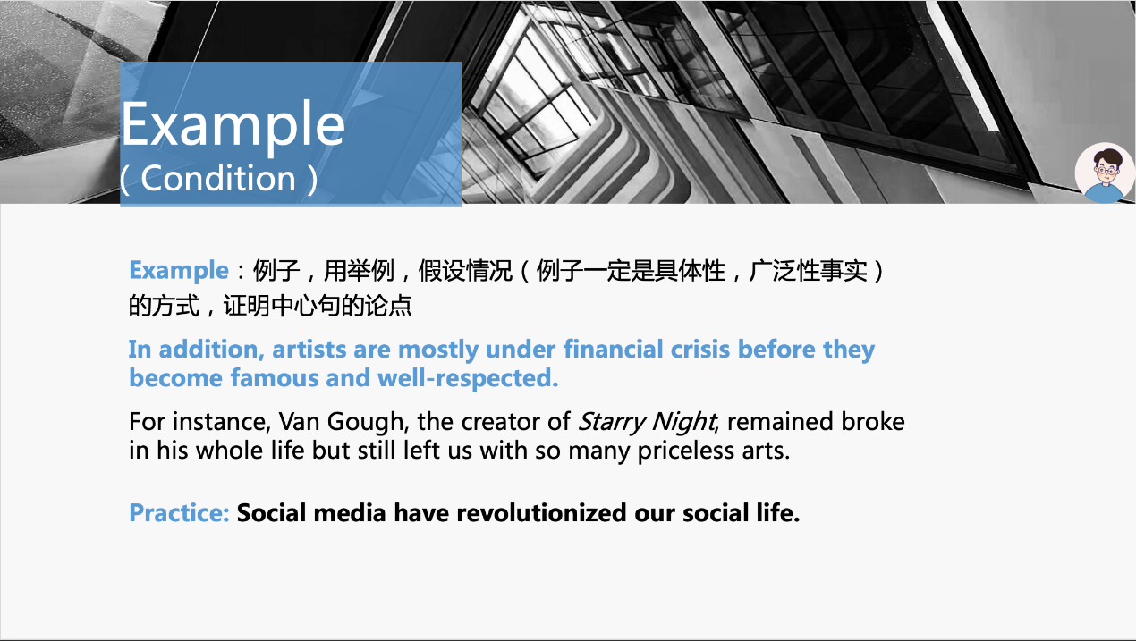

委婉的说穷: underachieved, struggling

委婉的说有钱: comfortable, well-off

委婉说残疾: physically challenged

human trafficking =人品买卖

trafficking =毒品走私

anecdote个人轶事 没有辩证价值

For example, WeChat makes us communicate with others faster than sending mail.

breaks the geographical barrier between people 打破人与人之间的地理隔阂(远程对话)

tax evasion 偷税

For instance, Fanbingbing, one of famous Chinese movie stars, committed tax evasion and caused a wide discussion. she had a negative impact on people.

This can be attributed to the fact that = because

cost- effectiveness 投资回报率

as is attested by 正如所证明的那样=for example