Domain Model and Sequence Diagram

# Domain Model

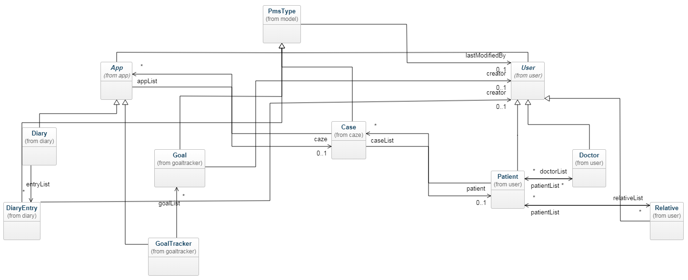

# Klassendiagramm (nur Modell)

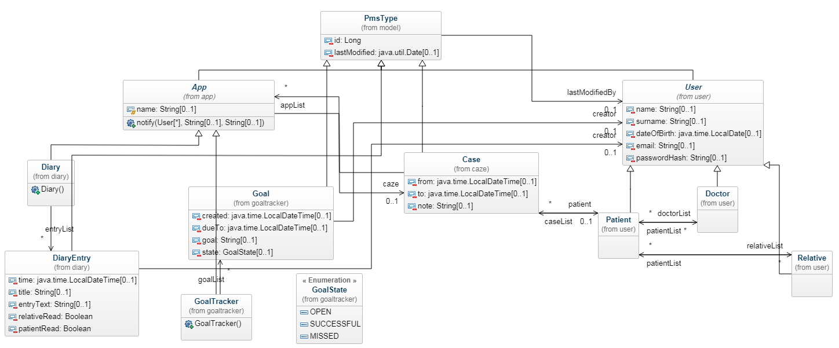

# Klassendiagramm (nur Services)

