Starting Off

1. Download the files from git in your preferred manner
2. In your terminal go to the location you downloaded the files to
3. Type into terminal: docker build --tag=neuro
   1. Wait a while it doesn’t give feedback as to whether its hanging or processing
   2. You should eventually get this: 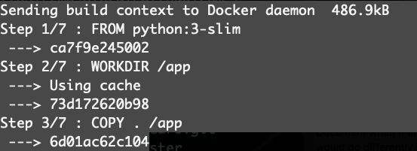

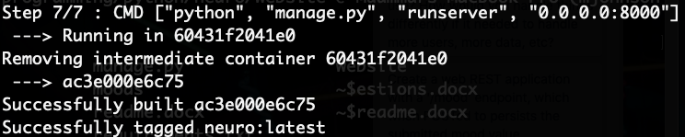

1. then type this in the same window: docker run -p 4000:8000 neuro
2. Congratulations …. Hopefully it is working

Logging Into admin/ creating new users:

1. In a webbrowser type : <http://localhost:4000/>admin/
2. Username: person
3. Password: person
4. In here you can create new users

Loggin in as user:

1. In a webbrowser type: <http://localhost:4000/auth/>
   1. Current user/passwords combos are: person/person person1/manmanman person2/manmanman
2. After you click login there is no feedback but you are logged in

Logging out:

1. In a webbrowser type: <http://localhost:4000/auth/>
2. Type in any non used name and password combo and click login
3. There is no feedback but you are now logged out

Viewing Moods:

1. In a webbrowser type: <http://localhost:4000/mood/>
2. If you are not logged or you have no moods you will get a screen with user moods and streak at the top and nothing else
3. If you are logged in you will be shown a list of your views, additionally if you above 50% you will be shown your placement percentage