Lab 5 of Compiler Construction

Mujtaba Shahid Faizi (#131818)

Abdul Basit (#146120)

Hamza Hafeez (#133127)

BSCS-5A

**Task 1:**

%{

#include<stdio.h>

%}

%%

"if"|"else"|"while"|"do"|"switch"|"case"|"begin"|"end"|"proedure"|"function" {ECHO; printf(" is Key Keyword\n");}

[a-zA-Z][a-z|0-9]* {ECHO; printf(" is Key Identifier\n");}

[0-9]* {ECHO; printf(" is Key Number\n");}

[+-]?([0-9]*[.])?[0-9]+ {ECHO; printf(" is Floating Point\n");}

"!"|"@"|"&"|"^"|"%"|"$"|"#" {ECHO; printf(" is Special Character\n");}

"+"|"-"|"*"|"/" {ECHO; printf(" is Arthmetic operator\n");}

%%

int yywrap()

{

return 1;

}

main()

{

printf("Enter a string of data\n");

yylex();

}

Screenshot:

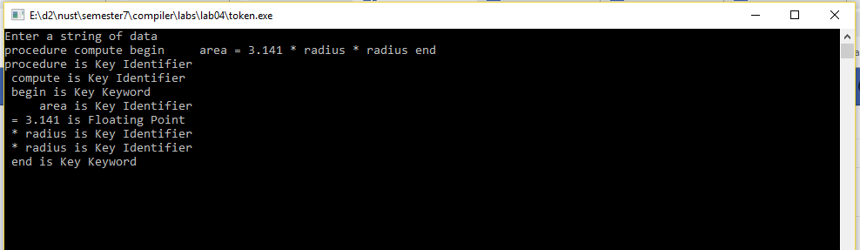

**Task 2:**

import java.io.*;

%%

%class task2

%public

%type void

%function getNextToken

%{

public static int[] arr;

public static void main(String[] args) {

arr = new int[4];

try {

InputStream is = new FileInputStream("in.txt");

task2 s = new task2(is);

s.getNextToken();

}

catch (IOException e) { }

}

public static void push(int v){

arr[3] = arr[2];

arr[2] = arr[1];

arr[1] = arr[0];

arr[0] = v;

}

public static void add(){

arr[0] = arr[0]+arr[1];

arr[1] = arr[2];

arr[2] = arr[3];

arr[3] = 0;

}

public static void mul(){

arr[0] = arr[0]*arr[1];

arr[1] = arr[2];

arr[2] = arr[3];

arr[3] = 0;

}

public static void sub(){

arr[0] = arr[1]-arr[0];

arr[1] = arr[2];

arr[2] = arr[3];

arr[3] = 0;

}

public static void printStack(){

System.out.println(arr[0] + " " + arr[1] + " " + arr[2] + " " + arr[3]);

}

public static int res(){

return arr[0];

}

%}

DIGIT=[0-9]+

ADD=[+]

MUL = [*]

SUB = [-]

NEWLINE = [\n]

SPACE = [\ ]

%%

{DIGIT} {push(Integer.parseInt(yytext()));printStack();}

{ADD} { add(); printStack(); }

{MUL} { mul(); printStack(); }

{SUB} { sub(); printStack(); }

{SPACE} { }

{NEWLINE} {System.out.println("Result: " + res());}

. { }

Screenshot:

