Mujtaba Shahid Faizi

BSCS-5A

#131818

Lab 1 of Computer Vision

Task 1

**Code:**

**from** PIL **import** Image  
**import** requests  
  
*#reading an image from the internet*url=**"http://ichef.bbci.co.uk/onesport/cps/480/mcs/media/images/57210000/jpg/_57210683_57210682.jpg"**im = Image.open(requests.get(url, stream=**True**).raw)  
im.show()  
outfile = **"cricket.jpg"**im.save(outfile)  
  
*#reading an image from a file*a = Image.open(**'4.PNG'**)  
print(a.format, a.size, a.mode)  
a.show()

**Screenshot:**

*(images are already saved in the “lab 1” folder)*

Task 2

**Code:**

**import** cv2  
  
*# reads image as RGB*img = cv2.imread(**'4.PNG'**)  
  
*# shows the image*cv2.imshow(**'image'**, img)  
cv2.waitKey(0)  
  
*#Convert to grayscale color space*img1 = cv2.cvtColor(img, cv2.COLOR_BGR2GRAY)  
  
*# Shows the image*cv2.imshow(**'grayscale'**, img1)  
cv2.waitKey(0)  
  
*# Convert to YCrCb color space*img2 = cv2.cvtColor(img, cv2.COLOR_BGR2YCrCb)  
  
*# Shows the image*cv2.imshow(**'YCrCb'**, img2)  
cv2.waitKey(0)  
  
*# Converts to HSV color space*img3 = cv2.cvtColor(img, cv2.COLOR_BGR2HSV)  
  
*# Shows the image*cv2.imshow(**'HSV'**, img3)  
cv2.waitKey(0)  
  
*# Converts to LAB color space*img4 = cv2.cvtColor(img, cv2.COLOR_BGR2LAB)  
  
*# Shows the image*cv2.imshow(**'LAB'**, img4)  
cv2.waitKey(0)

**Screenshot:**

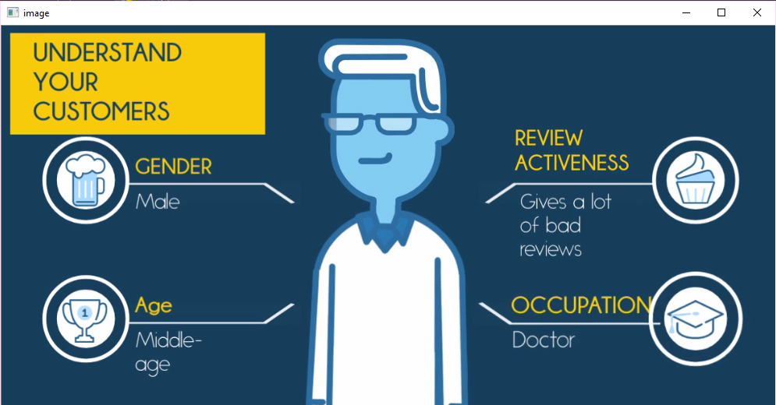

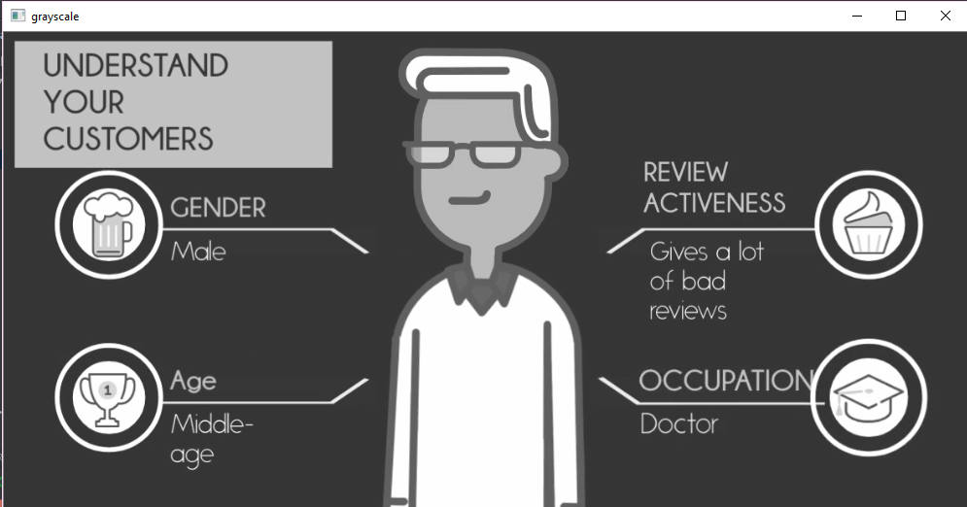

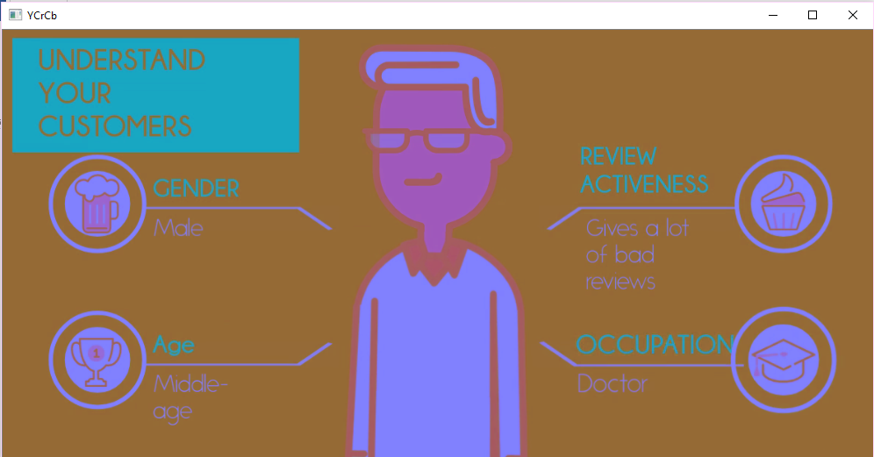

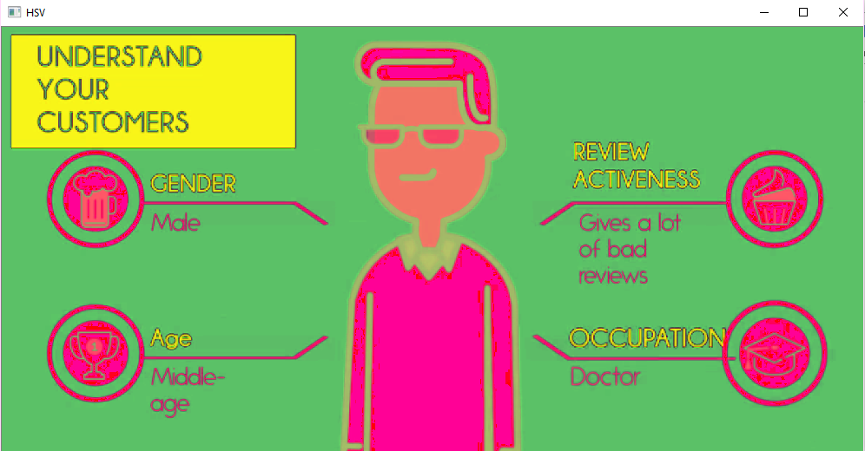

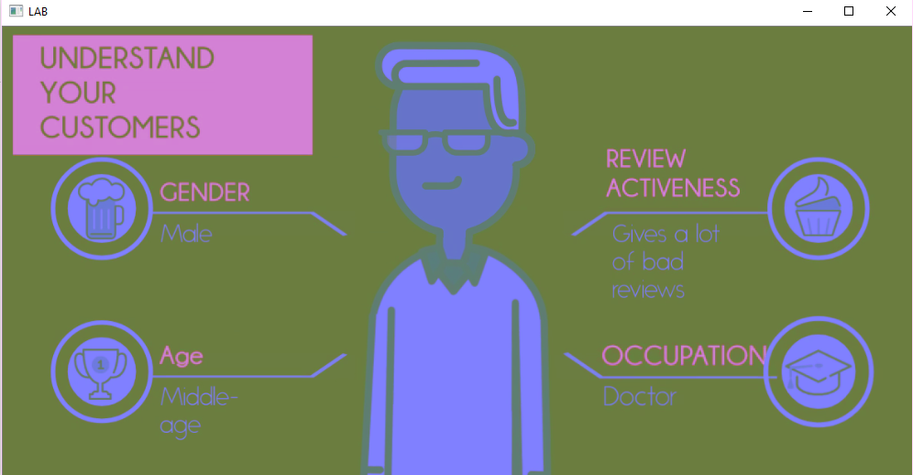

Task 3

**Code:**

**from** matplotlib **import** pyplot **as** plt  
**import** numpy **as** np  
**import** cv2  
  
img = cv2.imread(**'4.PNG'**)  
rows,cols,depth = img.shape  
arr = np.asarray(img)  
print(arr.shape)  
  
TF = arr[int(0):int(20), int(0):int(20)] *#top left patch*cv2.imshow(**'Top left patch'**, TF) *#show the patch*cv2.imwrite(**'task3-1_TL.png'**,TF)  
cv2.waitKey(0)  
BR = arr[int(arr.shape[0]-20):int(arr.shape[0]), int(arr.shape[1]-20):int(arr.shape[1])] *#bottom right patch*cv2.imshow(**'Bottom right patch'**, BR) *#show the patch*cv2.imwrite(**'task3-1_BR.png'**,BR)  
cv2.waitKey(0)  
M = arr[int((arr.shape[0])/2):int(((arr.shape[0])/2)+20), int((arr.shape[1])/2):int(((arr.shape[1])/2)+20)] *#middle patch*cv2.imshow(**'Middle patch'**, M) *#show the patch*cv2.imwrite(**'task3-1_M.png'**,M)  
cv2.waitKey(0)  
  
arr[int(0):int(20), int(0):int(20)] = np.ones((20, 20, 3)) * [0, 0, 255] *#convert the top left patch to red*arr[int(arr.shape[0]-20):int(arr.shape[0]), int(arr.shape[1]-20):int(arr.shape[1])]= np.ones((20, 20, 3)) * [0, 255, 0] *#convert the top left patch to green*arr[int((arr.shape[0])/2):int(((arr.shape[0])/2)+20), int((arr.shape[1])/2):int(((arr.shape[1])/2)+20)]= np.ones((20, 20, 3)) * [0, 255, 255] *#convert the midle patch to yellow*cv2.imwrite(**'task3-2.png'**,img)  
  
*#Adding text to the patches*font = cv2.FONT_HERSHEY_SIMPLEX  
cv2.putText(arr[int(0):int(20), int(0):int(20)],**'TL'**,(0,12), font, 0.5,(255,255,255),2,cv2.LINE_AA)  
cv2.putText(arr[int(arr.shape[0]-20):int(arr.shape[0]), int(arr.shape[1]-20):int(arr.shape[1])],**'BR'**,(0,12), font, 0.5,(0,0,0),2,cv2.LINE_AA)  
cv2.putText(arr[int((arr.shape[0])/2):int(((arr.shape[0])/2)+20), int((arr.shape[1])/2):int(((arr.shape[1])/2)+20)],**'M'**,(0,12), font, 0.5,(0,0,0),2,cv2.LINE_AA)  
cv2.imwrite(**'task3-3.png'**,img)  
  
*#Adding the footer*cv2.rectangle(img, (1, 400), (990, 487), (0, 255, 0), 3)  
cv2.circle(img,(850,450), 10, (0,255,0), -1)  
cv2.putText(img,**'Mujtaba Faizi'**,(865,455), font, 0.5,(0,255,0),2,cv2.LINE_AA)  
cv2.imwrite(**'task3-4.png'**,img)  
  
M = np.float32([[1,0,-(cols/2)+100],[0,1,0]])  
img = cv2.warpAffine(img,M,(cols,rows)) *#Translate the image such that the name is in the middle*cv2.imwrite(**'task3-5.png'**,img)  
  
M = cv2.getRotationMatrix2D(((cols-1)/2.0,(rows-1)/2.0),180,1)  
img = cv2.warpAffine(img,M,(cols,rows)) *#Rotate the image by 180 degrees*cv2.imwrite(**'task3-6.png'**,img)  
  
img = cv2.flip( img, 0 ) *#Now flip the image upside down.*cv2.imwrite(**'task3-7.png'**,img)  
  
img = arr[int(0):int(398), int(0):int(992)] *#image without the footer*cv2.imwrite(**'task3-8.png'**,img)  
  
img = arr[int(0):int(100), int(0):int(992)] *#extracting the header*cv2.imwrite(**'task3-9.png'**,img)

**Screenshot:**

*(images are already saved in the “lab 1” folder)*