Mujtaba Shahid Faizi

BSCS-5A

#131818

Lab 8 of Computer Vision

**CODE:**

**from** keras.preprocessing.image **import** ImageDataGenerator  
**from** keras.models **import** Sequential  
**from** keras.layers **import** Dense, Dropout, Flatten  
**from** keras.layers **import** Conv2D, MaxPooling2D  
**import** keras  
**import** matplotlib.pyplot **as** plt  
**from** keras.models **import** model_from_json  
**import** numpy  
**import** cv2  
  
*# Initialising the CNN*model = Sequential()  
model.add(Conv2D(32, (3, 3), input_shape = (224, 224, 3), activation = **'relu'**))  
model.add(MaxPooling2D(pool_size = (2, 2)))  
model.add(Conv2D(32, (3, 3), activation = **'relu'**))  
model.add(MaxPooling2D(pool_size = (2, 2)))  
model.add(Conv2D(32, (3, 3), activation = **'relu'**))  
model.add(MaxPooling2D(pool_size = (2, 2)))  
model.add(Flatten())  
model.add(Dense(units = 128, activation = **'relu'**))  
model.add(Dense(units = 1, activation = **'sigmoid'**))  
  
*# Compiling the CNN*model.compile(optimizer = **'adam'**, loss = **'binary_crossentropy'**, metrics = [**'accuracy'**])  
  
print(model.summary())  
  
*#image augmentations*train_datagen = ImageDataGenerator(rescale = 1./255,  
 shear_range = 0.2,  
 zoom_range = 0.2,  
 horizontal_flip = **True**,  
 validation_split=0.2)  
  
test_datagen = ImageDataGenerator(rescale = 1./255)  
  
training_set = train_datagen.flow_from_directory(**'data/train'**,  
 target_size = (224, 224),  
 batch_size = 16,  
 class_mode = **'binary'**,  
 subset = **'training'**)  
testing_set = train_datagen.flow_from_directory(**'data/train'**,  
 target_size = (224, 224),  
 batch_size = 16,  
 class_mode = **'binary'**,  
 subset=**'validation'**)  
validation_set = test_datagen.flow_from_directory(**'data/validation'**,  
 target_size = (224, 224),  
 batch_size = 16,  
 class_mode = **'binary'**)  
  
model.compile(loss=keras.losses.binary_crossentropy,  
 optimizer=**'rmsprop'**,  
 metrics=[**'accuracy'**])  
  
model.fit_generator(training_set,  
 epochs = 12,  
 validation_data = testing_set,  
 verbose=1)  
  
*# Save the weights*model.save_weights(**'my_model_weights.h5'**)  
  
*# Save the model architecture***with** open(**'my_model.json'**, **'w'**) **as** f:  
 f.write(model.to_json())  
  
score = model.evaluate_generator(testing_set)  
  
*# # Model reconstruction from JSON file  
# with open('my_model.json', 'r') as f:  
# model = model_from_json(f.read())  
#  
# # Load weights into the new model  
# model.load_weights('my_model_weights.h5')  
#  
# model.compile(loss=keras.losses.binary_crossentropy,  
# optimizer='rmsprop',  
# metrics=['accuracy'])*print(**'Test loss:'**, score[0])  
print(**'Test accuracy:'**, score[1])  
  
img1 = cv2.imread(**'dog1.jpg'**)  
img1 = cv2.resize(img1, (224,224))  
*# img1 = img1.reshape(1,224,224,3)*img2 = cv2.imread(**'cat1.jpg'**)  
img2 = cv2.resize(img2, (224,224))  
img3 = cv2.imread(**'dog2.jpg'**)  
img3 = cv2.resize(img3, (224,224))  
img4 = cv2.imread(**'cat2.jpg'**)  
img4 = cv2.resize(img4, (224,224))  
img=[img1,img2,img3,img4]  
img=numpy.array(img)  
  
pred = model.predict(img)  
list=[]  
**for** a **in** pred:  
 **if** a>0.5:  
 list.append(**"dog"**)  
 **else**:  
 list.append(**"cat"**)  
  
f, axarr = plt.subplots(2,2)  
axarr[0,0].imshow(img1)  
axarr[0,0].set_title(**"This is a "**+list[0])  
axarr[0,1].imshow(img2)  
axarr[0,1].set_title(**"This is a "**+list[1])  
axarr[1,0].imshow(img3)  
axarr[1,0].set_title(**"This is a "**+list[2])  
axarr[1,1].imshow(img4)  
axarr[1,1].set_title(**"This is a "**+list[3])  
plt.show()

**My CNN Structure:**

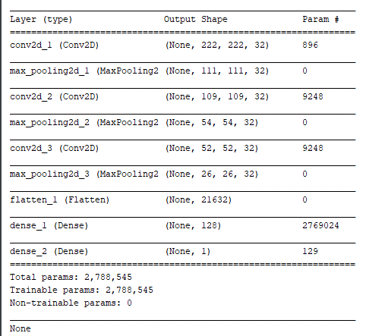

**Validation Accuracy: 76%**

**Testing Accuracy: 73%**



**Predictions:**

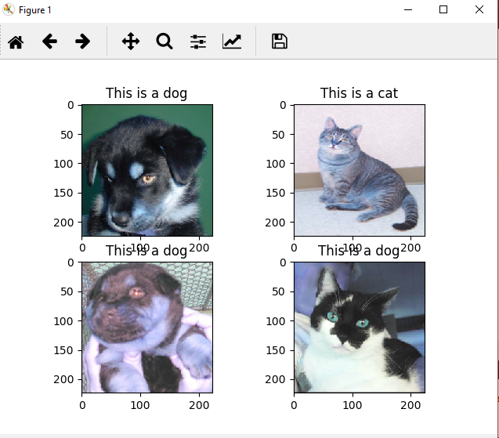

**CODE (Training VGG16 with imagenet weights) 🡪 Done on Colab:**

**from** keras.applications.vgg16 **import** VGG16  
**from** keras.preprocessing.image **import** ImageDataGenerator  
**from** keras.layers **import** Dense, Flatten  
**from** keras **import** Model  
**import** keras  
**import** matplotlib.pyplot **as** plt  
**import** cv2  
**import** numpy  
  
model = VGG16(weights=**"imagenet"**, include_top=**True**, input_shape=(224,224,3))  
last = model.output  
x = Flatten(name=**'flatten'**)(last)  
x = Dense(1000, activation=**'relu'**)(x)  
preds = Dense(1, activation=**'softmax'**)(x)  
model = Model(model.input, preds)  
  
print(model.summary())  
  
*#image augmentations*train_datagen = ImageDataGenerator(rescale = 1./255,  
 shear_range = 0.2,  
 zoom_range = 0.2,  
 horizontal_flip = **True**,  
 validation_split=0.2)  
  
test_datagen = ImageDataGenerator(rescale = 1./255)  
  
training_set = train_datagen.flow_from_directory(**"/content/drive/My Drive/Colab Notebooks/data/train"**,  
 target_size = (224, 224),  
 batch_size = 32,  
 class_mode = **'binary'**,  
 subset = **'training'**)  
testing_set = train_datagen.flow_from_directory(**"/content/drive/My Drive/Colab Notebooks/data/train"**,  
 target_size = (224, 224),  
 batch_size = 32,  
 class_mode = **'binary'**,  
 subset=**'validation'**)  
  
validation_set = test_datagen.flow_from_directory(**"/content/drive/My Drive/Colab Notebooks/data/validation"**,  
 target_size = (224, 224),  
 batch_size = 32,  
 class_mode = **'binary'**)  
  
  
model.compile(loss=keras.losses.binary_crossentropy,  
 optimizer=**'rmsprop'**,  
 metrics=[**'accuracy'**])  
  
model.fit_generator(training_set,  
 epochs = 12,  
 validation_data = testing_set,  
 steps_per_epoch=1,  
 validation_steps=1,  
 verbose=1)  
  
*# Save the weights*model.save_weights(**'/content/drive/My Drive/Colab Notebooks/VGG_model_weights.h5'**)  
  
*# Save the model architecture***with** open(**'/content/drive/My Drive/Colab Notebooks/VGG_model.json'**, **'w'**) **as** f:  
 f.write(model.to_json())  
  
score = model.evaluate_generator(testing_set, steps=1)  
  
*# # Model reconstruction from JSON file  
# with open('LSTM_model.json', 'r') as f:  
# model = model_from_json(f.read())  
#  
# # Load weights into the new model  
# model.load_weights('LSTM_model_weights.h5')*print(**'Test loss:'**, score[0])  
print(**'Test accuracy:'**, score[1])  
  
img1 = cv2.imread(**'/content/drive/My Drive/Colab Notebooks/dog1.jpg'**)  
img1 = cv2.resize(img1, (224,224))  
*# img1 = img1.reshape(1,224,224,3)*img2 = cv2.imread(**'/content/drive/My Drive/Colab Notebooks/cat1.jpg'**)  
img2 = cv2.resize(img2, (224,224))  
img3 = cv2.imread(**'/content/drive/My Drive/Colab Notebooks/dog2.jpg'**)  
img3 = cv2.resize(img3, (224,224))  
img4 = cv2.imread(**'/content/drive/My Drive/Colab Notebooks/cat2.jpg'**)  
img4 = cv2.resize(img4, (224,224))  
img=[img1,img2,img3,img4]  
img=numpy.array(img)  
  
pred = model.predict(img)  
list=[]  
**for** a **in** pred:  
 **if** a>0.5:  
 list.append(**"dog"**)  
 **else**:  
 list.append(**"cat"**)  
  
f, axarr = plt.subplots(2,2)  
axarr[0,0].imshow(img1)  
axarr[0,0].set_title(**"This is a "**+list[0])  
axarr[0,1].imshow(img2)  
axarr[0,1].set_title(**"This is a "**+list[1])  
axarr[1,0].imshow(img3)  
axarr[1,0].set_title(**"This is a "**+list[2])  
axarr[1,1].imshow(img4)  
axarr[1,1].set_title(**"This is a "**+list[3])  
plt.show()

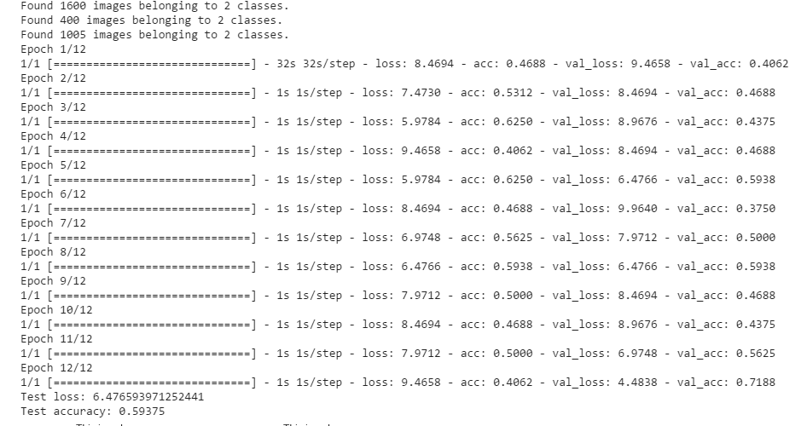

**Validation Accuracy: 71%**

**Testing Accuracy: 59%**

**Predictions:**

