National University of Sciences & Technology
School of Electrical Engineering and Computer Science
Department of Computing
EE 353: Computer Networks (3+1): BSCS-5AB Fall 2017
Assignment: 2
CLO: Apply the knowledge of Computer networking to understand contemporary networking issues
Maximum Marks: 10 | Instructor: Dr. Arsalan Ahmad
Announcement Date: 26th December 2017 | Due Date : 31st December 2017 11:00 pm on LMS

Instructions:

This is an individual assignment. Fill in your details as listed above. Each student will attempt all the questions in this document and upload the complete document to the course LMS site by the deadline. Please avoid plagiarism; any such case would result in award zero marks both to the “sharer” and the “acquirer”. You may note that submitted assignment would be checked through turnitin that would check similarly with not only internet resources but also with other submitted assignments.

MUJTABA SHAHID FAIZI
BSCS-5A
#131818

Tasks:

Q1.
Refer to lecture slides (Week11_L3, Bandwidth Allocation (AIMD), slide 10) which illustrate the convergence of TCP’s AIMD algorithm. Suppose that instead of a multiplicative decrease, TCP decreased the window size by a constant amount. Would the resulting AIAD (Additive Increase Additive Decrease) algorithm converge to an equal share algorithm? Now suppose that instead of an additive increase, TCP increase the window size by a multiplicative factor. Would the resulting MIMD (Multiplicative Increase Multiplicative Decrease) algorithm converge to an equal share algorithm? Justify your answers using a diagram similar to the one we saw in slides when we covered AIMD algorithm. (6 Points)

AIAD (Additive Increase Additive Decrease) algorithm & MIMD (Additive Increase Additive Decrease) algorithm doesnt converge to an equal share algorithm acc. to the following diagram.

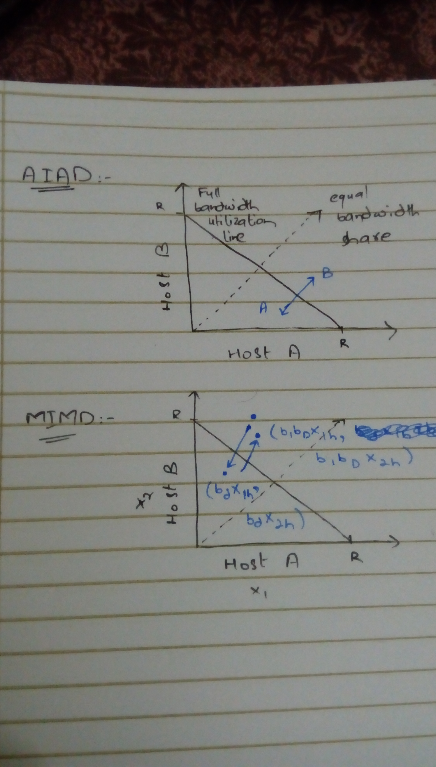

Q2.
What is TCP Incast problem? Give any one possible solution to this problem. (4 Points)
TCP Incast is a problem that occurs when the no. of storage servers sending data to a client, increases past the ability of an Ethernet switch to buffer packets. Say, a client requests some data that is stripped across several storage servers. The client will request for the next data block when all servers have responded with their parts. This synchronized approach can result in packet loses and timeouts since the packets will overfill the buffers on the client side.
Solution: Increasing the buffer size can reduce the TCP Incast problem since the no. of servers that can be contacted would also increase but with a disadvantage of greater cost.

