Name: Mujtaba shahid faizi
Regn No: 131818
Current IP: 10.99.24.126

Lab Title: Tracing the path to a destination

1.0 Objective of this lab:

In this lab, we’ll explore several networking tools to trace the path followed by packets to a particular destination.

2.0 Instructions:

- Read carefully before starting the lab.
- These exercises are to be done individually.
- You are supposed to provide the answers to the questions listed at the end of this document, paste the screenshots of your working and upload the completed report to your course’s LMS site.
- Avoid plagiarism by copying from the Internet or from your peers. You may refer to source/ text but you must paraphrase the original work.
Steps for performing this lab:

- Open the command prompt application

- Start up the Wireshark packet sniffer.

- Begin packet capture.

- Type “tracert www.usyd.edu.au” (or traceroute) in command prompt and press enter.

Now answer the following questions:

- How many hops is the destination host away from your machine?

21 hops
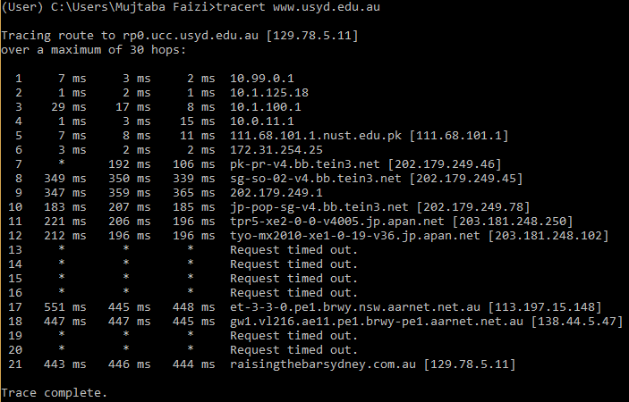

- How many routers does these packets visit in Pakistan?

7 routers

- Where is the website www.usyd.edu.au hosted (city and country)?

Australia and Darlington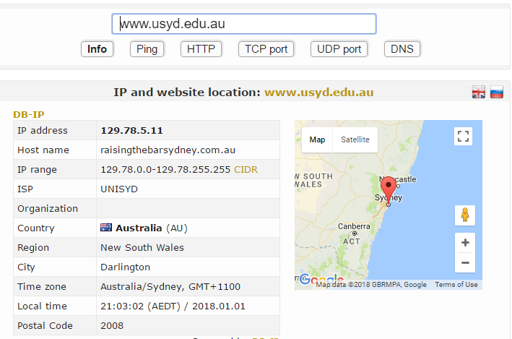

- How many cities your packets have actually visited? List all these cities along with the name of country in the order these have been visited?

111.68.101.1 Islamabad
202.179.249.46 Beijing(Haidian Qu)-China
203.181.248.250 Chiyoda-ku –Japan
113.197.15.148 Macquarie Park(New South Wales)-Australia
138.44.5.47 Mascot(New South Wales)-Australia
129.78.5.11 Destination 129.78.5.11 Darlington(New South Wales)-Australia

- Which hop is the longest in the path to the destination?

551ms 445ms 448ms Macquarie Park- Australia
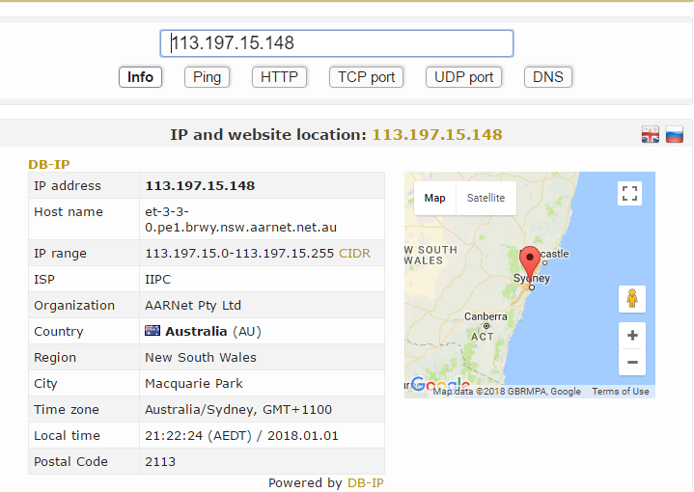

2. IP fragmentation

2.1 Background:

In this part of the lab, we will try to find out what happens when IP fragments a datagram by increasing the size of a datagram until fragmentation occurs. We will ping with options (use the –s option on MacOS, -l on windows) to set the size of data to be carried in the ICMP echo request message. Note that the default packet size is 64 bytes in MacOS and 32 Bytes in Windows. Once you have send a series of packets with the increasing data sizes, IP will start fragmenting packets that it cannot handle.

2.2 Steps for performing this part of the lab:

Startup Wireshark and begin packet capture (Capture->Start) and then press OK on the Wireshark Packet Capture Options screen (we’ll not need to select any options here).
Startup ping with default values to the target destination as 8.8.8.8
Stop the wireshark capture when you receive at least 6 replies from target destination.
Next, repeat the above steps by sending a set of ICMP requests with a length of 2000.
Finally, repeat again with length value set as 3500

Now answer the following questions.

Which datagram size has caused fragmentation and why? Which host/router has fragmented the original datagram? How many fragments have been created in this case?
The packets of size 2000 and 3500 have caused fragmentation

-l 2000
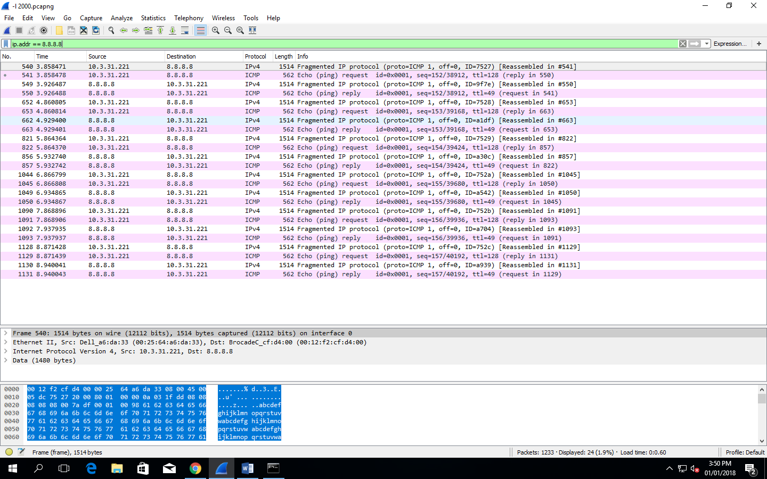

-l 3500
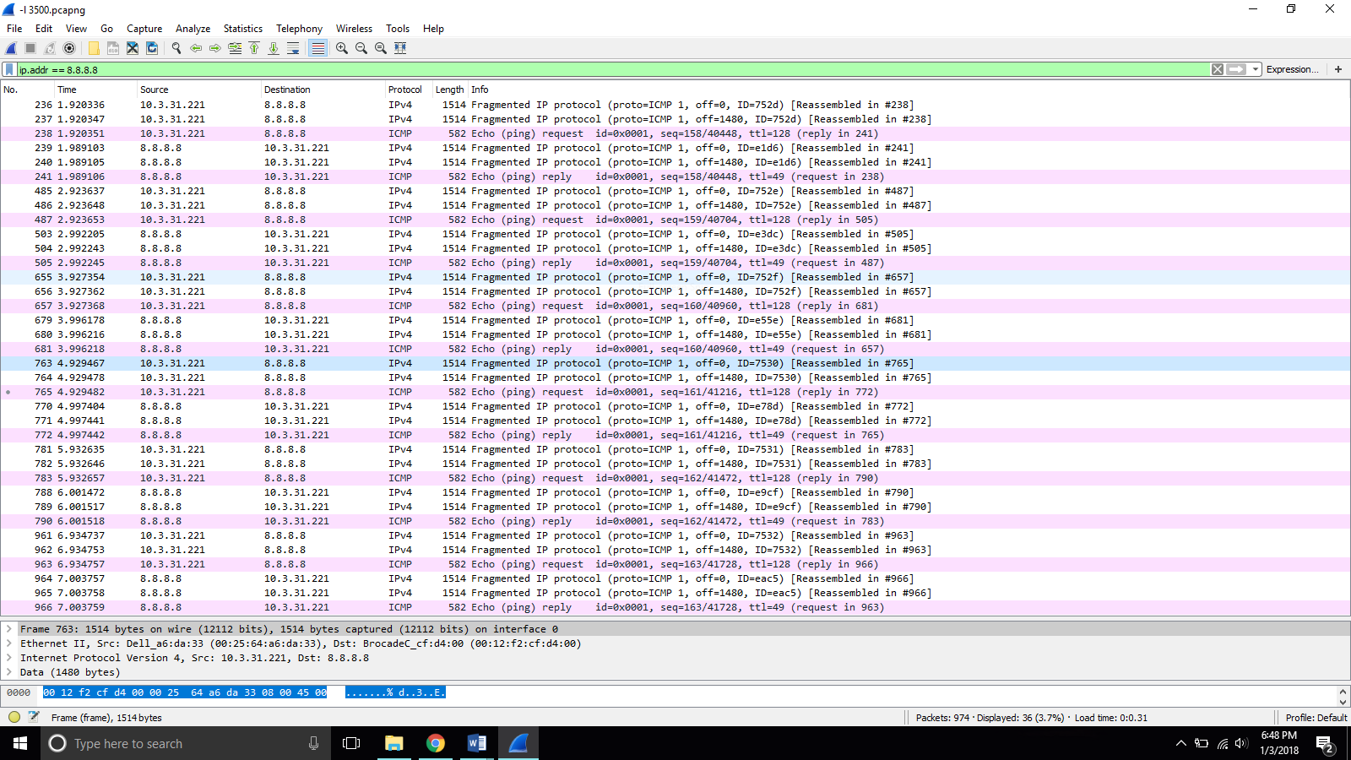

The packet of size 32 does not cause fragmentation
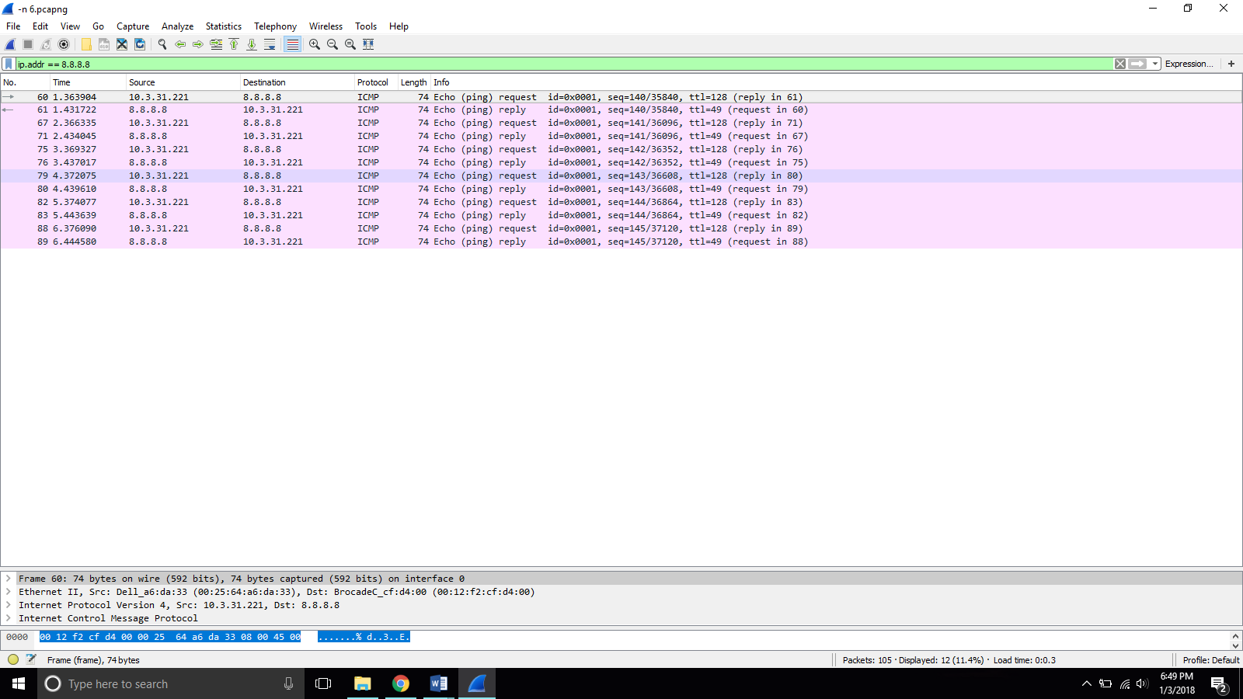

Original Datagram is fragmented by Ethernet. There are 2 fragments for the packet of size of 2000 and 3 fragments for the packet of the size 3500

- Did the reply from the destination 8.8.8.8. for 3500 byte datagram also get fragmented? Why and why not?

Yes, as it exceeds the size of MTU(1480 bytes) that a medium can transfer.

- Give the ID, length, MF and offset values (actual values in fragments, not the one reported by Wireshark) for all the fragments of any single datagram with size 3500 bytes?

1st Fragment
Identification = 0x193e
MF=1
Offset=0

2nd Fragment
Identification = 0x193e
MF=1
Offset=1480

3rd Fragment
Identification =0x193e
MF=0
Offset =2960

- Has fragmentation of fragments occurred when datagram of size 3500 has been used? Why and why not?

No because
the number of fragments sent = number of fragments received.

- What is the least MTU value along the complete path to destination? Which is the bottleneck link?

Bottleneck link is Ethernet because it has the minimum MTU

