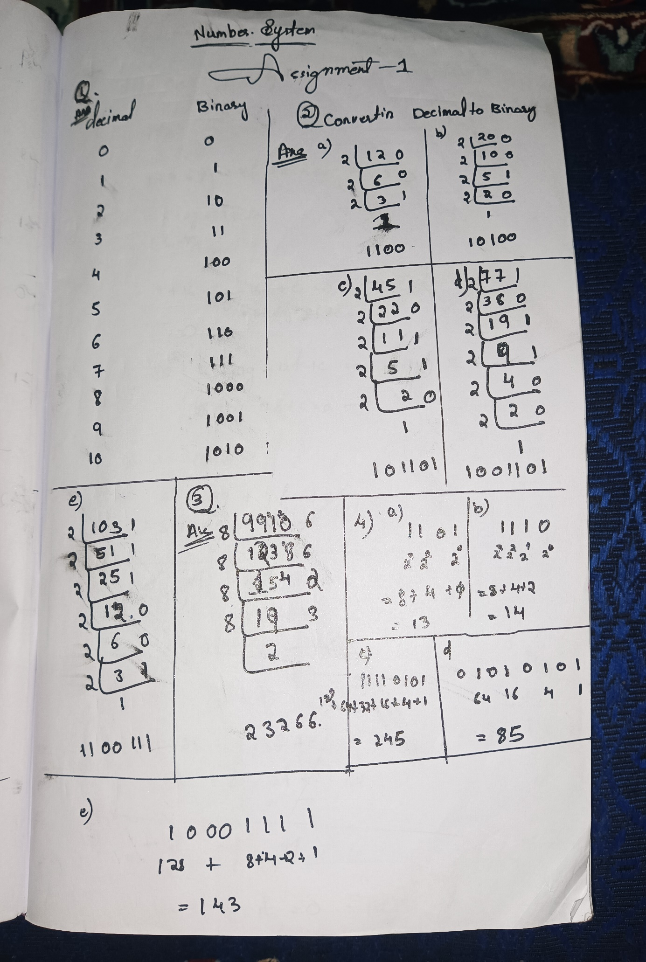

5) Convert the following numbers to the base indicated and vice-versa (Cross-Verify)

a. (1101)2 => ( ) 8

b. (1111 1111 1110) 2 => ( )10

c. (221201) 3 => ( ) 10

d. (76) 8 => ( ) 10

e. (231) 8 => ( ) 2

f. (0xF00) 16 => ( ) 8

g. (0xDACE) 16 => ( ) 12

h. (0x2B) 16 => ( )8

Ans)

a)     (1101)2 => ( ) 8

1101   =     001 101  = (15)8

         1    5

b) (1111 1111 1110)2 ->()10

 ( 1 \*211  + 1 \*210 + 1\*29 + 1 \*28 + 1\*27 +1\*26+1\*25 +1\*24+1\*23+1\*22+1\*21+\*20)

    2048 + 1024  + 512 +  256  +128   + 64  + 32 +16    +    8+     4+    2 +  0

     =4094

c) (2 2 1 2 0 1)3 ->  ()10

     101001100001

2187 729  243 81 27     9 3       1

   2      2    1          2    0    1

=(694)

d) (7  6)=()10

       111 110     =32 +16    +    8+     4+    2 + 0=62

e)(2    3     1)8 =(10011001)2

  010   011   001

f)( f     0 0  )=()8

    1111 0000 0000 =2048 + 1024  + 512 +  256= 8l3840  = 7400

                                                                              8l480    0

                                                                              8|60       0

                                                                                |7         4

g) (D         A C     E)16 ->()12

 1101 1010 1100 1110    = 12|56014   = 284ab

                                           12|4667  10 a

                                           12|388     11 b

                                           12|32         4

                                               |2           8

h) (2 B)16 ->()8

  0010 1011  = 8|43  3 =53

    5

7. Convert the following base 10 numbers to the base Indicated:

a. ( 5   6   1   0)10 => (1010111101010) 2

2 5610

2 285-0

2 152-1

2 76-0

2 38-0

2 19-0

2 9-1

2 4-1

2 2-0

2 1-0

b. (5 610)10 => ( 21200210  ) 3

3 5610

3 1870

3 623-2

3 207-2

3 69-0

3 23-0

3 7-2

3 2-1

c. (5610)10 => ( 12752 ) 8

8 5610

8 701-2

8 87-5

8 10-7

8 1-2

d. (5610)10 => ( 32b6 )12

12 5610

12 467-6

12 38-11

12 3-2

e. (5610)10 => ( 15ea )16

16 5610

16 350-10

16 21-14

16 1-5

f. (22110)10 => (101011001011110 )2

2 22110

2 11055-0

2 5527-1

2 2713-1

2 1381-1

2 690-1

2 345-0

2 172-1

2 86-0

2 43-0

2 21-1

2 10-1

2 5-0

2 2-1

2 1-0

g. (22110)10 => (1010022220  )3

3 22110

3 7370-0

3 2456-2

3 818-2

3 272-2

3 90-2

3 30-0

3

3

10-0

3-1

3 1-0

h. (22110)10 => (53136  )8

8 22110

8 2763-6

8 345-3

8 43-1

8 5-3

i.(22110)10 => (10966  )12

12 22110

12 1842-6

12 153-6

12 12-9

1-0

j. (22110)10 => (565e )16

16 22110

16 1381-14

16 86-5

16 5-6

8. Perform Binary Addition on the below numbers:

a. 9 + 12

 1001

 1100

10101

b. 40 + 31

  101000

    11111

1000111

c. 1110 + 0101

  1110

  0101

10011

d. 1111 0101 + 0111 1100

  11111

  11110101

  01111100

101110001

e. 1100 0011 + 0101 1110

 1     111

  11000011

  01011110 100100001

9. Perform Binary Subtraction on the below numbers:

a. 8 – 3

0112  c

1000= 8

0011= 3

 101  =5

b. 17 – 11

0112  =c

10001=17

  1011=11

00110=6

c. 25 – 7

11001 - 111 = 10010

d. 86 – 31

1010110 - 11111 = 110111

e. 1101 0001 – 01000111

11010001 -      1000111 = 10001010

209 - 71 = 138

10. Perform Binary Multiplication on the below numbers:

a. 12 x 3

0000 1100

0000 0011

0010 0100

b. 20 x 5

0001 0100 20

0000 0101 5

0110 0100 100

c. 0111 x 0010

0111  7

0010  2

1110 14

d. 0110 0111 x 101

  01100111

   00000101

1000000011

e. 1010 1010 x 0101

  1010 1010

           0101

1101010010

11. Perform Binary Division on the below numbers:

a. 15 / 2

Ans)

10)1111(0111=7

      10

     011

       10

        011

         10

          01

b. 45 / 5

101)101101(01001=9

       101

0101

  101

c. 121 / 14

1110)1111001(01000=8

         1110

         0001001

d. 1101 0100 / 101

101)110 10 100(0101010=42

       101

       00110

           101

              0110

    101

                    1 0

e. 1010 1010 / 0111

111)10101010(011000=24

         111

         0111

           111

           000010

12. Convert the following floating numbers

a. (34.34) 10>()2

2|34  0      0.34\*2=0.68 0

100010.0101… 2|17  1      0.68\*2=1.36  1

2|8     0      0.36\*2=0.72 0

2|4     0      0.72\*2=1.44 1

2|2    0

                                               2|1

()3

10021.1000…. 3|34  1      0.34\*3=1.02  1

311    2      0.02\*3=0.06 0

3|3     0      0.18\*3=0.54 0

  |1    0

0ctal

42.2506 8|34  2      0.34\*8=2.72  2

        |4             0.72\*8=5.76 5

    0.76\*8=6.08  6

Hexadecimal

22.570a 16|34  2      0.34\*16=5.44   2

          |2           0.44\*16=7.04   5

       0.04\*16=0.64   6

      0.64\*16=10.24  0

b.(125.125) 10>()2

2|125  1      0.125\*2=0.250 0

1111101.001 2|62    0      0.250\*2=0.500  0

2|31     1      0.500\*2=1. 0    1

2|15     1

2|7   1

                                                2|3   1

2|1

()3

11122.01010…. 3125  2      0.125\*3=0.375  0

3|41    2      0.375\*3=1.125 1

3|13   1      0.125\*3=0.375  0

3 |4   1

  |1

0ctal

175.1 8|125  5   0.125\*8=1.00

      8 | 15    7

          1

Hexadecimal

7D.2 16|125 13=d     0.125\*16=2.00   2

          |7

c. (10.16)10

Binary

2|10  0      0.16\*2=0.32 0

1010.0010… 2|5    1      0.32\*2=0.64  0

2|2    0      0.86\*2=1.28 1

2|1             0.28\*2=0.56 0

()3

101.0110…. 3|10  1      0.16\*3=0.48  0

3|3    0      0.48\*3=1.44  1

3|1           0.44\*3=1.32 1

    0.32\*3=0.96 0

0ctal

12.1217.. 8|10  2      0.16\*8=1.28  1

        |1             0.28\*8=2.24 2

    0.24\*8=1.96  1

     0.96\*8=7.36   7

Hexadecimal

A.28F5 16|10  A      0.16\*16=2.56      2

                       |0           0.56\*16=8.96      8

       0.96\*16=15.36   15

      0.36\*16=5.16      5

13)What is the largest positive number one can represent in a 12-bit 2's complement code? Write your result in binary and decimal?

Ans)

Msb should be 0=possitive

(0111 1111 1111)2

(2047)10

14)What are the 8-bit patterns used to represent each of the characters in the string "                                                                             :         CODE / THS    2 0 2 2"?

Ans)

binary using the ASCII code, we can use the following 8-bit patterns:

'C' = 01000011

'O' = 01001111

'D' = 01000100

'E' = 01000101

'/' = 00101111

'T' = 01010100

'H' = 01001000

'S' = 01010011

' ' = 00100000

'2' = 00110010

'0' = 00110000

'2' = 00110010

'2' = 00110010

So, the complete sequence of 8-bit patterns for "CODE/THS 2022" would be:

01000011 01001111 01000100 01000101 00101111 01010100 01001000 01010011 00100000 00110010 00110000 00110010 00110010

15. What is the biggest binary number you can write with 5 bits?

Ans)

11111=31          biggest binary 5 bits number

16. In hex, 2BFC + 54A7 ??

   111

   2BFC   19=13

+ 54A7     26=1A

    80A3    16=10

17. Convert the hex number ABC7 to binary?

Ans=

a=1010

b=1011

c=1100

7=0111

1010 1011 1100 0111=abc7

18. In hex, AC74 − B3F?

Ans)

          6 14

     AC7 4

-       B3 F

     A135

18)Convert the following binary fractions to ordinary fractions

a. 0.1001

b. 1.0011

c. 1.1111

* a. 0.1001 = 1/2 + 1/16 = 9/16
* b. 1.0011 = 1 + 1/8 + 1/16 = 13/8
* c. 1.1111 = 1 + 1/2 + 1/4 + 1/8 + 1/16 = 31/16

 20. The decimal expansion of 11/17 is 0.647. Find the binary expansion of the fraction 11/17

Ans)

0.647\*2=1.294 1

 0.294\*2=0.498 0

 0.498\*2=0.996 0

0.996\*2= 1.992 1

                                     11/17=(1001……)2

21. The decimal expansion of 3/11 is 0.2727. Find the binary expansion of the fraction 3/11

Ans)

0.2727\*2=0.5454 0

0.5454\*2=1.0908 1

0.0908\*2=0.1816  0

0.1813\*2=0.3632 0

                                     3/13=(0100….)2