**ASSIGNMENT – 2**

**1.   MODIFY original file of SOFT link and observe?**

**Ans) Modification in original file can be noticed In soft links**

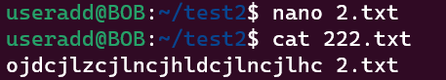

**2.   MODIFY any SOFT link and observer original ?**

**Ans)Modification in soft link file can be noticed In original file**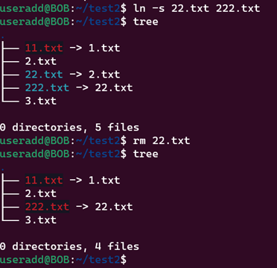

**3.   Remove any SOFT link and observer original**

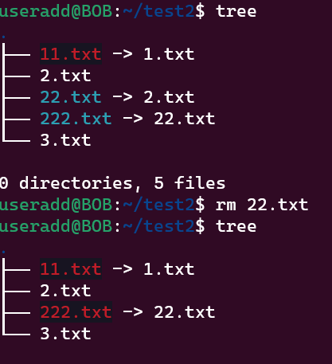

**4.   Remove original file of SOFT link and observe?**

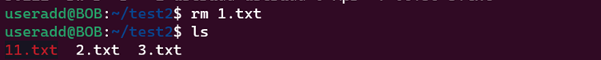

**5.   MODIFY any HARD link and observer original?**

**Modification in hard link file can be noticed In original file**

**6.    MODIFY Original file of HARD link and observe?**

**Modification in original file can be noticed In hard link**

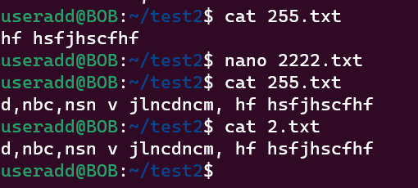

**7.   Remove any HARD link and observer original?**

**8.   Remove original file of HARD link and observe?**

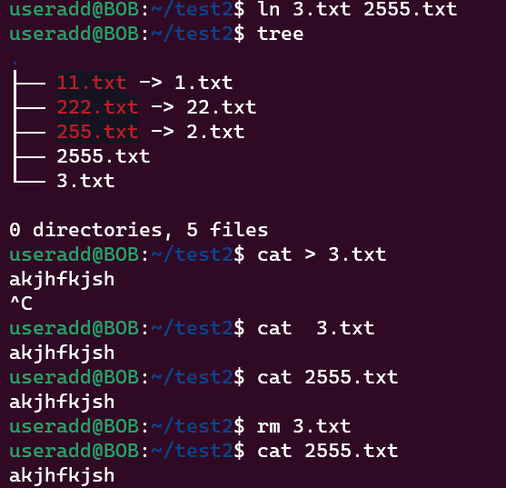

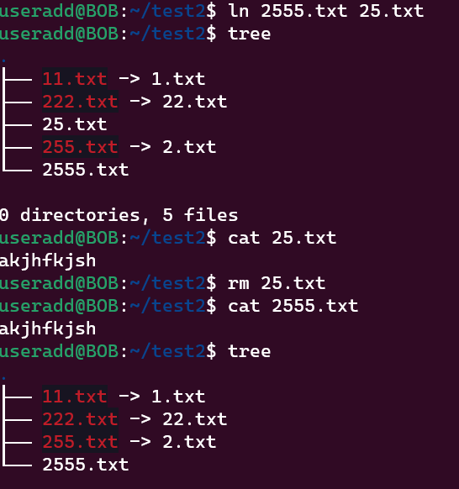

1. **what are wget , curl commands differences?**

**Ans) Curl command output can be redirected to any file and folder**

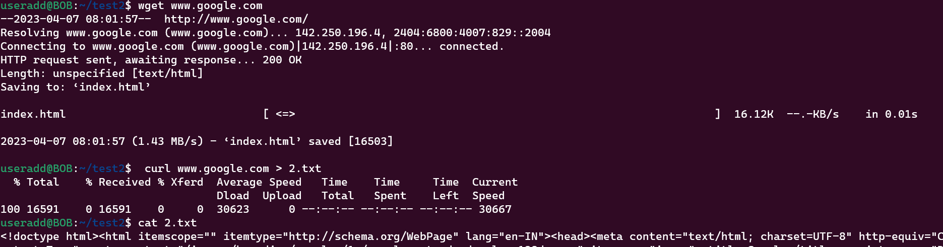

1. **Comparison among soft,hard,copy?**

**Ans)If you copy a file, it will duplicate the content. So if you modify the content of a single file, that has no effect on the other one.**

**If you make a hard link, that will create a file pointing to the same content. So if you change the content of either of the files, the change will be seen on both. if you delete original file there will be no effect on hard link**

**Softlink acts as a pointer or a reference to the file name. It does not access the data available in the original file. If the earlier file is deleted, the soft link will be pointing to a file that does not exist anymore**

1. **write a script to print the date and redirect it to output.txt?**
2. 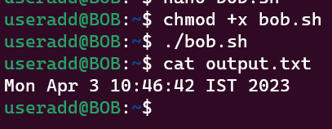
3. **create a file or folder using the date as the name**

1. **i) Create a bash script to print the local time, date, username of your system, and your current path.**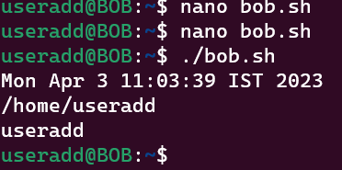

**ii) After printing, redirect the output into a file called output.txt**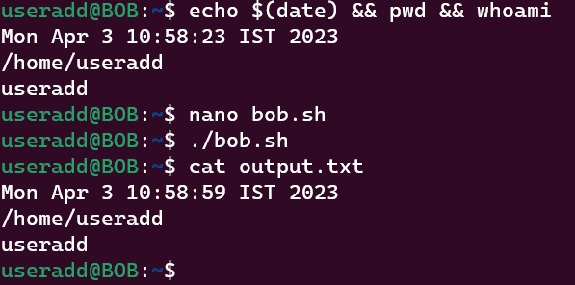

**iii) Insert output.txt into a new directory, where the directory name is the current timestamp.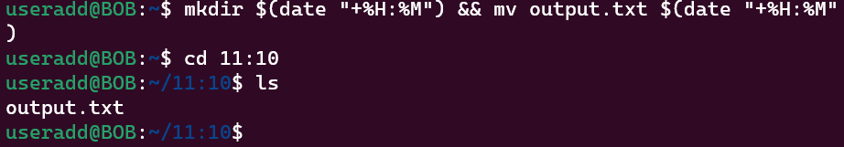4.Create a bash script to execute the date every 2 minutes once on Saturdays only**

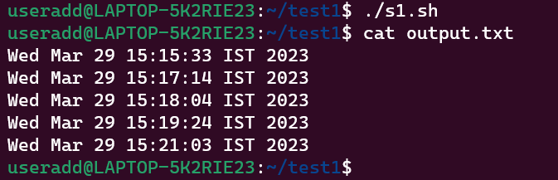

**5) Take a backup of a folder every month twice?**



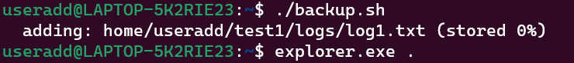



**6) Print the count of the number of files in a file called count.txt?**

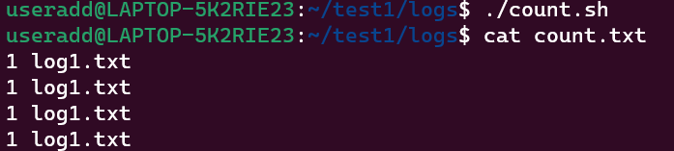

**7)** **Create files dynamically every day at 12 AM where the file name is a date?**







CRONTAB SCRIPTS LABS:

1. Write a script to print the current directory and username and redirect it to a file called output.txt?

(echo $(pwd && whoami) ) >> output.txt

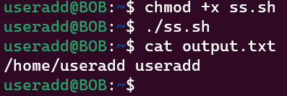

1. Create a file with the current timestamp as its name inside a folder with the current date as its name?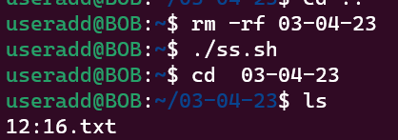
2. **Create a bash script to print the local time, date, username of your system, and your current path and redirect the output into a file called output.txt. Insert output.txt into a new directory, where the directory name is the current timestamp**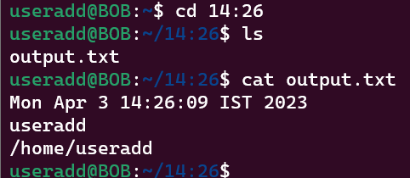
3. Write a script to print the count of the number of files in a folder and redirect the count to a file called count.txt. (Reference: Google about word count and pipe commands in Linux)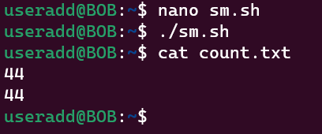
4. Create a bash script to execute the date every 2 minutes once on weekends only?



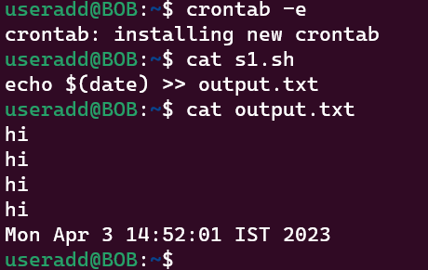

1. Take a backup of a folder daily twice?



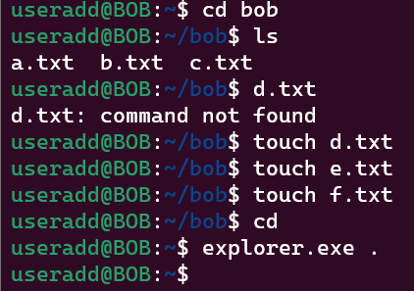

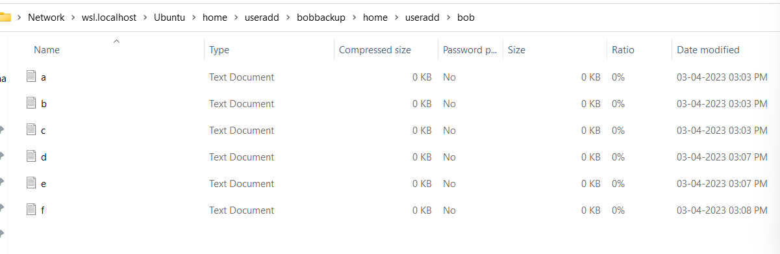

1. Bonus question:

Create a file with the current timestamp as its name once per minute inside a folder with the current timestamp as its name once per 4 minutes





