

**USER MANUAL V1.01**

**Ionix Advanced Technologies & Oceaneering**

Phase 1

***Table of contents***

1. Overview ---------------------------------------------------------------------------------------------------------------

a. System overview -------------------------------------------------------------------------------------------

2. System Requirements -----------------------------------------------------------------------------------------------

a. System Configurations ------------------------------------------------------------------------------------

3. Roles ---------------------------------------------------------------------------------------------------------------------

a. Roles overview ---------------------------------------------------------------------------------------------

b. Role permission --------------------------------------------------------------------------------------------

4. Create Users -----------------------------------------------------------------------------------------------------------

a. Create Manager --------------------------------------------------------------------------------------------

b. Create Technicians ----------------------------------------------------------------------------------------

c. Create Client ------------------------------------------------------------------------------------------------

5. Authentication---------------------------------------------------------------------------------------------------------

a. Authentication a user--------------------------------------------------------------------------------------

6. Dashboards-------------------------------------------------------------------------------------------------------------

a. Manager------------------------------------------------------------------------------------------------------

b. Technicians---------------------------------------------------------------------------------------------------

c. Client-----------------------------------------------------------------------------------------------------------

7. Reporting Module-----------------------------------------------------------------------------------------------------

a. Reports-------------------------------------------------------------------------------------------------------- i. Ultra Sonic Inspection Report (UT) ----------------------------------------------------------

b. Create Job----------------------------------------------------------------------------------------------------

c. View Job-------------------------------------------------------------------------------------------------------

8. Report Fill up----------------------------------------------------------------------------------------------------------- a. Ultra Sonic Inspection Report (UT) ---------------------------------------------------------------------

9. Report Inspection--------------------------------------------------------------------------------------------------------

a. Ultra Sonic Inspection Report (UT) -----------------------------------------------------------------------

10. Modification of reporting database system---------------------------------------------------------------------

a. Change Company Name----------------------------------------------------------------------------------

b. Change Job Information----------------------------------------------------------------------------------

c. Change Job Number-----------------------------------------------------------------------------------------

d. Change Information----------------------------------------------------------------------------------

e. Change Technician with completed reports---------------------------------------------------------- 11. Live Trackers-----------------------------------------------------------------------------------------------------------

12. Reports Status----------------------------------------------------------------------------------------------------------

13. Graph Charts-----------------------------------------------------------------------------------------------------------

14. Notifications------------------------------------------------------------------------------------------------------------

a. Report Start--------------------------------------------------------------------------------------------------

b. Report Reject------------------------------------------------------------------------------------------------

c. Report Completed------------------------------------------------------------------------------------------

d. Need Signature of reports---------------------------------------------------------------------------------

15. Activity Log-------------------------------------------------------------------------------------------------------------

16. Comments Log---------------------------------------------------------------------------------------------------------

17. Profile Managements------------------------------------------------------------------------------------------------

1. **Overview V1.01**
   1. System overview
      * The application is a reporting tool that will allow management staff, technicians and clients of Ionix/Oceaneering to use an online reporting and monitoring system for managing NDT reporting.
      * The CRM is web based designed using LAMP (Linux, Apache, Mysql and PHP). The application design is built in HTML/CSS for Responsive GUI optimized for multiple devices.
      * The first phase of CRM will provide following objectives:

i. UT Reports from handheld devise to completed PDF reports.

# System Overview

* Open-Source platform is used to power-up and secure the CRM. Combination of Linux, Apache, MySQL and PHP is used to cater the nature and scale of Ionix/Oceaneering reporting system.
* The following are the major components.

1. GNU/Linux ([www.gnu.org/www.linux.org)](http://www.gnu.org/www.linux.org)) is an Open Source, UNIX style operating system based on the combination of the “Kernel” developed by Linux Torvals with the user and developer tools from the GNU project. The result is a fast, reliable, and scalable basis for delivering web content.
2. Apache (www.apache.org), as mentioned previously, is the most popular web server in the world. Many of the commercial web servers are based upon Apache code.
3. MySQL (www.mysql.com) is an Open-Source client-server relational database system that has been turned towards online, dynamic content delivery. It lacks many of the features of larger database systems such as Oracle, DB2 and PostgresSQL and so can concentrate on being fast. The additional features of these systems are not necessary in a project such as the presence.
4. PHP (www.php.net) is a Server-Side scripting language that uses code embedded within HTML documents in a very similar manner to Microsoft’s Active Server Pages. The syntax and features are regarded as a combination of the better features of Perl, C and C++.

# Roles

* 1. Roles overview

The system provides multiple roles for different categories of the users. Each role has specific privileges and access to the system modules. The details of each role are elaborated here:

* 1. Role permission

1. Manager

The leading system role configured to the client requests, the manger manager can in most cases create jobs and view jobs being actioned along with all the attributes and current status. It can also start/delete reports which include number of jobs related to projects. The role is authorized to delete the projects also. Managers can further create technician and client roles within the system.

The Manager is capable of viewing overall activity feeds occurring in the system. It can view comments of all the users and can reply to any comment. Can create notification regarding any report/job and send notification to any technician for required signature. Manager can view Live tracker for accessing reports in start of jobs, during the progress and on completion.

1. Technician

The role of technician is restricted to few of the system modules. The role can start new job and can view active jobs. It has access to view all reports and live tracker to check the report status at different phases of job progress. Technician can assign reports and able to only view completed reports.

1. Client

The role of client is limited to view the reports,but can be configured to improve relationships.

# Create Users

* 1. Create Manager

The administrator can solely create/delete the role of manager for multiple users to allow them perform and access the managerial area of the reporting application.

* 1. Create Technicians

The role of technician can be created/deleted through administrator and manager roles. The create technician form requires basic info of user and particular Discipline.

* 1. Create Client

Administrator, manager and technician all three can create/delete the role of clients in reporting system. New or existing company can also be selected while creating a new client.

# Authentication

* 1. Authentication a user

The users are authenticated on the base of their roles defined in the system. Authentication process is carried out during login procedure of each role.

# Dashboards

* 1. Manager

The dashboard of manager role presents the Ionix/Oceaneering report status through Live Tracker. Comments and activity feeds are displayed at the right side of screen, whereas report notifications and job views are demonstrated underneath. Manager dashboard provides overall current status of active jobs.

* 1. Technicians

The dashboard of technicians provides view of current and completed reports. Technician can perform search and advance search operations by adding attributes of jobs in given fields.

* 1. Client

Client can only view reports that are affiliated to him through any company. The role can access search and advance search options from dashboard. And can only download a completed report of jobs.

# Reporting Module

* 1. Reports

The reporting module of the application provides multiple types of reports. Within (Phase

1. the report presents inspection details about the operations carried out.
   1. Ultra Sonic Inspection Report (UT)

The report displays the information related to ultra sonic inspection technique of locating defects in a specific material by passing acoustic energy in the ultrasound range through the material.

* 1. Create Job

To create job, manager have to input data related to client, project, job, number of spools, booking date and bay manager details. The job creation form will look like:

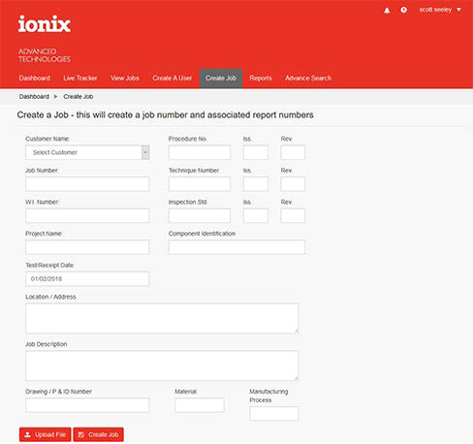

* 1. Upload Job Sheet CSV

The system is setup to minimize the amount of time required to populate manually fields. The user will simply click on the Upload File button, this will allow them to access the Job CSV and populate automatically the fields for creating a job.

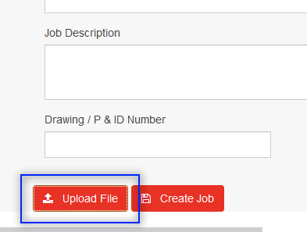

Here the user clicks on the Upload File button to access the job template CSV, this will automatically populate the job details. The user clicks Create JOB here and the report is waiting to start within that job.

* 1. View Jobs

Job view display all the current jobs with detailed attributes including client name, project name and number of test points as well as due date of jobs, booked-in date, job created date, client’s job number and recent status of the job – all configured to suit requirements.

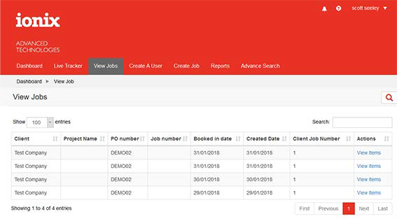

* 1. Clicking into View Items Link will open the Reports within a Job, the user will then be able to access the reports within this section.

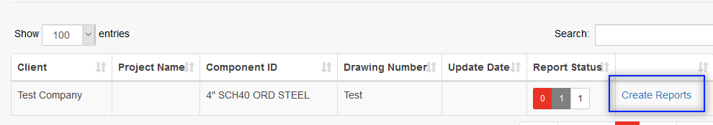

# Report Inspection

All the report inspections are done by the technicians. After running the test procedure the results are shown as follows:

* 1. Ultra Sonic Inspection Report (UT)

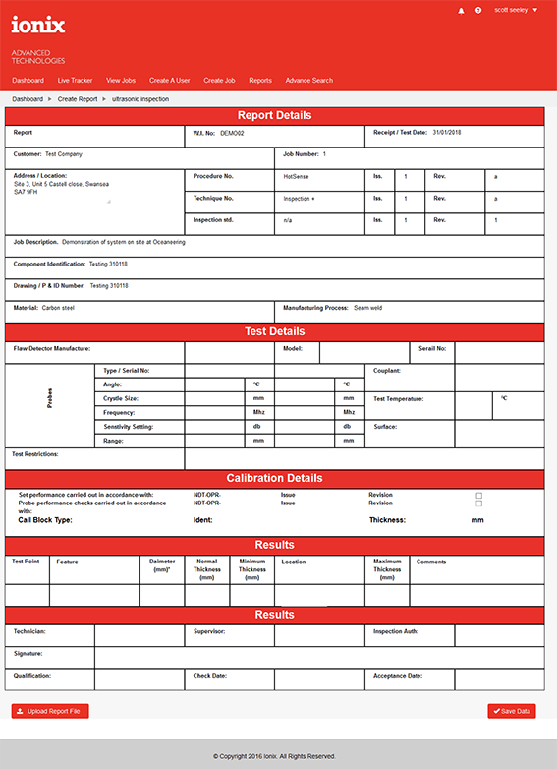Applus Report Database System for Great Yarmouth Phase

11

The template is build with steps to prevent issues. The user simply clicks the Upload Report, they then click on the report CSV to populate the data automatically. Once all fields are checked the template will show the next series of buttons (see below)

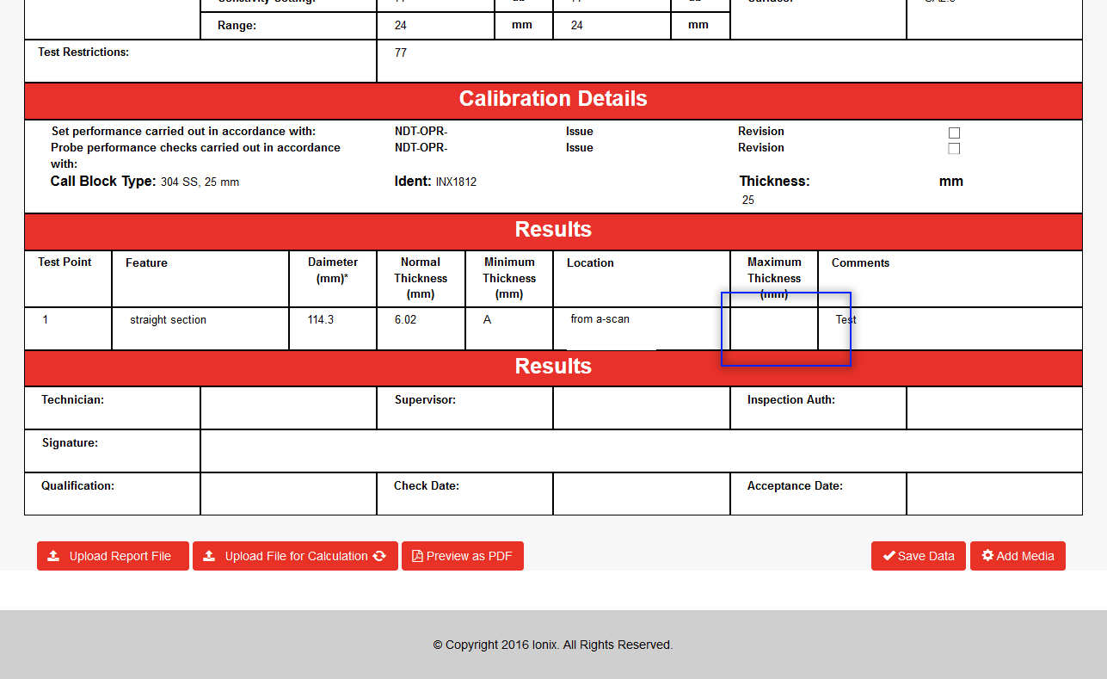

From here the user can now click the Upload for Calculation button, this will populate the Thickness field in the Results section (at any time the report fields can be edited manually). Once complete the system will allow the final step which is to get signatures starting with the Technician, then the Supervisior. (see below:

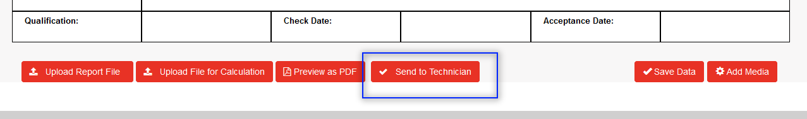

Once the tech has been notified and the signature applied the last button will appear ‘Supervision sign off’ This marks the final stage in the report and once all stages are complee only then will the report generate a signed PDF.

# Modification of reporting database system (V1.01)

Managers are capable of editing /modifying the database entries of jobs in the system. Changes can be made during the job progress or after the completion of report.

* 1. Change Project Name

Manager can change the project name in the table given in view job tab where all the jobs are appearing with complete attributes. Click on the edit button in project name column, edit/change the information and hot submit button.

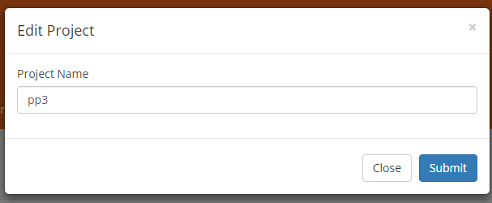

* 1. Change Spool Information

From the status column in the view job tab, manager can open specific job by clicking on view job link. The next screen will show jobs against a project with spool number, welds and drawing number attributes. Manager can edit/change spool information by clicking on edit button in the spool column.

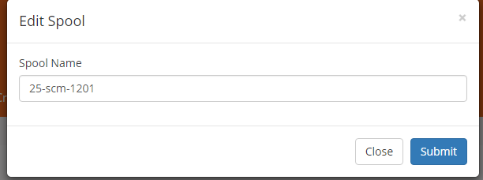

* 1. Change Job Number

Manager has also the privilege of changing the job number of a client from the view job tab. Click on the edit button in the client job number column, change the information and click on submit button.

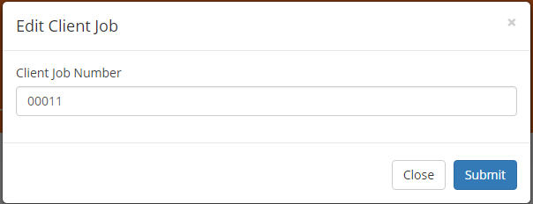

* 1. Change Weld Information

To make changes in the weld information of a job, technician has to click on report tab and from last column named report he can click on edit button. It will open the repot page and from the edit weld section he can add more welds to the job.

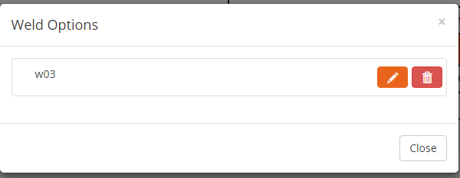

# Live Trackers

Live trackers provide SVRC report view to managers, technicians and clients. S stands for “view report in start”, V stands for “view report in progress”, R stands for “required technician sign” and C stands for “view completed report”. Each role can view its respective reports according to the system permissions.

# Reports Status

To show the status of the report different colors are used in the CRM. The green block against a report shows that it is completed. Red color block indicates the rejection of the report. Yellow color indicates that the report is under progress. Colors are used to help users identify the report status easily without navigating into menus.

# Graph Charts

Different graph charts in system displays the report progress, overall reports status and bay status to administrator and managers. Bar chart on top shows the reports in progress, completed and

rejected. The pie chart shows the overall status of the reports percentage according to their current status through different colors. In second pie chart the bay status is indicated.

# Notifications

Whenever a report is started, rejected, require signs or gets completed, email notifications are sent to the relevant stakeholders by the system.

* 1. Report Start

When a report is initiated, an email notification is sent to the clients.

* 1. Report Reject

After a report is rejected, an email notification is sent to the managers and technicians associated with the job.

* 1. Report Completed

After the completion of the report system sends and email notification to the clients.

* 1. Need Signature of reports

Whenever a report required signatures of technicians, an email notification is sent to the relevant technician.

# Activity Log

The activity log on dashboard shows the activities been taking place currently against different jobs in the system. Manager can view activities of all the technicians and clients including job creation/edit/deletion, reports, inspections etc. The role of technician can view the activity log of the jobs created by him and under his supervision. Client can only view activity feed about his own jobs. The activity log is displayed at the right side of the dashboard.

# Comments Log

Comment log is provided on dashboard for manager and client to view comments against jobs. Manager can view/reply the comments of all the users in system. Technician is able to view/reply comments related to the jobs he created and supervising, whereas client can only view/reply comments related to his own jobs.

# Profile Managements

Each role in the system whether manager, technician or client, each can change its basic information and account setting from profile management. Profile settings can be changed from the user name showing on the top left screen. User can also get help and logout from the top menu.