1. We need a blue border line between the job details and the results followed on, just title this Inspection Results Continued

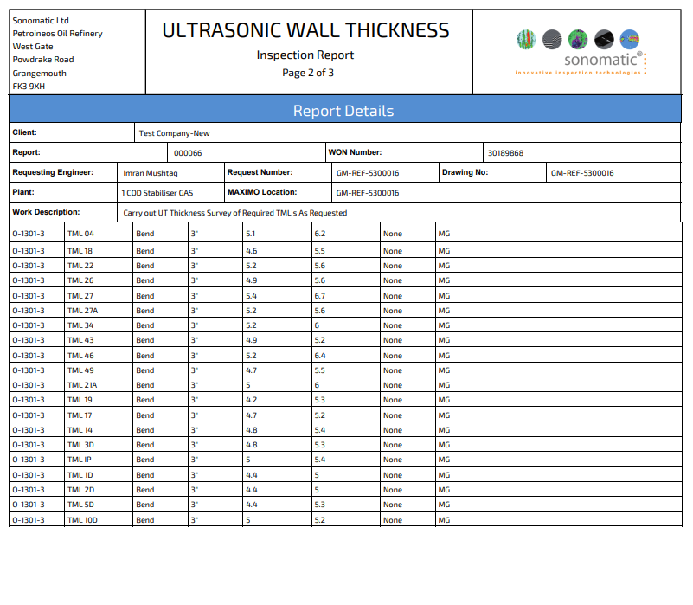

1. When going back to edit welds can the screen display the Test Point Number instead of the line number ?

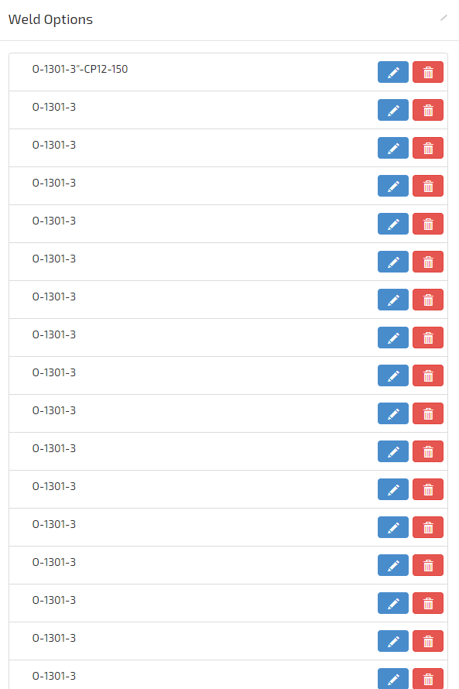

1. PO number Should also be WON Number
2. Looking more into this it seems all details have shifted across, See attached

Another thing, for some reason the project name is displaying the requesting engineers name.



1. Overlapping  
     
   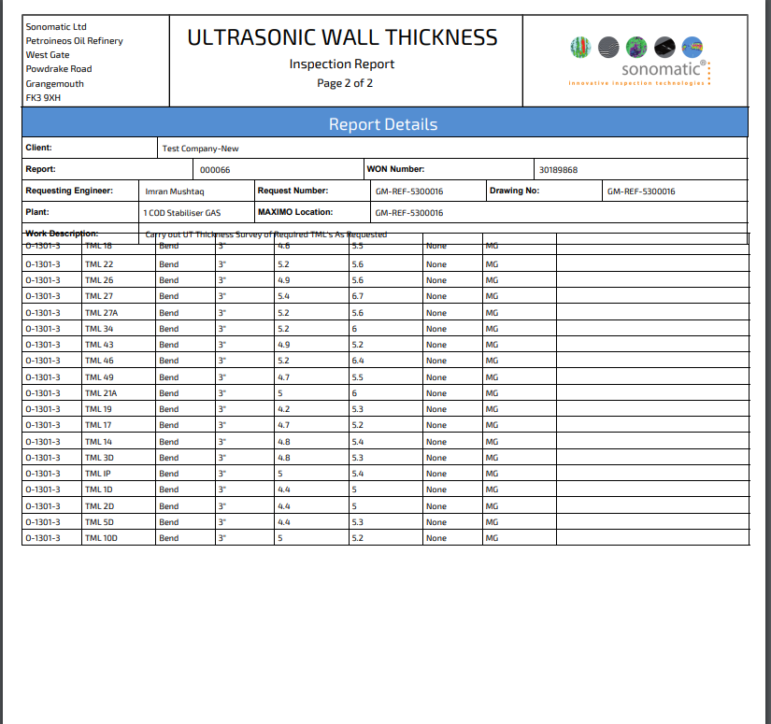
2. Also when adding multiple TML’s its removing some of the text from the line number  
     
   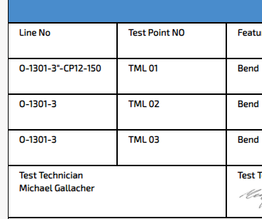

7. Also when revisiting the notifications tab for sign offs etc it does not give the full report name or have any links to click to sign off. The initial full size notification does however if multiple come through at one time there is no way of working through them

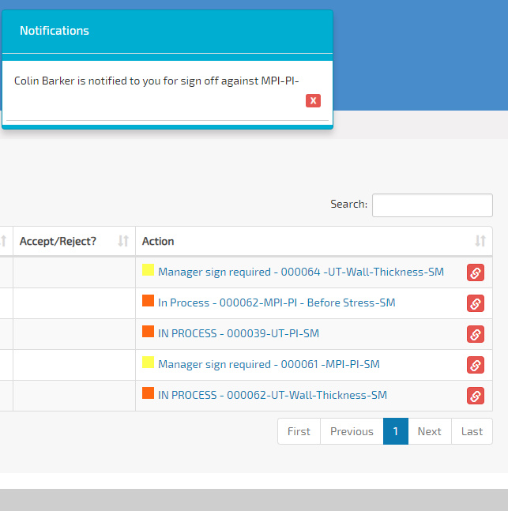

8. Been doing some testing on the software, the second pages of readings is forcing onto the first page of images, see attached screen capture.

Can we have the images kept completely separate from the readings, also can the image be centred in the middle of the page in the vertical axis instead of being placed at the top ?

I am looking to be testing this with other techs today with the view to starting using it next week, if this can be amended then we can start using it.

