1)
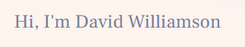

Welcome To iSeoAgency

- 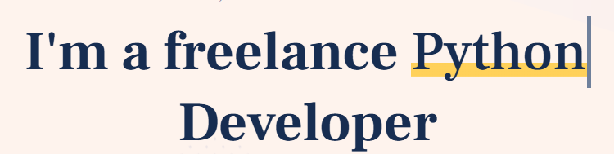
Dominate Search Results.
Measurable SEO Success.
Your Partner in Digital Growth and Organic Authority.
Not Just Clicks.

Note:Above are not bullet points, each line will be in form of typing as there in theme.

3)
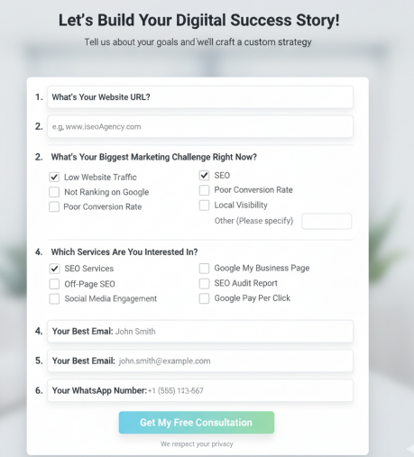

Above will be the contact form at top right of website.

Form text will be the same, but it will be in dropdown and next screen.
For Example:
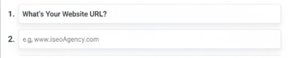
In firsrt screen only one question and answer field will be there to proceed further [NEXT] button will be there.

4)
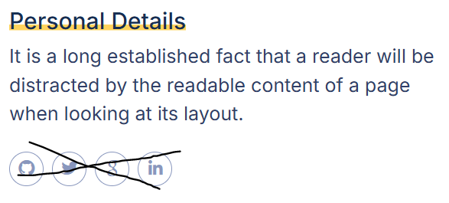
Mission:
iSeoAgency is driven by a singular mission to deliver sustainable, measurable organic growth and help businesses dominate their niche in the digital landscape.

5)
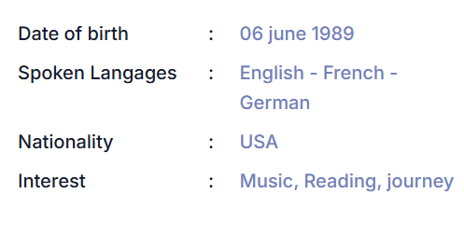
10+ Years Digital Marketing Service Experience
Focus On White-Hat Marketing
Dedicated SEO Manager for Every Client
Transparent Monthly Reporting.

5)
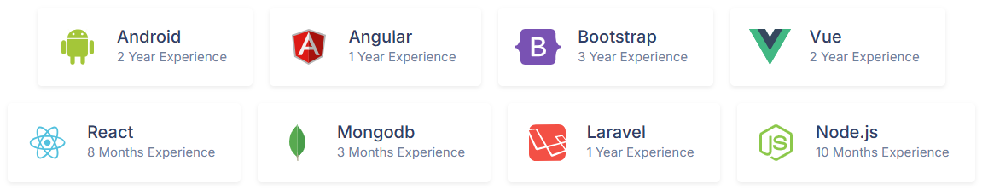

Experience Breakdown:
SEO (10 Year Experiance)
Pay Per Click - PPC (6 Year Experiance)
Social Media Marketing (4 Year Experience)
Google My Business - GMB (7 Year Experiance)
On-Page & Technical SEO (9 Year Experiance)
Off-Page SEO (10 Year Experiance)
Content Writing (3 Year Experience)
Banner/Logo Designing (3 Year Experience)

Note: Use above content with relevant (HD) icons.

6)
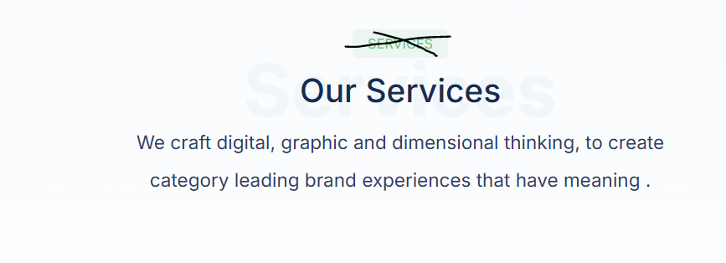
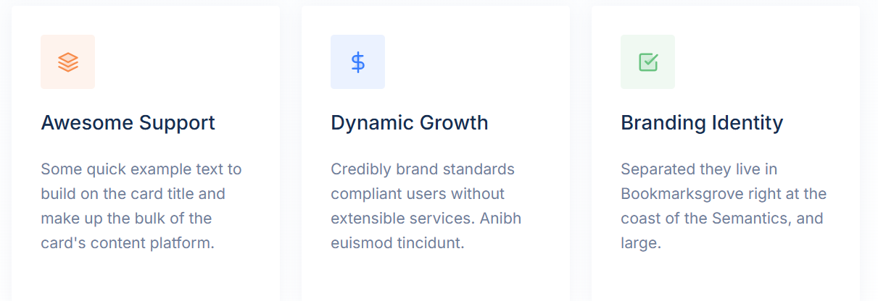

Our SEO Agency Services:

Service | Two-Line Description
Search Engine Optimization (SEO) | The process of increasing your website's organic visibility to drive targeted, high-quality traffic from search engines like Google. We implement long-term strategies to improve your site's authority and rankings.
SEO Audit | A deep, diagnostic analysis of your website's performance, health, and current rankings, highlighting all technical and content issues. We provide an actionable report detailing immediate steps needed for improvement and growth.
Pay Per Click (PPC) | Creating and managing targeted advertising campaigns on platforms like Google Ads to generate instant, measurable traffic and conversions. We optimize bidding and ad copy to ensure maximum return on your advertising spend (ROI).
Social Media Marketing (SMM) | Developing and executing strategies across platforms (e.g., Facebook, Instagram) to build brand awareness, engage audiences, and drive traffic. We handle content creation, scheduling, and community management.
Google My Business (GMB) | Optimizing your Google Business Profile to boost visibility in local searches and on Google Maps. This service drives local traffic, calls, and customer reviews to your physical business.
On-Page & Technical SEO | Optimizing all elements on your web pages, including content, internal links, headers, and meta tags, for search engine relevance. We also fix site speed, crawl errors, and mobile usability for optimal technical health.
Off-Page SEO | Building high-authority backlinks and managing brand mentions across external websites to increase your website's domain authority. This essential process establishes your site as a trusted, credible source.
Content Writing | Creating high-quality, SEO-optimized content, including blog posts, landing pages, and website copy, focused on search intent. Our content is designed not only to rank but also to engage and convert your target audience.
Banner Designing | Professional creation of visually appealing digital banners for your website, social media, and Pay Per Click campaigns. We design attention-grabbing creatives optimized for various ad platform specifications.
Logo Designing | Crafting a unique, professional, and memorable brand identity through the design of a distinctive business logo. We ensure your logo reflects your agency's mission and resonates with your target market.

7)
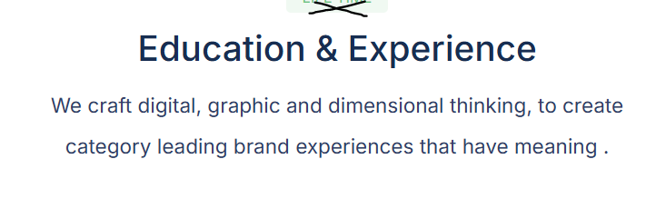
Our Focus:
We combine technical expertise with creative content strategy to offer a full service SEO solution. Our focus is always on your ROI and long-term search authority.

