

**Name:** Mujtaba Saqib

**Reg no:** SP23-BSE-138

**Section:** C

**Course:** Web Technologies

**Note: For this assignment I used dummyjson api to simulate CRUD operations using HTTP methods. The index.html file contains CSS styling and JS code. For screenshots I attached the interface I created and operations performed and also created similar requests on postman.**

**index.html:-**

<!DOCTYPE html>

<html lang="en">

<head>

<meta charset="UTF-8">

<meta name="viewport" content="width=device-width, initial-scale=1.0">

<title>CRUD operations</title>

<style>

body { font-family: Arial, sans-serif; margin: 20px; }

.container { max-width: 600px; margin: auto; }

.section { margin-bottom: 20px; }

label { display: block; margin: 5px 0 2px; }

input, button { padding: 8px; margin-top: 5px; }

.result { margin-top: 15px; padding: 10px; background: #f3f3f3; border: 1px solid #ddd; }

</style>

</head>

<body>

<div class="container">

<h1 class="heading">CRUD Operations</h1>

<h1>User Management Interface</h1>

<!-- GET User Section -->

<div class="section">

<h2>Get User</h2>

<label for="getUserId">User ID:</label>

<input type="number" id="getUserId" placeholder="Enter user ID">

<button onclick="handleGetUser()">Get User</button>

<div id="getUserResult" class="result"></div>

</div>

<!-- CREATE User Section -->

<div class="section">

<h2>Create User</h2>

<label for="createUserName">Name:</label>

<input type="text" id="createUserName" placeholder="Enter name">

<label for="createUserEmail">Email:</label>

<input type="email" id="createUserEmail" placeholder="Enter email">

<button onclick="handleCreateUser()">Create User</button>

<div id="createUserResult" class="result"></div>

</div>

<!-- UPDATE User Section -->

<div class="section">

<h2>Update User</h2>

<label for="updateUserId">User ID:</label>

<input type="number" id="updateUserId" placeholder="Enter user ID">

<label for="updateUserName">New Name:</label>

<input type="text" id="updateUserName" placeholder="Enter new name">

<label for="updateUserEmail">New Email:</label>

<input type="email" id="updateUserEmail" placeholder="Enter new email">

<button onclick="handleUpdateUser()">Update User</button>

<div id="updateUserResult" class="result"></div>

</div>

<!-- DELETE User Section -->

<div class="section">

<h2>Delete User</h2>

<label for="deleteUserId">User ID:</label>

<input type="number" id="deleteUserId" placeholder="Enter user ID">

<button onclick="handleDeleteUser()">Delete User</button>

<div id="deleteUserResult" class="result"></div>

</div>

</div>

<script>

// Fetch user by ID

function handleGetUser() {

const userId = document.getElementById('getUserId').value;

fetch(`https://dummyjson.com/users/${userId}`)

.then(res => res.json())

.then(data => {

document.getElementById('getUserResult').innerText = JSON.stringify(data, null, 2);

})

.catch(err => {

document.getElementById('getUserResult').innerText = 'Error fetching user';

});

}

// Create a new user

function handleCreateUser() {

const firstName = document.getElementById('createUserName').value;

const email = document.getElementById('createUserEmail').value;

const user = { firstName, email };

fetch('https://dummyjson.com/users/add', {

method: 'POST',

headers: { 'Content-Type': 'application/json' },

body: JSON.stringify(user)

})

.then(res => res.json())

.then(data => {

document.getElementById('createUserResult').innerText = JSON.stringify(data, null, 2);

})

.catch(err => {

document.getElementById('createUserResult').innerText = 'Error creating user';

});

}

// Update an existing user

function handleUpdateUser() {

const userId = document.getElementById('updateUserId').value;

const lastName = document.getElementById('updateUserName').value;

const email = document.getElementById('updateUserEmail').value;

const user = { lastName, email };

fetch(`https://dummyjson.com/users/${userId}`, {

method: 'PUT',

headers: { 'Content-Type': 'application/json' },

body: JSON.stringify(user)

})

.then(res => res.json())

.then(data => {

document.getElementById('updateUserResult').innerText = JSON.stringify(data, null, 2);

})

.catch(err => {

document.getElementById('updateUserResult').innerText = 'Error updating user';

});

}

// Delete a user by ID

function handleDeleteUser() {

const userId = document.getElementById('deleteUserId').value;

fetch(`https://dummyjson.com/users/${userId}`, {

method: 'DELETE'

})

.then(res => res.json())

.then(data => {

document.getElementById('deleteUserResult').innerText = JSON.stringify(data, null, 2);

})

.catch(err => {

document.getElementById('deleteUserResult').innerText = 'Error deleting user';

});

}

</script>

</body>

</html>

**Screenshots:-**

**Get a user:-**

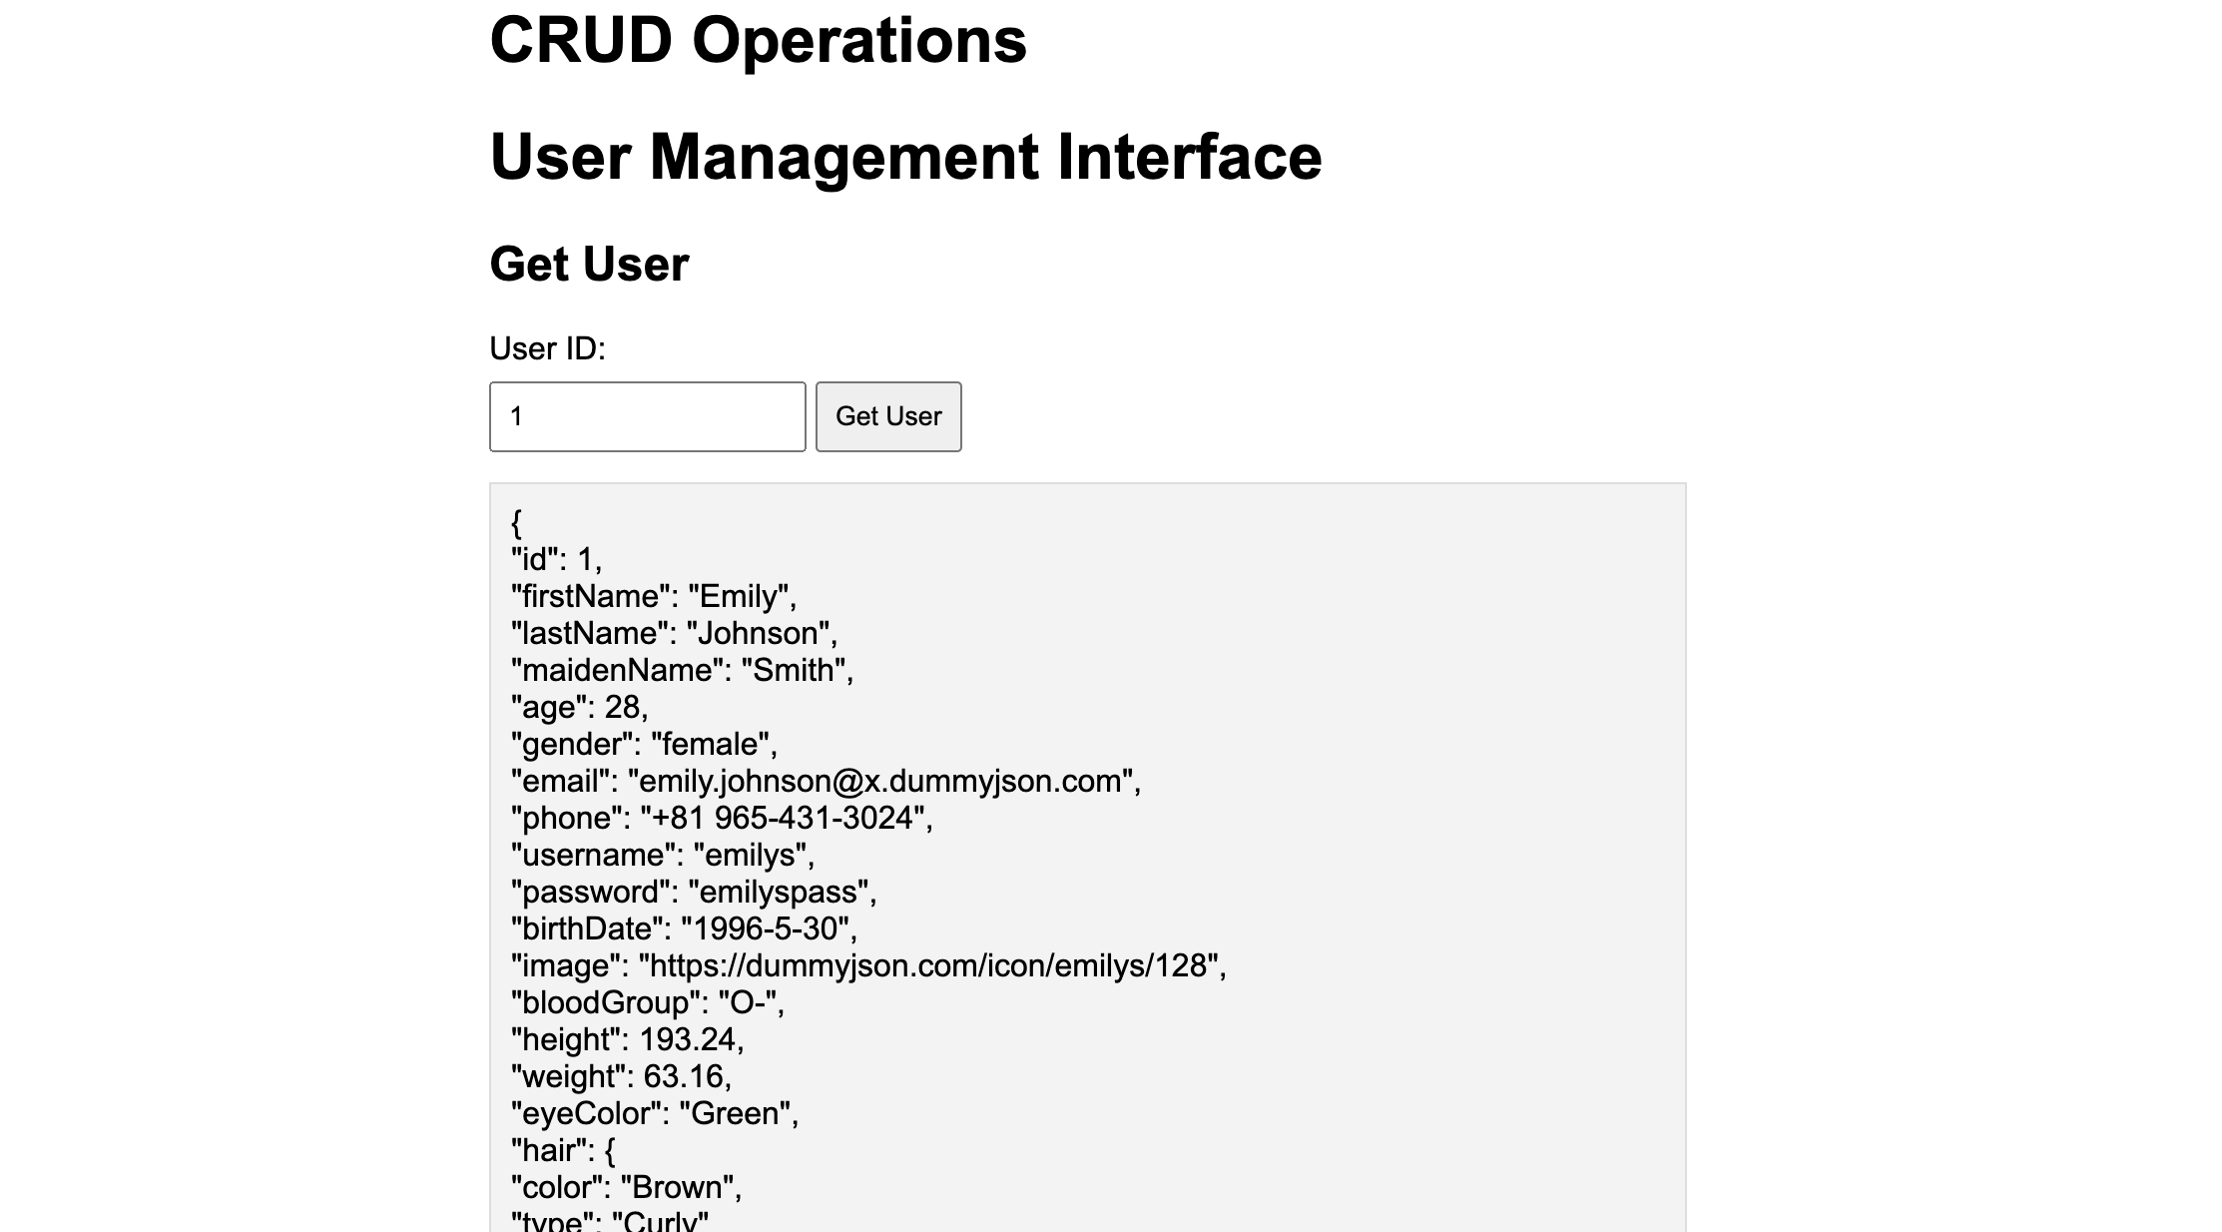

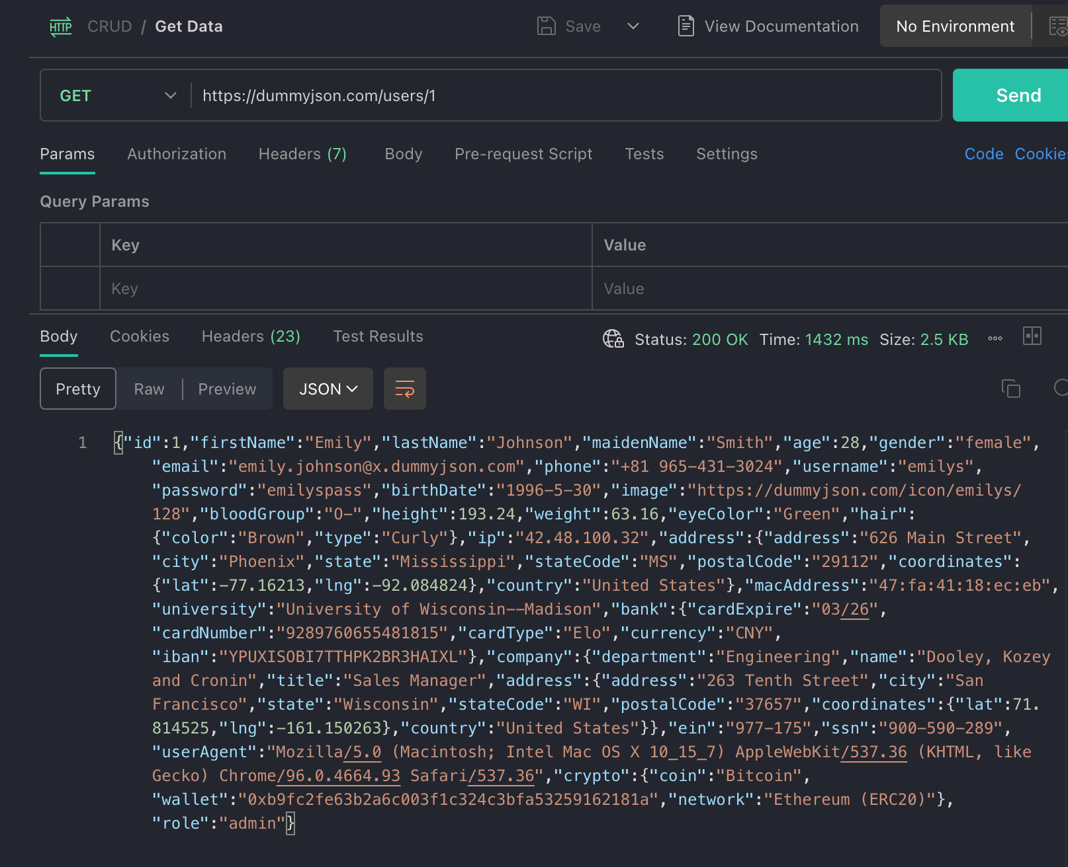

**Create a user:-**

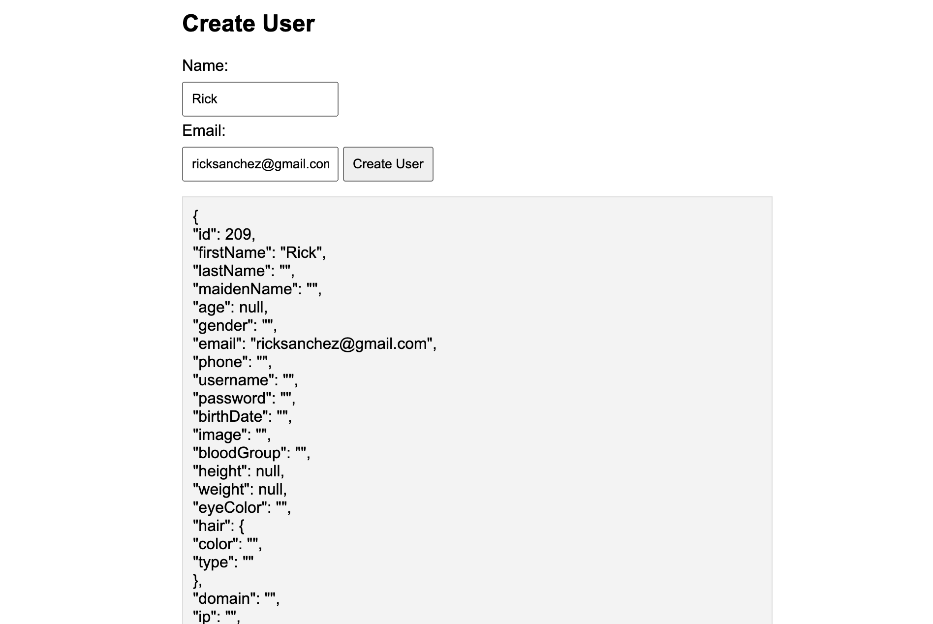

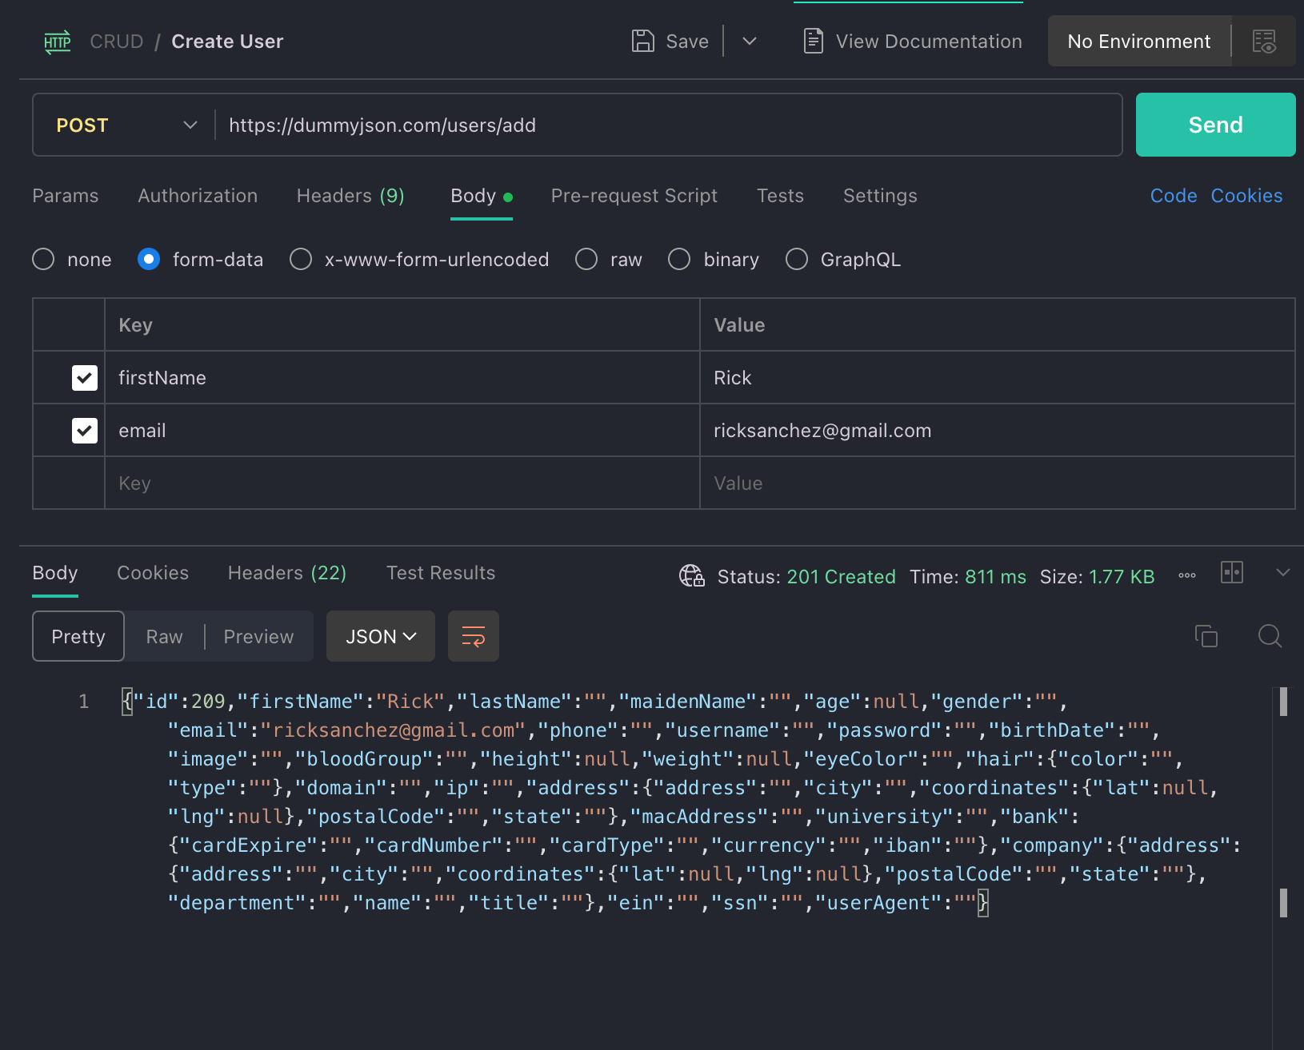

**Update an existing user:-**

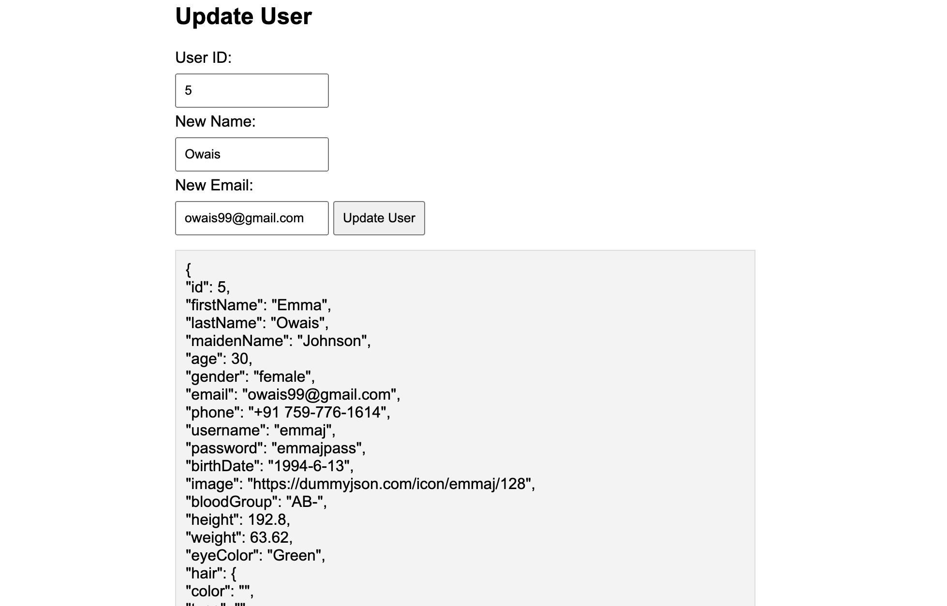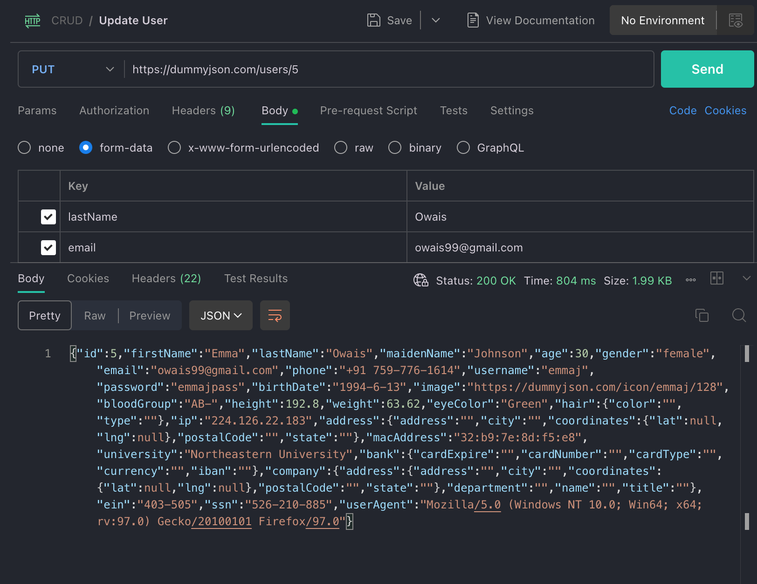

**Delete a user:-**

