# Quizzer Flutter

It is my 6th flutter app while learning the flutter. It is Quiz App with 13 Questions.

## Functionality:

## It is a Simple Quiz which will ask you 13 Question and Shows you result based on it.

## Learning

I have learned and Used in this Project

1. list
2. class
3. Inheritance
4. Abstract
5. Polymorphism
6. Alert

## Screenshots

### Starting Screen:

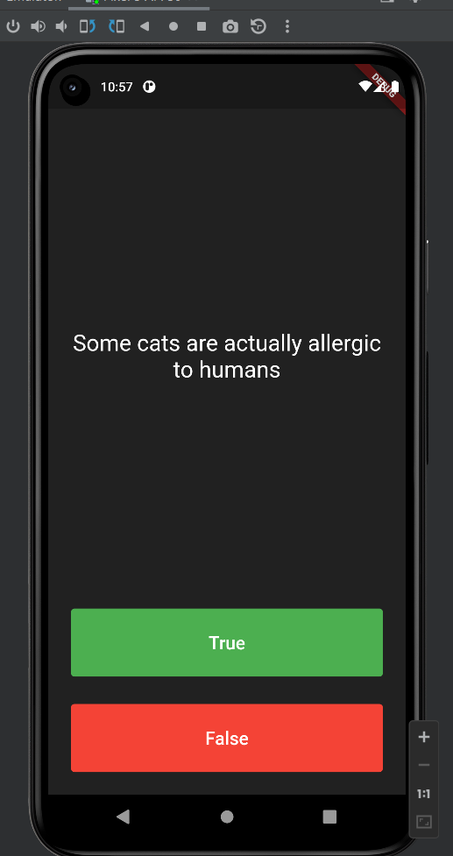

### Taking Quiz:

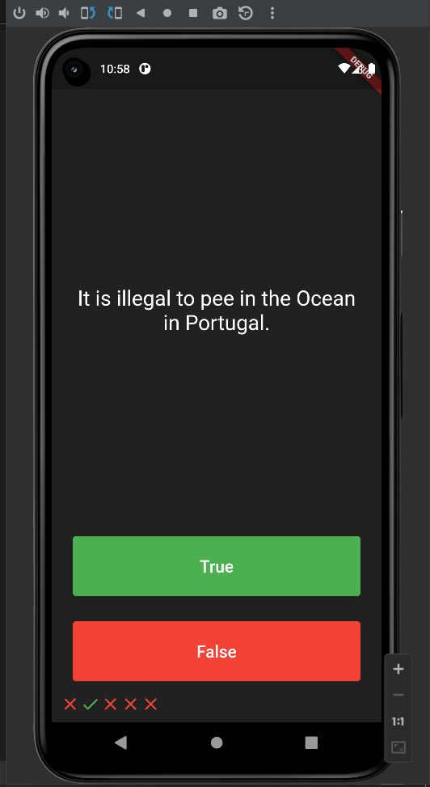

### Success:

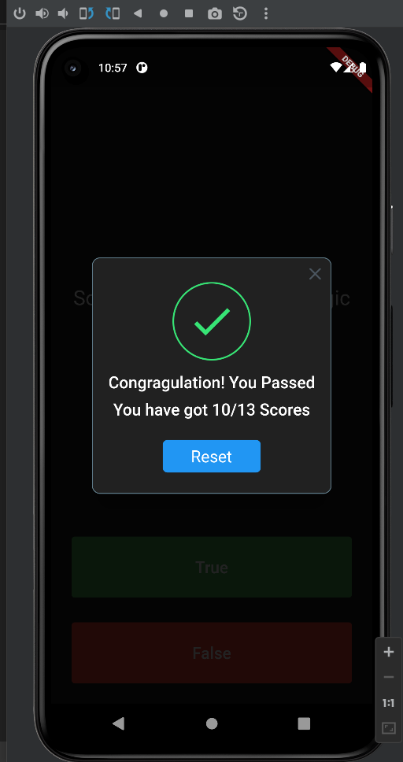

### Failed:

