

|  |  |  |
| --- | --- | --- |
| MODULE NAME: |  | FUNDAMENTALS OF SOFTWARE DEVELOPMENT |
| MODULE CODE: |  | CT010-3-1-FSD |
| ASSIGNMENT TYPE: |  | GROUP ASSIGNMENT |
| INTAKE: |  | UC1F1611SE |
| LECTURER: |  | SUMAIRA MUHAMMAD HAYAT KHAN |
| HAND OUT DATE: |  | 21 DECEMBER 2016 |
| HAND IN DATE: |  | 20 MARCH 2017 |
| STUDENTS: |  | TP043972, MUSTAFA AHMED ABDULJABBAR  TP039934, RASHAD HELMI ABDULAZIZ AL-YOUSEFI  TP040205, MUKABAK ORAZBEK  TP040164, YOUSEF THARAWAT |

MARKING GRID

Group Work

|  |  |
| --- | --- |
| **Design**  **(15%)** |  |
| **Module Integration**  **(10%)** |  |
| **Documentation**  **(15%)** |  |
| **Total** |  |

Individual Work

|  |  |  |  |  |
| --- | --- | --- | --- | --- |
| **Student**  **Name & TP** | MUSTAFA TP043972 | RASHAD TP039934 | ORAZBEK TP040205 | YOUSEF TP040164 |
| **Program Listing**  **(15%)** |  |  |  |  |
| **Presentation**  **(15%)** |  |  |  |  |
| **Q & A**  **(15%)** |  |  |  |  |
| **Contribution**  **(15%)** |  |  |  |  |
| **Group marks** |  |  |  |  |
| **Total marks** |  |  |  |  |

WORK BREAKDOWN STRUCTURE

|  |  |  |
| --- | --- | --- |
| **Student**  **Name & TP** | **Responsible Parts** | **Signature** |
| MUSTAFA TP043972 | Order Meals. Report. File Sorter. Test Plan*. |  |
| RASHAD TP039934 | Main Menu. Read Files. Conclusion. Test Plan*. |  |
| ORAZBEK TP040205 | Introduction. Payment. Test Plan*. |  |
| YOUSEF TP040164 | Order Page. Other Services. Test Plan*. |  |

ABSTRACT

Group members have done this assignment to prepare a python program and to know more information, as well as to get knowledge regarding different codes of python. This report is a summary of what students have done in their whole project. Group have used the pseudocodes to explain every single part of project codes, furthermore, they have aided their writhing with a screenshots of the program. Also, members have did the test plan to check the outputs of every algorithms. Finally, students have commented to their coding parts to make it understandable.

**TABLE OF CONTENTS**

MARKING GRID 2

Group Work 2

Individual Work 2

WORK BREAKDOWN STRUCTURE 3

ABSTRACT 4

INTRODUCTION 6

MAIN BODY 7

Main Menu 7

Display Main Menu 7

Main Menu Commands 7

Order Page 9

Display Order Page 9

Order Page Command Line 9

Create Global Variables 11

Read Files 12

Get Items Name from List 13

Get Items Price from List 14

Sort Items Name by Alphabet 15

Order Meals 16

Display Meals 16

Order Meals Basic Commands 17

Order Meals 17

Amounts of Meal 18

Other Services 19

Display Other Services 19

Other Services Basic Commands 19

Other Services Order 20

Report 21

Display Reports 21

Report Basic Commands 21

Payment 22

Display Payment 22

Payment Calculation 23

Pay and Upload Data to Report 25

test plan 26

Introduction 26

Team Members 26

Test Environment 26

Checking Process 26

Testing Process 27

Deliverables 28

CONCLUSION 29

REFFRENCES 30

INTRODUCTION

According to the researchers (Robertson, 2007), computer programming is an art. Unfortunately, many people believe that a programmer must be good in calculations and must figure out more about technical information, as well as must be prepared to spend long hours in front of computer screen. However, given the right tools and steps to follow, anyone can write well designed programs. It is a task worth doing, as it is both stimulating and fulfilling. In order to create a valuable software, developers should use their intellectual and imaginational skills, and it is the main philosophy of success in any case.

MAIN BODY

Main Menu

Display Main Menu

**Pseudocode:**

PROGRAM Main_Menu_Display:

DISPLAY "MAIN MENU";

DISPLAY "(O) ORDER";

DISPLAY "(R) REPORT";

DISPLAY "(P) PAYMENT";

DISPLAY "(E) EXIT";

END.

**Outputs:**

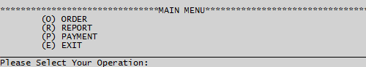

*Main Menu*

Main Menu Commands

**Pseudocode:**

PROGRAM Main_Menu_Command:

DOWHILE TRUE:

Var_Input = STRING(INPUT("Please Select Your Operation: ")) UPPER;

IF LENGTH(Var_Input) == 1 THEN:

IF Var_Input == "O" THEN:

ORDER_MENU;

BREAK;

ELSEIF Var_Input == "R" THEN:

REPORT;

BREAK;

ELSEIF Var_Input == "P" THEN:

PAYMENT;

BREAK;

ELSEIF Var_Input == "E" THEN:

DISPLAY "THANK YOU";

BREAK;

ELSE:

DISPLAY "ERROR: Invalid Input (" + STRING(Var_Input) + "). TRY again!";

ENDIF.

ELSE:

DISPLAY "ERROR: Invalid Input (" + STRING(Var_Input) + "). TRY again!";

ENDIF.

ENDWHILE.

END.

**Outputs:**



*Main Menu with Command Line*

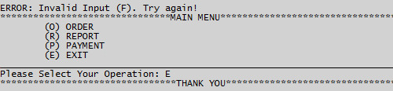

*Exit form Main Menu*

Order Page

Display Order Page

**Pseudocode:**

PROGRAM Order_Menu_Display:

DISPLAY "ORDER PAGE"

DISPLAY "(F) FOODS AND DRINKS"

DISPLAY "(O) OTHER SERVICES"

DISPLAY "(M) MAIN MENU"

DISPLAY "(E) EXIT"

END.

**Outputs:**

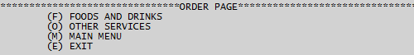

*Order Page*

Order Page Command Line

**Pseudocode:**

PROGRAM Order_Menu_Display:

DOWHILE TRUE:

Var_Input = STRING(INPUT("Please Select Your Operation: ")) UPPER;

IF LENGTH(Var_Input) == 1 THEN:

IF Var_Input == "F" THEN:

ORDER_MEALS;

BREAK;

ELSEIF Var_Input == "O" THEN:

OTHER_SERVICES;

BREAK;

ELSEIF Var_Input == "M" THEN:

MAIN_MENU;

BREAK;

ELSEIF Var_Input == "E" THEN:

DISPLAY "THANK YOU";

BREAK;

ELSE:

DISPLAY "ERROR: Invalid Input (" + STRING(Var_Input) + "). TRY again!";

ENDIF.

ELSE:

DISPLAY "ERROR: Invalid Input (" + STRING(Var_Input) + "). TRY again!";

ENDIF.

ENDWHILE.

END.

**Outputs:**

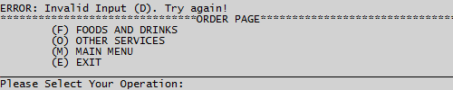

*Order Page Command Line*

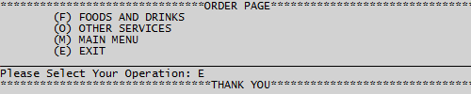

*Exit from Order Page*

Create Global Variables

**Pseudocode:**

PROGRAM Create_Global_Variables:

GLOBAL List_Drinks;

GLOBAL List_Foods;

GLOBAL List_Services;

GLOBAL List_Item_Order;

GLOBAL List_Item_Price;

END.

Read Files

**Pseudocode:**

PROGRAM File_Reader:

GLOBAL List_Foods;

GLOBAL List_Drinks;

GLOBAL List_Services;

File_Foods = OPEN("FOODS.FSD", "READ MODE");

FOR i IN File_Foods THEN:

List_Foods.APPEND(STRING(i.STRIP));

ENDFOR.

File_Foods.CLOSE;

File_Drinks = OPEN("DRINKS.FSD", "READ MODE");

FOR i IN File_Drinks THEN:

List_Drinks.APPEND(STRING(i.STRIP));

ENDFOR.

File_Drinks.CLOSE;

File_Services = OPEN("SERVICES.FSD", "READ MODE");

FOR i IN File_Services THEN:

List_Services.APPEND(STRING(i.STRIP));

ENDFOR.

File_Services.CLOSE;

END.

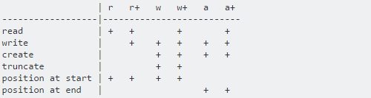

*Six different Modes*

Get Items Name from List

**Pseudocode:**

PROGRAM Get_Items_Name:

GLOBAL List_Foods;

GLOBAL List_Drinks;

GLOBAL List_Services;

List_Foods = ["Foods_Name_RM_00.00", "", "", ...];

List_Drinks = ["Drinks_Name_RM_00.00", "", "", ...];

List_Services = ["Services_Name_RM_00.00", "", "", ...];

i = 0;

DOWHILE i <= LENGTH(List_Foods) - 1:

IF "RM" IN List_Foods[i] THEN:

List_Foods[i] = STRING(List_Foods[i][:List_Foods[i].INDEX("RM") - 1]);

ENDIF.

STEP 1;

ENDWHILE.

i = 0;

DOWHILE i <= LENGTH(List_Drinks) - 1:

IF "RM" IN List_Drinks[i] THEN:

List_Drinks[i] = STRING(List_Drinks[i][:List_Drinks[i].INDEX("RM") - 1]);

ENDIF.

STEP 1;

ENDWHILE.

i = 0;

DOWHILE i <= LENGTH(List_Services) - 1:

IF "RM" IN List_Services[i] THEN:

List_Services[i] = STRING(List_Services[i][:List_Services[i].INDEX("RM") - 1]);

ENDIF.

STEP 1;

ENDWHILE.

END.

Get Items Price from List

**Pseudocode:**

PROGRAM Get_Items_Price:

GLOBAL List_Foods;

GLOBAL List_Drinks;

GLOBAL List_Services;

List_Foods = ["Foods_Name_RM_00.00", "", "", ...];

List_Drinks = ["Drinks_Name_RM_00.00", "", "", ...];

List_Services = ["Services_Name_RM_00.00", "", "", ...];

i = 0;

DOWHILE i < LENGTH(List_Foods):

List_Item_Price[i] = List_Foods[i][INTEGER(List_Foods[i].INDEX("RM") + 3):];

STEP 1;

ENDWHILE.

i = 0;

DOWHILE i < LENGTH(List_Drinks):

List_Item_Price[40 + i] =

List_Drinks[i][INTEGER(List_Drinks[i].INDEX("RM") + 3):];

STEP 1;

ENDWHILE.

i = 0;

DOWHILE i < LENGTH(List_Services):

List_Item_Price[80 + i] =

List_Services[i][INTEGER(List_Services[i].INDEX("RM") + 3):];

STEP 1;

ENDWHILE.

END.

Sort Items Name by Alphabet

**Pseudocode:**

PROGRAM Items_Name_Sorter:

GLOBAL List_Foods;

GLOBAL List_Drinks;

GLOBAL List_Services;

List_Foods = ["Foods_Name_RM_00.00", "", "", ...];

List_Drinks = ["Drinks_Name_RM_00.00", "", "", ...];

List_Services = ["Services_Name_RM_00.00", "", "", ...];

List_Foods = SORTED(List_Foods);

List_Drinks = SORTED(List_Drinks);

List_Services = SORTED(List_Services);

END.

**Outputs:**

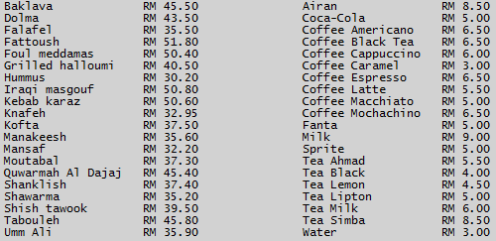

*Sorted Item Names*

Order Meals

Display Meals

**Pseudocode:**

PROGRAM Order_Meals_Display:

List_Foods = ["Foods_Name_RM_00.00", "", "", ...];

List_Drinks = ["Drinks_Name_RM_00.00", "", "", ...];

DOWHILE TRUE:

DISPLAY "ORDER FOODS & DRINKS";

DISPLAY " |NO| |FOOD NAME| |PRICE| | |NO| |DRINK NAME| |PRICE|";

i = 0;

DOWHILE i < LENGTH(List_Foods) OR i < LENGTH(List_Drinks):

IF i < LENGTH(List_Foods) THEN:

Food = STRING(i + 1) + STRING(List_Foods[i]);

ELSE:

Food = " " * 36;

ENDIF.

IF i < LENGTH(List_Drinks) THEN:

Drink = STRING(41 + i) + STRING(List_Drinks[i]);

ELSE:

Drink = "";

ENDIF.

DISPLAY Food, Drink;

STEP 1;

DISPLAY "(M) MAIN MENU";

DISPLAY "(P) PAYMENT";

DISPLAY "(E) EXIT";

ENDWHILE.

ENDWHILE.

END.

**Outputs:**

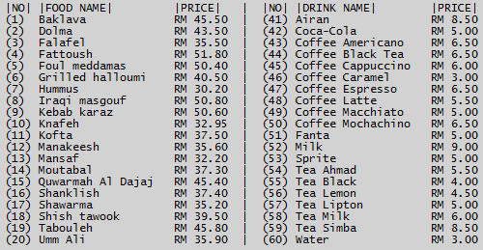

*Meals List*

Order Meals Basic Commands

**Pseudocode:**

PROGRAM Order_Meals_Basic_Command:

DOWHILE TRUE:

Var_Input = INPUT("Please Select Your Operation: ") UPPER;

IF Var_Input == "M" THEN:

MAIN_MENU;

BREAK;

ENDIF.

IF Var_Input == "E" THEN:

DISPLAY "THANK YOU";

BREAK;

ENDIF.

IF Var_Input == "P" THEN:

PAYMENT;

BREAK;

ENDIF.

ENDWHILE.

END.

**Outputs:**



*Basic Commands*

Order Meals

**Pseudocode:**

PROGRAM Order_Meals_Order_Command:

List_Foods = ["Foods_Name_RM_00.00", "", "", ...];

List_Drinks = ["Drinks_Name_RM_00.00", "", "", ...];

DOWHILE TRUE:

INTEGER(Var_Input);

IF (INTEGER(Var_Input) <= LENGTH(List_Foods) AND INTEGER(Var_Input) > 0)

OR (INTEGER(Var_Input) <= LENGTH(List_Drinks) + 40

AND INTEGER(Var_Input) > 40) THEN:

TRY:

DISPLAY STRING(List_Foods[INTEGER(Var_Input) - 1]);

EXCEPT:

PASS;

TRY:

DISPLAY STRING(List_Drinks[INTEGER(Var_Input) - 41]);

EXCEPT:

PASS;

ELSE:

DISPLAY "ERROR: Invalid Input (" + STRING(Var_Input) + "). TRY again!";

ENDIF.

ENDWHILE.

END.

**Outputs:**

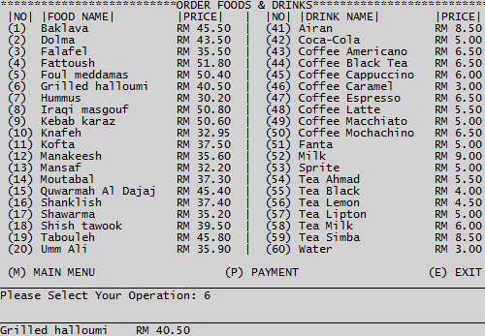

*Choosing Meals*

Amounts of Meal

**Pseudocode:**

PROGRAM Order_Meals_Amount_Command:

DOWHILE TRUE:

Var_Input_1 = INPUT("How Many You Want to Order?: ");

IF INTEGER(Var_Input_1) > 0 THEN:

List_Item_Order[INTEGER(Var_Input) - 1] += INTEGER(Var_Input_1);

DISPLAY "Successfully Ordered!";

ORDER_MEALS;

BREAK;

ELSE:

DISPLAY "ERROR: Invalid Input (" + STRING(Var_Input_1) + "). TRY again!";

ENDIF.

ENDWHILE.

END.

**Outputs:**



*Amounts of Meal*

Other Services

Display Other Services

**Pseudocode:**

PROGRAM Other_Services_Display:

List_Services = ["Services_Name_RM_00.00", "", "", ...];

DOWHILE TRUE:

DISPLAY "OTHER SERVICES";

DISPLAY " |NO| |SERVICE NAME| |PRICE|";

i = 0;

DOWHILE i < LENGTH(List_Services):

DISPLAY STRING(81 + i) + STRING(List_Services[i]);

STEP 1;

ENDWHILE.

DISPLAY "(M) MAIN MENU";

DISPLAY "(P) PAYMENT";

DISPLAY "(E) EXIT";

ENDWHILE.

END.

**Outputs:**

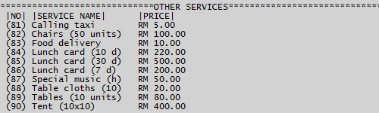

*Other Services*

Other Services Basic Commands

**Pseudocode:**

PROGRAM Other_Services_Basic_Command:

DOWHILE TRUE:

Var_Input = INPUT("Please Select Your Operation: ") UPPER;

IF Var_Input == "M" THEN:

MAIN_MENU;

BREAK;

ENDIF.

IF Var_Input == "E" THEN:

DISPLAY "THANK YOU";

BREAK;

ENDIF.

IF Var_Input == "O" THEN:

PAYMENT;

BREAK;

ENDIF.

ENDWHILE.

END.

**Outputs:**

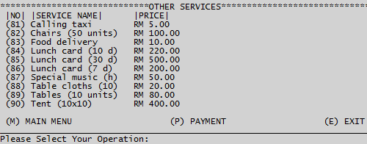

*Other Services Commands*

Other Services Order

**Pseudocode:**

PROGRAM Other_Services_Order_Command:

List_Services = ["Services_Name_RM_00.00", "", "", ...];

DOWHILE TRUE:

TRY:

INTEGER(Var_Input);

IF INTEGER(Var_Input) > 80 AND INTEGER(Var_Input) < 100 THEN:

DISPLAY "Successfully Ordered: ";

DISPLAY STRING(List_Services[INTEGER(Var_Input) - 81]);

List_Item_Order[INTEGER(Var_Input) - 1] = 1;

OTHER_SERVICES;

BREAK;

ELSE:

DISPLAY "ERROR: Invalid Input (" + STRING(Var_Input) + "). TRY again!";

ENDIF.

EXCEPT:

DISPLAY "ERROR: Invalid Input (" + STRING(Var_Input) + "). TRY again!";

ENDWHILE.

END.

**Outputs:**

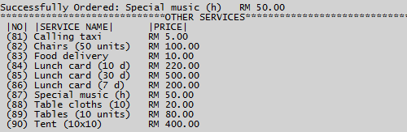

*Other Services Ordered*

Report

Display Reports

**Pseudocode:**

PROGRAM Report_Display

DOWHILE TRUE:

DISPLAY "REPORT";

File_Report = OPEN("REPORT.FSD", "READ MODE").READ;

DISPLAY File_Report;

DISPLAY "(M) MAIN MENU";

DISPLAY "(E) EXIT";

ENDWHILE.

END.

**Outputs:**

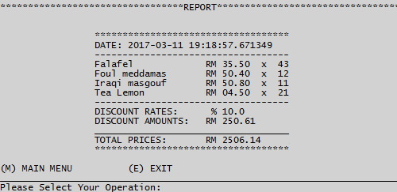

*Reports*

Report Basic Commands

**Pseudocode:**

PROGRAM Report_Basic_Command:

DOWHILE TRUE:

Var_Input = STRING(INPUT("Please Select Your Operation: "));

IF "M" IN Var_Input OR "m" IN Var_Input THEN:

MAIN_MENU;

BREAK;

ELSEIF "E" IN Var_Input OR "e" IN Var_Input THEN:

DISPLAY "THANK YOU";

BREAK;

ELSE:

DISPLAY "ERROR: Invalid Input (" + STRING(Var_Input) + "). TRY again!";

ENDIF.

ENDWHILE.

END.

Payment

Display Payment

**Pseudocode:**

PROGRAM Payment_Display:

DOWHILE TRUE:

DISPLAY "PAYMENT";

Total_Price = 0;

Report_New = "DATE:" + STRING(TIME.NOW);

i = 0;

DOWHILE i < LENGTH(List_Item_Order):

IF List_Item_Order[i] != 0 THEN:

IF i >= 0 AND i < 40 THEN:

Report_New += STRING(List_Foods[i]) + STRING(List_Item_Order[i]);

DISPLAY STRING(List_Foods[i]) + STRING(List_Item_Order[i]);

Total_Price += List_Item_Price[i] * List_Item_Order[i];

ENDIF.

IF i >= 40 AND i < 80 THEN:

Report_New += STRING(List_Drinks[i - 40]) + STRING(List_Item_Order[i]);

DISPLAY STRING(List_Drinks[i - 40]) + STRING(List_Item_Order[i]);

Total_Price += List_Item_Price[i] * List_Item_Order[i];

ENDIF.

IF i >= 80 AND i < 100 THEN:

Report_New += STRING(List_Services[i - 80]);

DISPLAY STRING(List_Services[i - 80]);

Total_Price += List_Item_Price[i] * List_Item_Order[i];

ENDIF.

STEP 1;

ELSE:

STEP 1;

ENDIF.

ENDWHILE.

ENDWHILE.

END.

**Outputs:**

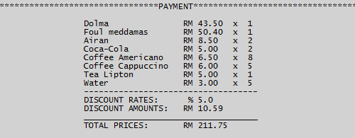

*Bill*

Payment Calculation

**Pseudocode:**

PROGRAM Payment_Calculation_With_Discounts:

Var_Discount_1 = 200;

Var_Discount_2 = 1000;

Var_Discount_3 = 5000;

Var_Discount_1_Rate = 5 %;

Var_Discount_2_Rate = 10 %;

Var_Discount_3_Rate = 15 %;

DOWHILE TRUE:

IF Total_Price > Var_Discount_3 THEN:

Total_Price -= Total_Price * Var_Discount_3_Rate;

Report_New += "DISCOUNT RATES: %" + STRING(Var_Discount_3_Rate * 100);

Report_New += "DISCOUNT AMOUNTS: RM" +

STRING(ROUND(Total_Price * Var_Discount_3_Rate, 2));

Report_New += "TOTAL PRICES: RM" + STRING(ROUND(Total_Price, 2)

Report_New += "DISCOUNT RATES: %" + STRING(Var_Discount_3_Rate * 100);

Report_New += "DISCOUNT AMOUNTS: RM" +

STRING(ROUND(Total_Price * Var_Discount_3_Rate, 2));

Report_New += "TOTAL PRICES: RM" + STRING(ROUND(Total_Price, 2)));

ELSEIF Total_Price > Var_Discount_2 THEN:

Total_Price -= Total_Price * Var_Discount_2_Rate;

Report_New += "DISCOUNT RATES: %" + STRING(Var_Discount_2_Rate * 100);

Report_New += "DISCOUNT AMOUNTS: RM" +

STRING(ROUND(Total_Price * Var_Discount_2_Rate, 2));

Report_New += "TOTAL PRICES: RM" + STRING(ROUND(Total_Price, 2);

Report_New += "DISCOUNT RATES: %" + STRING(Var_Discount_2_Rate * 100);

Report_New += "DISCOUNT AMOUNTS: RM" +

STRING(ROUND(Total_Price * Var_Discount_2_Rate, 2));

Report_New += "TOTAL PRICES: RM" + STRING(ROUND(Total_Price, 2)));

ELSEIF Total_Price > Var_Discount_1 THEN:

Total_Price -= Total_Price * Var_Discount_1_Rate;

Report_New += "DISCOUNT RATES: %" + STRING(Var_Discount_1_Rate * 100);

Report_New += "DISCOUNT AMOUNTS: RM" +

STRING(ROUND(Total_Price * Var_Discount_1_Rate, 2));

Report_New += "TOTAL PRICES: RM" + STRING(ROUND(Total_Price, 2)

Report_New += "DISCOUNT RATES: %" + STRING(Var_Discount_1_Rate * 100);

Report_New += "DISCOUNT AMOUNTS: RM" +

STRING(ROUND(Total_Price * Var_Discount_1_Rate, 2));

Report_New += "TOTAL PRICES: RM" + STRING(ROUND(Total_Price, 2)));

ELSE:

Report_New += "TOTAL PRICES: RM" + STRING(ROUND(Total_Price, 2));

DISPLAY "TOTAL PRICES: RM" + STRING(ROUND(Total_Price, 2));

ENDIF.

ENDWHILE.

END.

**Outputs:**



*Bill with 5% Discount (after RM 200)*

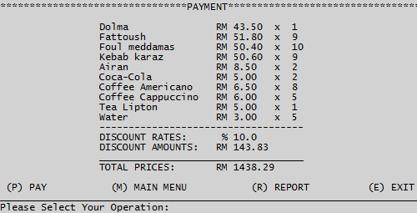

*Bill with 10% Discount (after RM 1000)*

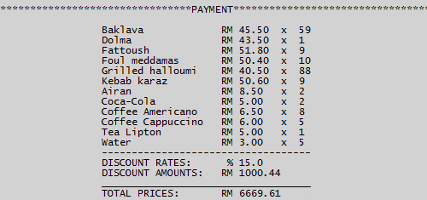

*Bill with 15% Discount (after RM 5000)*

Pay and Upload Data to Report

**Pseudocode:**

PROGRAM Upload_Data:

Var_Discount_1 = 200;

Var_Discount_2 = 1000;

Var_Discount_3 = 5000;

Var_Discount_1_Rate = 5 %;

Var_Discount_2_Rate = 10 %;

Var_Discount_3_Rate = 15 %;

DOWHILE TRUE:

DISPLAY "(P) PAY";

DISPLAY "(M) MAIN MENU";

DISPLAY "(R) REPORT";

DISPLAY "(E) EXIT";

Var_Input = STRING(INPUT("Please Select Your Operation: ")) UPPER;

IF Var_Input == "P" THEN

DISPLAY "Successfully Paid!";

File_Report = OPEN("REPORT.FSD", "WRITE MODE");

File_Report.WRITE(Report_New);

File_Report.CLOSE;

ELSEIF Var_Input == "M" THEN

MAIN_MENU;

BREAK;

ELSEIF Var_Input == "R" THEN

REPORT;

BREAK;

ELSEIF Var_Input == "E" THEN

DISPLAY "THANK YOU";

BREAK;

ELSE:

DISPLAY "ERROR: Invalid Input (" + STRING(Var_Input) + "). TRY again!";

ENDIF.

ENDWHILE.

END.

**Outputs:**

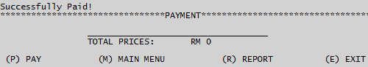

*Successfully Paid!*

test plan

**Project:** Restaurant Controller

**Date:** 14/3/2017

Introduction

The Test Plan has been created to communicate the test approach to team members. It includes team members list and role of them, test environment, test process and deliverables. This document will clearly identify the difference between expected results and actual results.

Team Members

|  |  |
| --- | --- |
| **MEMBERS** | **ROLE** |
| MUSTAFA AHMED ABDULJABBAR | Developer, Data Base Manager |
| RASHAD HELMI ABDULAZIZ AL-YOUSEFI | Developer, User Interface Designer |
| MUKABAK ORAZBEK | Developer, Project Manager |
| YOUSEF THARAWAT | Developer, Tester |

Test Environment

* A computer required.
* Empty space with 9 MB (1 MB for software, 8 MB for user data).
* 10 MB Memory.
* Python 2.7 or higher versions are required.

Checking Process

Checking python version:

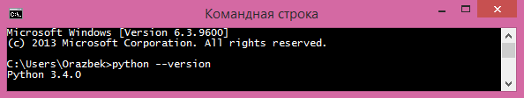

*Python Version*

Open project:

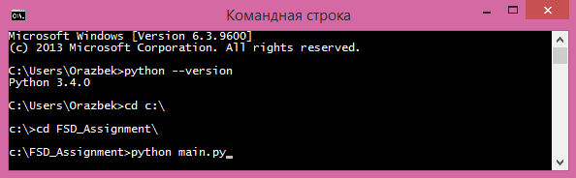

*Open project*

Running project:

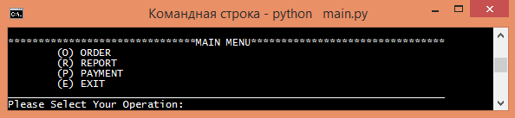

*Running project*

Testing Process

|  |  |  |
| --- | --- | --- |
| **ACTIONS** | **EXPECTED RESULTS** | **ACTUAL RESULTS** |
| **Input Test**  In this action, testers tried to insert risky symbols or key words to input operation.  Input symbol is: = | The algorithm need to identify invalid inputs, and display it on the screen. |  |
| **Sorting Items Name**  In this action, testers tried to test sorting function, and replaced all items name randomly. | Expected results is algorithm need to arrange all items name by alphabetic order. |  |
| **Display Ordered Items**  In this step, testers tried to check calculation part of payment. Firstly need to order some items. More than 1. | Expected result is:  45.5 * 2 = 91  35.5 * 2 = 71  6 * 3 = 18  Total: 180 |  |
| **Upload Data**  In this action, testers tried to upload data to into report file. | Expected results are:  Data have to locate into report.fsd file with uploading time, and have to show all order details |  |

Deliverables

|  |  |
| --- | --- |
| **DELIVERABLE** | **FOR** |
| Test Plan | Tester Team |
| Test Status report | Project Manager, Developer |
| Test Results | All team members |

CONCLUSION

In this documentation, students have prepared a python coding program. They have used a file which will enable to users to add or delete anything from the items menu. Furthermore, developers have used global variables, statements, conditions to minimize algorithms, and running it smoothly. Also, programmers used different functions for each actions, such as order, payment or report. Finally, students have tested their whole project to find differences between expected results and actual results, then used different risky inputs and testing environments to make sure the quality of algorithms.

REFFRENCES

Robertson, L.A. (2007) *Simple Program Design: A Step-by-Step Approach.* Fifth edition. Thomson. Nelson Australia Pty Limited.

Thenewboston. (2009) *Python Programming Tutorial: Video 1 – 43*. [Online] Available at: https://thenewboston.com/videos.php?cat=36.

[Accessed: 01/03/2017].

Python 3.4.5 Documentation. (2016). *Standard Library OS: Miscellaneous Operating System Interfaces.* [Online] Available at: https://docs.python.org/3.4/library/os.html.

[Accessed: 24/02/2017].

Stackoverflow. (2010) *Python Open Built-in Function: Difference between Modes a, a+, w, w+, and r+?* [Online] Available at: http://stackoverflow.com/questions/1466000/python-open-built-in-function-difference-between-modes-a-a-w-w-and-r.

[Accessed: 21/02/2017].