CoE202 - Basics of Artificial Intelligence “Big data analysis and machine learning”

Mukanov Ayan 20170881

Term Project Report

**Kakao Competition**

1. **I used 'brand', 'maker' and 'model' features in addition to ‘product’ features for training. Results:**

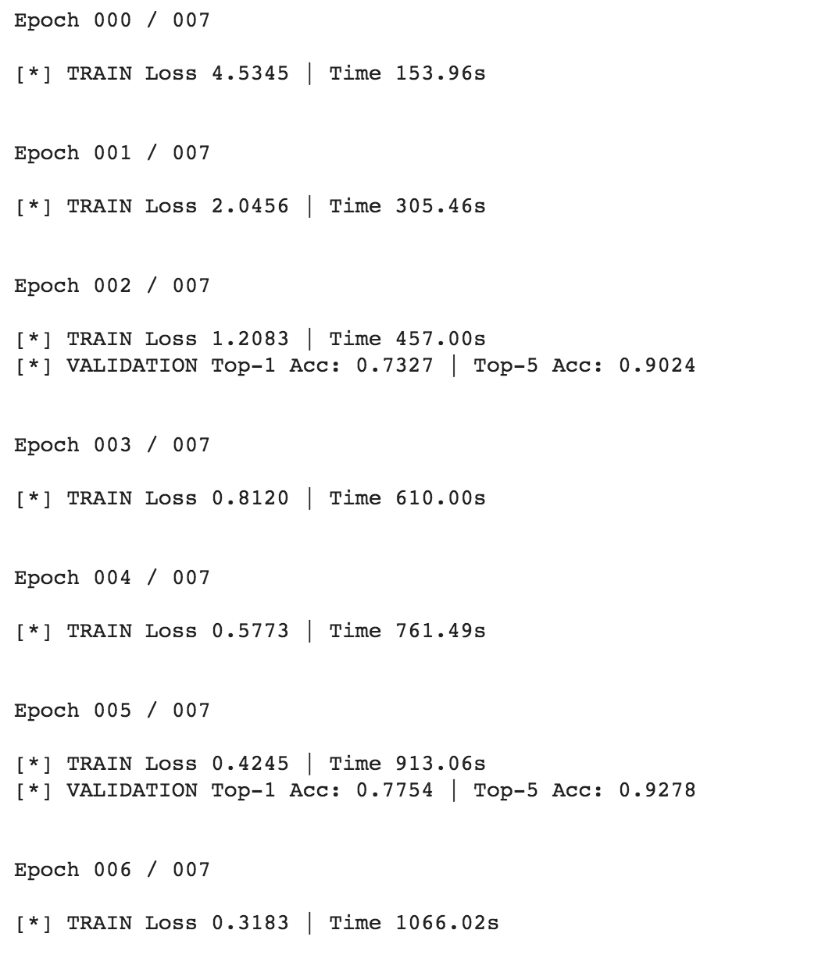

1. **Change the model to use ‘image’ features and ‘price’ features for training. Results:**

Not implemented

1. **Change the model and tune the hyperparameters to increase the score as much as possible.**

Optimized the model and changed number of epochs to 7 to get the highest score of below

Score:

