CoE202 - Basics of Artificial Intelligence “Big data analysis and machine learning”

Mukanov Ayan 20170881

Activity #4 Report

**MNIST Hand-written digit classification**

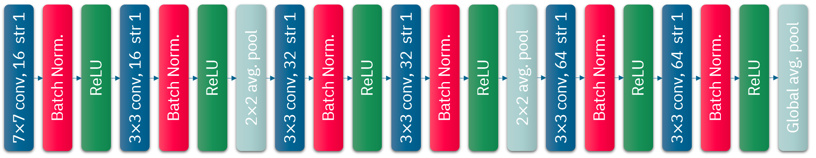

**Very Deep Convolutional Networks for Large-scale image recognition**

Average accuracy for the test set is **0.990**

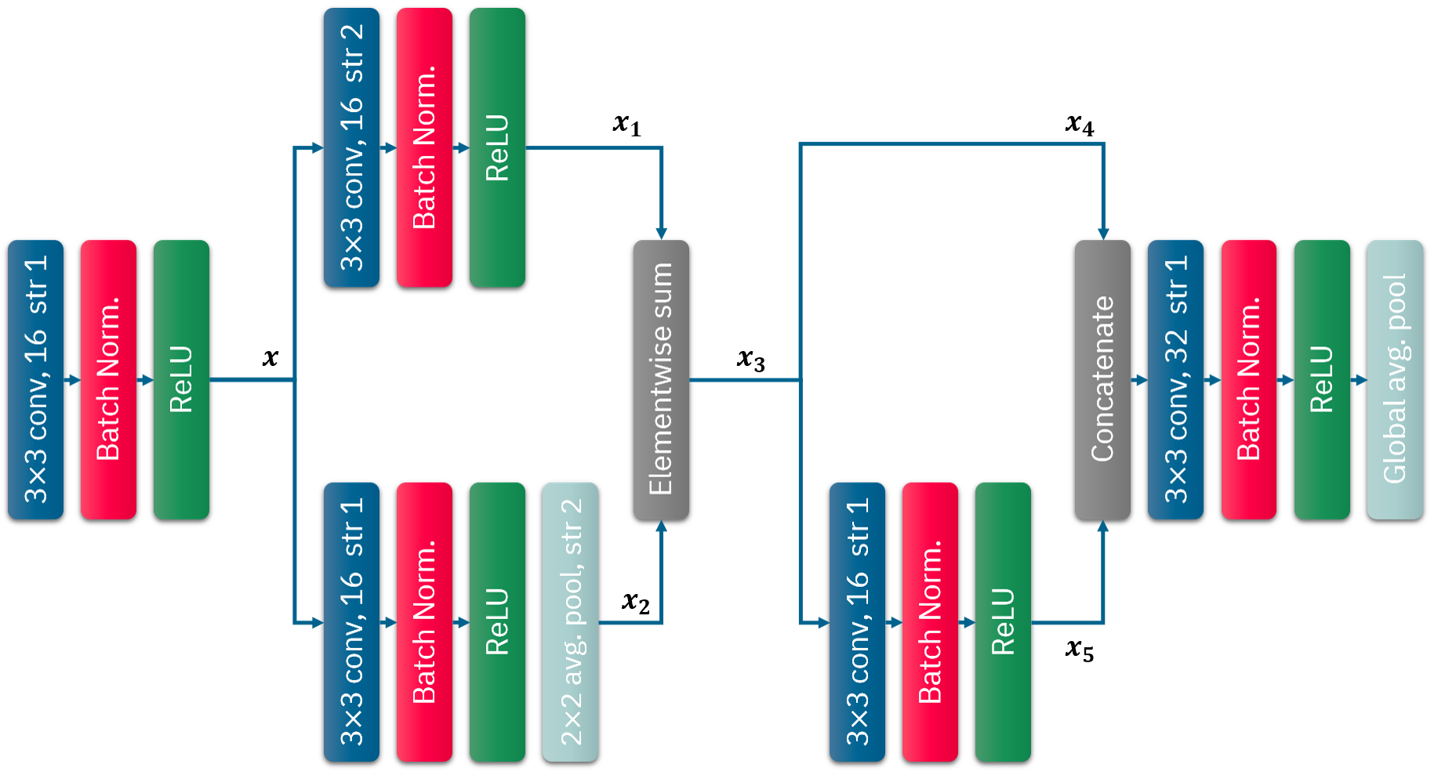

**Task #1: A simple network for MNIST**

Average accuracy for the test set is **0.981**

After the third convolutional filter, with tf.add function, I added the results of 2nd 3x3 filter and 3rd 3x3 filter together, and used this element in 4th conv. layer/filter. Next step, I used tf.concat function with last two elements (x5&x4) and used the result in the last conv.filter.

Batch size is 255