Query for Problem:

INSERT INTO FACILITY (FACNO,FACNAME) VALUES (‘F104’,’Swimming Pool’);

Snapshot :

Before Insertion
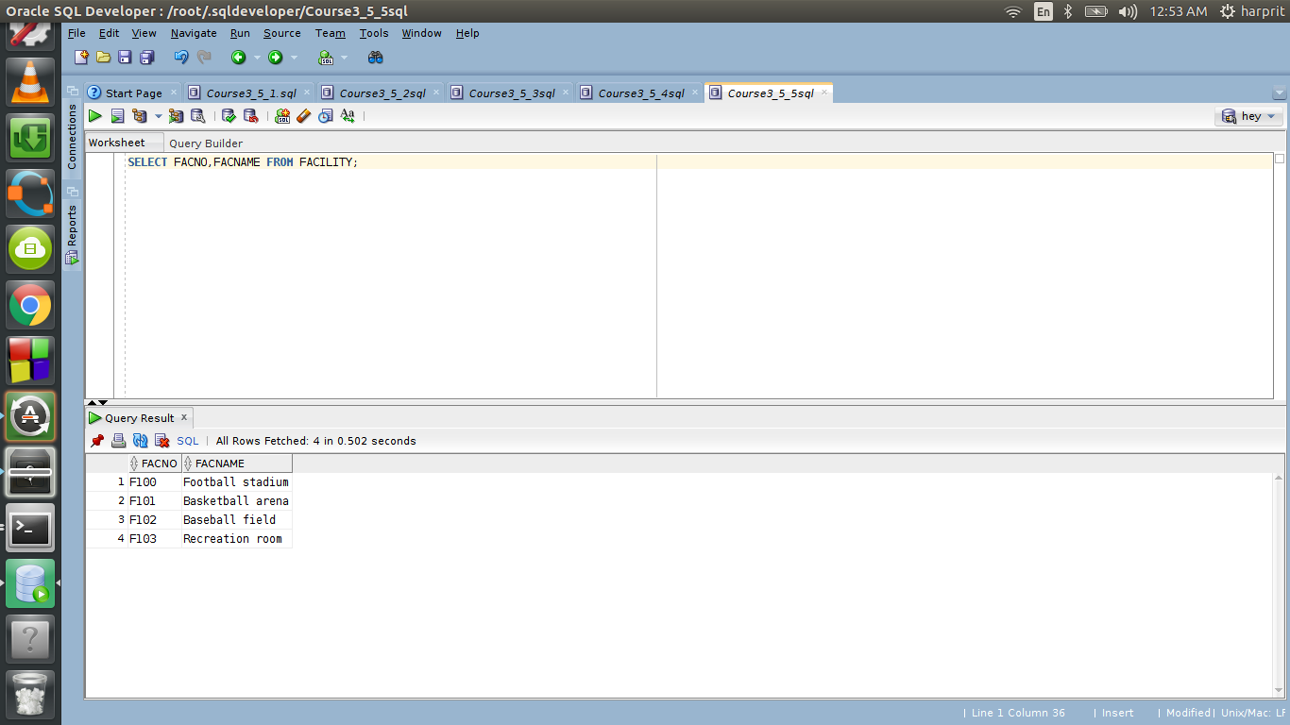

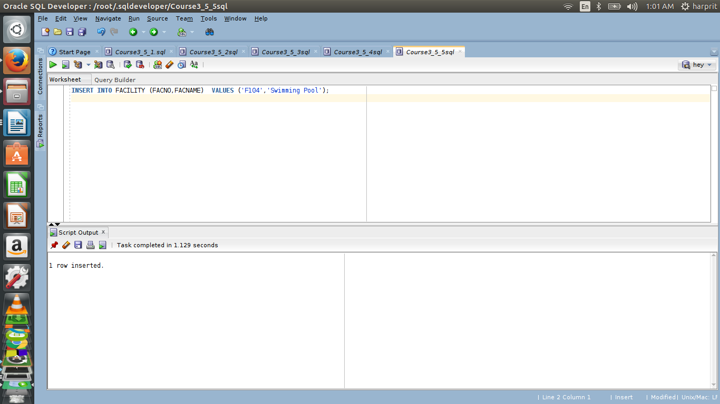
Executing Insert Statement

After insertion

